StressNet: Structural Stress Prediction for Tourist Bridges & Viewing Structures

1. Introduction
Tourist bridges, skywalks, and viewing platforms experience fluctuating loads due to changing crowd densities and environmental conditions. These structures must be continuously monitored to ensure safety and structural integrity.
StressNet is an IoT and Artificial Intelligence based monitoring system designed to collect real-time structural data from sensors and predict stress levels. The system integrates sensors, cloud computing, machine learning models, and dashboards to provide early warnings and actionable insights for safety management.

2. Problem Statement
Traditional bridge monitoring systems depend on manual inspections and fixed structural load limits. These approaches do not provide real-time insights into structural stress caused by:
- Sudden crowd accumulation
- Environmental variations
- Continuous load changes
As a result, potential overload situations may remain undetected, increasing the risk of structural damage and safety hazards.

3. Objectives
The main objectives of the StressNet system are:
- Monitor structural stress using IoT sensors
- Collect real-time environmental and load data
- Use machine learning models to predict structural stress levels
- Visualize system data using an interactive dashboard
- Provide early warnings for safety management

4. System Architecture Overview
The StressNet system follows a layered architecture consisting of:
- Sensor Layer
- Edge Processing Layer
- Cloud Data Layer
- AI/ML Processing Layer
- Visualization Layer
Sensor data is collected through a microcontroller and transmitted to cloud platforms where it is analyzed using machine learning algorithms. The processed information is then visualized through a real-time dashboard.

5.Hardware Components

ESP32-S3 Beta Microcontroller
The ESP32-S3 serves as the main controller that collects sensor data and sends it to the cloud through WiFi connectivity.
DHT22 Temperature Sensor
The DHT22 measures environmental temperature around the bridge structure, which may affect material behavior.
BMP180 Pressure Sensor
The BMP180 sensor measures atmospheric pressure conditions that could influence structural loads.
HX711 Load Cell Amplifier
HX711 is an amplifier module used to interface load cell sensors with the microcontroller.
5kg Load Cell (Force Sensor)
The load cell measures structural load or weight applied to the bridge.
Green LED Indicator
The LED provides a visual indication of system status or safe conditions.

6. Circuit Connections
DHT22 Sensor
VCC → 3.3V
GND → GND
DATA → GPIO 15
Pull-up resistor (10kΩ) between VCC and DATA
HX711 Module
VCC → 3.3V
GND → GND
DT → GPIO 4
SCK → GPIO 5
Load Cell to HX711
Red → E+
Black → E−
White → A−
Green → A+
BMP180 Pressure Sensor
VCC → 3.3V
GND → GND
SDA → GPIO 21
SCL → GPIO 22
Green LED
Anode → GPIO 18 through 220Ω resistor
Cathode → GND

7.Software Platforms

Cirkit Designer
Used to simulate and design the IoT circuit system.
ThingSpeak Cloud
Receives real-time sensor data from the ESP32 device.
Microsoft Azure
Used for backend processing, automation, and integration with machine learning services.
Google Colab
Used to train machine learning models using collected sensor datasets.
Power BI
Used to create a real-time monitoring dashboard.

8. Data Flow Architecture
The system follows the data pipeline below:
Sensors
↓
ESP32 Microcontroller
↓
WiFi Transmission
↓
ThingSpeak Cloud
↓
Azure Data Processing
↓
Machine Learning Model
↓
Prediction Output
↓
Power BI Dashboard
↓
Alert System

9. Machine Learning Model
Sensor data containing the following features is used for prediction:
- Force
- Temperature
- Pressure
- Timestamp
Machine learning algorithms such as:
- Random Forest
- Decision Tree
- Logistic Regression
are trained to classify structural stress levels into:
Safe (Low Stress)
Warning (Moderate Stress)
Danger (High Stress)

10. Dashboard Interface
The dashboard created using Microsoft Power BI displays:
- Live sensor readings
- Stress prediction results
- Historical stress trends
- Structural safety indicators
- Alert notifications
Color indicators are used for risk classification:
🟢 Safe
🟡 Warning
🔴 Danger

11. Real-Time Monitoring
The system continuously streams sensor data to the cloud. Automated processing scripts retrieve new data periodically and run machine learning predictions.
The dashboard updates automatically, allowing operators to monitor structural conditions in real time.

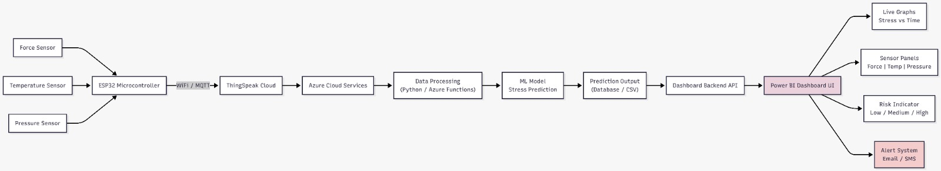

12. Expected Outcomes
The StressNet system will provide:
- Continuous structural monitoring
- Early detection of overload conditions
- Improved public safety
- Data-driven crowd management
- Smart infrastructure monitoring capability

13. Conclusion
StressNet demonstrates the effective integration of IoT, cloud computing, and artificial intelligence for structural health monitoring. By analyzing real-time sensor data and predicting stress levels, the system enables proactive safety management for tourist bridges and viewing structures.

