FIT5225 Assignment 1 — Generative AI Usage Documentation
Tsung-Yao Chen | 36006750
All AI interactions were conducted via Claude (Anthropic). I reviewed, tested, and modified all generated outputs before use.
- Web Service Design (main.py)
Prompt:
I'm building a FastAPI web service that runs YOLOv8m inference. It needs two endpoints: POST /api/predict (returns bounding boxes, confidence scores, class labels, and latency metrics as JSON) and POST /api/annotate (returns the annotated image as base64). The request body contains a uuid string and a base64-encoded image. The service must not block the event loop during CPU-bound inference. How should I structure this?
Output:
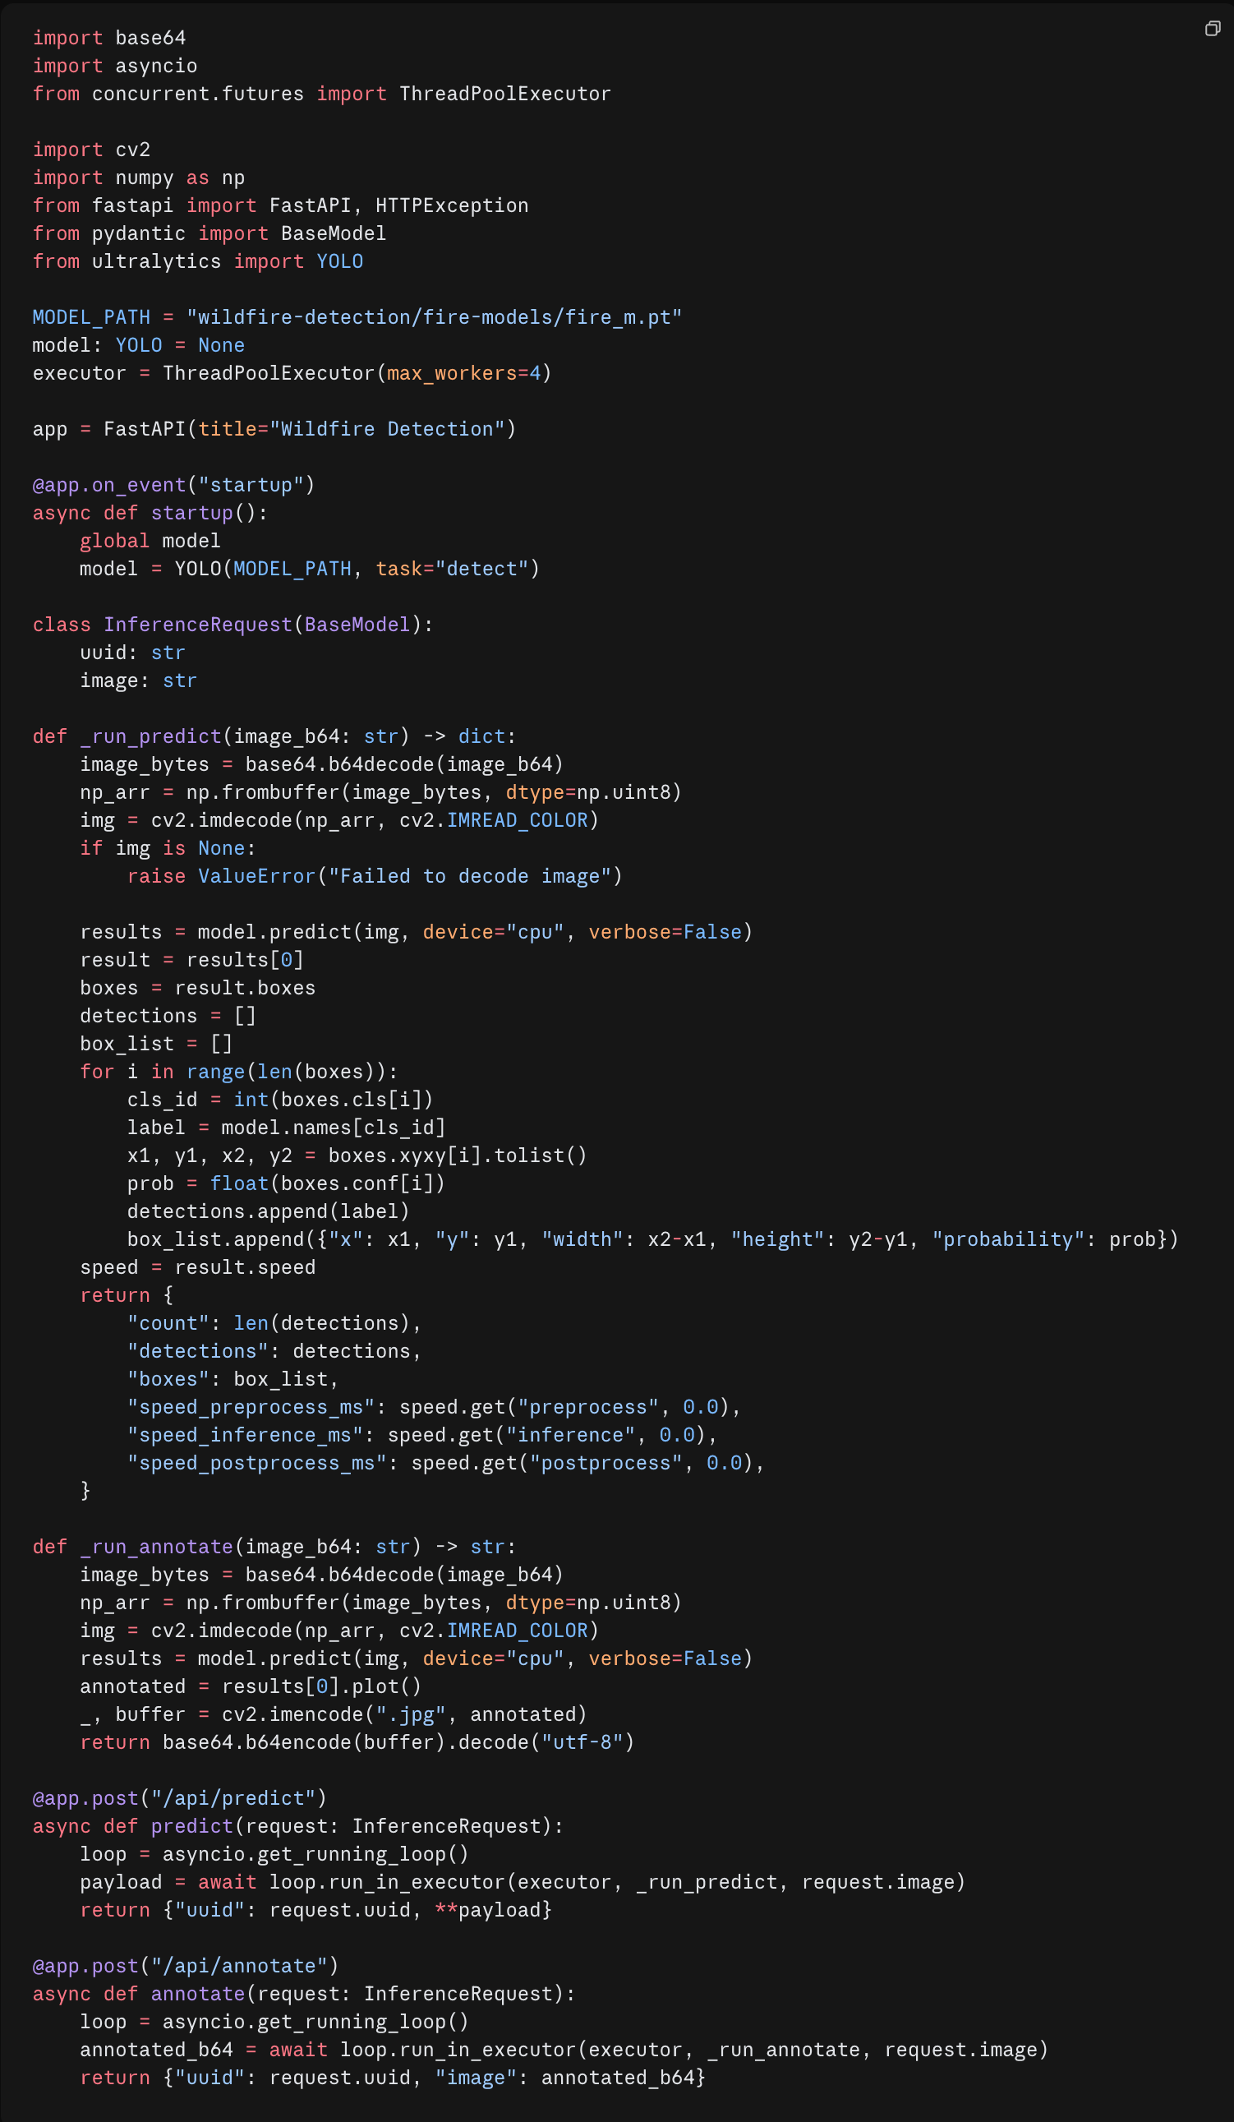
Follow-up Prompt:
My inference latency is inconsistent — sometimes 800ms, sometimes 3s+. I suspect it's because input images vary in resolution. How should I resize images before inference?
Output:
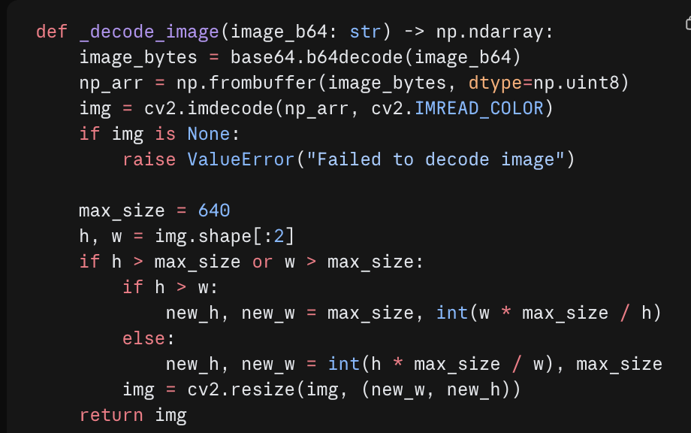
Modification
- Replaced deprecated @app.on_event("startup") with asynccontextmanager lifespan, and added executor.shutdown(wait=True) on teardown to drain in-flight requests cleanly
- Added torch.set_num_threads(1) to prevent PyTorch spawning extra threads that contend under 1 vCPU — this was identified after benchmarking showed unstable throughput with the default setting
- Reduced max_workers from 4 to 2 after load testing showed 4 workers caused CPU thrashing under the 1 vCPU limit
- Added logging and wrapped endpoints in try/except with proper HTTP error codes
- Added /health endpoint for Kubernetes readiness/liveness probes
- Dockerfile
Prompt:
Write an optimised Dockerfile for a Python 3.12 FastAPI app that uses PyTorch (CPU-only) and OpenCV. Requirements: multi-stage build to keep the image small, install CPU-only torch separately before other requirements, run as non-root user for security compliance.
Output:
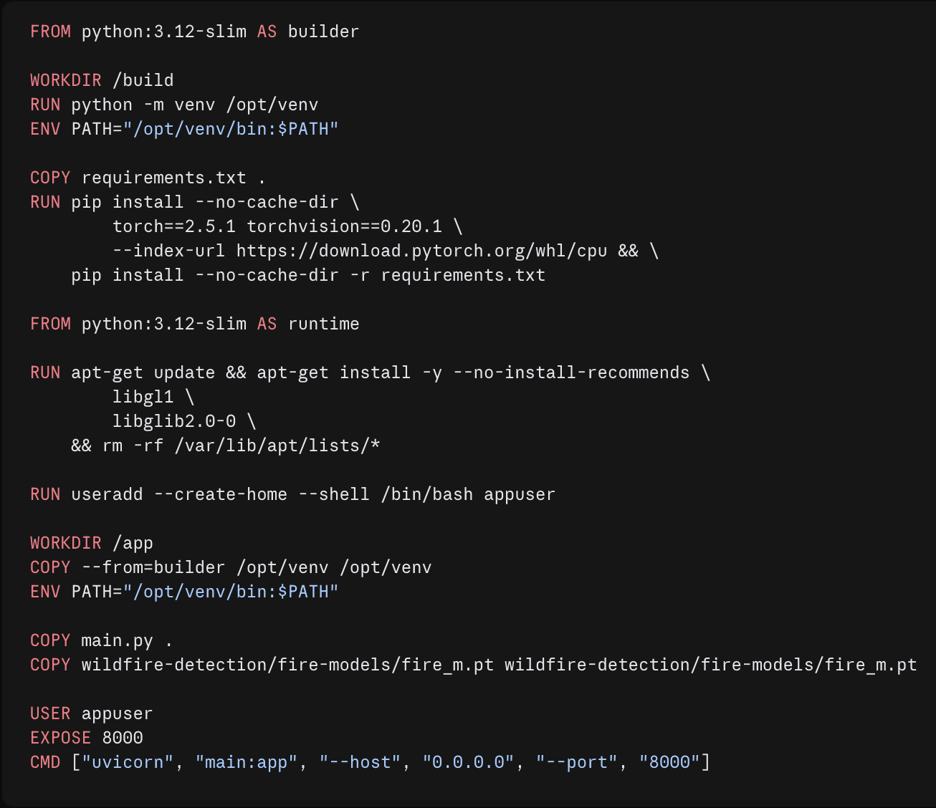
Modification
- Added libxcb1 to system dependencies — discovered at runtime that OpenCV requires it on this base image
- Added PYTHONUNBUFFERED=1 and PYTHONDONTWRITEBYTECODE=1 env vars to prevent buffered output and .pyc file generation in the container
- Added --log-level warning to the CMD to suppress per-request access logs under high load, which were adding measurable overhead
- Infrastructure as Code
Terraform
Prompt:
Write Terraform scripts for GCP to provision a Kubernetes cluster environment: 1 master node and 2 worker nodes using n2-custom-4-8192 machines in australia-southeast1-a, on a custom VPC with subnet 10.0.0.0/24. Use a modular structure with separate network and compute modules.
Output:
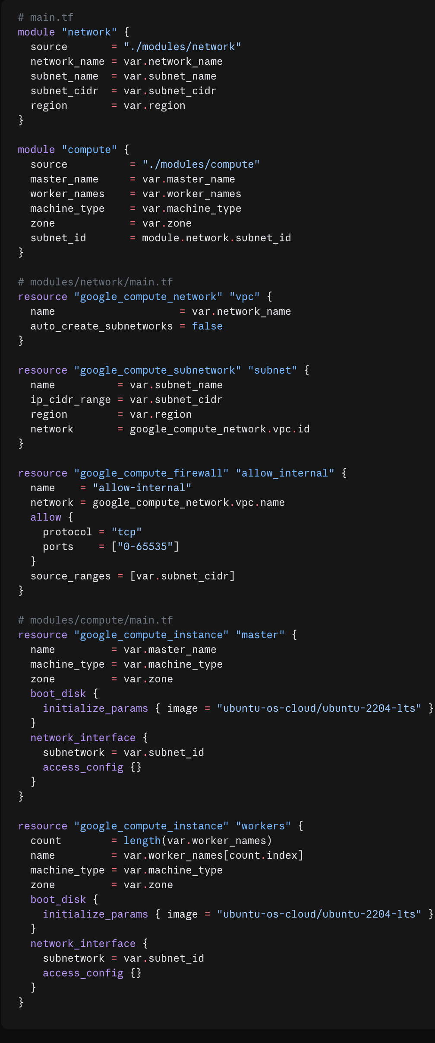
Modification
- Added a separate worker_machine_type variable and separate disk size variables (disk_size_master_gb, disk_size_worker_gb) — master and workers have different storage requirements
- Added a firewall rule to expose NodePort range (30000–32767) for external Locust access, which was missing from the generated output
- Added SSH firewall rule (tcp:22) to allow Ansible to connect to the VMs
Ansible
Prompt:
Write an Ansible playbook to install Kubernetes on Ubuntu VMs. It should: disable swap, install Docker with cri-dockerd as the container runtime, install kubeadm/kubelet/kubectl, initialise the cluster on the master with kubeadm init, and join worker nodes automatically.
Output:
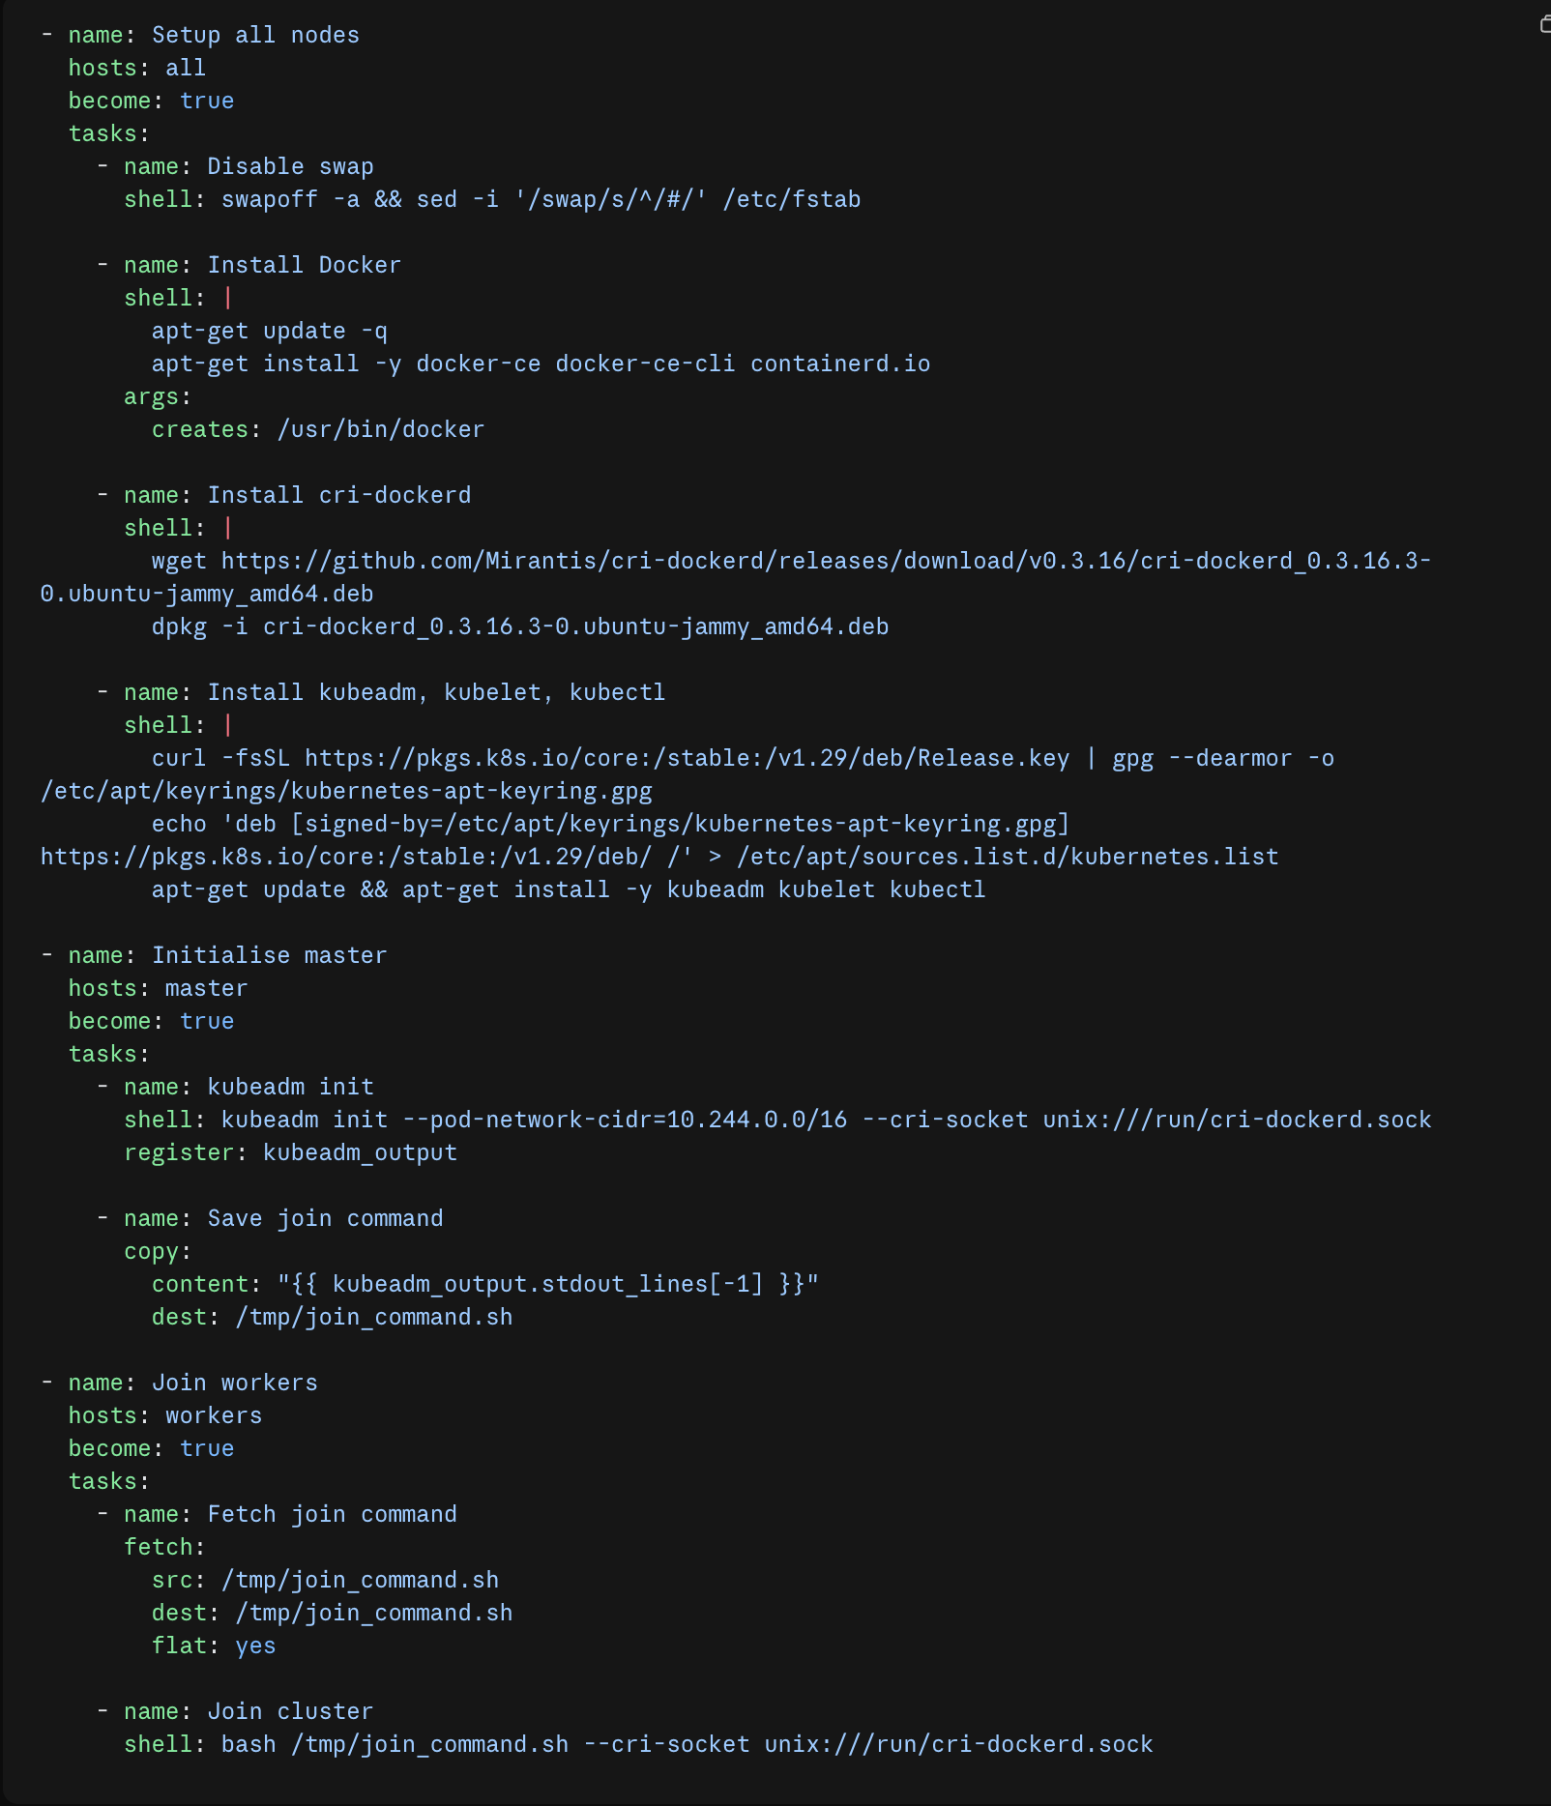
- Locust Load Testing Script
Prompt:
Write a Locust load testing script for my wildfire detection API. It should load and encode a test image to base64 once at module level, then send POST requests to /api/predict (weight 2) and /api/annotate (weight 1). Each user should wait 0.1–0.5 seconds between tasks. Validate the response structure.
Output:
Generative AI Usage Documentation
All AI interactions were conducted via Claude (Anthropic) — used to assist with web service architecture design, Dockerfile optimisation, IaC scripting (Terraform and Ansible), load testing script development, and drafting sections of this report. I reviewed, tested, and modified all generated outputs before use.
- Web Service Design (main.py)
Prompt:
I'm building a FastAPI web service that runs YOLOv8m inference. It needs two endpoints: POST /api/predict (returns bounding boxes, confidence scores, class labels, and latency metrics as JSON) and POST /api/annotate (returns the annotated image as base64). The request body contains a uuid string and a base64-encoded image. The service must not block the event loop during CPU-bound inference. How should I structure this?
Output:

Follow-up Prompt:
My inference latency is inconsistent — sometimes 800ms, sometimes 3s+. I suspect it's because input images vary in resolution. How should I resize images before inference?
Output:

Modification
- Replaced deprecated @app.on_event("startup") with asynccontextmanager lifespan, and added executor.shutdown(wait=True) on teardown to drain in-flight requests cleanly
- Added torch.set_num_threads(1) to prevent PyTorch spawning extra threads that contend under 1 vCPU — this was identified after benchmarking showed unstable throughput with the default setting
- Reduced max_workers from 4 to 2 after load testing showed 4 workers caused CPU thrashing under the 1 vCPU limit
- Added logging and wrapped endpoints in try/except with proper HTTP error codes
- Added /health endpoint for Kubernetes readiness/liveness probes
- Dockerfile
Prompt:
Write an optimised Dockerfile for a Python 3.12 FastAPI app that uses PyTorch (CPU-only) and OpenCV. Requirements: multi-stage build to keep the image small, install CPU-only torch separately before other requirements, run as non-root user for security compliance.
Output:

Modification
- Added libxcb1 to system dependencies — discovered at runtime that OpenCV requires it on this base image
- Added PYTHONUNBUFFERED=1 and PYTHONDONTWRITEBYTECODE=1 env vars to prevent buffered output and .pyc file generation in the container
- Added --log-level warning to the CMD to suppress per-request access logs under high load, which were adding measurable overhead
- Infrastructure as Code
Terraform
Prompt:
Write Terraform scripts for GCP to provision a Kubernetes cluster environment: 1 master node and 2 worker nodes using n2-custom-4-8192 machines in australia-southeast1-a, on a custom VPC with subnet 10.0.0.0/24. Use a modular structure with separate network and compute modules.
Output:

Modification
- Added a separate worker_machine_type variable and separate disk size variables (disk_size_master_gb, disk_size_worker_gb) — master and workers have different storage requirements
- Added a firewall rule to expose NodePort range (30000–32767) for external Locust access, which was missing from the generated output
- Added SSH firewall rule (tcp:22) to allow Ansible to connect to the VMs
Ansible
Prompt:
Write an Ansible playbook to install Kubernetes on Ubuntu VMs. It should: disable swap, install Docker with cri-dockerd as the container runtime, install kubeadm/kubelet/kubectl, initialise the cluster on the master with kubeadm init, and join worker nodes automatically.
Output:

- Locust Load Testing Script
Prompt:
Write a Locust load testing script for my wildfire detection API. It should load and encode a test image to base64 once at module level, then send POST requests to /api/predict (weight 2) and /api/annotate (weight 1). Each user should wait 0.1–0.5 seconds between tasks. Validate the response structure.
Output:
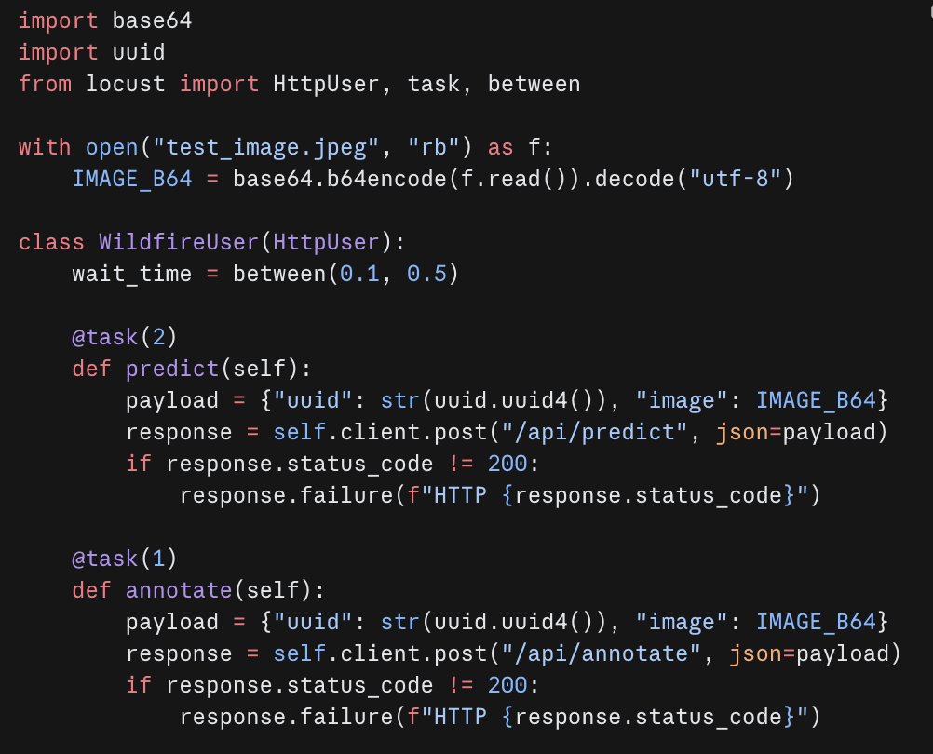
Modification
- Used os.path.join(os.path.dirname(__file__), "test_image.jpeg") instead of a bare filename so the script works when called from any working directory
- Added timeout=30 per request to match the benchmark's breaking point definition
- Added self.client.headers.update({"Connection": "close"}) in on_start() to prevent connection reuse issues observed under high concurrency

Appendix
Disclaimer of Generative AI use
This document lists the primary prompts and representative AI-generated outputs for the main implementation components of this assignment. It does not constitute a complete transcript of all AI interactions.
During development, many additional prompts were used for debugging (e.g., resolving runtime errors, interpreting stack traces), conceptual clarification (e.g., understanding queuing theory, Kubernetes networking), and iterative refinement. These have been omitted as they do not represent substantive code generation.
Additionally, Claude (Anthropic) automatically compresses long conversation histories when the context window approaches its limit. As a result, a complete verbatim log of all prompts and responses is not recoverable. The outputs presented here are reconstructed from the final implemented code and my recollection of the key generation steps.
All AI-generated code was reviewed, tested, and modified prior to use. No output was submitted without understanding and verification.

