CloudEco Experiments and Benchmark Report
Tsung-Yao Chen | 36006750
1. Experimental Setup
The CloudEco wildfire detection API (FastAPI + YOLOv8m) was deployed on a 3-node Kubernetes cluster on GCP (australia-southeast1-a): 1 master and 2 worker nodes, each n2-custom-4-8192 (4 vCPU, 8 GB RAM). Each pod was resource-limited to 1.0 vCPU and 2 Gi memory. Load was generated using Locust, mixing /api/predict (weight 2) and /api/annotate (weight 1) requests with a base64-encoded test image and 0.1–0.5 s inter-request wait. Concurrent users were ramped until the breaking point — defined as the first HTTP failure or exponential latency growth.
2. Results Table
Pods | Max Stable Users | Avg Latency at Threshold | Max Throughput (QPS) | Scaling Efficiency
1 | ~34 | 8,703 ms | 1.10 | 1.00x
2 | ~79 | 13,195 ms | 2.20 | 2.00x
4 | ~128 | 10,936 ms | 4.10 | 3.73x
8 | ~164 | 9,774 ms | 6.90 | 6.27x

3. Graphical Plots
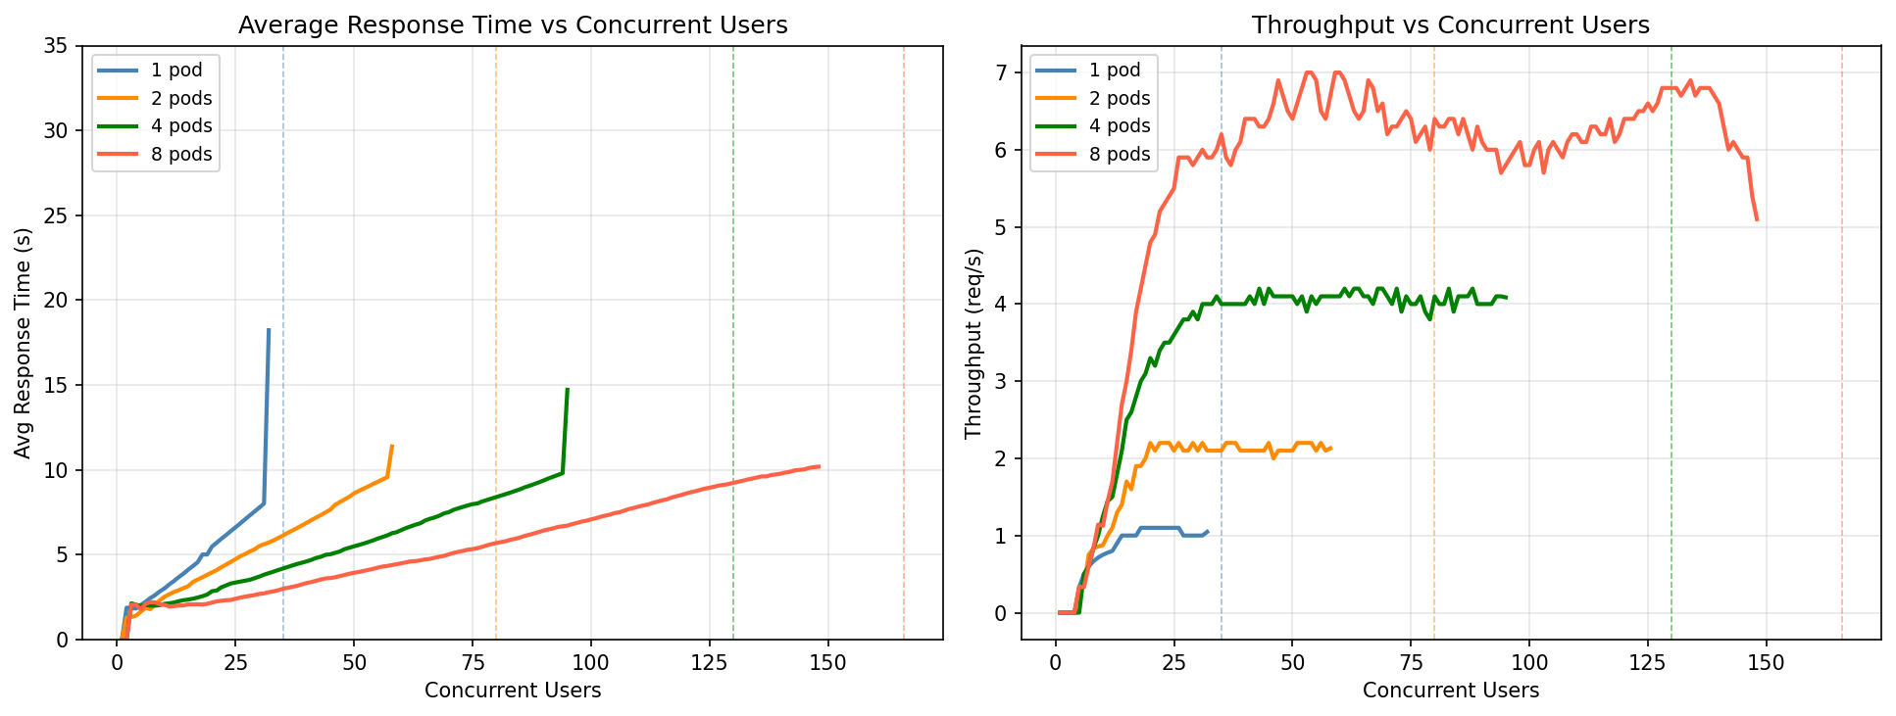
4. Performance Analysis
Bottleneck identification
The primary bottleneck is CPU-bound YOLOv8m inference. $torch.set_num_threads(1)$ confines each inference to a single thread, and with a 1 vCPU limit, the per-pod service rate is μ ≈ 0.91 req/s (≈1.1 s per inference).
$ThreadPoolExecutor(max_workers=2)$ overlaps I/O phases (request parsing, JSON serialisation) with inference, lifting the effective saturation throughput to ~1.10 QPS per pod before the CPU becomes the hard ceiling.
Little's Law verification
Little’s Law: the average number of items in a stable system (L) equals their average arrival rate (λ)multiplied by the average time they spend in the system (W).
At the 1-pod breaking point (λ = 1.10 req/s, W = 8.703 s):
$$L = λ × W = 1.10 × 8.703 ≈ 9.6 concurrent requests in flight$$
This confirms near-full CPU utilisation (ρ → 1) at saturation, consistent with M/M/1 queuing theory: once arrival rate approaches the service rate, queue length grows unboundedly and latency spikes.
Horizontal scaling characteristics
Throughput scales near-linearly: ×2.00, ×3.73, ×6.27 for 2, 4, and 8 pods respectively. The 8-pod parallel efficiency of 78% (6.27× vs theoretical 8×) reflects CPU contention between co-located pods competing for time slices on shared worker nodes. Breaking points scale proportionally (~35 → ~80 → ~130 → ~166 users), confirming that horizontal pod scaling provides predictable, linear capacity expansion.
Autoscaling justification
According to M/M/c Formulas in queuing theory (Multi-Server): For c servers, $Utilization:\left(ρ=\frac{λ}{cμ}\right)$
Because the service is stateless and CPU-bound, each additional pod adds an independent inference server, directly increasing aggregate service rate (c × μ). This was validated empirically through manual horizontal scaling. For example, at 25 concurrent users, 8 pods maintains ~2.5 s average latency compared to >7 s under a 1-pod configuration, confirming that pod count is the primary lever for capacity expansion.

Appendix
Acknowledgement of Generative AI Use
This assignment made use of generative artificial intelligence tools to support implementation and report writing.
Claude (Anthropic) — used to assist with web service architecture design, Dockerfile optimisation, IaC scripting (Terraform and Ansible), load testing script development, and drafting sections of this report.
All AI-generated code and text was reviewed, tested, and modified by me prior to submission. The analysis, benchmarking methodology, experimental results, and conclusions presented in this report are my own work. AI tools were used as productivity aids and not as a substitute for original implementation or academic integrity.

