|  |  |
| --- | --- |
| System Identification project proposal | |
| Write a short summary which describes the whole content in one or a few sentences. | |
| |  |  |  |  | | --- | --- | --- | --- | | Status | Name / Function | Date | Dig. Sign. | |  |  |  |  | | |
| For this document and the information contained therein, we reserve all rights. Reproduction, use or disclosure to third parties is prohibited without express permission. | © Marenco Swisshelicopter AG |

Content

1 Introduction 3

1.1 Summary and purpose 3

1.2 Preamble 3

1.3 Executive summary 3

2 Statement of the problem 4

3 Objectives 5

4 Technical approach 6

4.1 Introduction to Aircraft System Identification 6

4.2 Required technology 6

4.2.1 Software 6

4.2.2 Flight Testing 6

4.3 Implementation 10

4.3.1 Development 10

4.3.2 Involvement of third parties 10

5 Project management 11

5.1 Deliverables 11

5.2 Budget 11

6 Document information 12

6.1 Definitions/ Abbreviations 12

6.2 References 12

6.3 Revisions 12

# Introduction

## Summary and purpose

The present Kopter – Document of Kopter Group AG describes a project proposal. This consists on the implementation of

## Preamble

Aircraft System Identification the discipline that uses

In preparation of the present document, several meetings have been held. Starting from the meeting held in 02.03.2018, which minutes could be read under [Ref 1].

## Executive summary

Aircraft System Identification consists on a

The project proposed in this document intends to develop a technology to be implemented within Flight Physics Kopter department.

# Statement of the problem

A dynamic model of the helicopter is needed for various applications

The current approach used by Flight Physics department is Flightlab, which is a state-of-the-art, finite element, component-based, selective fidelity modelling and analysis software package. Flightlab is also a commercial software.

DRAFT:

* Need to validate Flightlab
* Need to have a proper model to develop a
* Need to proper way to design a FAS

# Objectives

There are several objectives that are aimed to be achieved:

The main objective is to validate the Flightlab model. The second phase of the development

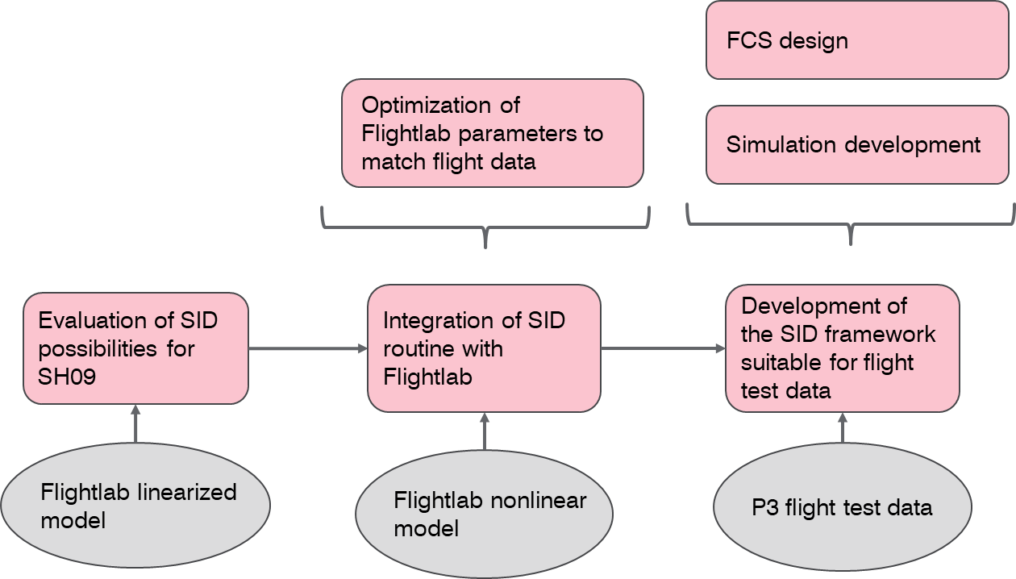

* FCS / CAS development
* **Helicopter Test Rig / Simulator development**  
    
  The development of a test rig for our SH09 is a required step to be able to provide a world-class helicopter. Such a test rig would incorporate a flight simulator of the helicopter plus a required set of systems to simulate the avionics. There are various uses that can be given to such a tool, for example:  
  + Avionics systems testing  
    A simulated helicopter environment would enable the evaluation and development of the avionics systems implemented in the helicopter.
  + Pilot training on newly developed avionics

The development of a Kopter is can be suitable to be certified under the EASA regulations for Flight Simulation Training Devices (FSTD), CS-FSTD(H) referenced in [Ref 2]. Depending on the complexity of the developed device, different qualification levels can be applied for.

# Technical approach

## Introduction to Aircraft System Identification

## Required technology

### Software

### Flight Testing

The implementation of SID methods requires the implementation dedicated flight test manoeuvres as part of the flight test program. This makes it possible to obtain suitable flight test data for parameter estimation.

Important considerations for the SID flight testing campaign:

* All parties involved in the testing campaign should be aware of what the objectives are. For example, what is the aimed accuracy for the parameter estimates? This factor will drive how the flight testing and data analysis will be done.
* Allow iteration into the plan. Best arrangement is to conduct an initial test flight, then stop flight-test operations and analyse the data all the way through to obtain model parameter estimates and error bounds.

The definition of the flight test manoeuvres need to take under consideration the following points:

* Amplitude constraints on selected aircraft response variables, imposed by:
  + Flight safety
  + Maintaining data downlink to the ground
* Inputs amplitudes limited by:
  + Mechanical stops
  + Flight Control software

#### Helicopter inputs

It is important to note that, the helicopter is an air vehicle in which multiple-inputs problems appear when considering the isolated longitudinal or lateral dynamics. Therefore, there are a number of considerations that need to be make:

* Relative effectiveness  
  It is necessary to consider the differences in control authority for each of the inputs considered.
* Coordination  
  Multiple inputs must be coordinated to maximize data information content and to make sure the aircraft response does not exceed the limits for model structure validity.
* Correlation  
  The inputs need to be decorrelated to provide the most accurate control effectiveness.

Input definition:

* Pilot inputs or automatically generated inputs?
* Manoeuvre time length
  + Longer manoeuvres provide more information
  + But it may be difficult to sustain certain flight conditions
  + Limited flight-test time available
* Input form: The aim to maximize the signal-to-noise ratio.
  + Shape
  + Amplitude
  + Frequency
    - High frequency: Limited by: instrument dynamic response, reduced dynamic system response to high-frequency inputs and high-frequency limitations of the pilot and control system
    - Low frequency: May cause the aircraft to drift away from the flight condition selected for the manoeuvre.
* Capacity to change the inputs:
  + If pilot inputs in the range of [0.016, 1.6] Hz
  + If automatic input, the limit is given by the rate of the control surface actuator rate limits

Types of inputs:

* Impulse:  
  Useful when no *a priori* information of the aircraft is available. Often impractical because of low input energy.

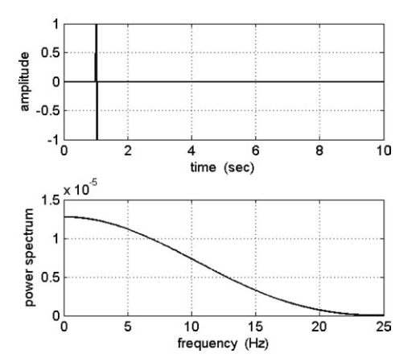

* Frequency sweeps:  
  The frequency content of the input covers a frequency band of interest. Provide useful data to build a Bode plot of the system.

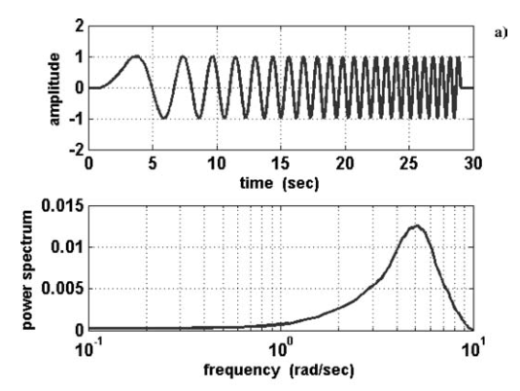

* Doublet input  
  When *a priori* information of the system dynamic response is available. The timing of the pulses is chosen so that the dominant frequency of in the input is at or close to the expected natural frequency of the dynamic system.

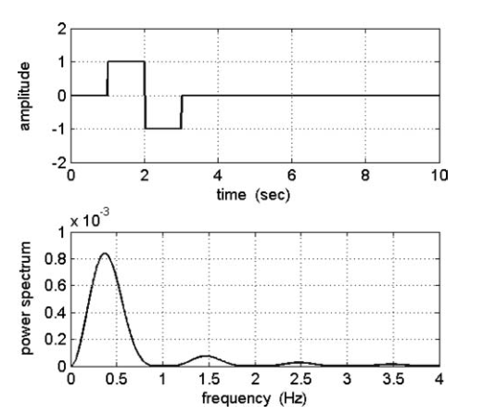

* Multi-steps inputs (3-2-1-1 and 2-1-1)  
  They provide much richer frequency content than a doublet. The 3-2-1-1 may be difficult to achieve as the 3 pulse may make the aircraft to depart. To address this, a 2-1-1 input can be used instead.

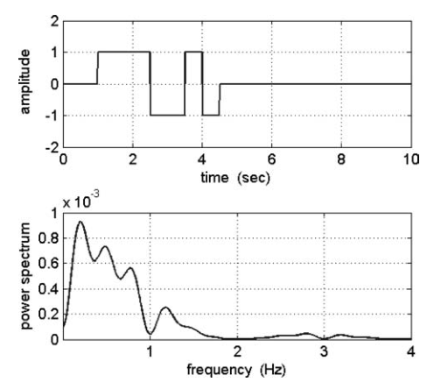

## Implementation

### Development

### Involvement of third parties

# Project management

The calendar of activities that follow the implementation of this technology.

In the scope of this project proposal, only the initial steps of the implementation of System Identification methodologies are considered. Further applications within Kopter shall be defined in attendance to future interests that require of SID to be properly address.

## Schedule

* Description of task phases
  + Planning
  + Concept Development
    - Phase 1
  + Implementation
    - Phase 2
    - Phase 3
* Gant diagram
  + Until the required model is implemented

## Resources

* Software -> Commercial software
* Flight test
  + Flight Test Program -> Calculate expected flight test hours required
  + Pilots
* Team qualifications
  + One analysis engineer dedicated exclusively to this task
  + Support from Flight Physics department

## Deliverables

* Data compilation
* Software development
  + Set of tools to integrate SID methodologies within Flightlab, being feed from flight test data, enabling the validation of the second
  + Identified dynamic model of the SH09 P3 prototype implemented in Matlab. This model can serve applications such as:
    - Flight simulator development
    - Stability Augmentation System development

## Budget

# Document information

## Definitions/ Abbreviations

|  |  |
| --- | --- |
| Abbreviation | Meaning |
| SID | System Identification |
| CAS | Control Augmentation System |
| CSAS | Control and Stability Augmentation System |
|  |  |

Table 1: Abbreviations

## References

**Kopter internal documents**

|  |  |  |
| --- | --- | --- |
| Reference description | Reference identifier | Name / Description |
| 1. MoM – 02.03.2018 | 10158326/18M/EN/00/01 | Minutes of meeting held on 02.03.2018 |

Table 2: References, Kopter internal documents

**External documents**

|  |  |
| --- | --- |
| Reference description | Name / Description |
| 1. CS-FSTD(H) | Certification Specifications for Helicopter Flight Simulation Training Devices |

<Rey/>

## Revisions

|  |  |  |  |
| --- | --- | --- | --- |
| Rev | Version | Comment | Name |
| A | 00 | Initial version | A. Valverde |

Table 3: Revisions