|  |  |
| --- | --- |
| System Identification project proposal | |
| Write a short summary which describes the whole content in one or a few sentences. | |
| |  |  |  |  | | --- | --- | --- | --- | | Status | Name / Function | Date | Dig. Sign. | |  |  |  |  | | |
| For this document and the information contained therein, we reserve all rights. Reproduction, use or disclosure to third parties is prohibited without express permission. | © Marenco Swisshelicopter AG |

Content

1 Introduction 2

1.1 Scope 2

1.1.1 Summary and purpose 2

1.1.2 Applicability 2

2 CM description 2

3 Document information 2

3.1 Definitions/ Abbreviations 2

3.2 References 3

3.3 Revisions 3

# Introduction

## Summary and purpose

The present Kopter – Document of Kopter Group AG describes a project proposal. This consists on the implementation of

## Preamble

In preparation of the present document, several meetings have been held. Starting from the meeting held in 02.03.2018, which minutes could be read under [Ref 1].

## Executive summary

Aircraft System Identification consists on a

# Technical approach

## Required technology

### Software

### Flight Testing

The implementation of SID methods requires the implementation dedicated flight test manoeuvres as part of the flight test program. This makes it possible to obtain suitable flight test data for parameter estimation.

It is important to note that, the helicopter is a air vehicle in which multiple-inputs problems appear when considering the isolated longitudinal or lateral dynamics. Therefore, there are a number of considerations that need to be make:

* Relative effectiveness  
  It is necessary to consider the differences in control authority for each of the inputs considered.
* Coordination  
  Multiple inputs must be coordinated to maximize data information content and to make sure the aircraft response does not exceed the limits for model structure validity.
* Correlation  
  The inputs need to be decorrelated to provide the most accurate control effectiveness.

Important considerations for the SID flight testing campaign:

* All parties involved in the testing campaign should be aware of what the objectives are. What is the aimed accuracy for the parameter estimates, for instance. This factor will drive how the flight testing and data analysis will be done.
* Allow iteration into the plan. Best arrangement is to conduct an initial test flight, then stop flight-test operations and analyse the data all the way through to obtain model parameter estimates and error bounds.

The definition of the flight test manoeuvres need to take under consideration the following points:

* Amplitude constraints on selected aircraft response variables, imposed by:
  + Flight safety
  + Maintaining data downlink to the ground
* Inputs amplitudes limited by:
  + Mechanical stops
  + Flight Control software

Input definition:

* Pilot inputs or automatically generated inputs?
* Manoeuvre time length
  + Longer manoeuvres provide more information
  + But it may be difficult to sustain certain flight conditions
  + Limited flight-test time available
* Input form: The aim to maximize the signal-to-noise ratio.
  + Shape
  + Amplitude
  + Frequency
    - High frequency: Limited by: instrument dynamic response, reduced dynamic system response to high-frequency inputs and high-frequency limitations of the pilot and control system
    - Low frequency: May cause the aircraft to drift away from the flight condition selected for the manoeuvre.
* Capacity to change the inputs:
  + If pilot inputs in the range of [0.016, 1.6] Hz
  + If automatic input, the limit is given by the rate of the control surface actuator rate limits

Types of inputs:

* Impulse:  
  Useful when no *a priori* information of the aircraft is available. Often impractical because of low input energy.

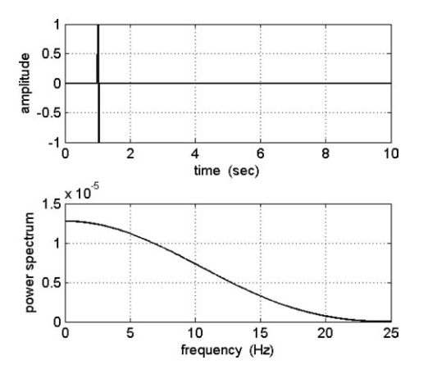

* Frequency sweeps:  
  The frequency content of the input covers a frequency band of interest. Provide useful data to build a Bode plot of the system.

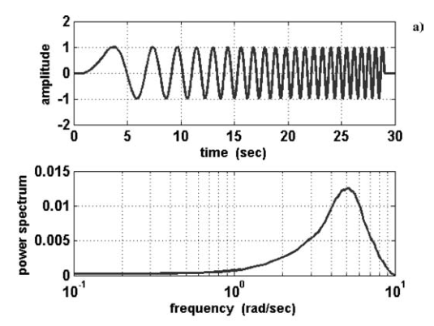

* Doublet input  
  When *a priori* information of the system dynamic response is available. The timing of the pulses is chosen so that the dominant frequency of in the input is at or close to the expected natural frequency of the dynamic system.

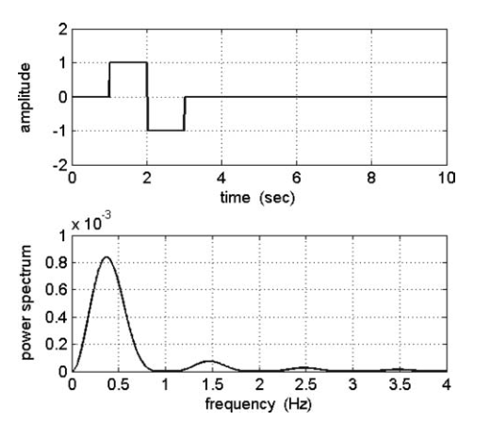

* Multi-steps inputs (3-2-1-1 and 2-1-1)  
  They provide much richer frequency content than a doublet. The 3-2-1-1 may be difficult to achieve as the 3 pulse may make the aircraft to depart. To address this, a 2-1-1 input can be used instead.

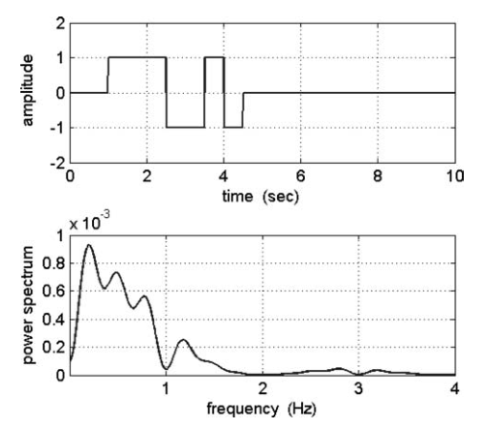

# Document information

## Definitions/ Abbreviations

|  |  |
| --- | --- |
| Abbreviation | Meaning |
| SID | System Identification |
| EIS | Entry into service |

Table 1: Abbreviations

## References

|  |  |  |
| --- | --- | --- |
| Reference description | Reference identifier | Name / Description |
| 1. MoM | 10158326/18M/EN/00/01 | Minutes of meeting hold on 02.03.2018 |

Table 2: References

<Rey/>

## Revisions

|  |  |  |  |
| --- | --- | --- | --- |
| Rev | Version | Comment | Name |
| A | 00 | Initial version | A. Lapice |
| A | 01 | Template number inserted | M. Schuler |