**Line Maze Solver**

The redbot has three IR sensors (right, middle, and left). This gives a total of eight different patterns.

000 = no line

001 = turn right NO

010 = go straight

011 = go straight over turning right

100 = turn left NO

110 = go straight over turning left

111 = possible finish line

If robot gets to a dead-end, store this. It is a bad choice.

Current problem: Need to expand the lines on the maze to make sure the robot has enough space to make a 180 degree turn without seen any other lines except for the one it came from before getting stuck. Going from 010 to 000. Makes a U-turn.

If 011, then we will need a function called inch() that will allow the robot to move forward one inch and retract one inch again. This is used to help the robot makes a decision or whether it should go straight or go right. If 011 turns to 000, then it is a right turn.

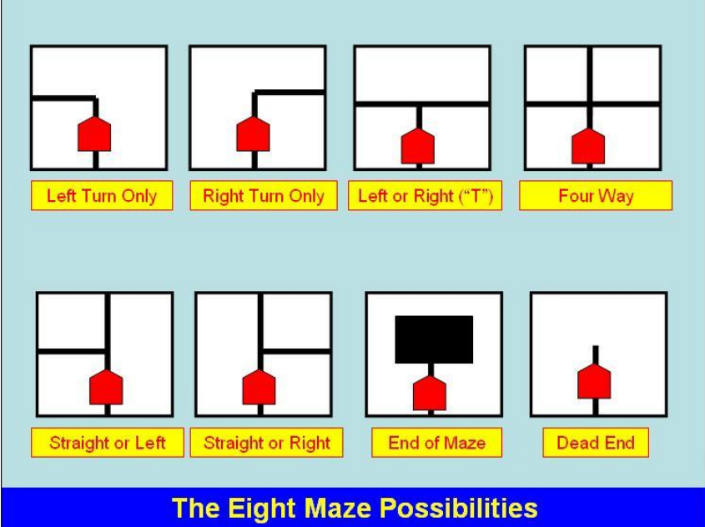

Source: https://www.pololu.com/file/0J195/line-maze-algorithm.pdf