precision recall f1-score support

pizza 0.91 0.93 0.92 250
hamburger 0.78 0.82 0.80 250
sushi 0.85 0.82 0.84 250
french_fries 0.88 0.90 0.89 250
ice_cream 0.90 0.79 0.84 250
caesar_salad 0.84 0.87 0.86 250
pancakes 0.84 0.89 0.86 250
fried_rice 0.82 0.84 0.83 250
donuts 0.84 0.83 0.83 250
spaghetti_bolognese 0.95 0.89 0.92 250

accuracy 0.86 2500
macro avg 0.86 0.86 0.86 2500
weighted avg 0.86 0.86 0.86 2500
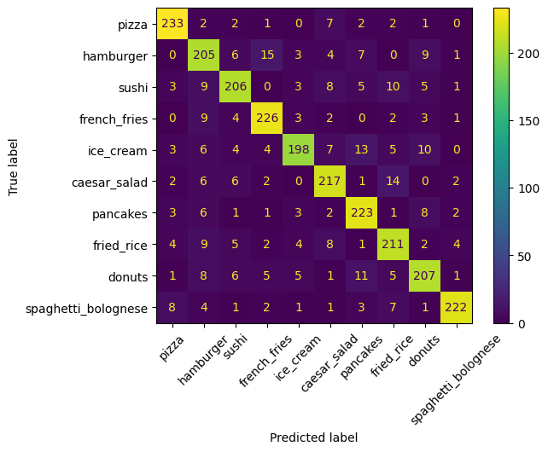[10]
2m
precision recall f1-score support

apple_pie 0.03 0.01 0.01 250
baby_back_ribs 0.00 0.00 0.00 250
baklava 0.00 0.00 0.00 250
beef_carpaccio 0.01 0.01 0.01 250
beef_tartare 0.00 0.00 0.00 250
beet_salad 0.00 0.00 0.00 250
beignets 0.00 0.00 0.00 250
bibimbap 0.01 0.01 0.01 250
bread_pudding 0.02 0.01 0.01 250
breakfast_burrito 0.00 0.00 0.00 250
bruschetta 0.03 0.05 0.04 250
caesar_salad 0.00 0.00 0.00 250
cannoli 0.00 0.00 0.00 250
caprese_salad 0.01 0.00 0.00 250
carrot_cake 0.00 0.00 0.00 250
ceviche 0.00 0.00 0.00 250
cheese_plate 0.00 0.00 0.00 250
cheesecake 0.00 0.00 0.00 250
chicken_curry 0.00 0.01 0.01 250
chicken_quesadilla 0.00 0.00 0.00 250
chicken_wings 0.02 0.01 0.02 250
chocolate_cake 0.00 0.00 0.00 250
chocolate_mousse 0.01 0.00 0.01 250
churros 0.00 0.00 0.00 250
clam_chowder 0.04 0.05 0.05 250
club_sandwich 0.04 0.06 0.05 250
crab_cakes 0.00 0.00 0.00 250
creme_brulee 0.00 0.00 0.00 250
croque_madame 0.00 0.00 0.00 250
cup_cakes 0.09 0.01 0.01 250
deviled_eggs 0.01 0.00 0.01 250
donuts 0.25 0.00 0.01 250
dumplings 0.00 0.00 0.00 250
edamame 0.00 0.00 0.00 250
eggs_benedict 0.00 0.00 0.00 250
escargots 0.01 0.04 0.01 250
falafel 0.02 0.16 0.04 250
filet_mignon 0.00 0.00 0.00 250
fish_and_chips 0.00 0.00 0.00 250
foie_gras 0.00 0.00 0.00 250
french_fries 0.14 0.00 0.01 250
french_onion_soup 0.00 0.00 0.00 250
french_toast 0.00 0.00 0.00 250
fried_calamari 0.00 0.00 0.00 250
fried_rice 0.00 0.00 0.00 250
frozen_yogurt 0.00 0.00 0.00 250
garlic_bread 0.00 0.00 0.00 250
gnocchi 0.00 0.00 0.00 250
greek_salad 0.01 0.00 0.00 250
grilled_cheese_sandwich 0.00 0.00 0.00 250
grilled_salmon 0.00 0.00 0.00 250
guacamole 0.00 0.00 0.00 250
gyoza 0.01 0.03 0.02 250
hamburger 0.01 0.02 0.02 250
hot_and_sour_soup 0.00 0.00 0.00 250
hot_dog 0.00 0.00 0.00 250
huevos_rancheros 0.02 0.02 0.02 250
hummus 0.04 0.01 0.01 250
ice_cream 0.01 0.02 0.01 250
lasagna 0.01 0.02 0.01 250
lobster_bisque 0.00 0.00 0.00 250
lobster_roll_sandwich 0.00 0.00 0.00 250
macaroni_and_cheese 0.08 0.00 0.01 250
macarons 0.00 0.00 0.00 250
miso_soup 0.02 0.06 0.03 250
mussels 0.02 0.02 0.02 250
nachos 0.01 0.10 0.02 250
omelette 0.00 0.00 0.00 250
onion_rings 0.02 0.00 0.01 250
oysters 0.00 0.00 0.00 250
pad_thai 0.00 0.00 0.00 250
paella 0.01 0.01 0.01 250
pancakes 0.00 0.00 0.00 250
panna_cotta 0.00 0.00 0.00 250
peking_duck 0.03 0.02 0.02 250
pho 0.00 0.00 0.00 250
pizza 0.00 0.00 0.00 250
pork_chop 0.00 0.00 0.00 250
poutine 0.01 0.24 0.02 250
prime_rib 0.00 0.00 0.00 250
pulled_pork_sandwich 0.02 0.01 0.01 250
ramen 0.00 0.00 0.00 250
ravioli 0.06 0.00 0.01 250
red_velvet_cake 0.00 0.00 0.00 250
risotto 0.00 0.00 0.00 250
samosa 0.00 0.00 0.00 250
sashimi 0.01 0.01 0.01 250
scallops 0.00 0.00 0.00 250
seaweed_salad 0.01 0.01 0.01 250
shrimp_and_grits 0.01 0.01 0.01 250
spaghetti_bolognese 0.00 0.00 0.00 250
spaghetti_carbonara 0.01 0.00 0.01 250
spring_rolls 0.00 0.00 0.00 250
steak 0.06 0.08 0.07 250
strawberry_shortcake 0.00 0.00 0.00 250
sushi 0.00 0.00 0.00 250
tacos 0.00 0.00 0.00 250
takoyaki 0.00 0.00 0.00 250
tiramisu 0.00 0.00 0.00 250
tuna_tartare 0.00 0.00 0.00 250
waffles 0.01 0.01 0.01 250
not_food 0.01 0.01 0.01 250

accuracy 0.01 25500
macro avg 0.01 0.01 0.01 25500
weighted avg 0.01 0.01 0.01 25500

spaghetti_carbonara predicted as french_onion_soup: 131 times
french_toast predicted as poutine: 114 times
prime_rib predicted as poutine: 106 times
escargots predicted as nachos: 106 times
gyoza predicted as poutine: 102 times
pork_chop predicted as poutine: 98 times
sushi predicted as poutine: 94 times
club_sandwich predicted as poutine: 93 times
french_fries predicted as chicken_curry: 90 times
bread_pudding predicted as poutine: 87 times

