STAT 101 - Agresti
Homework 6 Solutions
10/25/10

Chapter 7
7.26. df = 29 – 1 = 28. The one-sided P-value is between 0.005 and 0.01 (software indicates P = 0.006), and the two-sided P-value is between 0.01 and 0.02 (software indicates P = 0.012). There is strong evidence that those who are not children of alcoholics have a higher population mean well-being than those who are children of alcoholics.

7.27. The estimated standard error is 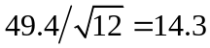, and the test statistic is t = 70.1/14.3 = 4.9 with df = 11, which has P < 0.01.

7.28. (a) We should treat these as dependent samples, since the same subjects are used in each sample. (b) We are 95% confidence that the mean number of times students went to movies was between 7.6 below and 15.6 above the mean number of times students went to sporting events. (c) t = 4.0/5.112 = 0.78. P = 0.454. It appears that there is no significant difference between the mean number of times students went to movies and the mean number of times students went to sporting events.

7.31. (a) (i) 40 – 20 = 20 (ii) 20; The difference between the means is equal to the mean difference. (b) s = 5.0; 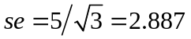. (c) The 95% confidence interval is 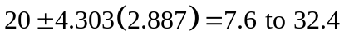. We are 95% confident that the mean difference between patients receiving therapy B and patients receiving therapy A is between 7.6 and 32.4. (d) t = 20/2.887 = 6.93; df = 3 – 1 = 2; 0.02 < P < 0.05 (P = 0.0202). There appears to be a difference between the mean scores for patients receiving therapy B and those receiving therapy A.

7.41. (a) The following is a bar chart:
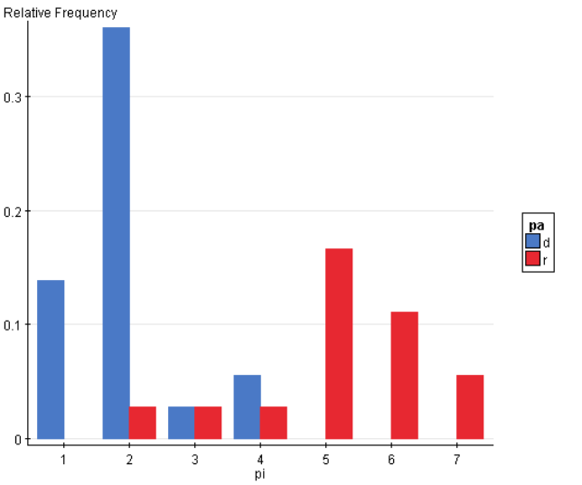
Summary statistics for political ideology:
pa | n | Mean | Std. Dev. | Std. Err. | Median | Range | Min | Max | Q1 | Q3
Dem | 21 | 2 | 0.84 | 0.18 | 2 | 3 | 1 | 4 | 2 | 2
Rep | 15 | 5.13 | 1.36 | 0.35 | 5 | 5 | 2 | 7 | 5 | 6
(b) Software gives us the following for a hypothesis test:
Hypothesis test results:
μ₁ : mean of Dem
μ₂ : mean of Rep
H₀ : μ₁ - μ₂ = 0
H_{A} : μ₁ - μ₂ ≠ 0
(allowing unequal population variances)
Difference | Sample Mean | Std. Err. | T-Stat | P-value
μ₁ - μ₂ | -3.13 | 0.39 | -7.94 | <0.0001

Software gives us the following for a confidence interval:
95% confidence interval results:
μ₁ : mean of Dem
μ₂ : mean of Rep
(allowing unequal population variances)
Difference | Sample Mean | Std. Err. | L. Limit | U. Limit
μ₁ - μ₂ | -3.13 | 0.39 | -3.95 | -2.31

The hypothesis test tells us that there is strong evidence that the population mean political ideology differs for students identifying with the Democratic party and with the Republican party. We would reject the null hypothesis of equal population means at the usual significance levels such as 0.05. The confidence interval tells us that we are 95% confident that the population mean political ideology for students identifying with the Democratic party is between 2.3 and 4.0 below (i.e., more liberal) than the population mean political ideology for students identifying with the Republican party.

Chapter 8

8.1. (a)
 | Allow unrestricted abortion
 | Yes | No
Male | 0.40 | 0.60
Female | 0.40 | 0.60
(b) Since the proportions do not depend on gender, statistical independence does seem plausible.

8.2. They would be associated, since the chance of pregnancy would be less for couples using contraceptives.

8.3. (a) Dependent. (b) One possible answer is
 | Legalize Marijuana
 | Yes | No
Male | 0.40 | 0.60
Female | 0.40 | 0.60

8.4. The response variable is whether a German has a favorable opinion of the U.S. The explanatory variable is year. The conditional distribution for 2000 is (0.78, 0.22) and for 2006 is (0.37, 0.63).
 | Favorable opinion of U.S.
 | Yes | No
2000 | 0.78 | 0.22
2006 | 0.37 | 0.63

8.5. (a) The conditional distribution is (86%, 14%) for the categories (Positive, Negative) for those who have breast cancer, and (12%, 88%) for those who do not have breast cancer. The mammogram does seem to be a good diagnostic tool. (b) (6.8%, 93.2%) for categories (Yes, No) in the “positive” column of the table. Of those with a positive test result, only 6.8% truly have breast cancer, so when the test says that a woman may have breast cancer, there is actually a small chance that she does. When a disease is not common, the number of positive diagnoses for people not having the disease (even though a small percentage of diagnoses for people not having the disease) can be much larger than the number of positive diagnoses for people having the disease.

8.9. (a) 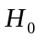: Sex and opinion about cuts in the standard or living to help the environment are independent. 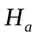: Sex and opinion about cuts in the standard or living to help the environment are not independent. (b) df = 4. (c) Based on the chi-squared table with df = 4, the P-value is between 0.05 and 0.10. (i) Do not reject ; There is not enough evidence to conclude that sex and opinion about cuts in the standard or living to help the environment are dependent. (ii) Reject; There is enough evidence to conclude that sex and opinion about cuts in the standard or living to help the environment are dependent.

8.10. (a) (74%, 26%) for those who have used alcohol, (14%, 86%) for those who have not; there is a strong association, whereby those who have used alcohol are much more likely to have smoked cigarettes than are those who have not used alcohol. (b) : Cigarette use and alcohol use are independent. : Cigarette use and alcohol use are not independent.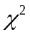 = 451.4, df = 1, P < 0.001. There is extremely strong evidence of an association between cigarette use and alcohol use.

8.11. (a) : Happiness and belief in life after death are independent. : Happiness and belief in life after death are dependent. (b) It is (32.6%, 54.4%, 13.0%) for the categories (Very happy, Pretty happy, Not too happy) for those who believe in life after death, and (25.8%, 60.4%, 13.8%) for those who do not believe in life after death. (c) = 7.98, df = 2, P = 0.02. There is strong evidence to suggest an association between happiness and belief in life after death. (d) The standardized residuals are (2.81, –2.32, –0.45) for the categories (Very happy, Pretty happy, Not too happy) for those who believe in life after death, and (–2.81, 2.32, 0.45) for those who do not believe in life after death. For those who believe in life after death, there are more people in the “very happy” category than we would expect if the two variables were independent. For those who do not believe in life after death, there are fewer people in the “very happy” category than we would expect if the two variables were independent.

8.14. (a) The expected frequency is 129.1, which is (373)(890)/2571. (b) : Party ID and race are independent. : Party ID and race are dependent. = 243.73, df = 2, P = 0.0000. There is strong evidence of an association between party ID and race. (c) Blacks tend to be Democrats more often than we would expect under independence, while whites tend to be Republicans more often than we would expect under independence.

8.16. (a) With df = 8, P < 0.001; there is strong evidence of an association between happiness and marital status. (b) There are (i) more married people and (ii) fewer widowed, divorced, separated, and never married people in the very happy category than if the variables were independent. (c) 42.5% of married people are in the very happy category, while 19.2% of divorced people are in the very happy category. The difference in proportions is 0.425 – 0.192 = 0.233. The sample proportion of married people in the very happy category is considerably higher than the proportion of divorced people in the very happy category.

8.17. Political party affiliation and opinion about Bush’s performance appears to be very strongly associated, with the sample difference of proportions approving of his performance being 0.82 – 0.09 = 0.73.

8.18. Race is more strongly associated with death penalty opinion than is gender, since the difference in proportions for whites and blacks (which is 0.31) who support the death penalty is much greater than the difference in proportions of males and females (which is 0.12).

8.20. (a) (2409/37,792) – (3865/30,902) = 0.064 – 0.125 = –0.061; the proportion who were injured or killed is 0.06 lower for those who wore seat belts. (b) (2409)(27,037)/[(3865)(35,383)] = 0.49; users of seat belts have odds of being injured or killed that are estimated to be 0.49 times the odds for nonusers of seat belts.

8.22. (a) (i) (1/108)/(1/1562) = 14.5; the odds that a male resident is incarcerated is 14.5 times the odds that a female resident is incarcerated. (ii) (1694/98,306)/(252/99,748) = 6.8; the odds that a black resident is incarcerated is 6.8 times the odds that a white resident is incarcerated. (b) Gender has a stronger association with whether incarcerated, since the odds ratio is greater for gender than for race.

8.29. (a) Computer output for relating opinion about abortion and political affiliation follows:

PolAffiliation * Abortion Crosstabulation
Count
 |  | Abortion |  | Total
 |  | n | y | n
PolAffiliation | d | 1 | 20 | 21
PolAffiliation | i | 3 | 21 | 24
PolAffiliation | r | 9 | 6 | 15
Total |  | 13 | 47 | 60

The sample conditional distributions computed within rows would show that the proportion who supported legalized abortion in this sample is much higher for Democrats and Independents than for Republicans.

Chi-Square Tests
 | Value | df | Asymp. Sig. (2-sided)
Pearson Chi-Square | 17.711 | 2 | 0.000

The P-value of 0.000 for testing that opinion about abortion is independent of political party affiliation gives very strong evidence against the null hypothesis and in favor of an association. A couple of the expected frequencies were small, so the Pearson test is on somewhat shaky grounds. Standardized residuals should also be reported, which back up the descriptive analysis given above.

8.40. (a) No, each column results from asking the question of the same sample of people, so the samples are not independent. (b)
 | OPINION ABOUT FACTOR A
GENDER | Yes | No
Men | 60 | 40
Women | 75 | 25
For testing independence of gender and opinion about factor A, the test statistic is = 5.1, df = 1, P < 0.05. The test suggests that women are more likely than men to believe that the increasing gap in income is a factor in increasing teenage crime.

8.44. (a) If z is a test statistic that has a standard normal distribution, z² is distributed as chi-squared with df = 1. (c) 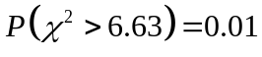; 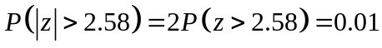. (c) The probability distribution of 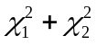 is chi-squared with df = 2 + 2 = 4.

