STAT 101 - Agresti
Homework 1 Solutions (including optional exercises)
9/2/10

1.2. (a) Population was all 7 million voters, and sample was 2705 voters in exit poll. (b) A statistic is the 56.5% who voted for Schwarzenegger from the exit poll sample of size 2705; a parameter is the 55.9% who actually voted for Schwarzenegger.

1.3. (a) All students at the University of Wisconsin. (b) A statistic, since it’s calculated only for the 100 sampled students.

1.5. (a) All adult Americans. (b) Proportion of all adult Americans who would answer definitely or probably true. (c) The sample proportion 0.523 estimates the population proportion. (d) No, it is a prediction of the population value but will not equal it exactly, because the sample is only a very small subset of the population.

1.17. (a) A statistic is the 45% of the sample of subjects interviewed in the UK who said yes. (b) A parameter is the true percent of the 48 million adults in the UK who would say yes. (c) A descriptive analysis is that the percentage of yes responses in the survey varied from 10% (in Bulgaria) to 60% in Luxembourg). (d) An inferential analysis is that the percentage of adults in the UK who would say yes falls between 41% and 49%.

2.1. (a) Discrete variables take a set of separate numbers for their values (such as nonnegative integers). Continuous variables take an infinite continuum of values. (b) Categorical variables have a scale that is a set of categories; for quantitative variables, the measurement scale has numerical values that represent different magnitudes of the variable. (c) Nominal variables have a scale of unordered categories, whereas ordinal variables have a scale of ordered categories. The distinctions among types of variables are important in determining the appropriate descriptive and inferential procedures for a statistical analysis.

2.2. (a) Quantitative (b) Categorical (c) Categorical (d) Quantitative (e) Categorical (f) Quantitative (g) Categorical (h) Quantitative (i) Categorical

2.3. (a) Ordinal (b) Nominal (c) Interval (d) Nominal (e) Nominal (f) Ordinal (g) Interval (h) Ordinal (i) Nominal (j) Interval (k) Ordinal

2.5. (a) Interval (b) Ordinal (c) Nominal

2.7. (a) Ordinal, since there is a sense of order to the categories. (b) Discrete, since separate values rather than continuum of numbers. (c) These values are statistics since they come from a sample.

2.13. (a) Observational study (b) Experiment (c) Observational study (d) Experiment

2.14. (a) Experimental study, since the researchers are assigning subjects to treatments. (b) An observational study could observe those who grew up in nonsmoking or smoking environments and examine incidence of lung cancer for each group.

2.22. (a) Categorical are GE, VE, AB, PI, PA, RE, LD, AA; quantitative are AG, HI, CO, DH, DR, NE, TV, SP, AH. (b) Nominal are GE, VE, AB, PA, LD, AA; ordinal are PI and RE; interval are AG, HI, CO, DH, DR, NE, TV, SP, AH.

2.27. (a) This is a volunteer sample, so results are unreliable; e.g., there is no way of judging how close 93% is to the actual population who believe that benefits should be reduced. (b) This is a volunteer sample; perhaps an organization opposing gun control laws has encouraged members to send letters, resulting in a distorted picture for the congresswoman. The results are completely unreliable as a guide to views of the overall population. She should take a probability sample of her constituents to get a less biased reaction to the issue. (c) The physical science majors who take the course might tend to be different from the entire population of physical science majors (perhaps more liberal minded on sexual attitudes, for example). Thus, it would be better to take random samples of students of the two majors from the population of all social science majors and all physical science majors at the college. (d) There would probably be a tendency for students within a given class to be more similar than students in the school as a whole. For example, if the chosen first period class consists of college-bound seniors, the members of the class will probably tend to be less opposed to the test than would be a class of lower achievement students planning to terminate their studies with high school. The design could be improved by taking a simple random sample of students, or a larger random sample of classes with a random sample of students then being selected from each of those classes (a two-stage random sample).

2.34. (b)

2.36. (c)

2.37. (a)

2.38. False. This is a convenience sample.

3.6. (a) GDP is rounded to the nearest thousand
Stem (10 thousands) | Leaves (thousands
2 | 023
2 | 58899
3 | 00011122233
3 | 8
4
4
5
5
6
6
7 | 0

(b)
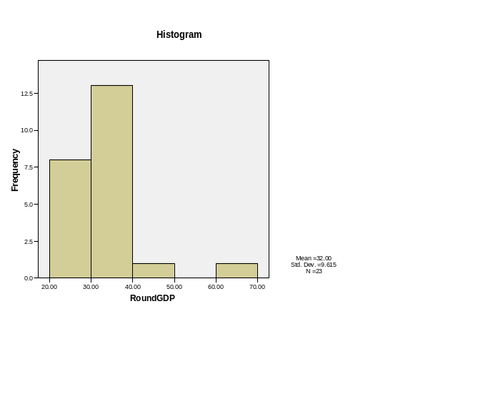
(c) The outlier in each plot is Luxembourg.

3.10. (a)
Stem | Leaves
0 | 4679
1 | 133
2 | 0
3 | 9
4 | 4
(b) The mean is 16.6 days, and the median is 12 days.

3.11. (a)
TV Hours | Frequency | Relative Frequency
0 | 79 | 4.0
1 | 422 | 21.2
2 | 577 | 29.0
3 | 337 | 17.0
4 | 226 | 11.4
5 | 136 | 6.8
6 | 99 | 5.0
7 | 23 | 1.2
8 | 34 | 1.7
9 | 4 | 0.2
10 | 23 | 1.2
12 | 14 | 0.7
13 | 1 | 0.1
14 | 7 | 0.4
15 | 2 | 0.1
18 | 2 | 0.1
24 | 1 | 0.1
Total | 1987 | 100.0
(b) The distribution is unimodal and right skewed. (c) The median is the 994th data value, which is 2. (d) The mean is larger than 2 because the data is skewed right by a few high values.

3.19. (a) Median: $10.13; mean: $10.18; range: $0.46; standard deviation: $0.22. (b) Median: $10.01; mean: $9.17; range: $5.31; standard deviation: $2.26. The median is resistant to outliers, but the mean, range, and standard deviation are highly impacted by outliers.

3.22. (a) The life expectancies in Africa vary more than the life expectancies in Western Europe, because the life expectancies for the African countries are more spread out than those for the Western European countries. (b) The standard deviation is 1.1 for the Western European nations and 7.1 for the African nations.

3.24. (a) Approximately 68% of the values are contained in the interval 32 to 38 days; approximately 95% of the values are contained in the interval 29 to 41 days; all or nearly all of the values are contained in the interval 26 to 44 days. (b) (i) The mean would decrease if the observation for the U.S. was included. (ii) The standard deviation would increase if the observation for the U.S. was included. (c) The U.S. observation is 5.3 standard deviations below the mean.

3.25. (a) 88.8% of the observations fall within one standard deviation of the mean. (b) The Empirical Rule is not appropriate for this variable, since the data are highly skewed to the right.

3.28. (d)

3.30. The distribution is most likely skewed to the right since the minimum water consumption (0 thousands of gallons) is less than one standard deviation below the mean.

3.35. (a) The sketch should show a right-skewed distribution. (b) The sketch should show a right-skewed distribution. (c) The sketch should show a left-skewed distribution. (d) The sketch should show a right-skewed distribution. (e) The sketch should show a left-skewed distribution.

3.64. The median is not impacted by gains made by the wealthiest Americans because the wealthiest Americans are at the high end of net worth, and the median is the value at the center of the data.

3.69. (a) The median is preferred over the mean when the data are skewed and/or there are outliers that will affect the mean. One example is income. (b) The mean is preferred over the mean when the distribution is approximately symmetric or when it is very highly discrete, such as the number of times you have been married.

3.73. (c)

