STAT 101 - Agresti
Homework 2 Solutions
9/17/10

Chapter 3
3.33. The mean, standard deviation, maximum, and range all increase, because the observation for D.C. was a high outlier. Note that these statistics are not resistant to outliers. On the other hand, the median, Q3, Q1, the interquartile range, and the mode remain the same, as these are all resistant to outliers. The minimum remains the same since D.C. was a high outlier and not a low outlier.

3.39. (a) Minimum = 0, Q1 = 2, median = 3, Q3 = 5, maximum = 14. (b) Same as part (a). (c) The observations with values 12 and 14 are outliers. (d) The standard deviation is 3.

3.41. (a)
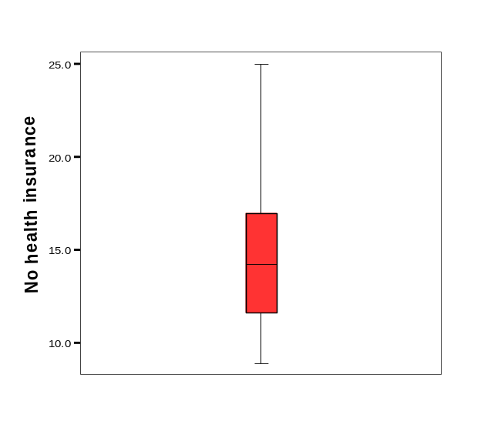
(b) The distribution appears to be skewed to the right, because of the long distance between the upper quartile and the maximum.

3.43. (a) Minimum = 1, Q1 = 3, median = 5, Q3 = 6, maximum = 13. (b)

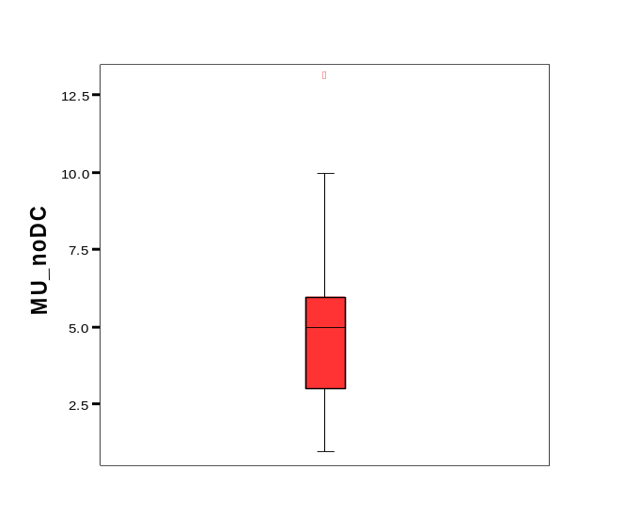
Louisiana appears to be a mild outlier. (c) Minimum = 1, Q1 = 3, median = 5, Q3 = 6, maximum = 44.

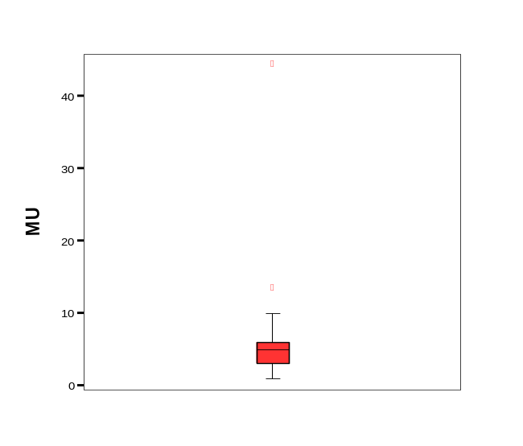

Louisiana is still a mild outlier, and D.C. is an extreme outlier. Only the maximum changes in the five-number summary when the observation for D.C. is added to the data set.

3.47. (a) Response variable: opinion about national health insurance (favor, oppose); explanatory variable: political party (Democrat, Republican). (b) The data could be summarized in a contingency table with political party as the rows and opinion about national health insurance as the columns.

3.48. (a) Response variable: happiness; explanatory variable: religious attendance. (b) For those who attend religious services nearly every week or more, 44.5% reported being very happy. For those who attend religious services never or less than once a year, 23.2% reported being very happy. (c) There appears to be an association between happiness and religious attendance since the percentages that reported being very happy differed greatly by attendance at religious services.

3.49. (a) United States: predicted fertility = 3.2 – 0.04(50) = 1.2; Yemen: predicted fertility = 3.2 – 0.04(0) = 3.2. (b) The negative value implies that the fertility rate decreases as Internet use increases.

3.50. (a) Points in a scatterplot for these data should have a negative association and be fairly tightly clustered in a straight-line pattern. (b) Contraceptive use is more strongly associated with fertility than is Internet use because –0.89 is larger in absolute value than –0.55.

3.51. (a) Based on the plot (see next page), the correlation should be positive, since higher values of GDP tend to go with higher values of CO2 (and vice versa). (b) Luxembourg has a GDP of 69,961 and CO2 of 22.0, both of which are extreme values.

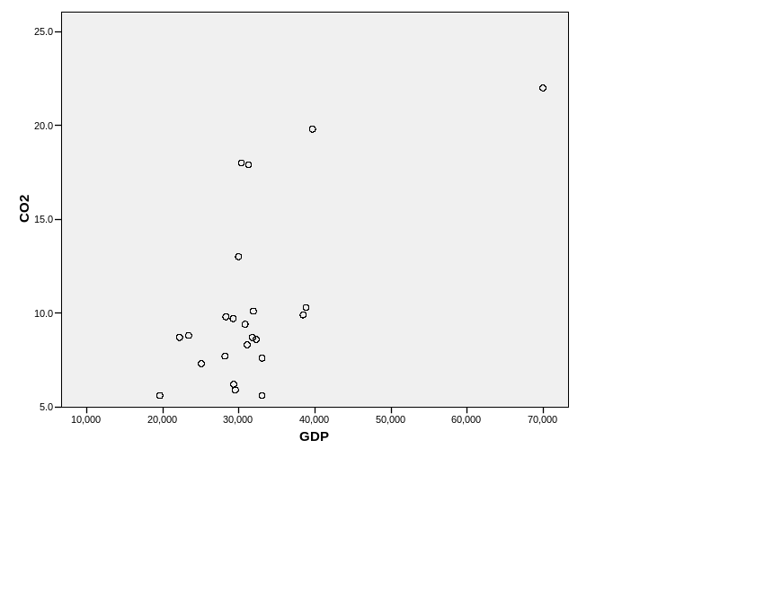

3.52. The number of physicians is more strongly correlated with carbon dioxide emissions than is female economic activity, since the absolute value of the correlation for number of physicians and CO2 emissions is closer to 1 than is the correlation for female economic activity and CO2 emissions

3.59. The distribution of cost for New York and Boston are similar, and both cities have high and low outliers. The distributions for all three cities are roughly symmetric. The distribution for cost in London is higher than the distributions in both New York and Boston, with 75% of the costs in London being higher than all costs in Boston and almost all costs in New York.

3.66. (a) The median male height is between 69 and 70 inches. (b) A rough approximation for the standard deviation can be found by dividing the range by 6, since almost all of the data in a bell-shaped distribution falls within 3 standard deviations of the mean. Thus, the standard deviation is approximately 20/6 = 3.3 inches.

3.68. (a) Heights (in inches) of adult women. (b) Incomes in a large city. (c) Scores on an easy exam. (d) Heights (in inches) of adults in the U.S. (e) Number of cigarettes smoked in a week.

3.70. (a) The standard deviation s is generally preferred over the range because it is calculated from all of the data and will not be impacted as much as the range when there are outliers. (b) The IQR is preferred to the standard deviation s when the distribution is very highly skewed or there are severe outliers, because the IQR is less sensitive to these features than s is.

3.72. (c)

3.74. (a)

3.78. (a) The mean is now 77, while the standard deviation stays at 20. (b) The mean is 50,000£, and the standard deviation is 15,000£. (c) The mean and standard deviation are both multiplied by 1.6.

Chapter 4

4.3. (a) 96 is the total number of members of an environmental group, and 1117 is the total number of subjects who answered both questions. (b) (i) 30/96 = 0.312 (ii) 88/1021 = 0.086. (c) (i) 30/1117 = 0.027 (ii) (0.086)(0.312) = 0.027. (d) (30 + 933)/1117 = 963/1117 = 0.862.

4.8. (a) 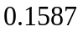
(b)
(c) 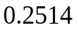

4.9. a) z = 1 gives tail probability .1587, two-tail prob = 0.317, and prob within a standard deviation of the mean = 1 - .317 = .68
(b) 0.95, (c) 0.997, (d) 0.497

4.10. (a) 2.33 (b) 1.96 (c) 1.64 (d) 1.28 (e) 0.67 (f) 0

4.11. (a) 0.67 (b) 1.64 (c) 1.96 (d) 2.33 (e) 2.58

4.12. (a) 1.28 (b) 1.64 (c) 2.06 (d) 2.33

4.17. (a) The 98th percentile is 2.05 standard deviations above the mean. (b) The IQ score for the 98th percentile is 100 + 2.05(16) = 132.8, or about 133.

4.19. (a) An MDI of 120 has z = (120 – 100)/16 = 1.25, and is 1.25 standard deviations above the mean. The proportion of children with an MDI of 120 or more is 0.1056. (b) The MDI score that is the 90th percentile is 1.28 standard deviations above the mean, so this score is 100 + 1.28(16) = 120.48, or 120. (c) The lower quartile is 0.67 standard deviations below the mean, which gives a lower quartile of 100 – 0.67(16) = 89.28, or 89. Similarly, the upper quartile is 0.67 standard deviations above the mean, which gives an upper quartile of 100 + 0.67(16) = 110.72, or 111. Since the MDI scores are approximately normal, the median will be equal to the mean of 100.

4.21. (a) 20 gallons per week has z = (20 – 16)/5 = 0.8, and is 0.8 standard deviations above the mean. The proportion of adults who use more than 20 gallons per week is 0.2119. (b) The 95th percentile is 1.645 standard deviations above the mean of a normal distribution. So, z = 1.645, and we need to solve for mu where z = 1.645 = (20 – mu)/5. The value of mu is 11.8. So, the mean would need to be about 11.8 gallons so that only 5% of adults use more than 20 gallons per week. (c) If the distribution of gasoline use is not actually normal, we should expect it to be right-skewed, since there will be some adults with very high gasoline usages that will cause the distribution to have a long right tail.

4.23. An SAT score of 600 is (600 – 500)/100 = 1.0 standard deviations above the mean. An ACT score of 29 is (29 – 21)/4.7 = 1.70 standard deviations above the mean. Relatively speaking, an ACT score of 29 is higher than an SAT score of 600.

4.47. (a) A lower bound for the mean is
.
(b) Since we know the category of ideal number of children that falls at the 50% point, we can find the median. The median is 4 children.

