STAT 101 - Agresti
Homework 4 Solutions
10/8/10

Chapter 6

6.1. (a) null hypothesis (b) alternative hypothesis (c) alternative hypothesis (d) 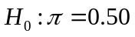; 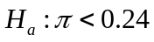; 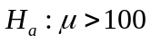.

6.2. (a) Let µ = the population mean ideal number of children. 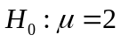 and 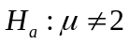. (b) The test statistic is t = 20.80. This test statistic was obtained with the following: 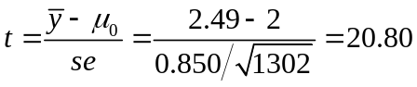. (c) The P-value is the probability, assuming the null hypothesis is true, that the test statistic equals the observed value or a value even more extreme in the direction predicted by the alternative hypothesis. In this case, the P-value = 0.0000 (rounded to 4 decimal places), which means that if the true mean were 2, we would see results as extreme as or more extreme than we did almost never.

6.3. (a) . If the true mean were 0, we would see results at least as extreme as we did about 30% of the time. (b) Now, . Since the P-value is smaller than the P-value calculated in part (a), we have stronger evidence against the null hypothesis. (c) (i) 0.15 (ii) 0.85.

6.6. “Upper” = 11.0; “t-value” = 4.19; “df” = 16.

6.9. (a) The null hypothesis is 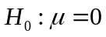, and the alternative hypothesis is 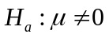. (b) 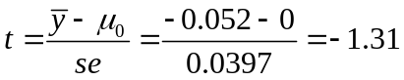. The P-value is P = 0.19. Since P > 0.05, we fail to reject the null hypothesis. There is not enough evidence to conclude that the mean score differs from the neutral value of zero. (c) We cannot accept , since failing to reject the null hypothesis does not prove the null hypothesis to be true. We just did not have enough evidence to reject the null hypothesis. (d) A 95% confidence interval is 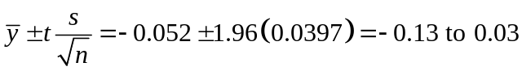. Note that zero falls within our confidence interval. When the null hypothesis value falls within the confidence interval, we fail to reject the null hypothesis; when the null hypothesis value falls outside of the confidence interval, we reject the null hypothesis (with Type I error probability = the error probability for the CI).

6.11. Results of 99% confidence intervals for means are consistent with results of two-sided tests at α = 1 – 0.99 = 0.01 level.

6.14. (a) 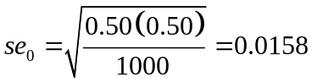 (b) 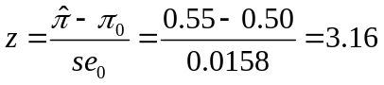 The sample proportion falls 3.16 standard errors in absolute value away from the null hypothesis value of the proportion. (c) 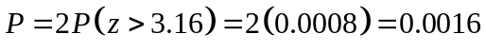 If the population proportion were 0.50, then the probability equals 0.0016 that a sample proportion of n = 1000 subjects would fall as extreme as or more extreme than 0.55. We reject the null hypothesis. There is enough evidence to conclude that the population proportion of Canadian adults who believe the bill should stand differs from 0.50.

6.15. (a) and 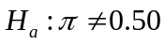. (b) z = –3.91 The sample proportion falls 3.91 standard errors below the null hypothesis value of the proportion. (c) P = 0.000 (rounded). If the null hypothesis were true, then there is almost no chance that we would see results as extreme as or more extreme than our sample results. We would conclude that the proportion of Americans who would be willing to pay higher taxes in order to protect the environment differs from 0.50. (d) The confidence interval is entirely below 0.50, which leads us to believe that a minority of Americans would be willing to pay higher taxes in order to protect the environment. It shows just how far from 0.50 the parameter could plausibly be.

6.16. The test statistic is 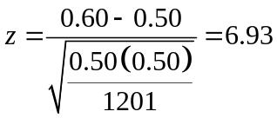. The P-value is P = 0.000. There is enough evidence to conclude that the proportion of adults who think affirmative action programs designed to increase the number of black and minority students on college campuses are good differs from 0.50.

6.17. 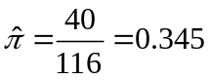 The test statistic is 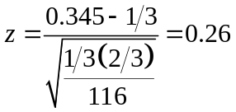. The P-value is 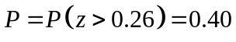. We fail to reject the null hypothesis at α = 0.05 level. There is not enough evidence to conclude that astrologers are correct with their predictions more than 1/3 of the time.

6.18. (a) A Type I error would be concluding that astrologers are correct with their predictions more than 1/3 of the time when they really are not. (b) A Type II error would be failing to conclude that the astrologers are correct with their predictions more than 1/3 of the time when they really are.

6.21. (a) 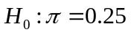 and 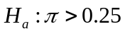. (b) = 125/400 = 0.3125, 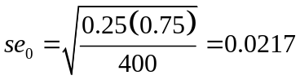, z = (0.3125 – 0.25)/0.0217 = 2.89, P = 0.0019. We reject the null hypothesis. There is enough evidence to conclude that more people answer the question correctly than would be expected just due to chance.

6.22. (a) (i) A Type I error would be concluding that the population mean weight change was positive when it was actually 0. (ii) A Type II error would be failing to conclude that the population mean weight change was positive when it really was. (b) This would be a Type I error. (c) If α = 0.01, we would fail to reject the null hypothesis. If this decision were in error, it would be a Type II error.

6.23. (a) Jones: 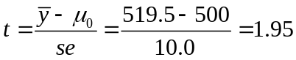,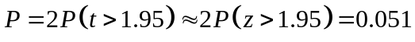; Smith: 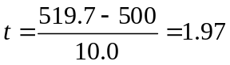,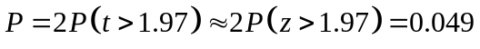. (b) Jones’s result is not statistically significant (since P-value > 0.050), but Smith’s result is. (c) These two studies give such similar results that they should not yield different conclusions. Reporting the actual P-value shows that each study has moderate evidence against 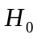 and shows that the results are very similar in practical terms.

6.24. (a) 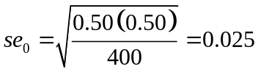;
Jones: 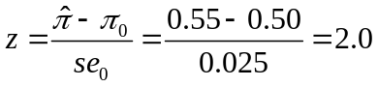,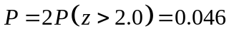;
Smith: 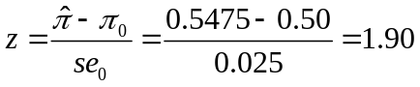,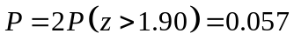. (b) Jones’s result is statistically significant (since P-value < 0.05), but Smith’s result is not. (c) These two studies give such similar results that they should not yield different conclusions. Reporting the actual P-value shows that each study has moderate evidence against and shows that the results are very similar in practical terms. (d) The two confidence intervals almost entirely overlap, showing that the results of Jones and Smith are very similar.

6.25. 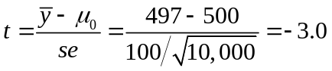, 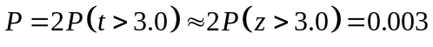 Since the P-value is so small, we reject the null hypothesis at the usual alpha-levels and find the results to be highly statistically significant. However, the difference between the sample mean of 497 and the hypothesized mean of 500 is not important in a practical sense.

6.26. With large sample sizes, it is not unusual to find that small results (e.g., the difference between 3.51 for females and 3.55 for males) are statistically significant. However, these results are certainly not different enough from each other in a practical sense.

6.27. Given that is rejected, P(Type I error) = 40/(40 + 140) = 40/180 = 0.22.

6.28. (a) If the true mean were 5, the probability that we would fail to reject is 0.17. (b) If the test used α = 0.01, the Type II error would increase. When we have a smaller significance level, the evidence must be more extreme to reject , and the rejection region is smaller, having smaller probability. (c) If µ = 10, the probability of a Type II error would be less than 0.17. The farther the true value is from , in the direction of 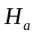, the greater the chance that the test statistic falls in the rejection region.

6.29. (a) is rejected when P ≤ 0.05, which happens when z ≥ 1.64, that is when the sample proportion falls at least 1.64 standard errors above the null hypothesis value of 0.50. This region is 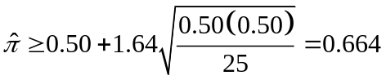. (b) z = (0.664 – 0.60)/0.10 = 0.64; We fail to reject if 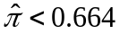, which happens with probability 0.74.

6.30. (a) is rejected when P ≤ 0.05, which happens when t ≥ 1.699 (for df=29), that is when the sample mean falls at least 1.699 standard errors above the null hypothesis value of 0. (b) This region is 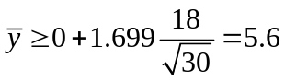, so we fail to reject if 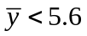 (c) 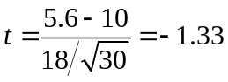; (d) P(Type II error) = P(t < –1.33) = 0.10.

6.31. (a) 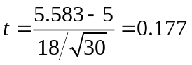; We fail to reject if 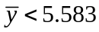, which happens with probability 0.57, so P(Type II error) = 0.57. Type II error increases as the alternative parameter value gets closer to . (b) is rejected when P ≤ 0.01, which happens when t ≥ 2.462, that is when the sample mean falls at least 2.462 standard errors above the null hypothesis value of 0. This region is 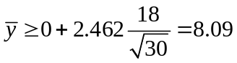. 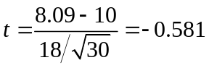; We fail to reject if 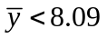, which happens with probability 0.28, so P(Type II error) = 0.28. Type II error increases as α decreases. (c) Type II error decreases as the sample size increases.

6.33. (a) Let π = probability she guesses correctly on a particular flip. We test and 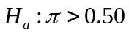. The null says she actually does no better than random guessing, whereas the alternative says she does better than that. (b) Find the right-tail probability for the binomial distribution with n = 5 and π = 0.50. That is, the P-value is P(4) + P(5) = 0.156 + 0.031 = 0.187. This outcome is not unusual if she does not actually possess ESP. It can be explained by chance. We cannot reject , and thus her claim is not convincing.

6.34. (a) We have a fixed number of observations (1336), each of which falls into one of two categories (voted for Clinton, did not vote for Clinton). The probability of falling in each category is the same for every observation. The outcomes of successive observations are independent (no person’s vote impacted any other person’s vote).
(b) 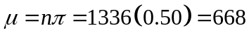; 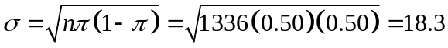. (c) We would almost certainly expect x to fall in the interval 613 to 723 (i.e., within 3 standard deviations). (d) Since x = 895 exceeds the upper bound of the interval in part (c), it appears that the population proportion of voters who voted for Hillary Clinton in the 2006 Senatorial election in New York is greater than 0.50.

6.39. The report should include = 4, s = 2, , 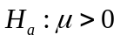, t = (4 – 0)/1 = 4.0, P = 0.014.

6.40. With a P-value of 0.1985, we fail to reject the null hypothesis. There is not enough evidence to conclude that a majority of students prefer one drink over the other.

6.45. (a) A Type I error occurs when one convicts the defendant, when he or she is actually innocent; a Type II error occurs when one acquits the defendant even though he or she is actually guilty. Most people would consider convicting an innocent defendant to be more serious. (b) To decrease the chance of a Type I error, one gives the defendant additional rights and makes it more difficult to introduce evidence that may be inadmissible in some way; this makes it more likely that the defendant will not be convicted, hence the relatively more guilty parties will be incorrectly acquitted. (c) If this strategy is used, α = 0.000000001, which means that the jury would almost never find the defendant guilty. It would be almost impossible to convict a defendant, and many guilty defendants would be acquitted.

6.46. Type I error: The diagnostic test is positive, indicating that the disease is present, even though the disease is actually absent. Type II error: The diagnostic test is negative, indicating that the disease is absent, even though the disease is actually present.

6.50. If is true every time, the expected number of times one would get P ≤ 0.05 just by chance is 60(0.05) = 3, which is the mean of the binomial distribution with n = 60 and π = 0.05; thus, the 3 cases could all simply be Type I errors.

6.51. (a) For each test, the probability equals 0.05 of falsely rejecting and committing a Type I error. This policy encourages the publishing of Type I errors, if actually many researchers are conducting studies in which the null hypotheses are correct. (b) Of all the studies conducted, the one with the most extreme or unusual results is the one that gets substantial attention. That result may be an unusual sample, with the sample far from the actual population mean. Further studies in later research would reveal that the true mean is not so extreme.

6.52. (a)

6.53. (b) and (e) are both correct

6.54. (b)

6.55. (a) and (c) are both correct

6.56. (b) and (d) are both correct

6.57. (a) False; P(Type I error) is a single value, the fixed α value (such as 0.05), whereas P(Type II error) decreases as the true parameter value falls farther from the value in the direction of values in . (b) True; If we reject using α = 0.01, then P ≤ 0.01. Thus, P ≤ 0.05 also, so we also reject using α = 0.05. (c) False; The P-value is the probability of obtaining a sample statistic as extreme as or more extreme than we did, given is true. (d) True; Since P = 0.063 is greater than 0.05, we fail to reject at that level and do not conclude that µ differs from 0. Similarly, the 95% confidence interval would contain 0, indicating that 0 is plausible for µ. The confidence interval shows precisely which values are plausible.

6.59. The value in is only one of many plausible values for the parameter. A confidence interval displays a range of possible values for the parameter. The terminology “accept ” makes it seem as if the null value is the only plausible one.

6.61. (a) either is, or is not, correct. It is not a variable, so one cannot phrase probability statements about it. (b) If is true, the probability that ≥ 120 or that ≤ 80 (i.e., that is at least 20 from 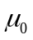 = 100, so that |z| is at least as large as observed) is 0.057. (c) This is true if the statement “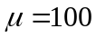” is substituted for “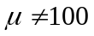.” (d) The probability of a Type I error equals α (which is not specified here), not the P-value. The P-value is compared to α in determining whether one can reject . (e) It would be better to say “We do not reject at the α = 0.05 level.” (f) No, we need P ≤ 0.05 to be able to reject .

6.63. (a) Binomial, n = 100, π = 0.05. (b) Yes. Since the binomial has µ = 100(0.05) = 5, rejecting in 5 of the tests would not be unusual, since that is the expected value.

6.65. If 0 were in the category of interest, 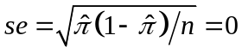, which means that the value of the test statistic z would be ∞. For tests, we are assuming that the null hypothesis is true. Because of the relationship between the mean and standard deviation in the binomial setting, if we assume 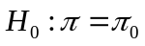, we should use the value 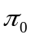 for both the mean and the standard deviation of the null distribution. Thus, we should use 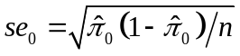 for the hypothesis test.

