STAT 101 - Agresti
Homework 5 Solutions
10/18/10
Chapter 7

7.1. These are independent samples, because the subjects in the two samples are different, with no matching between one sample with the other sample.

7.5. (a) 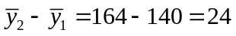; 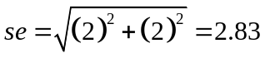. (b) 164/140 = 1.17, which is a 17% increase. (c) 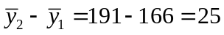; There was an estimated 25 pound increase in the mean weight of adult American men between 1962 and 2002. 191/166 = 1.15; There was an estimated 15% increase in the mean weight of adult American men between 1962 and 2002.

7.6. (a) The response variable is median net worth in 2002. The explanatory variable is race (white, black). (b) (i) $89,000 - $6,000 = $83,000; There is an estimated difference of $83,000 in median net worth between white and black households in 2002. (ii) $89,000/$6,000 = 14.8; The median net worth in white households in 2002 was estimated to be 14.8 times the median net worth in black households in 2002.

7.8. (a) 0.00164 – 0.00015 = 0.00149; This estimated difference of 0.001 seems very small. (b) 0.00164/0.00015 = 10.9; The probability that a black male is a homicide victim is 10.9 times the probability that a white male is a homicide victim, which is a very large effect. (c) The relative risk better summarizes results, especially when both proportions are very small.

7.9. (a) We can be 95% confident that the interval 0.18 to 0.26 contains the difference between the population proportion of teens who listen to lots of music with degrading sexual messages and have intercourse and the population proportion of teens who listen to little or no music with degrading sexual messages and have intercourse. (b) If the two population proportions were equal, it would be very unlikely to observe a difference as large as we did. It appears that the proportion of teens who listen to lots of music with degrading sexual messages and have intercourse is greater than the proportion of teens who listen to little or no degrading music and have intercourse.

7.11. (a)
(b) We can be 95% confident that interval 0.069 to 0.097 contains the difference in the population proportion of college students who drank to get drunk in 2001 and the population proportion of college students who drank to get drunk in 1993.

7.12. (a) We have two independent random samples with at least 10 observations in each category for each group. Let 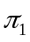 = the proportion of students in 1993 who said they engaged in unplanned sexual activities because of drinking alcohol and 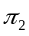 = the proportion of students in 2001 who said they engaged in unplanned sexual activities because of drinking alcohol. The null hypothesis is 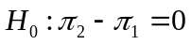, and the alternative hypothesis is 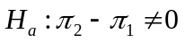. (b) If the true difference in proportions were really 0, the chance of seeing results as extreme as or more extreme than we did would happen about 0.02% of the time. In other words, these results are unlikely to have occurred by chance alone. (c) We are 95% confident that the true difference in proportions between 2001 and 1993 falls in the interval 0.009 to 0.033. The lower bound of this interval is very close to 0, and the upper bound is not strikingly different from 0 in a practical sense. Thus, while our hypothesis test results are statistically significant, they do not appear to be practically important.

7.14. (a) 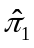 = 989/1503 = 0.66; 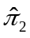 = 704/1968 = 0.36; 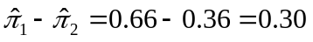; . (b) 0.30 ±1.96(0.0163) = 0.27 to 0.33; We are 95% confident that the interval 0.27 to 0.33 contains the true difference in proportions who agree that “it is much better if the man is the achiever outside the home and the woman takes care of the home and family” between 1977 and 2006. (c) The se would not change in the confidence interval. The sample proportions for each sample would be the respective proportions in part (a) subtracted from 1. Thus, the 95% confidence interval for comparing the proportions who did not agree in the two years would be 0.67 to 0.73.

7.16. (a) Let = the population proportion of female senior high school students who have ever used marijuana and 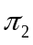 = the population proportion of male senior high school students who have ever used marijuana. We could investigate whether there is a difference by testing , against . (b) We are 95% confident that the population proportion of female senior high school students who have used marijuana is between 0.089 and 0.008 lower than the population proportion of male senior high school students who have used marijuana. (c) If the difference between the true population proportions of female and male senior high school students who have ever used marijuana were actually 0, we would see this large a difference or even larger with probability 0.02 (i.e., quite unlikely). It appears that the population proportion of male senior high school students who have ever used marijuana is greater than the population proportion of female senior high school students who have ever used marijuana.

7.17. Let = the proportion of men judged to be compulsive buyers and = the proportion of women judged to be compulsive buyers. , . 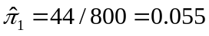; 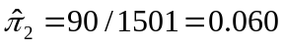; 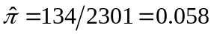; 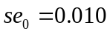; 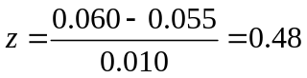; P = 0.63. It appears that there is no difference between the proportion of men judged to be compulsive buyers and the proportion of women judged to be compulsive buyers. A 95% confidence interval for this difference is –0.015 to 0.025.

7.21. (a) The estimated difference between the HONC means for smokers and ex-smokers is 4.9. (b) We can be 95% confident that the HONC population mean for smokers is between 4.1 and 5.7 higher than the HONC population mean for ex-smokers. (c) THE HONC sample data distribution for ex-smokers appears to be right-skewed, since the standard deviation is greater than the mean. If there are no severe outliers, the inference might not be affected too much, since two-sided t procedures are robust against violations of normality and the sample size is large (so the sampling distribution is bell-shaped by the CLT).

7.22. (a) Let 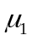 = the mean total credit card balance for non-compulsive buyers and 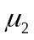 = the mean total credit card balance for compulsive buyers. 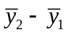 = $3399 – $2837 = $562; 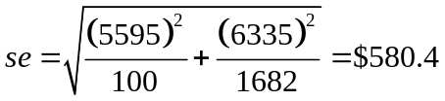. (b) 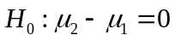, 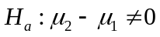; 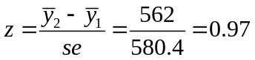; P = 0.33. It is plausible that there is no difference in the mean total credit card balance for compulsive buyers and the mean total credit card balance for non-compulsive

7.23. We can be 95% confident that the population mean number of days in the past 7 days that women have felt sad is between 0.2 and 0.6 greater than the population mean number of days in the past 7 days that men have felt sad. If the population means were identical, the probability would be 0.000 (rounded to 3 decimal places) of observing a sample difference this large or even larger (in either direction). Both the confidence interval and the hypothesis test lead us to believe that there is a difference in the population mean number of days in the past 7 days that women have felt sad and the population mean number of days in the past 7 days that men have felt sad. These results are statistically significant, but the confidence interval indicates that the results may not be practically significant because the plausible differences are close to 0.

7.32. (a) 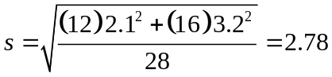, 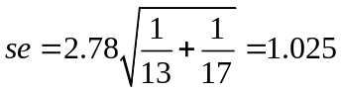. The 95% confidence interval is 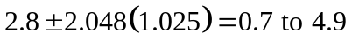. We can be 95% confident that the population mean family cohesion for nonabused students is between 0.7 and 4.9 higher than the population mean family cohesion for sexually abused students. (b) With P = 0.01 (rounded) for each two-sided analysis, there is strong evidence of a difference between the population mean family cohesion for nonabused students and the population mean family cohesion for sexually abused students. If the null hypothesis of identical population means were true, it would be very unusual to get a sample mean difference of 2.8 or even larger.

7.47. The report should include the following: Let = the proportion of teens who watch TV less than 1 hour per day and have committed aggressive acts and = the proportion of teens who watch TV at least 1 hour per day and have committed aggressive acts. = 5/88 = 0.06; = 154/619 = 0.25. The report should also include a hypothesis test (z = –4.04, P < 0.0001) and/or a confidence interval (95% CI: –0.25 to –0.13).

7.49. (a) (i) The interpretation suggests that the 95% confidence interval is (46-42) ± 3.4, or (0.6, 7.4). (ii) The interpretation suggests that the P-value is 0.02 for a two-sided test.

7.50. One possible approach compares mean numbers of dates for different levels of attractiveness within each gender. For example, a 95% confidence interval for More – Less for Men is: 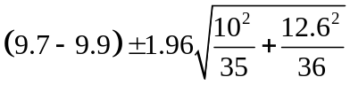 = –5.5 to 5.1, for which it is plausible that there is no difference between the population mean number of dates for the two levels of attractiveness. By contrast, a 95% confidence interval for More – Less for Women is: 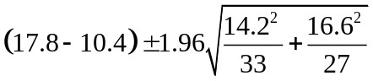 = –0.52 to 15.3. Here, 0 is barely in the interval, and it is plausible that the population mean number of dates is very much larger for the more attractive group. One could alternatively compare population means between genders within each level of attractiveness.

7.52. We would not have enough information. We also need to know the number of male managers and number of female managers.

7.55. The se value for estimating a difference between two means is larger than the se value for estimating a single mean. The analysis in Chapter 6 was for a single mean, for which the se value is smaller. So, a difference of 3.0 pounds in the Chapter 6 analysis is not necessarily less significant that a difference of 3.46 pounds in the analysis in Example 7.7 because the latter difference compared two sample means and had a larger se.

7.59. (a) False: The confidence interval addresses the difference between the population proportions for Hispanic and white youths, not the population proportion of white youths alone. (b) False: The samples are independent, because a youth is either a female or a male (i.e., the two groups had separate individuals).

7.60. False: We can conclude that is greater than but the confidence interval does not indicate plausible values for the separate population means.

7.61. True, from the formula on p. 185 you could figure out the standard error of the difference between the sample means.

7.62. (b)

7.63. (a), (c), and (d)

7.65. (a) The sample proportion correct has approximately a normal sampling distribution with mean 0.5 and standard error 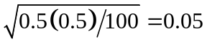. A score of 70 has z = (0.7 – 0.5)/0.05 = 4.0. The probability of a score of at least 70 is approximately the probability that a normal random variable falls at least 4 standard deviations above its mean, which is less than 0.0001. (b) The sampling distribution of the difference between Jane’s and Joe’s proportions is approximately normal with mean 0.6 – 0.5 = 0.1 and standard error 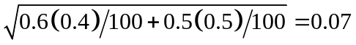. The probability that the difference is negative is approximately equal to the probability that a z-score from a standard normal distribution is less than (0 – 0.1)/0.07 = –1.43, which is 0.08. (c) The standard errors decrease as the number of questions increases, and the probabilities decrease. Thus, larger sample sizes are more likely to reveal the truth concerning Joe’s achievement and concerning the fact that Jane knows somewhat more than Joe.

