STAT 101 - Agresti
Homework 7 Solutions
11/1/10
Chapter 9

9.1. (a) y = college GPA. (b) y = number of children. (c) y = annual income. (d) y = assessed value of home.

9.3. (a) The y-intercept is 61.4, and the slope is 2.4. For each additional centimeter in length of the femur, predicted height increases by 2.4 centimeters. (b) = 61.4 + 2.4(50) = 181.4 cm.

9.7. (a) (i) = 1.26 + 0.346(0.8) = 1.54; (ii) = 1.26 + 0.346(34.3) = 13.1. (b) 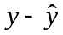 = 19.7 – 13.1 = 6.6; the U.S. is producing 6.6 metric tons per capita more in CO₂ emissions than predicted by the regression line. (c) = 1.26 + 0.346(28.1) = 11.0; = 5.7 – 11.0 = –5.3; Switzerland is producing 5.3 metric tons per capita less in CO₂ emissions than predicted by the regression line.

9.10. (a) The point for Palm Beach county appears to be an outlier, with more votes for Buchanan than we would expect based on the number of votes for Perot. (b) = 45.7 + 0.02414(30,739) = 788; = 3407 – 788 = 2619; the number of Buchanan votes in Palm Beach county is 2619 higher than we would predict with the regression equation. (c) The two rightmost points follow the pattern of the regression line for the rest of the data, whereas the top point is quite far from the trend that the rest of the data follow.

9.11. (a) (i) (20, 85); (ii) (34, 45). (b) = –0.13 + 2.62(34.3) = 89.7; = 45.1 – 89.7 =
–44.6; the percent of people using cell phones in the U.S. is 44.6% lower than would be predicted by the regression line. (c) The correlation is positive; higher values of percent of people using cell phones are associated with higher values of GDP, and lower values of percent of people using cell phones are associated with lower values of GDP.

9.12. (a) (i) higher percents of people using the Internet are associated with higher per capita GDP; (ii) higher percents of people using the Internet are associated with lower fertility rates. (b) (i) Per capita GDP has the strongest linear association with Internet use, because it has the largest correlation (in absolute value). (ii) Fertility rate has the weakest linear association with Internet use.

9.18. (a) (i) = 30 + 0.60(100) = 90; (ii) = 30 + 0.60(50) = 60.

9.20. (a) = –0.105 + 0.546x; for each $1000 increase in GDP per person, the predicted annual oil consumption per person increases by 0.55 barrels.
(c) = –0.105 + 0.546(41) = 22.3; = 26 – 22.3 = 3.7; the predicted annual oil consumption per person is 3.7 barrels higher than would be predicted by the regression line.

9.25. (a) There appears to be a positive relationship between poverty rate and murder rate. One point (D.C.) does appear to fall outside of the pattern of the rest of the data.
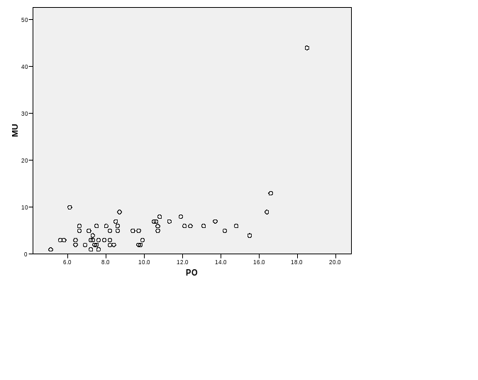
(b) = –5.176 + 1.130x. For D.C.: = 15.7; the residual is 28.3. The murder rate for D.C. is 28.3 higher than we would predict with the regression equation. (c) D.C. is definitely a regression outlier, because it falls far from the least squares line that would fit through the rest of the data. That estimated regression line without D.C. is = 0.197 + 0.494x. The slope is less than half of what it was when the point for D.C. was included.

9.58. (a) True, that correlation is largest in absolute value. (b) False, 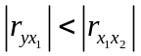. (c) True, because 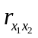< 0. (f) True, because the coefficient of 0.40 for X₂ corresponds to $400. (g) True, since 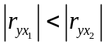, their squares have the same order, and because larger r-squared values occur with smaller SSE values (for a given total sum of squares, TSS), it follows that SSE₁ > SSE₂. (h) True, a 10-unit increase in x₂ is estimated to correspond to a 0.40(10) = 4.0 (i.e., $4000) increase in mean income. (i) False, = 10 + 1.0(10) = 20. If s = 8, then an income of $70,000 is (70 – 20)/8 = 6.25 standard deviations above the predicted value, which would be very unusual. (k) False. At x₁ = 13, = 10 + 1.0(13) = 23. Since the least squares line must pass through the point 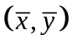, this would imply that = 23 rather than 20.

