**Installing Ubuntu:**

Download Ubuntu onto a flash drive. I already have a flash drive with Ubuntu on it, you can borrow mine if you want.

Instructions:

I can’t find the source I originally used, but this one looks similar

<https://www.cnet.com/how-to/what-to-do-with-your-usb-flash-drive-run-linux/>

**Downloading repo:**

<https://openrazer.github.io/>

Download Tarball. I found this to be the easier method. Save it to an easily accessible location, like the Desktop.

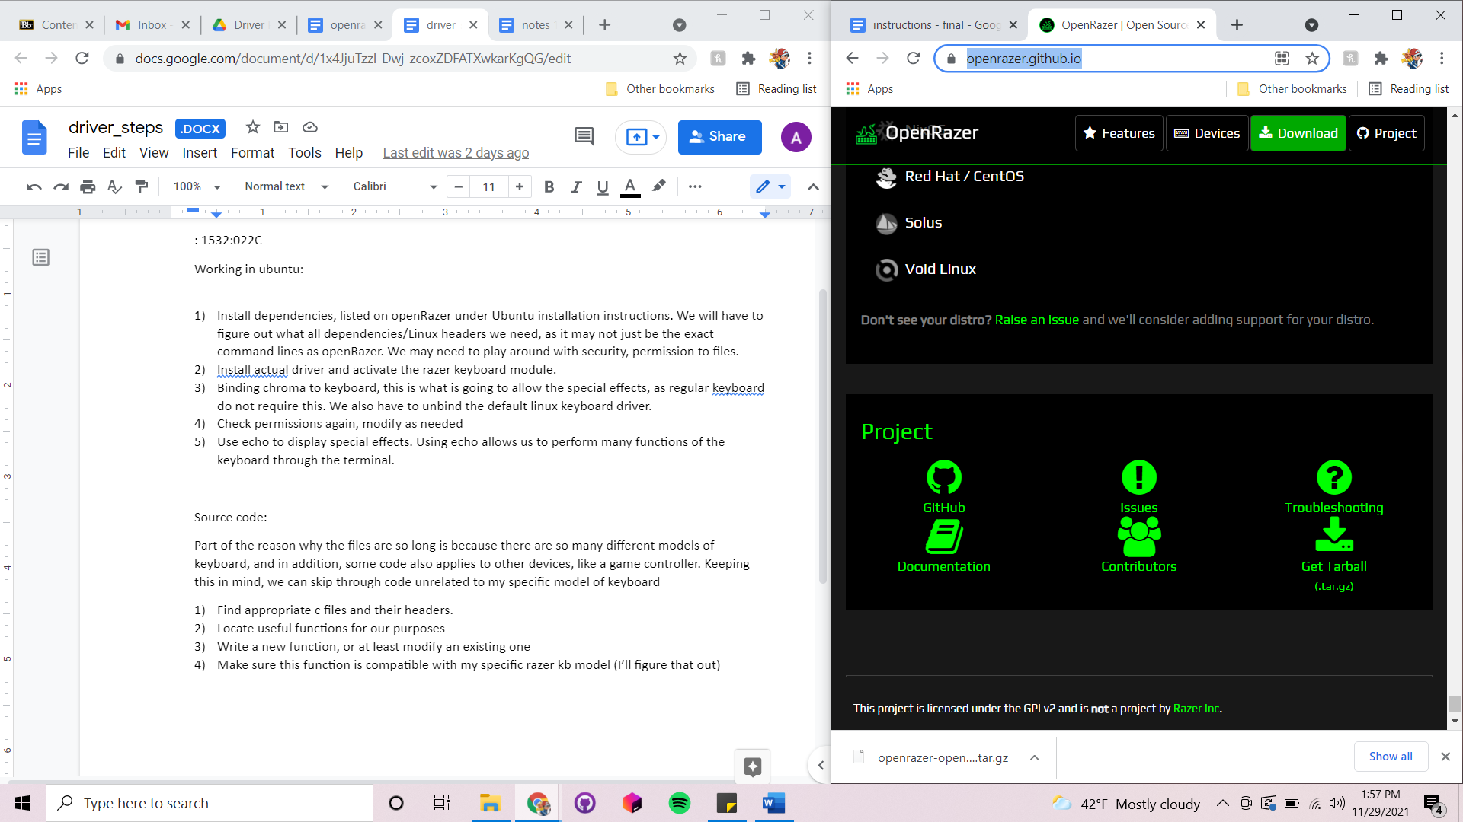

If you download the Tarball file, I don’t know if all these steps below are still necessary, but it doesn’t hurt to run the commands anyway.

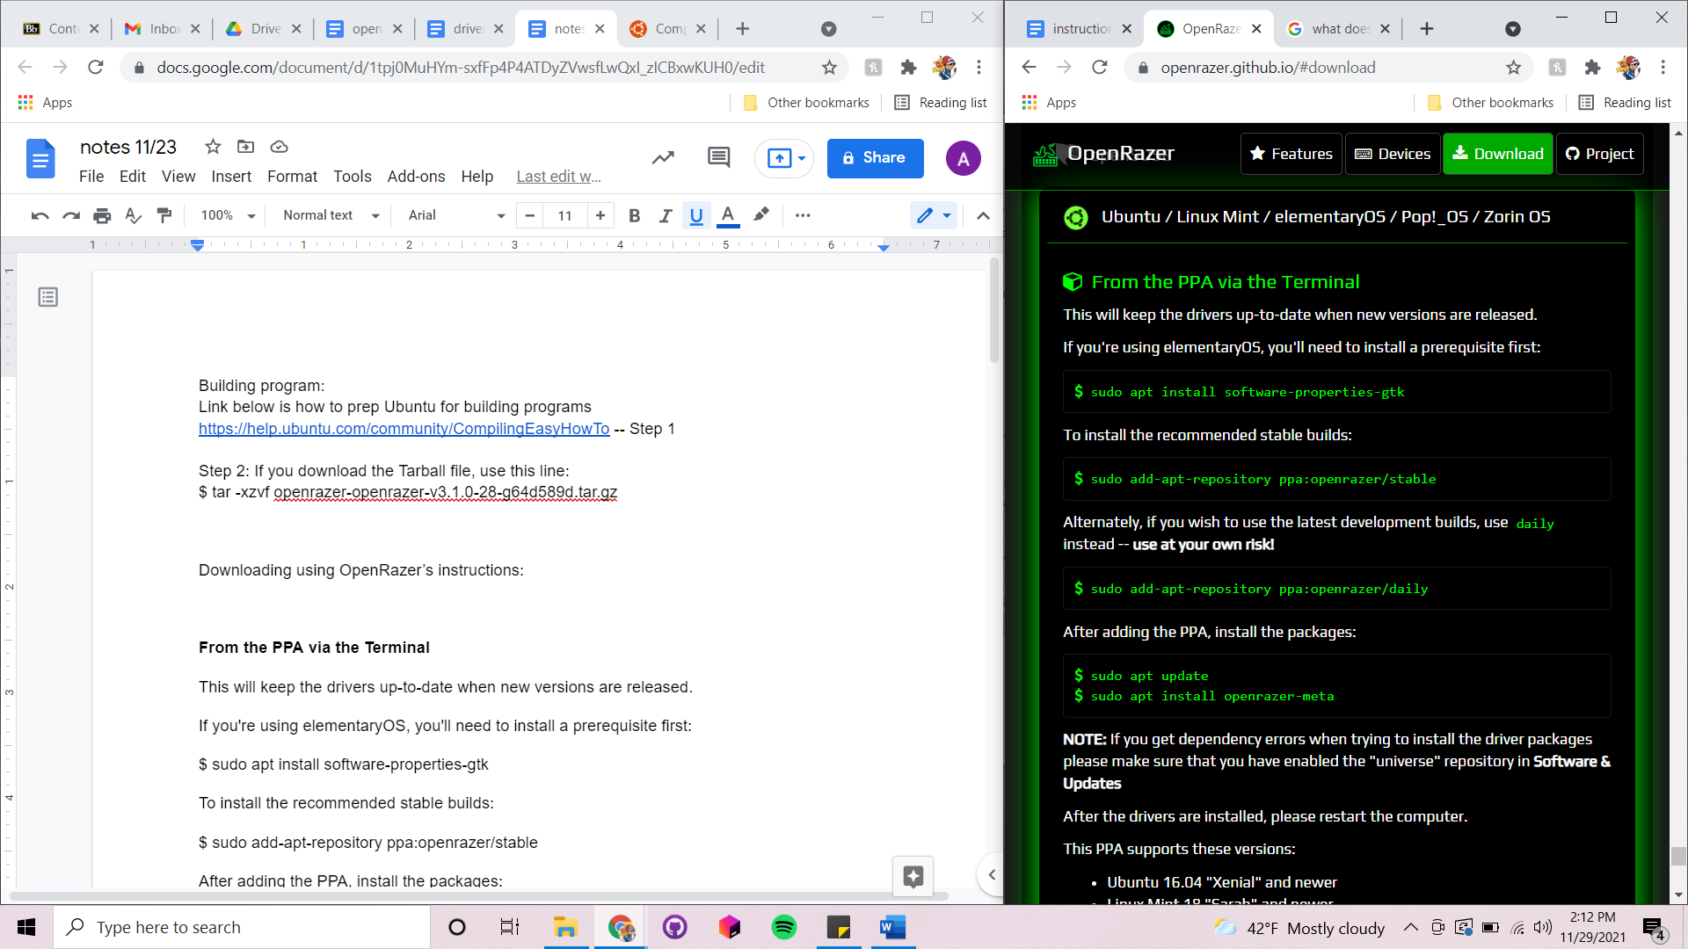

**Prep Ubuntu for building the program:**

**sudo apt-get install build-essential checkinstall**

**sudo apt-get install cvs subversion git-core mercurial**

**sudo chown $USER /usr/local/src**

**sudo chmod u+rwx /usr/local/src**

**Extract from Tarball file:**

**tar -xzvf tarballname.tar.gz**

**autogen.sh**

**make**

**If there are dependency problems:**

Follow Step 3 at <https://help.ubuntu.com/community/CompilingEasyHowTo>

This may be helpful:

**Build and Install program:**

**make**

**sudo checkinstall**

**sudo checkinstall --fstrans=0**

Performing these steps with the Tarball file allows us to get .ko files

.ko files are object files that can be used with a kernel

**Insert module into kernel:**

sudo insmod ./razerkbd.ko (ko means kernel object)

modprobe razerkbd

**Load keyboard kernel module:**

What we are doing here is unbinding the default linux USB module and binding our module.

Using razerkbd.ko

-Get the HID address, 16 characters (it may not be the same numbers as mine)

echo -n "0003:046D:C229.0036" > /sys/bus/hid/drivers/<generic driver name>/unbind

echo -n "0003:046D:C229.0036" > /sys/bus/hid/drivers/<our driver name>bind

**additional information on Linux loadable kernel modules: <https://www.thegeekstuff.com/2012/04/linux-lkm-basics/>

At this point, everything should be successfully set up.

