SIMATS ENGINEERING (SAVEETHA SCHOOL OF ENGINEERING)
Department of Computer Science and Engineering
CO1 ASSESSMENT TOOL 1 – Case Study Analysis
Course Code | CSA10 / CSA1005 | Course Title | Software Engineering
CO Assessed | CO1 | Assessment | Assessment Tool 1 – Case Study Analysis
Weightage | 20% | Total Marks | 25
CO1 Statement | Apply advanced methodologies and agile project management techniques to manage software projects effectively
Student Name | E.A ALAN ALDRIN | Reg. No. | 192411023

Code of Conduct
I E.A ALAN ALDRIN (192411023) certify that this submission is my original work and that I have adhered to the guidelines specified for this assessment. I understand that any violation of academic integrity rules will result in disciplinary action.
Signature of the Student: E.A ALAN ALDRIN

Annexure A – Case Study Analysis
Case Study Title: Digital Asset Management System for Creative Organizations

1. Understand the Problem Statement
Problem in my own words: Media organizations, advertising agencies, educational institutions, and creative teams produce and manage large collections of images, videos, audio files, design files, documents, and marketing materials. When these assets are stored across separate folders, devices, cloud drives, or email threads, employees may struggle to find the correct file. Duplicate files, outdated versions, unclear ownership, and uncontrolled sharing can waste time and create legal, security, and brand-consistency risks. The proposed Digital Asset Management System (DAMS) provides a centralized and secure platform to upload, classify, search, version, share, approve, track, and archive digital assets.
Objectives of the proposed system:
- Upload and organize images, videos, audio, designs, documents, and marketing materials.
- Maintain metadata such as title, description, asset type, tags, creator, date, project, and usage rights.
- Provide advanced search and filters based on metadata, file type, tags, owner, date, and status.
- Maintain version history and allow authorized users to compare or restore earlier versions.
- Implement role-based access permissions for administrators, creators, reviewers, and viewers.
- Support review and approval workflows before assets are published or shared.
- Track asset downloads, views, shares, edits, and other usage activities.
- Maintain audit trails for uploads, edits, approvals, permission changes, and archiving.
- Archive obsolete assets while preserving records and approved historical versions.
- Generate reports on asset usage, duplicates, approvals, storage, and access activity.
Scope: The system covers user authentication, asset upload, metadata management, classification, search, version control, permissions, approval workflows, sharing, usage analytics, audit logging, archiving, and reporting. It can be delivered as a secure web application with responsive support for common devices. It does not replace creative editing software, and correct metadata, rights information, and approval decisions still depend on users and organizational policy.

2. Identify Key Stakeholders and Challenges
Creative team members / asset creators: Upload files, add descriptions and tags, maintain versions, and submit assets for review. Challenges include repetitive data entry, unclear naming conventions, and uncertainty about which version is final.
Reviewers / approvers: Check content quality, brand consistency, permissions, and readiness for publication. Challenges include missed requests, unclear approval status, and difficulty comparing revisions.
Marketing and communications teams: Search for approved assets and reuse them in campaigns, presentations, websites, and social media. They need reliable search, current approved versions, and clear usage rights.
System administrators: Manage accounts, roles, storage, retention policies, audit logs, and system configuration. They must protect sensitive content and prevent unauthorized access.
Legal, compliance, and brand managers: Check licensing, consent, copyright, retention, and brand rules. They need traceable approvals and clear records of where assets are used.
Major shared challenges include inconsistent metadata, duplicate content, large file sizes, slow search, permission errors, outdated materials, unclear licensing, storage growth, and limited visibility into asset usage.

3. Analyze the Current Approach
Existing process: Organizations may store digital assets in shared folders, individual computers, email attachments, generic cloud drives, or separate project tools. File names and folder structures are often created independently by each team. Approvals may happen through email or chat, and usage information may not be recorded in one place.
Strengths of the current approach:
- Teams can start using familiar folders and cloud-storage tools with little training.
- Files can be shared quickly within small teams.
- Existing storage tools may already be available to the organization.
Limitations and gaps:
- Employees may spend excessive time locating assets across multiple repositories.
- Similar or duplicate files can occupy storage and cause confusion.
- Outdated or unapproved versions may be reused in campaigns or publications.
- Metadata and usage-rights information may be missing or inconsistent.
- Email-based approvals are difficult to track and audit.
- Public or broad sharing links can expose confidential or licensed assets.
- Usage, downloads, and asset effectiveness may not be measured consistently.
A centralized asset repository with standardized metadata, permissions, version history, and approval status can reduce these gaps and improve collaboration.

4. Propose a Suitable Solution Using Software Engineering Principles
Proposed solution: Develop a secure, centralized Digital Asset Management System with separate workspaces and permissions for creators, reviewers, marketers, and administrators. Users can upload assets, apply metadata and tags, search the repository, review version history, request approval, share approved files, and view usage reports.
Major functional modules:
- User Registration and Role Management: Authenticates users and assigns roles and permissions.
- Asset Upload and Repository: Accepts supported file types, validates uploads, stores files securely, and generates unique asset IDs.
- Metadata and Classification: Stores titles, descriptions, tags, creator, project, asset type, dates, rights, and status.
- Advanced Search: Supports keyword search, metadata filters, tags, file type, date ranges, owner, and approval status.
- Version Control: Keeps version numbers, change notes, timestamps, contributors, and authorized restore options.
- Approval Workflow: Routes assets to reviewers, records comments, and changes status to pending, approved, rejected, or revision required.
- Access and Sharing: Applies role-based permissions and controlled links with optional expiry or download restrictions.
- Usage Tracking and Audit Trail: Records views, downloads, shares, edits, approvals, permission changes, and archive events.
- Archiving and Reporting: Moves obsolete assets to controlled archives and generates storage, usage, approval, and activity reports.
Functional requirements: The system shall allow authorized users to upload and classify assets; create and edit metadata; search and filter assets; maintain version history; assign role-based permissions; submit assets for approval; approve, reject, or request revisions; share assets securely; track usage; archive obsolete assets; and generate reports.
Non-functional requirements: Security—authentication, authorization, encryption, and protected sharing; usability—clear navigation and consistent metadata forms; performance—search and previews should respond within a reasonable time; reliability—assets and metadata should remain consistent; scalability—support growing file collections and users; maintainability—modular components and documented APIs; availability—regular backups and recovery procedures; accessibility—usable interface for diverse users.
Application of software engineering principles: Modularity separates identity, repository, metadata, search, workflow, reporting, and audit services. Security is supported by least-privilege access and validation of uploaded files. Reliability is improved through backups, transactional metadata updates, and version history. Maintainability is supported by clear interfaces and automated tests. Scalability can be achieved through object storage, indexed metadata, and background processing for previews and large files.

5. Justify the Chosen Methodology / Framework
Selected methodology: Agile development using short iterations with Scrum practices for planning, review, and feedback.
Justification: The system contains several connected features and different stakeholder groups may have different priorities. Agile enables the team to deliver a usable repository first, then incorporate metadata search, version control, approvals, access control, analytics, and archiving in later increments. Feedback from creators, approvers, and marketing users can guide improvements to the workflow and interface.
How it supports development and maintenance: The team can maintain a prioritized product backlog, plan work in sprints, demonstrate completed functions, and test each increment. Version control for source code, automated tests, and regular sprint reviews help identify defects early. After deployment, the team can improve search quality, add file-format support, refine permissions, and adjust reporting based on organizational needs.

6. Discuss Expected Outcomes and Limitations
Expected outcomes:
- Faster retrieval of assets through centralized storage and metadata-based search.
- Reduced duplicate content and less confusion about current versions.
- Better asset organization and more consistent metadata.
- Improved collaboration through clear approval and sharing workflows.
- Reduced unauthorized use through role-based access and usage-rights metadata.
- Greater accountability through audit trails and asset usage tracking.
- Improved governance through archiving, retention controls, and management reports.
How the solution addresses challenges: Centralized storage and indexing improve discovery; duplicate checks and unique identifiers reduce confusion; version control identifies the latest revision; approval states make publication readiness clear; role-based permissions limit access; audit trails record important actions; and reports help administrators understand storage and usage.
Potential risks and limitations: Poor metadata quality can reduce search accuracy. Large video and design files may require substantial storage and bandwidth. Users may resist new tagging and approval procedures. Incorrect rights information can still lead to misuse. Complex permission rules can be configured incorrectly, and automated duplicate detection may not identify every visually similar file.
Risk mitigation: Define shared metadata standards, provide templates and required fields, train users, use secure authentication and least-privilege roles, back up files and metadata, validate file types, review access logs, and periodically audit rights and retention settings. Pilot the system with one creative team before organization-wide deployment.
Future enhancements: Add AI-assisted tagging and image recognition, visual similarity search, automatic duplicate detection, OCR for documents, video transcription, integrations with creative applications and content-management systems, automated rights-expiry alerts, and dashboards showing asset performance.

JIRA TASK BOARD – PROJECT PROGRESS
Digital Asset Management System for Creative Organizations
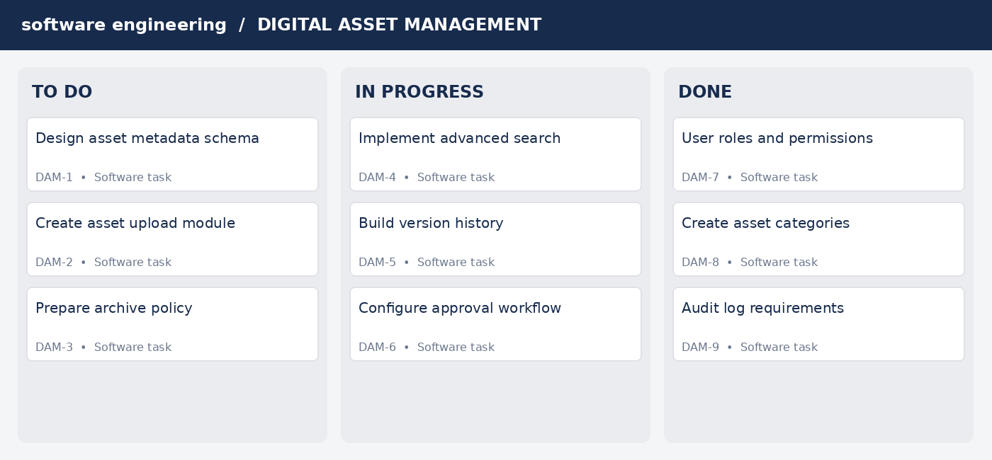

Figure: Illustrative Jira-style task board showing Digital Asset Management System work items in To Do, In Progress, and Done.
Example sprint tasks: define asset metadata schema; implement secure upload; create search filters; implement version history; configure approval workflow; enforce role permissions; record audit events; build usage reports; and implement archive controls.

Conclusion
The Digital Asset Management System provides a structured approach to managing the growing collections of digital content used by creative organizations. By combining centralized storage, metadata-based search, version control, role-based permissions, approval workflows, usage tracking, audit trails, archiving, and reporting, the system can improve retrieval speed, collaboration, and content governance. Agile development is suitable because the platform can be delivered incrementally and refined through feedback from its users.

Rubrics for Calculation
Criteria | Excellent (5 Marks) | Good (3 Marks) | Satisfactory (2 Marks) | Needs Improvement (1 Mark)
Problem Understanding (30%) | Clearly explains problem, objectives, and scope. | Explains problem with minor omissions. | Basic understanding; limited detail. | Problem, objectives, or scope unclear.
Stakeholder & Challenge Analysis (25%) | Identifies stakeholders, roles, and challenges clearly. | Identifies most stakeholders and challenges. | Identifies only a few stakeholders. | Stakeholders and challenges incomplete.
Current System Analysis (20%) | Thoroughly analyzes existing approach and gaps. | Identifies most strengths and weaknesses. | Limited analysis of current practice. | Current system analysis missing or inaccurate.
Solution & Engineering Principles (15%) | Feasible solution applies modularity, security, and maintainability. | Suitable solution with good engineering principles. | Basic solution with limited principles. | Solution unclear or principles missing.
Methodology / Framework (10%) | Agile/Scrum choice strongly justified. | Suitable methodology with adequate justification. | Weak justification. | Methodology inappropriate or absent.

Criteria | Mark
Problem Understanding (30%) | /5
Stakeholder & Challenge Analysis (25%) | /5
Current System Analysis (20%) | /5
Proposed Solution & Software Engineering Principles (15%) | /5
TOTAL | /25

