SIMATS ENGINEERING (SAVEETHA SCHOOL OF ENGINEERING)
Department of Computer Science and Engineering
CO1 ASSESSMENT TOOL 2 – Agile Sprint Planning & User Story Workshop
Course Code | CSA10 / CSA1005 | Course Title | Software Engineering
CO Assessed | CO1 | Assessment | Agile Sprint Planning & User Story Workshop
Weightage | 20% | Total Marks | 25
CO1 Statement | Apply advanced methodologies and agile project management techniques to manage software projects effectively
Student Name | E.A ALAN ALDRIN | Reg. No. | 192411023
Date | 20/10/2026 | Duration | 60 minutes

Code of Conduct
I, E.A Alan Aldrin (Reg. No. 192411023),certify that this submission is my original work and that I have adhered to the guidelines specified for this assessment.
Signature of the Student: E.A ALAN ALDRIN

Annexure A – Agile Sprint Planning & User Story Workshop
Case Study: Digital Asset Management System for Creative Organizations
Course: Software Engineering | Course Code: CSA1005 | Student: E.A Alan Aldrin | Register Number: 192411023

1. Project Vision and Industry Context
Media organizations, advertising agencies, educational institutions, and creative teams manage many images, videos, audio files, designs, documents, and marketing materials. When these assets are scattered across folders, computers, and cloud platforms, users may struggle to find the correct file. Duplicate files, outdated versions, unclear usage rights, and uncontrolled sharing waste time and create security risks.
Project vision: To provide a centralized and secure platform that enables organizations to upload, classify, search, version, share, approve, track, and archive digital assets.
Project Objectives:
- Upload and organize images, videos, audio, designs, and documents.
- Maintain metadata such as title, description, tags, creator, date, project, and usage rights.
- Provide advanced metadata-based search and filters.
- Maintain version history and restore earlier versions when permitted.
- Manage access through role-based permissions.
- Support approval workflows before assets are published or shared.
- Track views, downloads, edits, and sharing activities.
- Maintain audit trails and archive obsolete assets.
- Generate asset management and usage reports.
Key Stakeholders:
- Asset creators – upload files, add metadata, and submit assets for review.
- Reviewers / approvers – check content quality, brand consistency, and usage rights.
- Marketing teams – find and reuse approved assets.
- System administrators – manage users, permissions, storage, and audit records.
- Legal / brand managers – verify copyright, licensing, consent, and brand compliance.

2. Epics and User Stories
- Epic 1 – User Access: As a user, I want to sign in with an assigned role, so that I can access permitted functions and assets.
- Epic 2 – Asset Upload: As a creator, I want to upload images, videos, audio, and documents, so that content is stored in one repository.
- Epic 3 – Metadata: As a creator, I want to add titles, descriptions, tags, categories, and usage rights, so that assets are organized.
- Epic 4 – Advanced Search: As a team member, I want to search by keyword, tag, file type, creator, date, and status, so that I can locate assets quickly.
- Epic 5 – Version Control: As a creator, I want to upload new versions while retaining earlier versions, so that the latest file is clear and previous work can be restored.
- Epic 6 – Approval Workflow: As a reviewer, I want to approve, reject, or request changes, so that only reviewed content is published.
- Epic 7 – Permissions and Sharing: As an administrator, I want to assign permissions and control sharing, so that confidential assets are protected.
- Epic 8 – Usage, Audit, and Archive: As an administrator, I want to track activity, archive obsolete assets, and generate reports, so that governance can be monitored.

3. Acceptance Criteria (Given–When–Then)
- Asset upload: Given a user has upload permission, when a supported file is uploaded with required details, then the system stores it and displays its asset record.
- Metadata: Given an asset exists, when an authorized user saves its title, tags, category, and rights details, then the updated metadata is searchable.
- Search: Given matching assets exist, when a user enters a keyword or selects filters, then matching assets permitted to that user are displayed.
- Version control: Given an asset exists, when a creator uploads a revision, then the system saves it as a new version and preserves previous versions.
- Approval: Given an asset is submitted for review, when the reviewer approves, rejects, or requests changes, then the status is updated and the action recorded.
- Access control: Given a user has a defined role, when the user attempts an action, then authorized actions are allowed and unauthorized actions are blocked.
- Usage tracking: Given a user views, downloads, or shares an asset, when the action occurs, then the event is recorded.
- Archive and reports: Given an asset is obsolete, when an administrator archives it, then it leaves ordinary active search and the archive action appears in reports.

4. Prioritized Product Backlog
Priority is based on user value and feature dependencies. Authentication and asset storage are prioritized because other functions depend on them.
Priority | Backlog Item | User Value / Dependency | Story Points
P1 | Authentication and roles | Protects assets and controls access | 3
P2 | Asset upload and repository | Core storage for all functions | 5
P3 | Metadata and classification | Enables consistent organization | 5
P4 | Advanced search | Depends on metadata; speeds retrieval | 5
P5 | Version control | Distinguishes current and older files | 5
P6 | Approval workflow | Ensures content review before release | 8
P7 | Usage tracking and audit trail | Improves accountability | 5
P8 | Archive and reports | Supports retention and governance | 5

5. Sprint Backlog – Sprint 1
Sprint duration: 2 weeks (proposed). Sprint 1 establishes the foundation and makes basic asset upload and classification available.
- Task 1: Define user roles and access rules.
- Task 2: Create basic sign-in screens.
- Task 3: Define metadata fields such as title, description, tags, category, creator, and upload date.
- Task 4: Build an asset upload form with file and required-field validation.
- Task 5: Store uploaded assets and display them in a repository view.
- Task 6: Test sign-in, upload validation, metadata saving, and repository display.

6. Story Point Estimation and Justification
Estimation approach: Relative estimation using a Fibonacci-style scale (1, 2, 3, 5, 8). Points represent relative effort, complexity, and uncertainty, not hours.
- Authentication and role setup – 3 points: basic access workflow with role checks.
- Asset upload – 5 points: requires file validation, storage, and error handling.
- Metadata management – 5 points: structured fields, validation, and searchable records.
- Advanced search – 5 points: multiple filters and indexed metadata.
- Approval workflow – 8 points: multiple states, reviewer actions, and status updates.

7. Sprint Goal and Expected Deliverables
Sprint goal: Enable authorized users to access the system, upload digital assets, add essential metadata, and view saved assets in a centralized repository.
Expected deliverables at the end of Sprint 1:
- Basic sign-in and role-aware access flow.
- Asset upload form with validation.
- Metadata fields for title, description, tags, category, and creator.
- Repository view displaying uploaded assets and metadata.
- Basic test cases and recorded test results.
- A short demonstration of working Sprint 1 features.

JIRA TASK BOARD – PROJECT PROGRESS
Digital Asset Management System for Creative Organizations
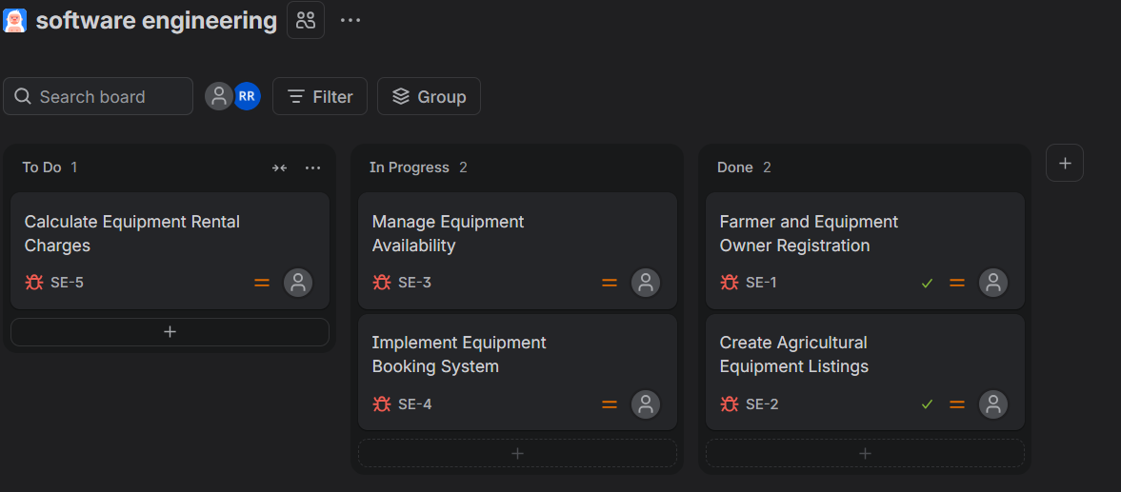

Figure: Illustrative Jira-style board showing tasks in To Do, In Progress, and Done.

Conclusion
The Agile plan delivers the Digital Asset Management System incrementally, beginning with user access, asset upload, and metadata before adding search, version control, approvals, usage tracking, archiving, and reports. Prioritizing dependencies helps the team deliver useful functions in manageable sprints and improve the platform through stakeholder feedback.

Rubrics for Calculation
Criteria | Excellent (5) | Good (3) |  | Satisfactory (2) | Needs Improvement (1)
Vision & Stakeholders (30%) | Clear vision and complete stakeholders. | Mostly clear. |  | Partially defined. | Unclear or incomplete.
Epics & User Stories (25%) | Complete Agile-format stories. | Minor gaps. |  | Partially complete. | Unclear or missing.
Acceptance Criteria (20%) | Specific and testable. | Mostly testable. |  | Some unclear. | Missing or misaligned.
Backlog & Sprint Planning (15%) | Logical priorities and realistic tasks. | Mostly appropriate. |  | Partially complete. | Poorly organized.
Estimation, Goal & Presentation (10%) | Justified points and clear deliverables. | Minor gaps. |  | Limited justification. | Missing or unrealistic.
Criteria |  |  | Mark
Project Vision & Stakeholder Identification (30%) |  |  | /5
Epics & User Stories (25%) |  |  | /5
Acceptance Criteria (20%) |  |  | /5
Product Backlog Prioritization & Sprint Planning (15%) |  |  | /5
Story Point Estimation, Sprint Goal & Presentation (10%) |  |  | /5
TOTAL |  |  | /25

