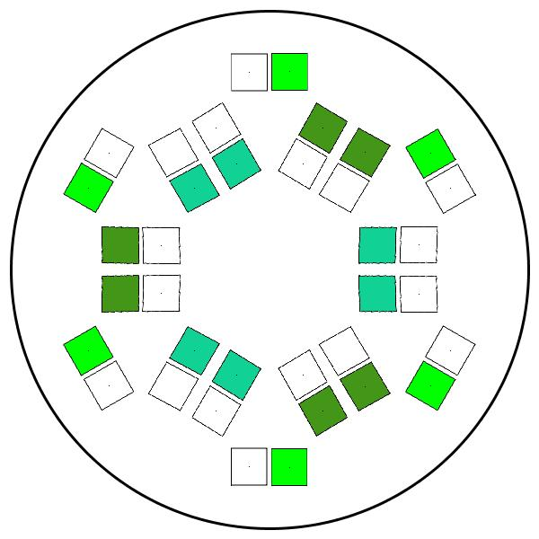

My Application

Welcome to ….

User Interface

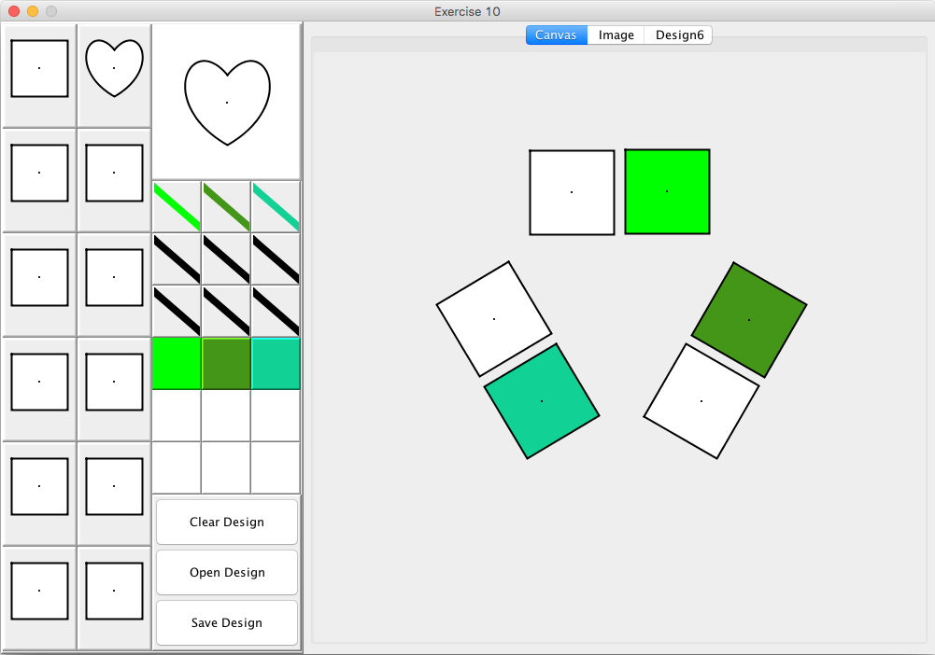

Design Elements:

Stroke Palette:

Fill Palette:

Buttons:

Mouse

Left mouse button:

Left mouse button with shift pressed:

Left mouse button with control pressed:

Right mouse button:

Key Actions

Arrow keys:

+ and – keys:

L and R keys:

Delete key:

B and F keys:

Tabs

Canvas:

Image:

Design6:

Design8:

Kaleidoscope:

Input and Output

Design Element file:

Image files: