Homework with **rmarkdown** and **knitr**

Alan T. Arnholt

2015-07-21

This document assumes you are using the [Rstudio](https://www.rstudio.com/) [IDE](https://www.rstudio.com/products/RStudio/). The best way to obtain this document and examine all the files associated with the project is to:

1. [Fork](https://help.github.com/articles/fork-a-repo/) this repository to your own [GitHub](https://github.com/) account.
2. Clone the forked repository into a local RStudio [project](https://support.rstudio.com/hc/en-us/articles/200526207-Using-Projects).

To clone the repository, you will need a recent version of [Git](http://git-scm.com/) installed on your machine. This video shows how to clone the repository using the RStudio [IDE](https://www.rstudio.com/products/RStudio/). Several features from [Pandoc](http://pandoc.org/) (MacFarlane 2015), **rmarkdown** (Allaire et al. 2015), and **knitr** (Xie 2015) are illustrated in the document including numerous **knitr** chunk options (both local and global) which are fully documented [online](http://yihui.name/knitr/options/). [Rstudio](https://www.rstudio.com/) has a great "[cheat sheet](https://www.rstudio.com/wp-content/uploads/2015/02/rmarkdown-cheatsheet.pdf)" for writing R markdown documents. Further information about R markdown can be found [online](http://rmarkdown.rstudio.com/). This document shows R code in the answers only when specifically directed in the question; however, all R code used in the document is visible in an **R-Code Appendix**. The [YAML](http://yaml.org/) for this document is written as:

---  
title: "Homework with **rmarkdown** and **knitr**"  
author: "Alan T. Arnholt"  
date: '2015-07-21'  
output: html_document  
bibliography:  
- References/PackagesUsed.bib  
- References/Main.bib  
---

To add a bibliography to your document, you will need to create one or more *.bib files and add the YAML entry bibliography: PathTo/file.bib or use a list as above for multiple *.bib files. The **knitr** function write_bib() (Xie 2015) is used to create *automagically* a *.bib file of the R packages used in this document and store the file in ./References/PackagesUsed.bib (See the **R-Code Appendix**). The two entries in ./References/Main.bib were created by hand. The citation management system [Zotero](https://www.zotero.org/) can create BibTeX files. This [4 minute video](https://www.youtube.com/watch?v=erTi298SX_w&list=PLJBNI3mCp9g0wsSDK111qgimqVF1dwPXO) illustrates how to store bibliographic information using Zotero, and the following [2 minute video](https://www.youtube.com/watch?v=ixUF3BN_KOA&list=PLJBNI3mCp9g0wsSDK111qgimqVF1dwPXO&index=3) shows how to export the bibliographic information from Zotero to a BibTeX file. Inline LaTeX equations and display equations are placed between single and double $ symbols, respectively. To learn more about LaTeX, see online resources such as [<https://en.wikibooks.org/wiki/LaTeX>](https://en.wikibooks.org/wiki/LaTeX). If you need help with how to write a symbol in LaTeX, you can draw the symbol at this [site](http://detexify.kirelabs.org/classify.html); and LaTeX code corresponding to the user drawn symbol will appear.

## Notes:

1. The [RStudio](https://www.rstudio.com/) [IDE](https://www.rstudio.com/products/RStudio/) will populate most entries for the YAML; however, you will need manually to add the bibliography entry.
2. To create a PDF document (you must have [LaTeX](http://latex-project.org/ftp.html) installed) or a Word document, change the YAML entry output: html_document to output: pdf_document or output: word_document, respectively.
3. To define the styles in a Word document generated from R markdown see this [video](https://vimeo.com/110804387).

## Code chunks

1. The first code chunk named setup has local options echo = FALSE, results= 'hide', message = FALSE, and warning = FALSE. These options have the chunk execute without echoing the code, displaying any results, messages, or warnings in the console. The global options for the document are defined with knitr::opts_chunk$set() (shown below). After the global options are defined, a character vector (PackagesUsed) is created with the names of the packages used in this document. The bibliographic information for the packages is automatically written to a file with the write_bib() function. Last, the packages are loaded and attached. If your installation does not have any of the packages referenced in PackagesUsed, you should install the missing packages using the function install.packages().

knitr::opts_chunk$set(fig.show = 'as.is', fig.height = 6,   
 fig.width = 6, prompt = FALSE, highlight = TRUE,   
 tidy = FALSE, warning = FALSE, message = FALSE,   
 echo = FALSE, tidy.opts=list(blank = TRUE, width.cutoff= 65))  
# Lists of R packages used  
PackagesUsed <- c("PASWR2", "ggplot2", "knitr", "MASS", "DT", "lattice", "rmarkdown")  
# Write bib information  
knitr::write_bib(PackagesUsed, file = "./References/PackagesUsed.bib")  
# Load packages  
lapply(PackagesUsed, library, character.only = TRUE)

1. The second code chunk named load uses the local options echo = TRUE, comment = NA, and prompt = TRUE. The echo = TRUE overwrites the global option echo = FALSE and echoes all R code and output to the console. The option comment = NA removes the default comment (##), and the option prompt = TRUE displays the R prompt symbol (>).
2. The third code chunk named partA changes the height and width of the plot used in the graphics device from the global settings of 5 and 5, to 12 and 12 with the options fig.height = 12, and fig.width = 12.
3. The fourth code chunk named partB changes the height and width of the plot used in the graphics device from the global settings of 5 and 5, to 12 and 12 with the options fig.height = 12, and fig.width = 12.
4. The fifth code chunk named partC does not overwrite any of the global option setting.
5. The sixth code chunk named partD does not overwrite any of the global options.
6. The seventh code chunk named partE hides output send to the console with the local option results = "hide".
7. The eighth code chunk named tablestuff uses the default global options.
8. The ninth code chunk named appendix shows all of the code used for all code chunks without evaluating the code with the options echo = TRUE, ref.label = all_labels(), and eval = FALSE.
9. The tenth code chunk named SessionInfo uses the local option echo = TRUE to show the results of sessionInfo() in the console.

#### Modified question 2 from chapter 2 of (Ugarte, Militino, and Arnholt 2015) with brief answers.

Load Cars93 from the **MASS** package (Ripley 2015), and use the function str() on the Cars93 data frame.

> library(MASS)   
> str(Cars93)

'data.frame': 93 obs. of 27 variables:  
 $ Manufacturer : Factor w/ 32 levels "Acura","Audi",..: 1 1 2 2 3 4 4 4 4 5 ...  
 $ Model : Factor w/ 93 levels "100","190E","240",..: 49 56 9 1 6 24 54 74 73 35 ...  
 $ Type : Factor w/ 6 levels "Compact","Large",..: 4 3 1 3 3 3 2 2 3 2 ...  
 $ Min.Price : num 12.9 29.2 25.9 30.8 23.7 14.2 19.9 22.6 26.3 33 ...  
 $ Price : num 15.9 33.9 29.1 37.7 30 15.7 20.8 23.7 26.3 34.7 ...  
 $ Max.Price : num 18.8 38.7 32.3 44.6 36.2 17.3 21.7 24.9 26.3 36.3 ...  
 $ MPG.city : int 25 18 20 19 22 22 19 16 19 16 ...  
 $ MPG.highway : int 31 25 26 26 30 31 28 25 27 25 ...  
 $ AirBags : Factor w/ 3 levels "Driver & Passenger",..: 3 1 2 1 2 2 2 2 2 2 ...  
 $ DriveTrain : Factor w/ 3 levels "4WD","Front",..: 2 2 2 2 3 2 2 3 2 2 ...  
 $ Cylinders : Factor w/ 6 levels "3","4","5","6",..: 2 4 4 4 2 2 4 4 4 5 ...  
 $ EngineSize : num 1.8 3.2 2.8 2.8 3.5 2.2 3.8 5.7 3.8 4.9 ...  
 $ Horsepower : int 140 200 172 172 208 110 170 180 170 200 ...  
 $ RPM : int 6300 5500 5500 5500 5700 5200 4800 4000 4800 4100 ...  
 $ Rev.per.mile : int 2890 2335 2280 2535 2545 2565 1570 1320 1690 1510 ...  
 $ Man.trans.avail : Factor w/ 2 levels "No","Yes": 2 2 2 2 2 1 1 1 1 1 ...  
 $ Fuel.tank.capacity: num 13.2 18 16.9 21.1 21.1 16.4 18 23 18.8 18 ...  
 $ Passengers : int 5 5 5 6 4 6 6 6 5 6 ...  
 $ Length : int 177 195 180 193 186 189 200 216 198 206 ...  
 $ Wheelbase : int 102 115 102 106 109 105 111 116 108 114 ...  
 $ Width : int 68 71 67 70 69 69 74 78 73 73 ...  
 $ Turn.circle : int 37 38 37 37 39 41 42 45 41 43 ...  
 $ Rear.seat.room : num 26.5 30 28 31 27 28 30.5 30.5 26.5 35 ...  
 $ Luggage.room : int 11 15 14 17 13 16 17 21 14 18 ...  
 $ Weight : int 2705 3560 3375 3405 3640 2880 3470 4105 3495 3620 ...  
 $ Origin : Factor w/ 2 levels "USA","non-USA": 2 2 2 2 2 1 1 1 1 1 ...  
 $ Make : Factor w/ 93 levels "Acura Integra",..: 1 2 4 3 5 6 7 9 8 10 ...

1. Create density histograms for the variables Min.Price, Max.Price, Weight, and Length variables using a different color for each histogram.

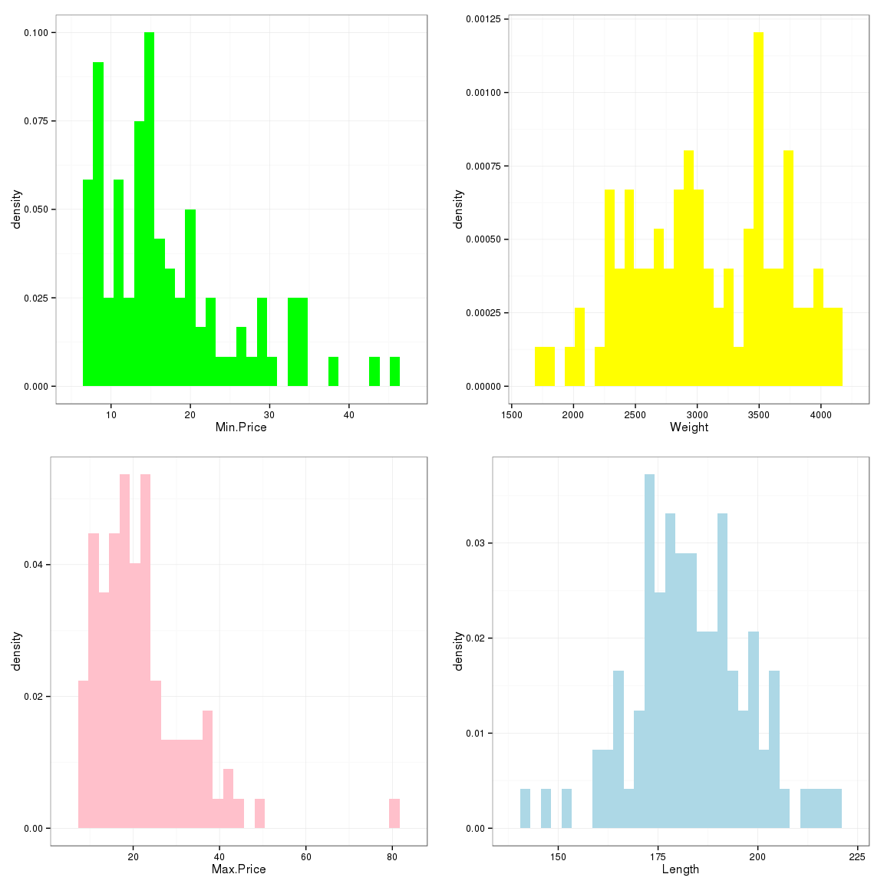

1. Superimpose estimated density curves over the histograms.

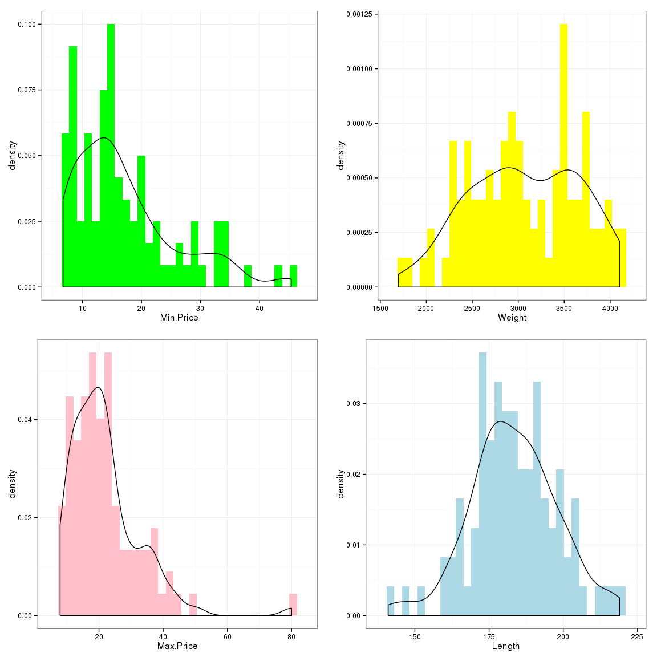

1. Use the bwplot() function from **lattice** (Sarkar 2015) to create a box and whiskers plot of Price for every type of vehicle according to the drive train. Do you observe any differences between prices? *Rear wheel drive vehicles are generally more expensive than either 4WD or front wheel drive vehicles.*

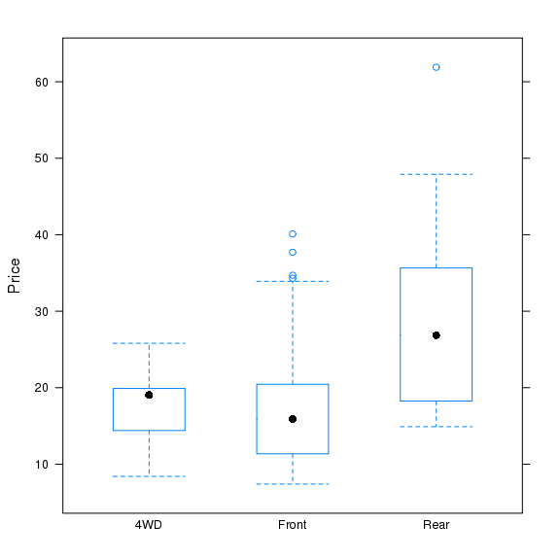

1. Create a graph similar to the one created in (c) using functions from **ggplot2** (Wickham and Chang 2015).

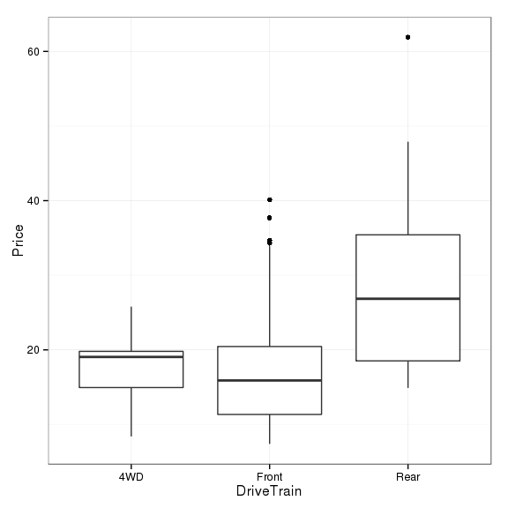

1. Create scatter plot of Horsepower versus Weight, and superimpose the least squares line from regressing Horsepower onto Weight. Write out the least squares line and the theoretical least squares model.

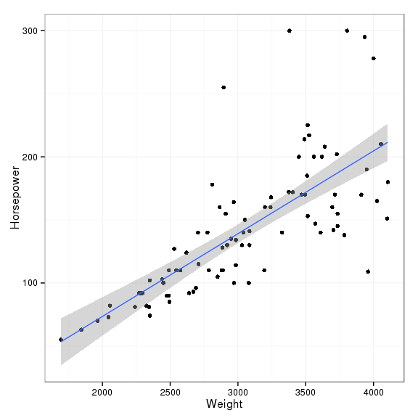

The least squares line from regressing Horsepower onto Weight is: $\overset{ˆ}{Horsepower}=−57.7382032+0.0655947×Weight.$ The theoretical model for least squares regression is: $Y=β_{0}+β_{1}x+ϵ$ where $ϵ∼N(0,σ^{2}).$

Use the data frame EPIDURALF from the **PASWR2** package (Arnholt 2014), and create a table of the average weight of parturient women classified by ease and treatment.

|  |  |  |
| --- | --- | --- |
|  | Hamstring Stretch | Traditional Sitting |
| Easy | 78.67000 | 79.40187 |
| Difficult | 92.66667 | 94.27451 |
| Impossible | 127.87500 | 113.61538 |

Table: Mean weight (kg.) of parturient women classified by ease and treatment

# R-Code Appendix

knitr::opts_chunk$set(fig.show = 'as.is', fig.height = 6,   
 fig.width = 6, prompt = FALSE, highlight = TRUE,   
 tidy = FALSE, warning = FALSE, message = FALSE,   
 echo = FALSE, tidy.opts=list(blank = TRUE, width.cutoff= 65))  
# Lists of R packages used  
PackagesUsed <- c("PASWR2", "ggplot2", "knitr", "MASS", "DT", "lattice", "rmarkdown")  
# Write bib information  
knitr::write_bib(PackagesUsed, file = "./References/PackagesUsed.bib")  
# Load packages  
lapply(PackagesUsed, library, character.only = TRUE)  
library(MASS)   
str(Cars93)  
# Create graphs for part a  
p1 <- ggplot(data = Cars93, aes(x = Min.Price, y = ..density..)) +   
 geom_histogram(fill = "green") +   
 theme_bw()  
p2 <- ggplot(data = Cars93, aes(x = Max.Price, y = ..density..)) +   
 geom_histogram(fill = "pink") +   
 theme_bw()  
p3 <- ggplot(data = Cars93, aes(x = Weight, y = ..density..)) +   
 geom_histogram(fill = "yellow") +   
 theme_bw()  
p4 <- ggplot(data = Cars93, aes(x = Length, y = ..density..)) +   
 geom_histogram(fill = "lightblue") +   
 theme_bw()  
multiplot(p1, p2, p3, p4, cols = 2)  
# Create graphs for part b  
p1 <- ggplot(data = Cars93, aes(x = Min.Price, y = ..density..)) +   
 geom_histogram(fill = "green") +   
 theme_bw() +   
 geom_density()  
p2 <- ggplot(data = Cars93, aes(x = Max.Price, y = ..density..)) +   
 geom_histogram(fill = "pink") +   
 theme_bw() +   
 geom_density()  
p3 <- ggplot(data = Cars93, aes(x = Weight, y = ..density..)) +   
 geom_histogram(fill = "yellow") +   
 theme_bw() +   
 geom_density()  
p4 <- ggplot(data = Cars93, aes(x = Length, y = ..density..)) +   
 geom_histogram(fill = "lightblue") +   
 theme_bw() +   
 geom_density()  
multiplot(p1, p2, p3, p4, cols = 2)  
# Graph for part c  
bwplot(Price ~ DriveTrain, data = Cars93)  
# Graph for part d  
ggplot(data = Cars93, aes(x = DriveTrain, y = Price)) +  
 geom_boxplot() +  
 theme_bw()  
# Graph for part e  
ggplot(data = Cars93, aes(x = Weight, y = Horsepower)) +   
 geom_point() +   
 stat_smooth(method = "lm") +   
 theme_bw()  
mod_lm <- lm(Horsepower ~ Weight, data = Cars93)  
summary(mod_lm)  
# Create requested table with kable  
# levels in order of difficulty  
EPIDURALF$ease <- factor(EPIDURALF$ease, levels = c("Easy", "Difficult", "Impossible"))   
TS <- with(data = EPIDURALF, {tapply(kg, list(ease, treatment), mean)})  
DF <- data.frame(TS)  
knitr::kable(DF, col.names = c("Hamstring Stretch", "Traditional Sitting"),   
 caption = "Table: Mean weight (kg.) of parturient women   
 classified by `ease` and `treatment`")  
sessionInfo()

It is always a good idea to include your sessionInfo():

sessionInfo()

## R version 3.2.1 (2015-06-18)  
## Platform: x86_64-unknown-linux-gnu (64-bit)  
## Running under: Red Hat Enterprise Linux Server release 6.6 (Santiago)  
##   
## locale:  
## [1] LC_CTYPE=en_US.UTF-8 LC_NUMERIC=C   
## [3] LC_TIME=en_US.UTF-8 LC_COLLATE=en_US.UTF-8   
## [5] LC_MONETARY=en_US.UTF-8 LC_MESSAGES=en_US.UTF-8   
## [7] LC_PAPER=en_US.UTF-8 LC_NAME=C   
## [9] LC_ADDRESS=C LC_TELEPHONE=C   
## [11] LC_MEASUREMENT=en_US.UTF-8 LC_IDENTIFICATION=C   
##   
## attached base packages:  
## [1] stats graphics grDevices utils datasets methods base   
##   
## other attached packages:  
## [1] rmarkdown_0.7 DT_0.1 MASS_7.3-40 knitr_1.10.5   
## [5] PASWR2_1.0 lattice_0.20-31 ggplot2_1.0.1   
##   
## loaded via a namespace (and not attached):  
## [1] Rcpp_0.11.6 magrittr_1.5 munsell_0.4.2 colorspace_1.2-6  
## [5] highr_0.5 stringr_1.0.0 plyr_1.8.3 tools_3.2.1   
## [9] grid_3.2.1 gtable_0.1.2 e1071_1.6-4 htmltools_0.2.6   
## [13] class_7.3-12 yaml_2.1.13 digest_0.6.8 reshape2_1.4.1   
## [17] formatR_1.2 htmlwidgets_0.5 evaluate_0.7 labeling_0.3   
## [21] stringi_0.5-5 scales_0.2.5 proto_0.3-10

# References

Allaire, JJ, Joe Cheng, Yihui Xie, Jonathan McPherson, Winston Chang, Jeff Allen, Hadley Wickham, and Rob Hyndman. 2015. *Rmarkdown: Dynamic Documents for R*. <http://CRAN.R-project.org/package=rmarkdown>.

Arnholt, Alan T. 2014. *PASWR2: Probability and Statistics with R, Second Edition*. <http://CRAN.R-project.org/package=PASWR2>.

MacFarlane, John. 2015. *Pandoc: A Universal Document Converter*. <http://johnmacfarlane.net/pandoc/index.html>.

Ripley, Brian. 2015. *MASS: Support Functions and Datasets for Venables and Ripley’s MASS*. <http://CRAN.R-project.org/package=MASS>.

Sarkar, Deepayan. 2015. *Lattice: Lattice Graphics*. <http://CRAN.R-project.org/package=lattice>.

Ugarte, María Dolores, Ana F. Militino, and Alan T. Arnholt. 2015. *Probability and Statistics with R*. Second. Boca Raton, FL: CRC Press.

Wickham, Hadley, and Winston Chang. 2015. *Ggplot2: An Implementation of the Grammar of Graphics*. <http://CRAN.R-project.org/package=ggplot2>.

Xie, Yihui. 2015. *Knitr: A General-Purpose Package for Dynamic Report Generation in R*. <http://CRAN.R-project.org/package=knitr>.