Project Formatting Examples

Your Name¹ & Partner’s Name²
¹Affiliation 1
²Affiliation 2

Abstract
This is not an example of a full Final Project! The purpose of this document is to show you some useful formatting options for R Markdown. Note I can change the size of my section headers based on how many # I put.

1. Introduction
I put my introduction here.

2. Methods

3. Results
In my results section, I might want to put some graphics! I am actually creating my graphics in the Appendix. After creating and saving the graphs, I can reference the .png files in this section to print the image.
I might want to insert an image that I generated previously in my appendix. 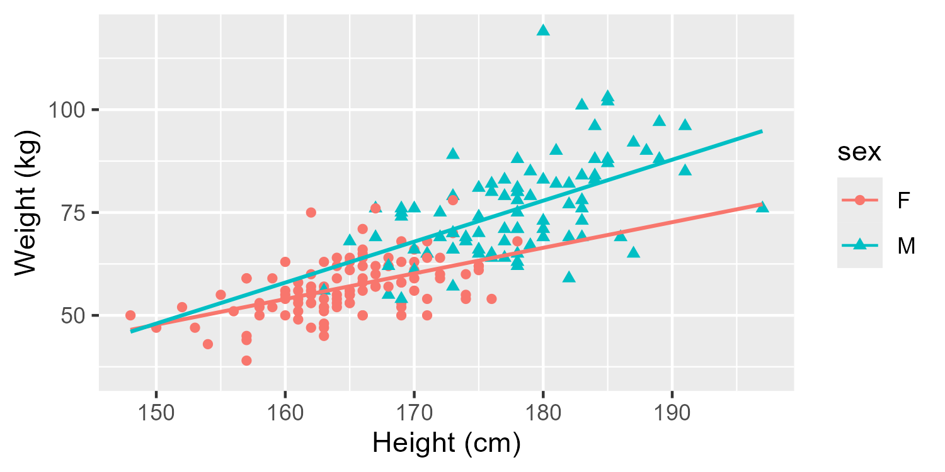
I can also insert an image via an R code chunk. If I do it this way, I need to be sure to suppress the code from printing!


3.1 Subheader 1
I should include a written version of my model. Remember, we have seen how to write this type of language in labs! Reference old labs to write something similar for your project.
${\hat{y}}_{myresponsevar}=0+1x_{var1}+2x_{var2}+...$

3.2 Subheader 2
In this section, I might want to create a table to show my model parameter estimates. Here is a small example of how I can build a table manually.
Parameter | Estimate | p-value
Intercept | -76.64 | <.0001
Here is a more advanced version:
Predictor | Estimate | Std. Error | z-value | p-value
(Intercept) | -0.76246 | 0.69687 | -1.094 | 0.273900
Height | -0.41946 | 0.27438 | -1.529 | 0.126320
Yet another option is to generate the table automatically. This requires running the code to fit and print the model within the paper body itself, like this:
Term | Estimate | SE | t | p-value
(Intercept) | -77 | 15.8 | -4.86 | <0.001
height | 0.81 | 0.096 | 8.49 | <0.001
sex | 8.2 | 1.72 | 4.78 | <0.001
Abbreviation: SE = Standard Error

Table 1: My Table

4. Discussion / Conclusion
5 page limit ends and the bottom of this section!

5. References

6. Statement on the Use of AI

7. Appendix of All R Code
This is where I should show ALL of my R code! Even R code that I might have used in the body of the paper but suppressed.
#mosaic package makes some functions more user-friendly for Intro Stat topics
library(mosaic)
#ggformula package is for graphics
library(ggformula)
#janitor package will help us clean up variable names
library(janitor)
#for nicely formatted tables of parameter estimates and related statistics.
library(gtsummary)
Read in the data and create an example graphic to put in our paper. We want the rendered file to show ALL code AND output.
library(car)
data(Davis) #found in the car package
#clean names
davis <- Davis |>
clean_names()
#Just view the first couple of rows of data
head(davis)
sex weight height repwt repht
1 M 77 182 77 180
2 F 58 161 51 159
3 F 53 161 54 158
4 M 68 177 70 175
5 F 59 157 59 155
6 M 76 170 76 165
#variable information
str(davis)
'data.frame': 200 obs. of 5 variables:
$ sex : Factor w/ 2 levels "F","M": 2 1 1 2 1 2 2 2 2 2 ...
$ weight: int 77 58 53 68 59 76 76 69 71 65 ...
$ height: int 182 161 161 177 157 170 167 186 178 171 ...
$ repwt : int 77 51 54 70 59 76 77 73 71 64 ...
$ repht : int 180 159 158 175 155 165 165 180 175 170 ...
There is an obvious outlier and after some investigation, we see it is row 12. Therefore, we want to remove that data point from our analysis (this is most likely a data entry error as there would not be someone who is less than 60 cm in real life, or at least not an adult).
#remove an outlier and create a plot
new_davis <- davis[-12,] #removes row 12 from the dataframe
Let’s use some new arguments in ggformula to look at our data, but split by sex.
#including sex in the model, outlier removed
gf_point(weight ~ height, shape = ~sex, color = ~sex, data=new_davis, xlab="Height (cm)", ylab="Weight (kg)") |>
gf_lm()
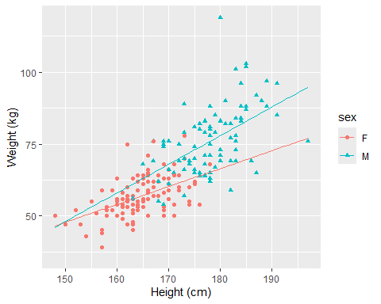
Now we want to save this graph so we can insert it earlier in our paper.
#by default this saves the last graph you created. you can change the width or height (inches)
ggsave("myplot.png", width=5, height=2.5)
#once I have run this code once to save the graph I just created, I can comment out the line of code. I don't need to run it every time.
After I run this code once to save the graph, THEN I can go back to the top of my document and insert the image.
Now I will run the model and output the results. I could take
#Run the model, view coefficients and hypothesis tests
model_final <- lm(weight ~ height + sex, data = new_davis)
#the usual way we get model output, but it's not very pretty. However, this gives me the values I need to manually put in my table up in the body of the paper.
summary(model_final)
Call:
lm(formula = weight ~ height + sex, data = new_davis)
Residuals:
Min 1Q Median 3Q Max
-20.131 -4.889 -0.404 5.205 41.490
Coefficients:
Estimate Std. Error t value Pr(>|t|)
(Intercept) -76.63620 15.75543 -4.864 2.36e-06 ***
height 0.81072 0.09555 8.485 5.24e-15 ***
sexM 8.21621 1.71726 4.784 3.37e-06 ***
---
Signif. codes: 0 '***' 0.001 '**' 0.01 '*' 0.05 '.' 0.1 ' ' 1
Residual standard error: 8.086 on 196 degrees of freedom
Multiple R-squared: 0.6365, Adjusted R-squared: 0.6328
F-statistic: 171.6 on 2 and 196 DF, p-value: < 2.2e-16
#alternatively, I could use the gtsummary package to output model results in a nice table! If I want this format in the paper itself, I would need to rerun the model as shown up above in the body of the paper.
#here is more information on the tbl_regression function: https://www.danieldsjoberg.com/gtsummary/articles/tbl_regression.html
library(gtsummary)
#output the table using the tbl_regression function from the gtsummary package.
#show_single_row should only be used for a binary categorical variable which is listed after the = sign. (Remove it and see what the output looks like!)
model_table <- model_final |>
tbl_regression(conf.int = FALSE,
intercept = TRUE,
show_single_row = sex)
#modify the table to include standard erorr and test statistic, and rename all the column headers to be more appropriate
model_table |>
modify_column_unhide(c(estimate, std.error, statistic, p.value)) |>
modify_header(
label ~ "**Term**",
estimate ~ "**Estimate**",
std.error ~ "**SE**",
statistic ~ "**t**",
p.value ~ "**p-value**"
)
Term | Estimate | SE | t | p-value
(Intercept) | -77 | 15.8 | -4.86 | <0.001
height | 0.81 | 0.096 | 8.49 | <0.001
sex | 8.2 | 1.72 | 4.78 | <0.001
Abbreviation: SE = Standard Error

