Triggers
- Write a PL/SQL trigger to restrict the insert/update/delete operations on a table.

create table sample(sid number,sname varchar(20));

insert into sample values(101,'ajay');
insert into sample values(101,'fabin');

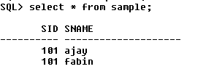

create or replace trigger t1
before insert or update or delete on sample for each
row
begin
raise_application_error(-20000,'you are not permitted to do INSERT/UPDATE/DELETE');
end;

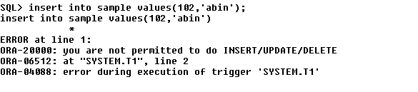

- Assume our DB has a relation schema :Pfessor (pNum, pName, salary) create a trigger to ensure that any new professor inserted has salary >= 60000.

create table professor(pnum int,pname varchar(30),salary int);

insert into professor values(101,'nishan',70000);
insert into professor values(102,'sreerag',80000);

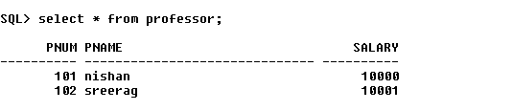

create or replace trigger minsalary
before insert on professor
for each row
begin
if(:new.salary<60000)
then
raise_application_error(-20000,'violation of minimum professor salary');
end if;
end;

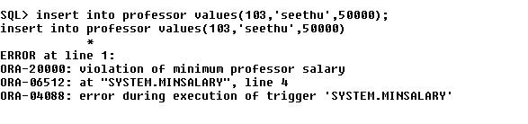

- Create a backlog table for professor to store deleted professor details. Manage the operation using trigger.

create table probacklog(pnum int,pname varchar(30),salary int);

create or replace trigger tiger
after delete on professor
for each row
begin
insert into probacklog values(:old.pnum,:old.pname,:old.salary);
end;

delete from professor where pnum=102;

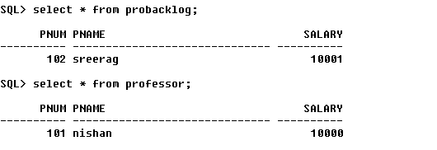

- Maintain a Gold Price History table using trigger.

create table gold(cdate date,price int);

create table pricehistory(odate date,price int);

insert into gold values(sysdate,30000);

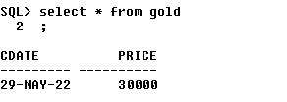

create or replace trigger s2
after update on gold
for each row
begin
insert into pricehistory values(:old.cdate,:old.price);
end;

