- In database Employee.
- find the average salary of each dept.
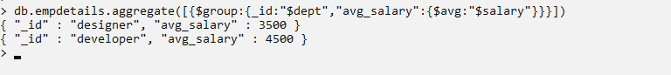

- find the minimum salary of each dept.

- find the maximum salary of each dept.
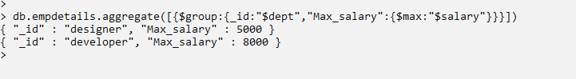

- find the no.of employees of each dept.

- sort the collection empDetails in descending order of name

- Create a text index for ‘name’ and search for names mohan and bhuvan
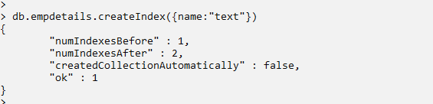

- create a database Inventory and create an orders collection. Apply MapReduce operation for finding the total purchase of each customer.

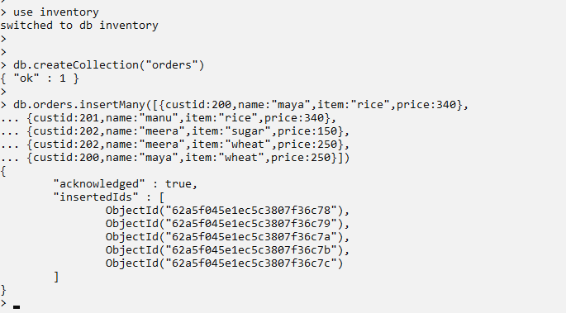

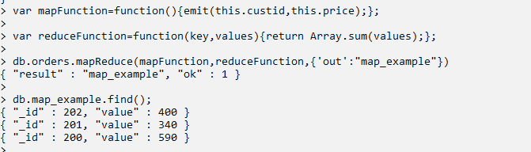

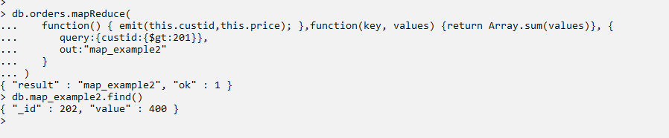

Example Queries
>db.emp1.aggregate([{$group:{_id:"$dept","avg sal":{$avg:"$sal"}}}])
> db.emp1.aggregate([{$group:{_id:"$dept","minimum sal":{$min:"$sal"}}}])
> db.emp1.aggregate([{$group:{_id:"$dept","maximum sal":{$max:"$sal"}}}])
> db.emp1.aggregate([{$group:{_id:"$dept","no of emp":{$sum:1}}}])

> db.bookdata.find().sort({"Author":1})
> db.bookdata.find().sort({"Author":-1})

> db.bookdata.createIndex({Title:"text"})
> db.bookdata.find({$text:{$search:"DBMS COA"}})

