1.Create a database named Employee. Create a collection named empDetails
You can use any of the fields Name, Age ,e_mail, phone,salary

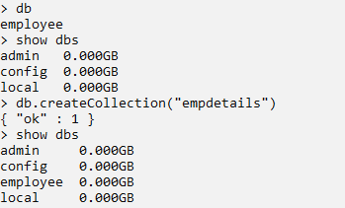

- Insert 5 documents in it using the different insert() methods and
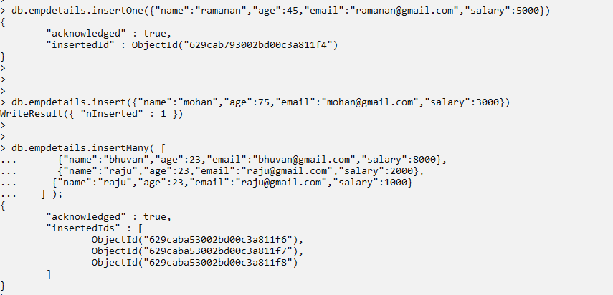

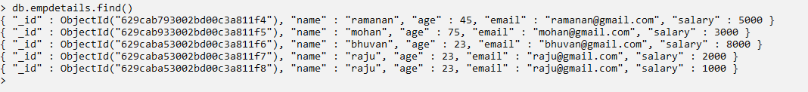
- Find the details of employee whose name is mohan

- Fetch the documents of employees whose salary >=5000

- Find the documents of employees whose name starts with letter r

- Find the documents of employees whose name is not in mohan , raju, bhuvan

- Find the documents of employees whose names are mohan , raju, bhuvan

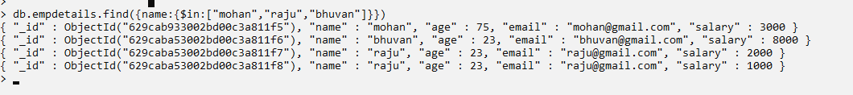

- Retrieve the details of employees whose age is less than 30. Display only the fields name, salary

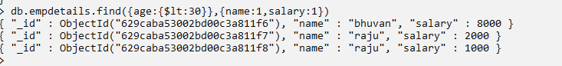

- Find the details of employees whose salary is >5000 and age is < 30

- Update the e-mail of employee whose name is mohan // findOneAndUpdate()

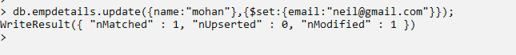

- Delete all the documents of employees whose age>56

