Introduction

Ornamental turning is a process of cutting complex patterns on materials such as wood, metals and plastics.
One method of doing this is called Rose Engine Turning which uses a special lathe upon which a rotating pattern called a rosette is used to rock the lathe headstock from side to side as it rotates. By this means the tool can be made to cut a non circular pattern on the work piece held on the headstock spindle even though this work piece is itself moving in a circular path around the spindle centre. The rocking motion will move the position of the centre of the headstock relative to the tool so that the tool cuts at different radial values as the work rotates.
Another method is to attach a complex device called a Geometrical chuck to the spindle of a standard lathe. The geometric chuck is made so that its centre of rotation moves as the spindle rotates. This again causes a non circular path to be cut by a tool in a fixed position.

When simulating this motion on a CNC based system we want to generate the path the cutter would trace on the work piece as a sequence of points. From this sequence of points we can then generate the G code instructions to control our CNC system.

The OTWB program has several options for generating paths displayed on the opening page. Choosing an option will send you to a page dedicated to that option.

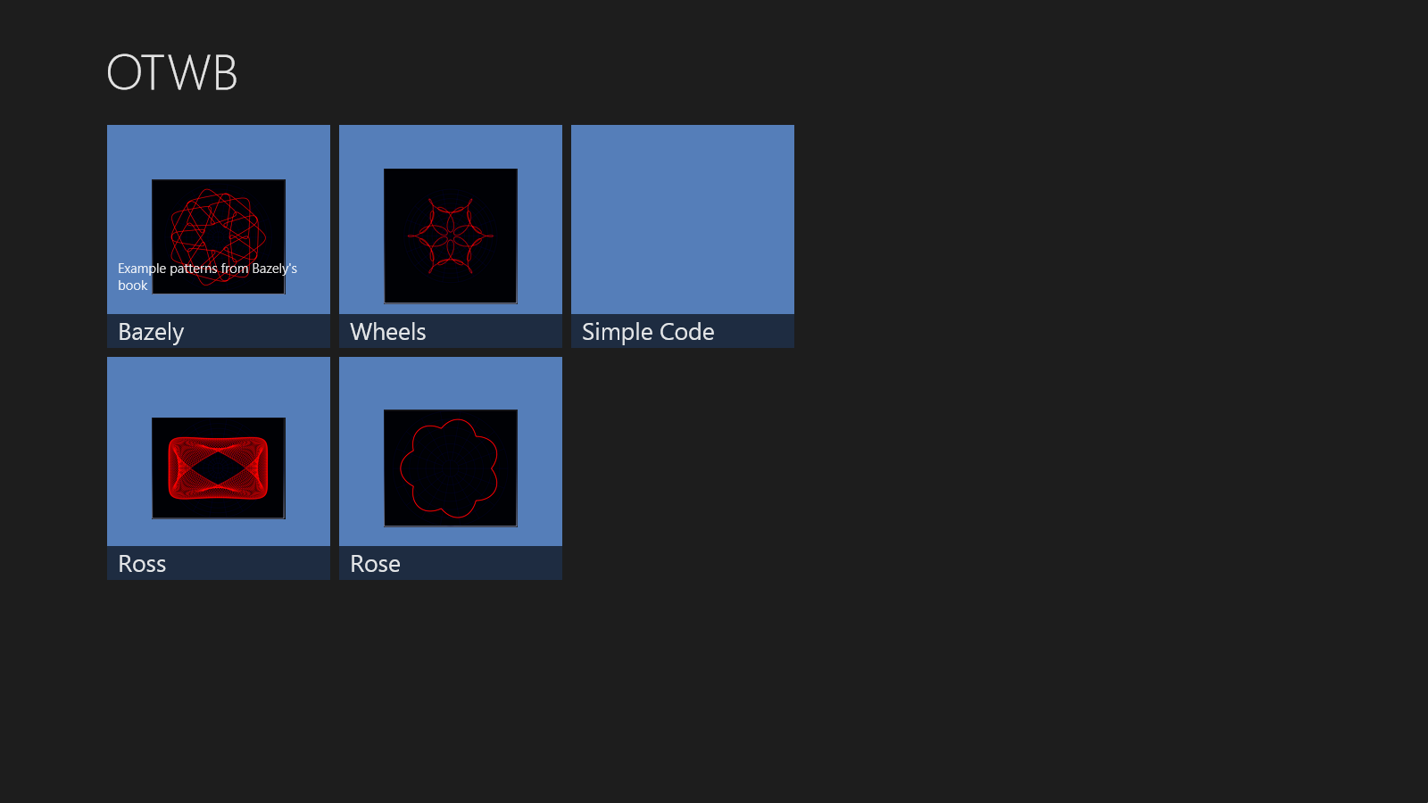

Currently there are four options for generating paths
- Geometric Chuck patterns following Thomas Bazeley
- Patterns developed by Ross
- Patterns developed by following the Wheels in Wheels approach
- Patterns developed by utilising virtual rosettes on a Rose Engine
The final option takes you to the G code generation page.

