A real-time Right Ascension (RA) compensation calculator.

A user guide for version 1.0 of the compensation calculator software.

Given a target RA and telescope calibration date, this code displays the compensated
RA value for a telescope with a fixed RA-aligned axis. The calculator runs on a Raspberry Pi Pico and MicroPython, aided with buttons, a dot-matrix LED displays, real-time clock and memory-based I2C hardware modules. A simple reference design is accompanied by a prototype breadboard assembly, shown below.

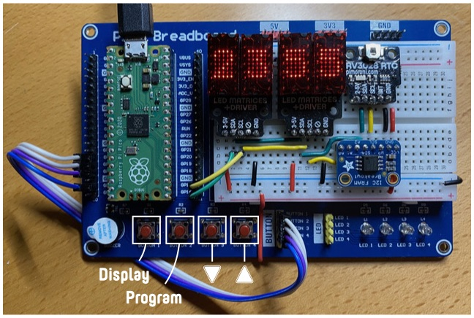

The control buttons
There are 4 control buttons whose functions are: -

- DISPLAY
- PROGRAM
- DOWN
- UP

The display
The display, using two red-LED dot-matrix displays, momentarily shows a number of items. After 4 seconds the display is extinguished. This helps reduce power consumption but also maximise darkness.

To illuminate the display, hit the DISPLAY button. This will briefly display the compensated RA axis value.

Pressing the DISPLAY button again while the display is illuminated cycles through a number of different compensator values. The values are: -

- The compensated RA target value (Hours and Minutes)
(what to set on the telescope’s fixes RA axis)
- The desired RA target value (Hours and Minutes)
(the RA you want to see in the telescope)
- The current temperature
(degrees celsius)
- The current time
(UTC)
- The telescope calibration date (Day and Month)

Setting display brightness
While displaying a value you can adjust the display brightness by pressing the UP or DOWN buttons. There are 20 levels of brightness. The value is stored in the hardware’s FRAM module, preserving the value even when power’s been removed.

Programming
The compensated RA value is calculated using the target (desired) RA value, the telescope calibration date and the current time of day. Each of these is memorised but can be adjusted.

To adjust one of the values, select the chosen value using the DISPLAY button ands then hit the PROGRAM button.

The compensated RA value is calculated, and cannot be programmed directly.

Programming the target (desired) RA
Thee target (desired) RA is the RA of the celestial object you want to locate. The compensated RA value the calculator displays is based on this value, the elapsed time since the calibration date and the current time.

To change the target RA select t using the DISPLAY button and then hit the PROGRAM button.

Initially the target RA is displayed, flashing the value that you’re adjusting. Initially the RA “hours” value is flashing. Hit the UP and DOWN buttons to adjust the RA hour value.

Hit the PROGRAM button again to toggle between adjusting the RA hour and minute value.

When your chosen value is displayed press and hold the PROGRAM button for at least 2 seconds. When programming is complete the target RA value will be briefly displayed,

To cancel the programming mode hit the DISPLAY button.

Programming the telescope calibration date
The calibration date is the date that you set the RA axis on your telescope. Hopefully you rarely need to change this value but you can if you need to. To change the calibration date first select it in the display using the DISPLAY button and then hit the PROGRAM button.

You toggle between adjusting the calibration date (day of month) and month separately. Toggle between data and month by pressing he PROGRAM button. Adjust the individual values using the UP and DOWN buttons.

When your chosen value is displayed press and hold the PROGRAM button for at least 2 seconds. When programming is complete the new calibration date will be briefly displayed,

You cannot set the calibration date to the 29th of February.

To cancel the programming mode hit the DISPLAY button.

Programming the real-time clock
The clock on the calculator is driven by a real-time clock module with a battery-backup. The clock module is accurate but may drift over time. To adjust the clock first select it in the display using the DISPLAY button and then hit the PROGRAM button.

Adjust the clock using the UP and DOWN buttons.

When your chosen value is displayed press and hold the PROGRAM button for at least 2 seconds. When programming is complete the new clock will be briefly displayed,

To cancel the programming mode hit the DISPLAY button.

Always program the value using UTC. The clock should display a fixed universal time (UTC), and does not support daylight saving time.

