Applied Fluids Project: Pipe Flow Computational Analysis

MEMS 1071: Applied Fluid Dynamics

Lab Instructor: Dr. Sung Kwon Cho

Submitted by: Alan Browning

Abstract

This project is aimed at determining the entrance lengths (ze) for an incompressible, pipe flow at varying Reynold’s numbers. The problem was approached by using computational methods (ANSYS FLUENT) to solve various fluid properties. From these properties, an entrance length was determined. This study found that ze/D had a linear relationship to the Reynold’s number (Re). The study found the slope to be around 0.54, which is around 10% than the theoretical value. To validate the results, the study compared the velocity profiles and volumetric flow rates to known theoretical ones for Re = 50. The study found both of these metrics to be highly accurate, giving validity to the results.

Objective

The objective of this project was to computationally determine the entrance length (ze) for a viscous, laminar, cylindrical pipe. The accuracy of the analysis was also tested by comparing the mass flowrate & velocity profiles to known values from the textbook.

Theory

To fully understand the project, it is first important to cover the fundamentals of pipe flow. This project will cover two main types of flow: steady-state full developed & developing pipe flow.

***Fully Developed Laminar Pipe Flow***

Fully developed pipe flow is a region where the velocity of the flow does not change with respect to the axial direction. To begin, consider the Navier-Stokes equation for an incompressible fluid in a cylindrical pipe in the axial direction [1]:

|  |  |  |
| --- | --- | --- |
|  | (…) $$\frac{dp}{dz}=μ\frac{∂}{∂r}\left(r\frac{∂V_{z}}{∂r}\right)$$ | (1) |

The reduction from the first to the second line has to do with a few boundary conditions:

1. The flow is irrotational
2. The flow is steady state
3. Vr = 0 (from dVz/dr = 0 @ centerline & Vr = 0 at pipe boundary)
4. Gravity is negligible
5. The flow is fully developed

Because the left and right sides of equation 1 are derivatives of different variables, the only solution is that both sides are constant. Thus, we can assume that in the developed region, dp/dz is constant.

If we take the same assumptions as before and add that r runs between 0 & R, we can integrate equation 1 and create equation 2:

|  |  |  |
| --- | --- | --- |
|  | $$V_{z}=-\frac{R^{2}}{4μ}\left(\frac{∂p}{∂z}\right)\left[1-{\left(\frac{r}{R}\right)}^{2}\right]$$ | (2) |

We assume the point of maximum velocity is at the centerline (because dVz/dr = 0) & denote this value as “U”. By using the derivative of equation 2 we find:

|  |  |  |  |  |
| --- | --- | --- | --- | --- |
|  | $$U=-\frac{R^{2}}{4μ}\left(\frac{∂p}{∂z}\right)$$ | (3) |  |  |

Now we consider Vz as “u” and now we have a velocity profile for the developed region:

|  |  |  |
| --- | --- | --- |
|  | $$\frac{u}{U}=\left[1-{\left(\frac{r}{R}\right)}^{2}\right]$$ | (4) |

Further, we can calculate the volumetric flow rate using equation 2:

|  |  |  |
| --- | --- | --- |
|  | $$Q=\int{VdA}=\int_{0}^{R}{V_{z}2πrdr}$$ (…) $$Q=\frac{πR^{4}}{8μ}\left(\frac{dp}{dz}\right)$$ | (5) |

Using equations 4 & 5, we can mostly understand the fluid within the developed region. The physical meaning of these equations is that:

1. The velocity profile is parabolic. This is caused by the no-slip condition at the pipe wall. Friction prevents any fluid motion, and conservation of mass/momentum forces the profile into a parabolic shape to make up for this loss.
2. The volumetric flow rate is driven by the differential change in pressure within the pipe. This change in pressure should be constant within the developed region, and thus flow rate should be as well.

***Developing Laminar Pipe Flow***

The second region that will be covered is the developing laminar region. In this region, the axial velocity profile is a function of the axial position. This phenomenon is caused by the boundary layer flow. The boundary layer is a vertical region in which viscous and inertial forces play a significant role in the flow profile. Near the surface (boundary) of an object, flow is slowed down significantly due to the friction created by the solid. In laminar flow, the direction of the velocity remains parallel to the axial direction, but the magnitude is affected. This is the same affect that was mentioned before in the fully developed region. In that case, the boundary layers had grown so large that they merge into each other, creating a parabolic velocity profile. In the developing region, this is not the case.

Within the developing region, there is no exact solution for velocity profiles. The flow is still governed by the Navier-Stokes equations, but they involve complex partial differential equations which, at this point in time, have not yet been solved. Rather, some empirical results are used to characterize the flow in this region.

Typically, for laminar developing pipe flow, a pseudo-parabolic velocity profile emerges shown in figure 1 below:

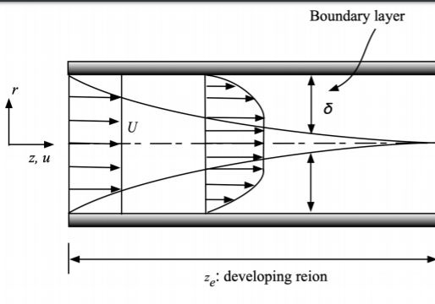

Figure 1: Developing Laminar Pipe Flow [2]

Another key concept is the entrance length, Ze. This variable is the distance between the inlet and the developed region. The entrance length is essentially the total horizontal length of the developing region. As z approaches the entrance length, it is expected that the velocity profile starts to transform from the pseudo-parabolic developing flow to the parabolic full developed flow. The entrance length has been empirically determined to be a function of the pipe diameter as well as the Reynold’s number, which is a dimensionless quantity that relates the inertial forces to viscous forces. This seems intuitively true: a wider pipe or faster flow would make it more difficult (i.e. take a longer distance) for the boundary layers to converge. An empirical formula is shown in equation 6 [1]:

|  |  |  |
| --- | --- | --- |
|  | $$\frac{Z_{e}}{D}≅0.06*{Re}_{d}=0.06*\frac{ρUD}{μ}$$ | (6) |

***Computational Fluid Dynamics***

Computational Fluid Dynamics, or CFD, is a commonly used method for solving complex fluid dynamics. The essence of CFD is based in the mesh. A mesh is a finite number of discrete elements which are used to model complex geometries. Instead of trying to solve on set Navier-Stokes equations for complex geometries, CFD attempts to solve hundreds of thousands of sets of N.S. equations for relatively simple geometries. These geometries are known as elements.

Typically, elements are some sort of simple 3D object, such as a prism or tetrahedron. When an element has boundary conditions applied, the conditions at the opposite sides of the element can now be solved for. These new conditions then become the boundary conditions for the adjacent elements, and a cascading effect is created. Using this method, we can assign important boundary conditions to some elements (such as pressure, velocity, etc.) and then the other elements properties can be solved for. Once each element is solved, the outputs (like pressure, velocity, etc.) can be average along the dimensions of the elements, so that the output looks like a continuous result, rather than a discrete one.

It is important to note that the accuracy of the simulation is heavily dependent on the creation of the mesh. When solving each individual element, it is often assumed that the variation of properties along the length of the element is either linear or quadratic. In solid mechanics, this is often not a huge issue. However, fluid dynamics often involves highly non-linear equations, and thus large elements (i.e. large amounts of assumed linearity) can lead to substantial error. Thus, smaller element sizes (and more desirable element types) can create a smaller assumed linearity, which will ultimately lead to more accurate results.

Regarding the solver, many programs use what is considered an iterative solver. This type of solver will approximate and simplify the N.S. equations around a “guess” value. However, this solution often has substantial error, so the solver must rerun the simulation, but this time the solution linearizes around a new value. This process is iterated many times until the error between the “guess” value and the actual value is small enough. This process is known as convergence. The acceptable amount of error is often specified by the user and is known as a residual. As the user specifies a smaller residual (i.e. less error), the analysis will take a longer time and require more memory.

This is a vast simplification of how CFD works. The intricacies of solving fluid equations is beyond the scope of this project. For a more in depth look at CFD, consider reviewing chapter 5 in the textbook [1], or refer to a finite element analysis textbook.

Procedure

To conduct the experiment, ANSYS workbench was used. Within workbench, a FLUENT simulation was conducted. The geometry of the pipe (cylinder with radius = 5 [cm], length = 2 [m]) was created via ANSYS design modeler.

After creating CAD, the model was imported into ANSYS’s local mesher. A body sizing of 6.35 [mm] was applied to the model to increase accuracy. To model the boundary layers, an inflation with 9 layers and 1.05 growth rate was created. Additionally, the element type was set to tetrahedrons. These inputs resulted in approximately 226,000 elements.

The first simulation required a Reynold’s number (Red) = 50. Using equation 6, it was determined that the inlet velocity should be around 0.001 [m/s]. Additionally, it was assumed that the inlet and outlet were both exposed to atmospheric pressure (e.g. 1 atm). The wall was assumed to have a perfect no-slip condition. The boundary conditions (shown below) were set to a standard initialization.

1. Zero gauge pressure & 1 [mm/s] velocity inlet
2. Zero gauge pressure outlet
3. No-slip wall
4. Steady-state analysis
5. Liquid water working fluid

The solver was also configured to be optimized for the expected results. The velocity residuals were set to an absolute value of .05 [mm/s]. This was to ensure that velocities were captured accurately, but not too fine that would slow the solver. Additionally, the solver was set to a maximum of 1000 iterations. This allowed the solver ample iterations to converge before the simulation ended.

After the simulation was complete, the results were imported into CFD-post, where various lines, planes, and streamlines were created to analyze the results.

Results

***Velocity Profiles***

The first set of results comes from the determination of the velocity profiles. At various lengths, “z”, in the tube, velocity was measured as a function of the radial distance, “r”. Figure 2, shown below, illustrates the relationship between u/U and r/D for various distances along the pipe.

Figure 2: Velocity Profiles

*Note, only half the graph was included for clarity of values. A full one can be found in the appendix as figure 17

The color coating was created in a rainbow to indicate where the measurement was taken along the Z axis of the tube (cooler = closer to inlet; warmer = farther from the inlet). The dotted line shows the theoretical solution provided by the textbook. It is important to note that the theoretical solution is only provided for the developed region; there is no exact solution for the developing region. An equation for the exact solution can be found as equation 4 in the theory section. To further demonstrate the accuracy, a plot of the velocity vs. the radial distance for the developed region is shown below.

Figure 3: Developed Velocity Profiles

*Note, a full set of tabular data can be found in the attached excel spreadsheet “data”.

***Volumetric Flow Rate***

Another way to measure the accuracy of the simulation was to find to volumetric flow rate “Q” in the developed region. The experimental value was calculated by using a circular plane. In CFD-post, the average velocity across the plane was multiplied by the area of the plane, which gives the volumetric flow rate. To calculate the theoretical value, pressure was sampled every 5 [mm] along the Z-axis. Then, a dp/dz vs. z graph was created (shown below).

Figure 4: dp/dz for Re = 50

As the flow becomes developed, dp/dz approaches a constant value of 0.012839 [Pa/m] (found by averaging dp/dz at the last 40 points). Using this value, I found the theoretical value for volumetric flow rate using equation 5**.** Table 1compares the experimental with the theoretical value:

Table 1: Volumetric Flow Rate Comparison

|  |  |  |
| --- | --- | --- |
| **Q (theoretical) [mm3/s]** | **Q (actual)**  **[mm3/s]** | **Error [%]** |
| 1964 | 1949 | 0.76% |

***Entrance Length***

The entrance length is defined as the distance down the Z-axis before the flow becomes developed. A way of calculating this distance is by finding when dp/dz becomes constant (i.e. flow is fully developed when dp/dz = constant). To do so, the developed dp/dz was calculated by average the last 40 data points along the pipe. Next, at a single data point, I took an 11 point moving average. This average value was compared to the developed dp/dz value to ± 1%. If 5 averages in a row all fell within 1%, then it could be assumed that dp/dz was constant. The z value at the first of the 5 data points was then determined to be the entrance length.

Empirically, the entrance length was given via equation 5**.** The computational results for varying Reynold’s numbers (same pipe geometry, different inlet velocities) were plotted against the theoretical equation. The results are shown in figure 5 below:

Figure 5: Entrance Length vs. Reynold’s number.

The equation of the linear trendline for the computational results is shown on figure 5 above. The slope was then compared to that of the theoretical results. These values are shown in table 2 below.

Table 2: Entrance Length Comparisons

|  |  |  |
| --- | --- | --- |
| **Slope [ ] (Expected)** | **Slope [ ] (Actual)** | **Error [%]** |
| 0.06 | 0.054 | 10.00% |

Discussion

The solution of the computational analysis seems to be quite accurate. The developing velocity profiles gradually merge into the developed one (shown through the rainbow effect), which was to be expected. As z increases, the profiles reach the parabolic theoretical value. Eventually, the fully developed velocity profile almost exactly matches the expected theoretical value (shown in both figures 2 & 3**)**.

I analyzed the developing region by using different inlet velocities to vary the Reynold’s numbers. Figure 5 showed the similarity in the trendlines, just with a slightly different slope. The difference in the slopes was around 10% error. I further tested the accuracy using flow rates. For the developed region, the flowrate had around 0.76% error (table 1).

Despite the relatively accurate results, there is still error. The main reason for this is likely the mesh quality. As mentioned in the theory section, assumed linearity can cause substantial error. This was mitigated through the low residuals, but error still exists. Additionally, nearly all meshes are slightly asymmetric. This asymmetry can cause slight variations in velocity & pressure. This can be seen in figure 4,where the dp/dz values slightly fluctuate around the average value. This is likely due to the mesh asymmetry or rounding errors.

A possible source is error for the entrance length could be reduced to the analyst. When calculating the entrance length, I had to determine when dp/dz was approximately constant. However, as mentioned above, dp/dz was never really constant due to meshing. Thus, I had to take averages of values to compare. I assumed the last 40 data points (0.2 [m] of pipe) was considered developed. However, using more or less data points could slightly change the “constant” dp/dz value, which would change the entrance length. Additionally, I looked for when the 11-point moving average was within 1% of the constant value. Changing the percentage or the number of data point in the moving average could greatly affect the entrance length.

The physical significance of these results is related to the boundary layer. The boundary layer is a region where the viscous force dominates the inertial force. Eventually, we can see that the boundary layers meet at some entrance length, which increases with Reynold’s number. At the entrance length, the flow becomes completely viscid. Thus, we can assume that nearly all developed pipe flow is substantially affected by the drag caused by the pipe wall, which causes the parabolic velocity profile. This phenomenon is expressed through the friction factor and head losses that are present in nearly all pipe flow problems.

The results of this experiment seem fairly valid. They mimic the expected trends (e.g. entrance length and velocity profiles). However, there is always a slight uncertainty within the results. As discussed before, mesh size, mesh quality, & residuals all have a large effect on the results. Because the developed flow results match the well-known theoretical values, I would argue the uncertainty is fairly low. To further add validity to this project, the experiment could be run again with differing geometries and mesh sizes to ensure the accuracy of the findings. Additionally, physical testing could be utilized to further increase fidelity.

Conclusion

Overall, this project did an effective job at quantitatively determining the relationships between Reynold’s number and entrance length. The simulations created a similar trendline with around a 10% error. The project gave a good look at how the velocity profile is affected by the axial length. The velocity profile in the developed region was near identical to the theoretical profile. To ensure the accuracy of the developing region, more simulations or physical testing may be required.

References

[1] Fox, Robert W., and John W. Mitchell. *Fox and McDonald's Introduction to Fluid Mechanics*. Wiley, 2019.

[2] Taken from Dr. Sung Kwon Cho’s Project Description

Appendix

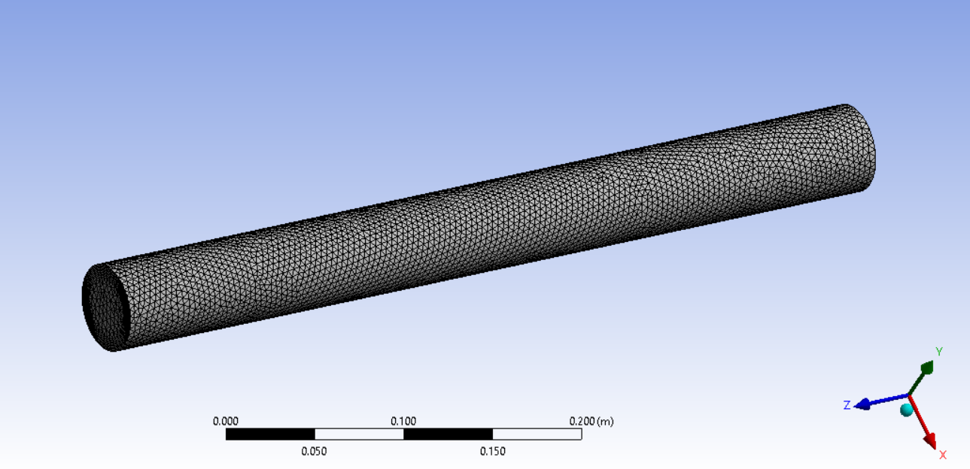

Figure 6: Mesh Generation for Re = 50

*Note, this geometry has a shorter length than the others

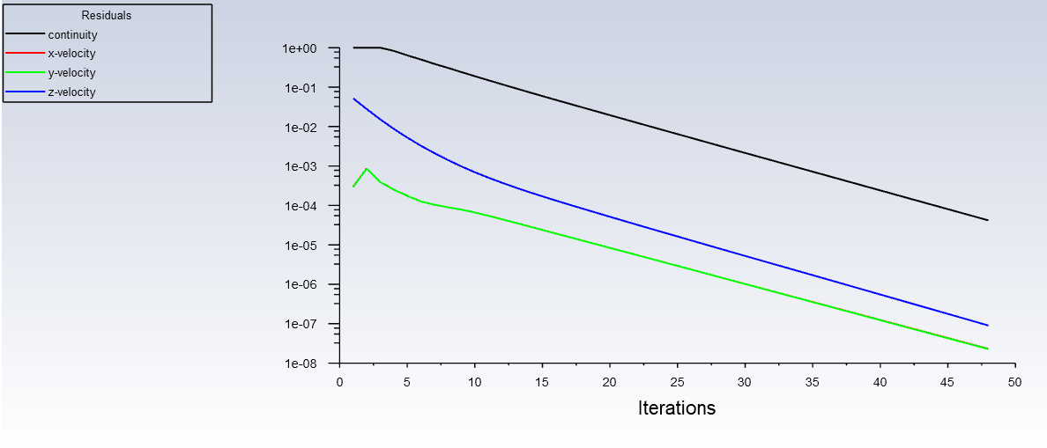

Figure 7: Convergence Plot for Re = 50

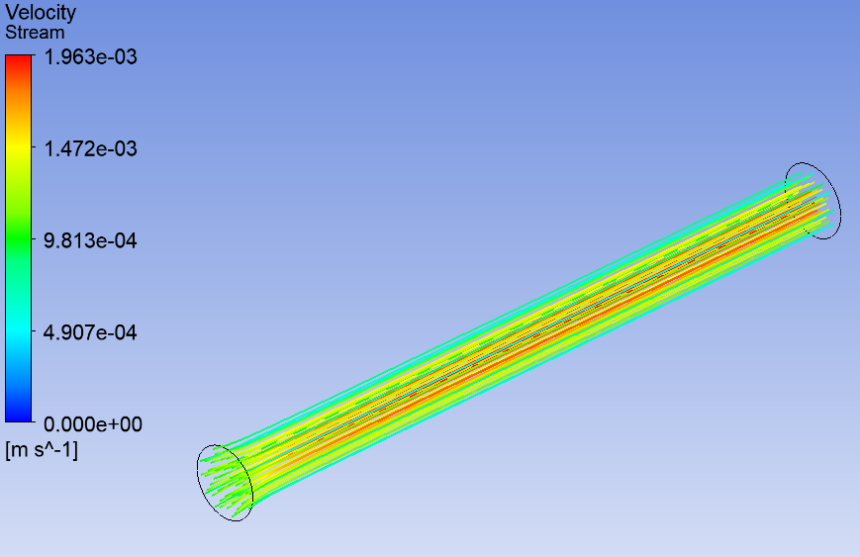

Figure 8: Streamline Contour for Re = 50

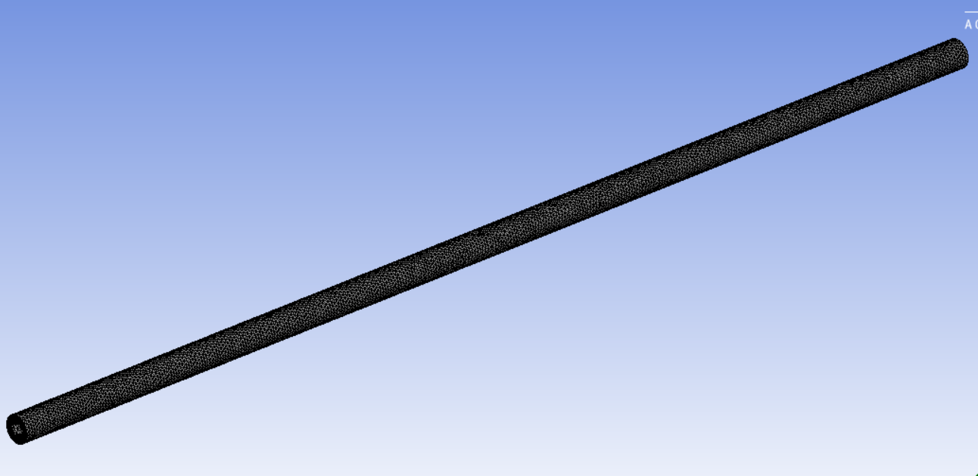

Figure 9: Overall Mesh Generation for Re = 100 - 600

**\*NOTE, the same mesh was used for all trials between Re = 100 & 600**

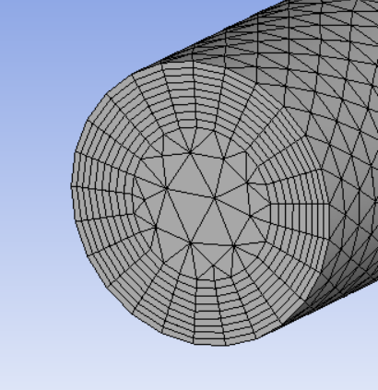

Figure 10: Wall Mesh Generation for Re = 100 – 600

**\*NOTE, the same mesh was used for all trials between Re = 100 & 600**

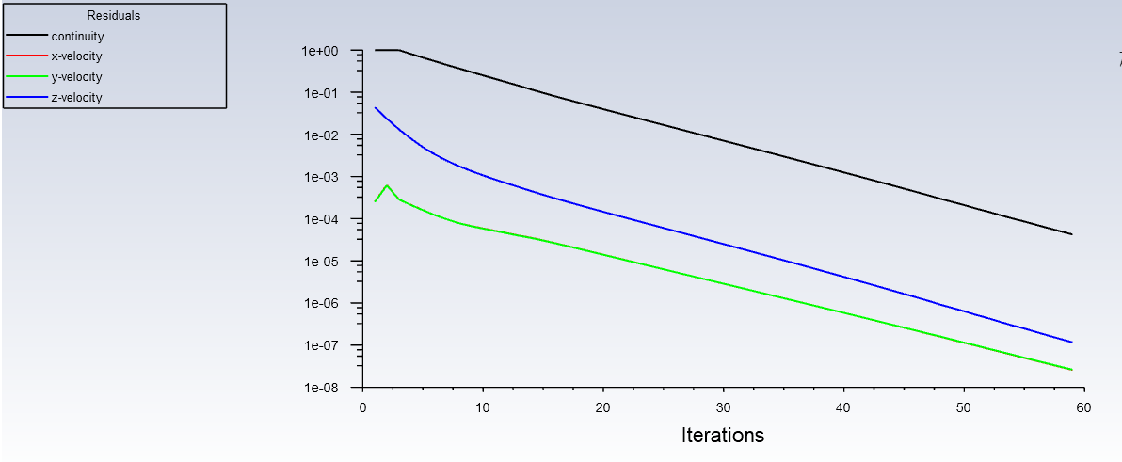

Figure 11: Convergence Plot for Re = 100

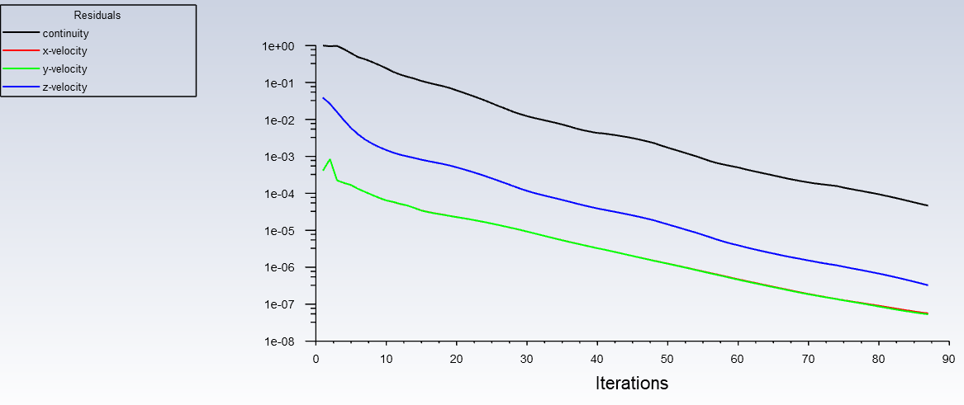

Figure 12: Convergence Plot for Re = 200

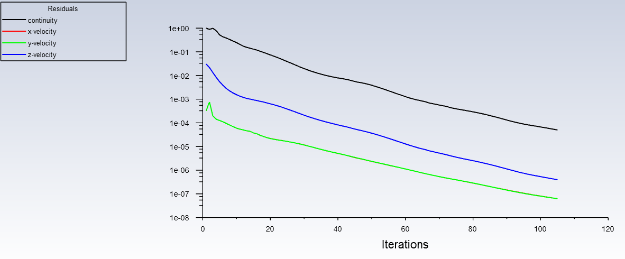

Figure 13: Convergence Plot for Re = 300

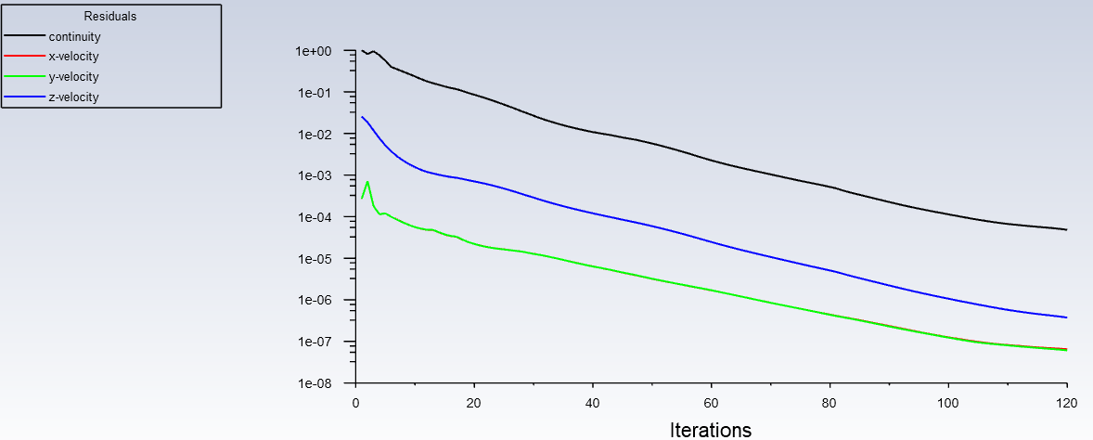

Figure 14: Convergence Plot for Re = 400

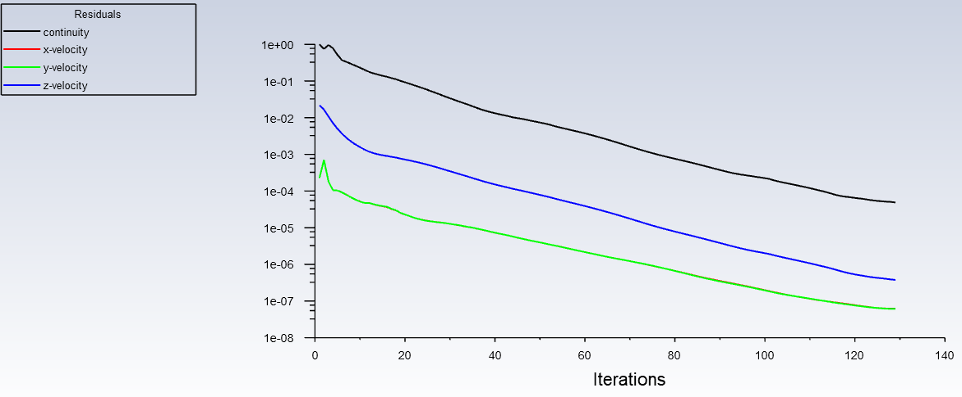

Figure 15: Convergence Plot for Re = 500

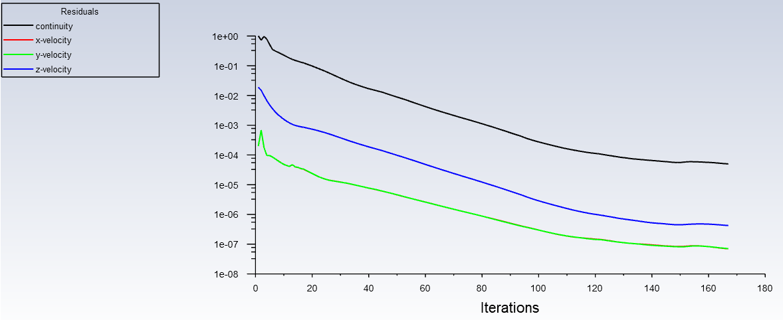

Figure 16: Convergence Plot for Re = 600

Figure 17: Full Velocity Profile for Re = 50