MEMS 1041: Mechanical Measurement I

Semester Project: iPhone 6s Screen Failure Analysis

Due Date: December 6th, 2019

Lab Instructor: Taylor Price

Course Instructor: Dr. John Whitefoot

Submitted By: Alan Browning & Josh Tarlo

# Abstract

Currently, we live in an age of digital technology. Billions of people use smartphones every day. It seems frequent that the glass screens break on the smallest impacts. Many companies offer aftermarket glass to replace these screens. We decided to investigate the reliability of these screens by creating a device to test the actual strength. In this experiment, we used Corning Gorilla Glass for an iPhone 6s. We placed the glass on 2 supports and treated the system as a simply supported beam. We attached strain gages from the glass and connected them to a Wheatstone bridge, differential amplifier, low-pass filter, and then a DAQ respectively. We then dropped balls from varying heights onto the screen, measured the voltage output, and then related these findings to the glass strain and strength. The calculated strains were compared to theoretical strains by using known forces. We found 5.25% difference in estimated strain calculations compared to experimental data. Peak stress in the glass was measured as 405.66 [MPa], which was higher than the expected 250-350 [MPa] range. Additionally, the actual breakage drop height (23 inches) was higher than the expected breakage height (~14 inches). From these results, the strength of the glass is 15.7% higher than published specs.

After the experiment, we ran an uncertainty calculation to help understand the validity of our results. We found our experiment had a 10.59% uncertainty. There were many contributing factors such as resistor, caliper, and gage factor tolerances. Beyond these known uncertainties, there were also other factors that could contribute to the accuracy of the experiment. The most important factor was the fatigue of the glass. Repeated drops may have caused fatigue within the glass, leading to compromised strength. By using more screen samples, we could drop the number of drops per screen down to one, which would ensure no fatigue and provide the most accurate results. Considering these possible inaccuracies, a 15.7% higher glass strength seems reasonable. Overall, our test specimen outperformed the expected strengths. However, it is vital that more experiments are run to create statically significant values.

Table of Contents

Abstract 1

Theory 3

Strain gage 3

Wheatstone Bridge 4

Beam Theory 5

Signal conditioning 7

Procedure 10

Drop Height 10

Forces and Strain Gage Output 12

Strain Gage Placement 13

Mounting and Wiring Strain Gages 14

Amplifying and Conditioning Signal from Strain Gages 14

Calibrating the Sensor 16

Creating Data Acquisition Program 16

Drop Test Forces 17

Uncertainty Analysis 18

Summary of Results 19

Calibration 19

Ball Drop Tests 20

Breakage Stress 22

Breakage Stress: Actual vs Expected 22

Breakage Height: Actual vs Expected 23

Discussion 24

Comparison of Strain at Estimated Breakage Height 24

Comparison Actual to Theoretical Breakage Stress 24

Recommendations 25

References 26

Appendix 27

Uncertainty Derivation 27

Calculation of Strain at Estimated Breakage Force 30

MATLAB Code 31

# 

# Theory

## Strain gage

Strain gages are made of a thin wire in a serpentine pattern that when strained, provides a very small change in electrical resistance due to the changes in length, cross sectional area, and the resistivity. The electrical resistance of a wire is given by Equation 1.

|  |  |  |
| --- | --- | --- |
|  | $$R∝ ρ_{R}LA$$ | (1) |

Where: $R≡$ Resistance

$ρ_{R}≡$ Resistivity

$h≡$ Length

$A≡$ Cross Sectional Area

By putting a voltage potential through the wire, the change in resistance can be measured. The Gage Factor is used to relate the change in resistance to the strain of the system. The relation between Gage Factor, change in resistance, and strain can be seen in Equation 2.

|  |  |  |
| --- | --- | --- |
|  | $$GF=\frac{{dR}/R}{ε}$$ | (2) |

Where: $GF≡$ Gage Factor

$\frac{dR}{R}≡$ Change in Resistance

$ε≡$ Strain

The strain is the final value that the strain gage is designed to measure, however information about the strain in a system can also be used to quantify the force applied to a material. In order to do this, the strain can be used with the Elastic Modulus of the material to determine the corresponding stress that is being applied to the system, shown in equation 3.

|  |  |  |
| --- | --- | --- |
|  | $$E=\frac{σ}{ε}$$ | (3) |

Where: $E≡$ Elastic Modulus

$σ≡$ Stress

$ε≡$ Strain

Applied forces and moments are directly related to the stress that an object may be subjected to. By this methodology, the strain gages can be used to determine the forces applied to a system. Such relations between stresses and moments can be seen in equation 4.

|  |  |  |
| --- | --- | --- |
|  | $$σ=\frac{Mc}{I}$$ | (4) |

Where: $σ≡$ Stress

$M≡$ Applied Moment

$c≡$ Distance to Neutral Axis

$I≡$ Second Moment of

Inertia

By knowing the change in resistance from a strain gage as well as its corresponding gage factor, the strain of an object can be known, as seen in equation 2. The stress can then be derived using equation 3 with the known strain and the elastic modulus of the material. Finally, using equation 4 will relate the stress to the moment applied to the object. Both c and I are properties of the geometry of the object, hence the moment and corresponding force can be derived. [4]

## Wheatstone Bridge

A Wheatstone bridge is used to measure the change in resistance in a strain gage by using voltage as the medium. When there is no strain applied to the strain gage, the output voltage of the Wheatstone bridge will be 0, however once a strain is applied, the output voltage will slightly change. Voltage tends to be easier to measure than resistance, which is why this circuit is used. An example Wheatstone bridge can be seen in figure 1.

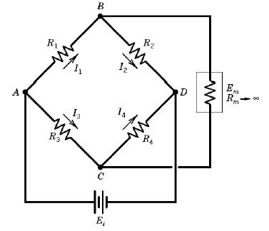

*Figure 1: Wheatstone bridge. (Originally from MEMS 1041 Strain Gage notes with permission of the MEMS Dept., University of Pittsburgh)*

The equation for the voltage output of a Wheatstone Bridge is shown in equation 5. As seen in this equation, depending on what branches the strain gages are connected to, the total strain can either be subtracted or added within the equation. This not only provides the ability to combine strain values to get better measurement accuracy, but also can subtract strain values to compensate for unintended loading, such a bending, tension, temperature, etc.

|  |  |
| --- | --- |
| $$\frac{ΔE_{o}}{E_{i}}=\frac{1}{4}GF\left[ε_{1}-ε_{2}-ε_{3}+ε_{4}\right]$$ | (5) |

There is also a Bridge Constant, usually denoted as κ, which is defined as the ratio of the bridge voltage output compared to the output of a quarter-bridge if it were to be measuring the same strains. This provides an easy and quick way of comparing output voltages of quarter-bridge, half-bridge, and full-bridge circuits. [4]

## Beam Theory

In this experiment, we are placing a glass screen between two supports. This glass can then be idealized as a simply supported beam with one end pinned and the other end free to translate. A drawing of this can be seen below in Figure 2.

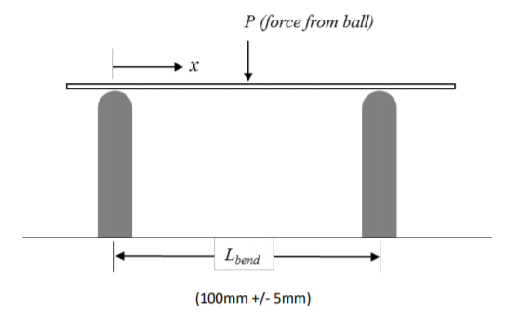

*Figure 2: iPhone Screen as a Beam. (Originally from MEMS 1041 Detailed Gage Placement Design Strategy notes with permission of the MEMS Dept., University of Pittsburgh)*

Because the phone screen can be idealized as a beam, equations describing beams can be used in this analysis. Maximum stress occurs at the top and bottom face of the screen. Modifying equation 4 yields:

|  |  |  |
| --- | --- | --- |
|  | $$σ=\frac{M*h}{2*I}$$ | (6) |

Where: $σ≡$ Stress

$M≡$ Bending Moment

$h≡$ Beam Height

$I≡$ Second Moment of Area

Also, with a force applied to the center of the beam, the max deflection of the beam will occur in the middle, which can be calculated using equation 7.

|  |  |  |
| --- | --- | --- |
|  | $$δ=\frac{P*{L_{bend}}^{3}}{48*E*I}$$ | (7) |

Where: $δ≡$ Vertical Displacement

$P≡$ Applied Force

$L_{bend}≡$ Distance between supports

$E≡$ Young’s Modulus

$I≡$ Second Moment of Area

A beam in bending can also be idealized as a linear spring. This is because as a force is applied to it, the beam will bend elastically. The energy of the force, or in this experiment the kinetic energy of the falling mass, will be stored in the spring of the beam. The stiffness of a beam in the orientation shown in Figure 2 is given by k, which is defined in equation 8.

|  |  |  |
| --- | --- | --- |
|  | $$k= \frac{48*E*I}{{L_{bend}}^{3}}$$ | (8) |

Where: $L_{bend}≡$ Distance between supports

$E≡$ Young’s Modulus

$I≡$ Second Moment of Area

Consistent with a spring, the reactionary force of the beam will be in the form:

|  |  |  |
| --- | --- | --- |
|  | $$F=kδ$$ | (9) |

Where: $F≡$ Force Applied

$k≡$ Spring constant

$δ≡$ Deflection from equilibrium

And the energy stored in the beam due from bending elastically is described using equation 10.

|  |  |  |
| --- | --- | --- |
|  | $$E=\frac{1}{2}kδ^{2}$$ | (10) |

Where: $E≡$ Potential Energy

$k≡$ Spring constant

$δ≡$ Deflection from equilibrium

## Signal conditioning

For this experiment, the output of the Wheatstone bridge needs to be conditioned. By amplifying the voltage output to the full voltage range of the DAQ, the measurement precision can be increased. Also, a low pass filter may be useful since the measurement device takes individual samples of data, which allows aliasing of the data to be possible. The low pass filter can be set to have a cutoff frequency such that aliasing does not occur.

An Op-amp provides the perfect solution to this, as it both filters the input signal and amplifies the output. Op-amps can be either high pass or low pass. Low pass filters can filter out signals that rest above the cutoff frequency, while high-pass filters can filter out signals that are below the cutoff frequency. To be concise, only the active low-pass filter will be discussed. The active low-pass filter can be seen below in Figure 3.

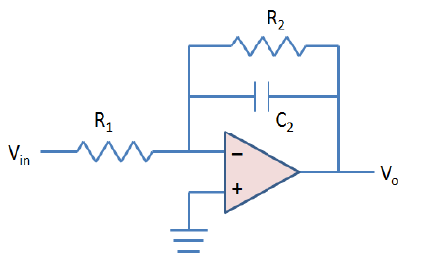

*Figure 3: Active Low-Pass Filter (Originally from MEMS 1041 Active Filters Using Op-amps notes with permission of the MEMS Dept., University of Pittsburgh)*

The magnitude ratio of the above circuit with respect to frequency can be seen in figure 4. Note that the x-axis of this graph is logarithmic, and the y-axis is in terms of the magnitude ratio, or the gain of the circuit.

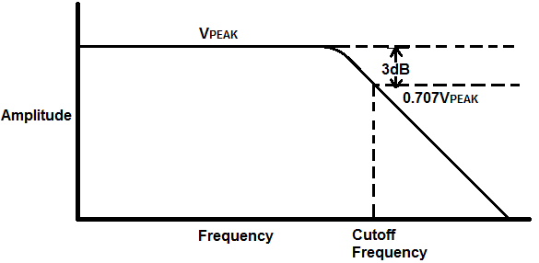

**Magnitude Ratio**

*Figure 4: Magnitude Ratio vs Frequency Graph* [1]

For all filters, the cutoff frequency lies at the -3dB point related to the peak magnitude ratio of the circuit. The filter also has a roll-off slope of -20 dB per decade after the cutoff frequency is reached. The cutoff frequency is dependent on the resistor and capacitor values in the circuit. Matching the labels in Figure 3, the cutoff frequency, ωc, can be calculated using equation 11.

|  |  |  |
| --- | --- | --- |
|  | $$ω_{C}=\frac{1}{R_{2}C_{2}}$$ | (11) |

A differential amplifier can be used to amplify the signal without filtering. A diagram of a differential amplifier is seen in Figure 5.

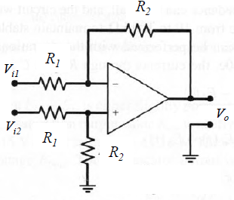

*Figure 5: Differential Amplifier (Originally from MEMS 1041 Amplifiers – Loading Errors notes with permission of the MEMS Dept., University of Pittsburgh)*

A differential amplifier has an output that is a function of the difference of the two inputs. An equation for this can be seen in equation 12.

|  |  |  |
| --- | --- | --- |
|  | $$V_{o}=G(V_{i1}-V_{i2})$$ | (12) |

Where: $V_{o}≡$ Voltage Output

$V_{i1}≡$ Voltage Input 1

$V_{i2}≡$ Voltage Input 2

$G ≡$ Gain

The gain represents the increase in voltage by the amplifier. The gain of both the differential amplifier and low pass filter is found using the two resister values in the corresponding circuits. The equation for absolute gain is found using equation 13, which once again reflects the labeling shown in Figure 3 and Figure 5.

|  |  |  |
| --- | --- | --- |
|  | $$Gain=\frac{R_{2}}{R_{1}}$$ | (13) |

To plot this on a Magnitude Ratio vs Frequency graph, such in Figure 4, the gain needs to be converted into decibels. Equation 14 is used to do this.

|  |  |  |
| --- | --- | --- |
|  | $$Decibel \left[dB\right]=20\log_{10}{\frac{V_{o}}{V_{i}}}$$ | (14) |

# Procedure

## Drop Height

To understand our results, we must first look at the procedure behind the setup. We calculated theoretical values for yield stress & strain by idealizing the iPhone screen as a beam in bending. An idealized beam is shown in the graphic below:



*Figure 6: iPhone Screen with Drop Force*

Beams with such loading will tend to break directly beneath the applied load, “P”. An ultimate strength of the screen is given as a range of expected stress: 250-350 [MPa]. Our goal is to calculate the drop height above the center of the screen that can reach this stress. This height will help us determine a proper placement of the strain gages to accurately record our data. To begin, we should find the bending moment at the center of the beam. Also, we should calculate the second moment of area. These values will allow us to find the maximum stress the screen will experience:

|  |  |  |
| --- | --- | --- |
|  | $$M=\frac{P*x}{2}$$ | (15) |

Where: $P≡$ Applied Force

$x≡$ Distance from support

$M≡$ Bending Moment

|  |  |  |
| --- | --- | --- |
|  | $$I=\frac{b*h^{3}}{12}$$ | (16) |

Where: $I≡$ Second Moment of Area

$b≡$ Beam width

$h≡$ Beam Height

Now, we rearranged equation 6 to solve for the applied force:

|  |  |  |
| --- | --- | --- |
|  | $$P=\frac{σ*b*h^{2}}{3*x}$$ | (17) |

Equation 7 from the beam theory section relates maximum beam displacement to the applied load:

|  |  |  |
| --- | --- | --- |
|  | $$δ=\frac{P*{L_{bend}}^{3}}{48*E*I}$$ | (7) |

We can substitute equations 16 & 17 into equation 7:

|  |  |  |
| --- | --- | --- |
|  | $$δ=\frac{σ*{L_{bend}}^{3}}{12*E*x*h}$$ | (18) |

Equation 18 is very useful as it gives the vertical displacement of the beam (δ) as a function of the distance from the supports (x). This will also end up giving a maximum displacement at x = L/2.

Next, we can use an energy equation to relate the transfer of kinetic energy from the falling ball to stored “spring” energy due to the deflection of the beam. Note that we assume 70% of the kinetic energy is transferred. The other 30% is lost due to irreversibilities (e.g. friction, glass mounting, etc).

|  |  |  |
| --- | --- | --- |
|  | $$.7*m*g*z=.5*k*δ^{2}$$ | (19) |

Where: $m≡$ Mass of ball

$z≡$ Drop height

$k≡$ Equivalent stiffness

$δ≡$ Vertical beam displacement

In equation 8 from the beam theory section, the equivalent stiffness is given:

|  |  |  |
| --- | --- | --- |
|  | $$k= \frac{48*E*I}{{L_{bend}}^{3}}$$ | (8) |

By substituting equation 8 into equation 19, an equation for drop height as a function of displacement is derived.

|  |  |  |
| --- | --- | --- |
|  | $$z=\frac{240*E*I*δ^{2}}{7*m*g*{L_{bend}}^{3}}$$ | (20) |

At maximum drop height, the vertical beam deflection will also be maximized. To find this value, stress will be substituted by the maximum ultimate strength of the glass (350 MPa). Also, the horizontal distance from the supports (x) is maximized at the center of the beam (L/2). The measurements of the beam (E, I, h) are also replaced, creating equation 21.

|  |  |  |
| --- | --- | --- |
|  | $$z=\frac{5*I*σ^{2}*{L_{bend}}^{3}}{21*E*x^{2}*h^{2}*m*g}$$ | … |
|  | $$z=\frac{5*(2.825*{10}^{-12})*{(350*{10}^{6})}^{2}*{(.1)}^{3}}{21*(69.3*{10}^{9})*{\left(.05\right)}^{2}*{\left(.00081\right)}^{2}*(.2055)*(9.81)}$$ | … |
|  | $z=0.360$**[m]** | (21) |

The maximum ultimate strength of the glass was used to ensure that the drop height calculated would break the glass.

## Forces and Strain Gage Output

By using this drop height, a value for the force (P) required to cause failure can be calculated (equation 17):

$P=97.66$**[N]**

When: $σ≡$ 350 [MPa]

$b≡$ 63.79 [mm]

$h≡$ 0.81 [mm]

$x≡$ 50 [mm]

We can also relate this breakage force to a failure strain. We can use Hooke’s law and equation 17 to relate strain to force:

|  |  |  |
| --- | --- | --- |
|  | $$ε=\frac{3*P*x}{b*h^{2}*E}$$ | (22) |

An important aspect of this equation is the “x” component. This strain equation not only allows us to find the failure strain, but also any strain experienced along the entire beam. We can use this equation to determine the theoretical strain at our strain gages.

## Strain Gage Placement

One of the key design requirements was to ensure strain gages do not fail (i.e. measure a strain > 5000µε). We decided that a good placement of a gage was ¼ of the bending length (x = 25 [mm]). Using equation 22, we tested for the strain at the theoretic glass failure point to ensure the gages not exceed their rated capacity. The strain expected to see at failure is:

$ε=2525.35$ [µε]

When: $P=$ 97.66 [N]

$E=$ 69.3 [GPa]

$b=$ 63.79 [mm]

$h=$ 0.81 [mm]

$x=$ 25 [mm]

Because the maximum expected strain is less than 5000 µε, it validates that 25 mm is a valid distance to place the strain gage from the center of the glass. Another important design requirement is the ability to calibrate the strain gages. Calibration drops typically replicate around 5% of the expected maximum force (to ensure no damage to the screen). This relatively low percentage of force translates into small strains. Small strains can be problematic as gages lose accuracy below around 10 [µε]. Thus, we must ensure that our current placement (at 5% drop force) yields a strain that can be read accurately:

$ε_{calibration}=126.27$ [µε]

When: $P=97.66 x 5\%= 4.88$ [N]

$E=$ 69.3 [GPa]

$b=$ 63.79 [mm]

$h=$ 0.81 [mm]

$x=$ 25 [mm]

Lastly, we decided to use a half bridge, with one gage on the top face and one on the bottom face. This would allow us to compensate for temperature effects. It would also create a more accurate measurement compared to a quarter bridge. Below is an aerial view of the strain gage placement.

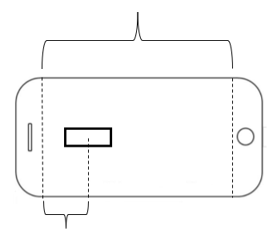

LBend = 100 [mm]

25 [mm]

*Figure 7: Aerial View of Strain Gages*

## Mounting and Wiring Strain Gages

For a strain gage to read accurately, a solid bond must be made between the gages and the glass. To do so, we first marked out the location of the strain gages (to scale) on a piece of paper. We then placed the glass directly on top of the paper such that the sketch and the glass were aligned. To clean the expected placement area, a neutralizer and degreaser was applied to the glass. Next, we placed the gage in the marked area and placed a piece of masking tape overtop of the gage. We carefully pealed the tape (with the gage attached) back and applied a catalyst to the bottom of the gage as well as an adhesive to the glass. Lastly, we slowly pressed the gage back onto the glass with the tape and held it until the bond had solidified. We then carefully removed the tape and repeated the process on the other side of the glass.

After the strain gages were successfully bonded to the glass, we had to connect wires to each gage. For each strain gage, we soldered on two wires, one for each pad. These four wires would then be integrated into our Wheatstone bridge circuit.

## Amplifying and Conditioning Signal from Strain Gages

Strain gages often output low changes in voltage and are subject to static noise. These two effects can create substantial error in data. To avoid this, we connected our strain gages to a Wheatstone bridge, differential amplifier, and active low pass filter respectively. A schematic of this layout is shown below.

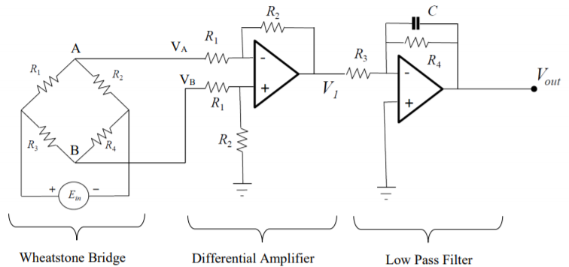

*Figure 7: Complete Circuit Diagram (Originally from MEMS 1041 Circuitry Guidelines notes with permission of the MEMS Dept., University of Pittsburgh)*

*Note, resistor values for the Wheatstone bridge are not the same as the differential amplifier or low pass filter. For the remainder of the report, Wheatstone bridge resistors will have a subscript “b”, differential amplifier resistors will have subscript “a”, and low pass filter will have subscript “f”.

With this setup, our goal was to amplify the signal by about 200x and create a cutoff frequency around 100 [Hz]. To prevent error, the gain of the amplifier and filter should be around the same magnitude. Further, resistor values for the Wheatstone bridge needed to be as similar as possible. To use Wheatstone bridge equations, it is assumed that all resistors are the same. When resistor values vary, the bridge is considered “unbalanced,” which causes error in the expected voltage output.

By measuring resistors and capacitors with the multimeter and using equations 11 and 13, we were able to predict what our cutoff frequency and gain would be. The measured values are shown below:

R1,b = RStrain gage = 120 [Ω]

R2,b = RStrain gage = 120 [Ω]

R3,b = 119.85 [Ω]

R4,b = 119.76 [Ω]

R1,a = 0.98 [kΩ]

R2,a = 21.61 [kΩ]

R3,f = 3.27 [kΩ]

R4,f = 32.49 [kΩ]

Cf = 0.047 [µF]

Using equation 11 we find:

ωc = 654.9 [rad/s] = 104.2 [Hz]

Using equation 13 we find:

Gamp = 22.05

Gfilter = 9.94

Gtotal = Gamp * Gfilter = 219.10

## Calibrating the Sensor

After creating our circuit, the next step was the calibrate the sensor. Calibration is essential as it allows you to relate the output of the sensor to a force. From this force we can find stress and strain via equations 3 and 22.

To calibrate the sensor, we had to find the static sensitivity and reference voltage. Static sensitivity is a relationship between a change in input to a change in output. For strain gages, static sensitivity is a linear relationship. The reference voltage is just the output when no loading is applied. To find both values, we applied three small loads to the screen and measured the output voltage. We could easily calculate the gravitational force created by the loads and then construct a linear relationship to the voltage output. This process would yield a linear equation in the form:

|  |  |  |
| --- | --- | --- |
|  | $$E=κP+b$$ | (23) |

Where: $E≡$ Measured Voltage [V]

$κ≡$ Static Sensitivity [V/N]

$P≡$ Applied Force [N]

$b≡$ Reference Voltage [V]

## Creating Data Acquisition Program

To collect data, we used a NI USB-6008 DAQ to convert the changes in output voltage into digital values. One end of the DAQ was attached to the two output leads from the low pass filter. The other end of the DAQ was connected to a computer, where the data was read through MATLAB.

A custom MATLAB script was created to read the DAQ output. The script had three main parameters: sampling frequency, number of samples, and voltage range. We set the sampling frequency to 10000 [Hz]. The Nyquist frequency is the highest frequency that can be accurately sampled. The Nyquist frequency is the sampling frequency divided by 2. Thus, our highest measurable frequency is 5000 [Hz]. This frequency is fairly high and was sufficient for measuring our data. For the trials, we adjusted the number of samples and voltage range appropriately for the expected output.

## Drop Test Forces

Once all the previous steps where completed, our experiment was ready to be run. We began by placing our screen underneath a hollow PVC pipe. We dropped steel balls through the pipe and recorded the output voltages. We repeated this process until the screen broke. We were able to relate the output voltages to various properties of the screen such as force, stress, and strain.

Before the actual drops, we decided to calculate expected drop forces based on heights. To do so, we can use the energy equation and beam theory to estimate these results:

From beam theory, we can treat the screen as a spring, and the resultant force to bend the screen is described by equation 9:

|  |  |  |
| --- | --- | --- |
|  | $$F=kδ$$ | (9) |

By plugging this relationship into the energy equation, we get:

|  |  |  |
| --- | --- | --- |
|  | $.7*m*g*z=.5*k*δ^{2}$ (…) | (19) |
|  | $.7*m*g*z=\frac{F^{2}}{2*k}$ (…) $F=\sqrt{1.4*k*m*g*z}$ (…) $$F=162.86\sqrt{z}$$ | (24) |

Given that “k” is a constant value (equation 8) based on geometry, we have the drop force “F” as a function of the square root of the drop height “z”. We evaluated this function at our drop heights in the table below.

*Table 1: Expected Forces*

|  |  |
| --- | --- |
| **Drop Height** | **Expected Force** |
| 13” (.330 m) | 93.55 [N] |
| 14.17” (.360 m) | 97.66 [N] * |
| 20” (.508 m) | 116.07 [N] |
| 23” (.584 m) | 124.45 [N] |

* Note similarity to expected breakage from “Forces and Strain Gage Output” Section

## Uncertainty Analysis

For the measuring of any system, there will always be some degree of uncertainty. In our case, we calculated the uncertainty of the measured voltage. We used the following equation to determine the total uncertainty:

|  |  |  |
| --- | --- | --- |
|  | $$u_{y}=\sqrt{{\left(\frac{∂y}{∂x_{1}}u_{x1}\right)}^{2}+{\left(\frac{∂y}{∂x_{2}}u_{x2}\right)}^{2}+...+{\left(\frac{∂y}{∂x_{n}}u_{xn}\right)}^{2}}$$ | (25) |

Where: $u≡$ Absolute uncertainty

$y≡$ Dependent variable

$x(1:n)≡$ Independent Variables

This equation utilizes many partial derivatives which can become difficult to evaluate. However, if the independent variable equation takes the form: y = (x1a1)(x2a2) … (xnan), then the previous equation can be simplified:

|  |  |  |
| --- | --- | --- |
|  | $$\frac{u_{y}}{y}=\sqrt{{\left(\frac{u_{x1}}{x1}a1\right)}^{2}+{\left(\frac{u_{x2}}{x2}a2\right)}^{2}+...+{\left(\frac{u_{xn}}{xn}an\right)}^{2}}$$ | (26) |

Where: $u≡$ Absolute uncertainty

$y≡$ Dependent variable

$x(1:n)≡$ Independent Variables

$a(1:n)≡$ Exponent

*Note, constants in the original equation are ignored in the uncertainty calculation. This is because it is assumed that constants provide zero uncertainty.

Equation 26 greatly simplifies the calculations involved in uncertainty analysis. An important feature of equation 26 is the expression, $\frac{u_{n}}{n}$. This is the generalized expression for percent uncertainty. We found that the total uncertainty of the system was 10.79% A full derivation of these finding can be found in the appendix.

# Summary of Results

## Calibration

The graph created from while calibrating the strain gages is shown below in Figure 8.

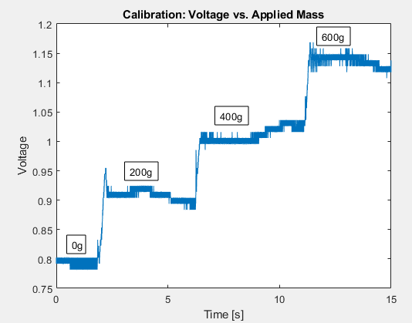

*Figure 8: Calibration using 200g, 400g, and 600g masses*

Based off this data, the following voltage values for each mass were determined using the averages from each section. This can be seen on the table below.

*Table 2: Calibration Forces and Voltages*

|  |  |  |
| --- | --- | --- |
| **Mass [g]** | **Force [N]** | **Voltage [V]** |
| 0 | 0 | 0.795 |
| 200 | 1.962 | 0.911 |
| 400 | 3.924 | 1.003 |
| 600 | 5.886 | 1.141 |

Using this data, Figure 9 was created and a corresponding trendline was added to determine the sensitivity of the system.

*Figure 9: Calibration Plot: Voltage vs. Load*

The equation of the line of best fit is equivalent to the static sensitivity of the system. In this case, the measured static sensitivity is 0.0576 [V/N] with a reference voltage of 0.793 [V].

## Ball Drop Tests

The following graphs show each of the three trials: 13”, 20”, and 23” drop heights, with the glass breaking at the 23” drop height. The graphs are in the form of Voltage vs Time and Strain vs Time. The equation used for determining the strain is found below these figures. The strain presented on these graphs is the strain appearing at the location of the strain gage.

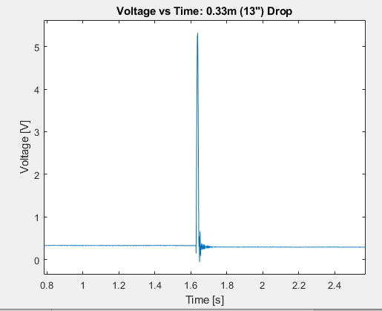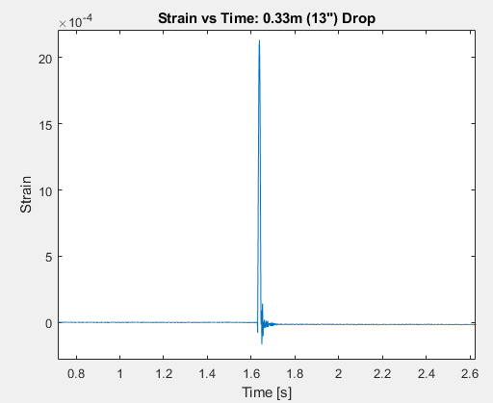

*Figure 9: Drop Test Results From 13”*

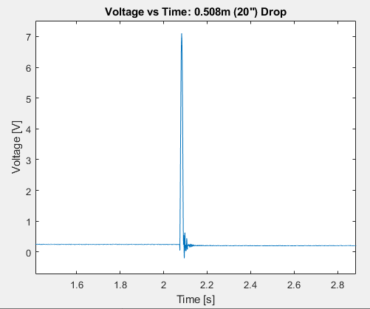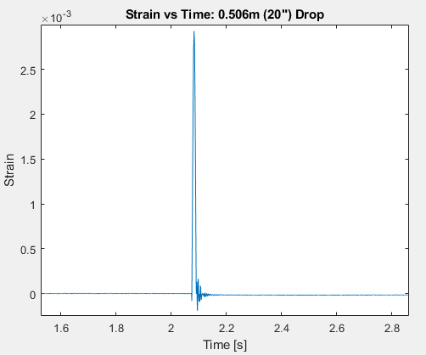

*Figure 10: Drop Test from 20”*

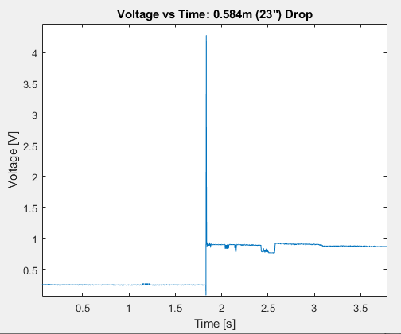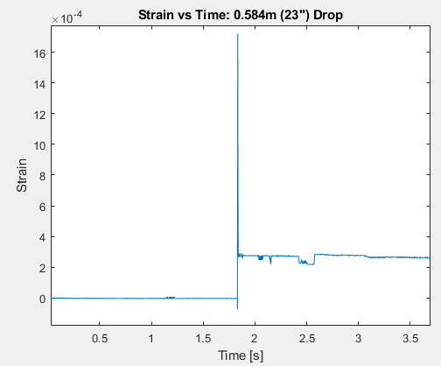

*Figure 11: Drop Test from 23” Causing Breakage*

The following table shows key information from each of the voltage graphs. It was observed that the reference voltage changed after calibration and between tests, so the values at the beginning of each trial are shown below as well as the peak voltage measured from each trial.

*Table 3: Important Voltage Characteristics for Trials*

|  |  |  |  |
| --- | --- | --- | --- |
| **Trial** | **Drop Height [m]** | **Peak Voltage [V]** | **Reference Voltage [V]** |
| 1 | 0.330 | 5.3222 | 0.3237 |
| 2 | 0.508 | 7.1038 | 0.2424 |
| 3 | 0.584 | 4.2838 | 0.2525 |

## Breakage Stress

Using equation 5 in terms of a half bridge system in the configuration used in the experiment yields equation 27.

|  |  |  |
| --- | --- | --- |
|  | $$\frac{ΔE_{o}}{E_{i}}=\frac{1}{2}GF*Gain*ε$$ | (27) |

For our setup we used a difference in electric potential of 10V for the strain gages, which is represented as the Ei value. The ΔEo is the difference between the measured voltage value at a point and the reference voltage, where the strain is 0. The total gain was of the electrical circuit was previously determined and is a value of 219.10. The gage factor was 2.14 for the strain gages that were used. Using the data collected with equation 27 provides the maximum strain of the glass at the gage for each trial, which can then be combined with equation 3 with the elastic modulus to get the maximum stress at the strain gages. The maximum stress in the glass is at the center, which experiences twice the stress of the strain gage since it is twice the distance from the supports. The calculated results of the trials are shown in the table below.

*Table 4: Maximum Stress and Strain for Trials*

|  |  |  |  |  |
| --- | --- | --- | --- | --- |
| **Trial** | **Drop Height [m]** | **Strain at Gage [µε]** | **Stress at Gage [MPa]** | **Stress at Center [MPa]** |
| 1 | 0.330 | 2132.13 | 147.76 | 295.51 |
| 2 | 0.508 | 2926.81 | 242.27 | 405.66 |
| 3 | 0.584 | 1719.59 | 119.17 | 238.33 |

The glass broke with at a maximum stress of 238.33 MPa. It is interesting to note that this is the smallest stress measured out of all three trials.

## Breakage Stress: Actual vs Expected

The expected breakage stress of the glass was 250 - 350 MPa according to the specification of the glass (350 MPa was used for calculation of expected breakage values). During the third trial when the glass broke, the measured stress was 238.33 MPa, which is lower than the expected breakage stress range of the glass. However, when looking through the other trials’ stress values, trial 2 exceeds the breakage stress of the glass, but it did not shatter. Because of this, it is possible that the glass became structurally compromised after the second trial, significantly lowering the strength of the glass. During the third trial not as much stress was needed to fully shatter the glass.

## Breakage Height: Actual vs Expected

The expected height it would take to break the glass was estimated to be 0.360 m (14.17 inches). We did not see breakage until a height of 0.584 m (23 inches) which is a considerable 0.224 m (8.81 inch) difference. Continuing with the assumption that the glass was compromised during the second trial, the drop height was still considerable larger than the expected breakage height (41.14%).

# Discussion

## Comparison of Strain at Estimated Breakage Height

The actual strain of the glass at the location of the strain gages with estimated breaking force was calculated to be 2399.45 µε using the calibration plot, and the calculations for this can be seen in the appendix. This deviates slightly from the 2525.35 µε (5.25% error) that was originally estimated in the *Procedure* Section under *Strain Gage Placement*. This difference could be caused by a variety of factors that could include a slightly smaller applied force due to losses unaccounted in the system or a slightly inaccurate static sensitivity. Also, inaccuracies and errors in the setup of the experiment could have led to differences that varied from the theory. Such errors could have been mounting the strain gages at a slight angle or in a slightly wrong location, accidentally scratching the glass, or not placing the masses perfectly at the center of the glass during calibration.

## Comparison Actual to Theoretical Breakage Stress

The theoretical breakage stress that was assumed in our calculations was 350 MPa, which is the upper range of the 250 to 350 MPa range that the manufacturer specified. The measured breakage stress that was slightly under the range with a value of 238.33 MPa. However, assuming the second trial compromised the structural integrity of the class, a more valid comparison is between the stress of the second trial and the theoretical breakage stress. The second trial yielded a much higher stress at 405.66 MPa, which is 58.66 MPa greater than the breakage stress range.

The uncertainty in these calculations are 10.79%. When looking at the stress at breakage (trial 3), the uncertainty allows the breakage stress value to be above the minimum expected breakage threshold range but is still significantly lower than the estimated 350 MPa value that was used in calculations. When the uncertainty is applied to the measured stress in trial 2, the value becomes much closer to the estimated breakage stress than in trial 3, but is slightly above the range. This further enforces the idea that trial 2 fractured the glass which allowed trial 3 to break it from a smaller stress value.

Although the system broke due to the combined effect of two separate drops, those stresses that were measured in trials 2 and 3 did revolve around the expected breakage range of 250-350 MPa. More accurate experimental results may have been gathered if the glass was only subjected to one large impact so that the breakage stress would not be affected by previous drops, which should increase the stress measured during breakage.

## Recommendations

The strain gages and circuit worked very well, and we did not experience any issues that originated from the design. However, in order to increase the accuracy of the measurements, we could increase the amplification on the circuit which would provide a better resolution when gathering data using the DAQ. Also, we could move from a half-bridge to a full bridge to further increase the accuracy of the data. During testing, a concern was the metal ball may accidentally impact the strain gage on the top of the glass. To avoid this issue, both strain gages could be mounted on the bottom of the glass so that there will never be a direct impact of the ball with either gage.

Regarding the test itself, we had a few recommendations. One issue was the locational accuracy of the ball drop. Often, it seemed like the balls fell randomly on the glass with not much precision. Having a more precise way of dropping the ball could greatly increase the accuracy of the results. One way to do this would be to extend the tube down lower. This could ensure exactly where the ball will contact the glass. Another issue with the test was the number of test specimens. Because there were a limited number of screens, multiple drop tests were used to break this glass. In some cases, the drop that broke the glass had a low stress. This could be because prior drops compromised the glass but did not break it. To create more accurate results, we could use new screens for different drop heights. This would ensure that previous drops don’t compromise the screen and skew results. Additionally, more testing would create more samples, which would help shift the sample mean to the population mean.

# References

[1] “How to Build an Active Low Pass Filter Circuit with an Op Amp.” *Learning About Electronics*, www.learningaboutelectronics.com/Articles/Active-op-amp-low-pass-filter-circuit.php.

[2] Rigol. (2012). *DM3058/DM3058E Digital Multimeter.* Retrieved from https://www.csulb.edu/sites/default/files/groups/college-of-engineering/About/rigol-dm3058-digital-multimeter-user-guide.pdf.

[3] Rigol. (2015). *DP800 Series Programmable Linear DC Power Supply.* Retrieved from https://www.sicamax.ch/downloads/dp800_userguide_en.pdf.

[4] Tarlo, Josh. *“Use of Strain Gages to Determine the Strain in Cantilever Beams”*, Oct. 2019.

# Appendix

## Uncertainty Derivation

We first consider our equation for measured voltage output. We can use equation 13 and apply it to the low pass filter. Variables in the following equations will be based off our circuit diagram shown in figure 7.

|  |  |  |
| --- | --- | --- |
|  | $$V_{out}=\frac{R_{4}}{R_{3}}V_{1}$$ | (28) |

We can then rearrange this equation to fit the required form (y = (x1a1)(x2a2) … (xnan)).

|  |  |
| --- | --- |
|  |  |

An equation for the percent uncertainty of for the low pass filter can now be created.

|  |  |  |
| --- | --- | --- |
|  | $$\frac{u_{V_{out}}}{V_{out}}=\sqrt{{\left(\frac{u_{R_{4}}}{R_{4}}*1\right)}^{2}+{\left(\frac{u_{R_{3}}}{R_{3}}*-1\right)}^{2}+{\left(\frac{u_{V_{1}}}{V_{1}}*1\right)}^{2}}$$ | (29) |

Uncertainty values for R3 and R4 are given by the manufacturer. V1 is a function of the differential amplifier. To find its uncertainty, we must consider the equation for V1.

|  |  |  |
| --- | --- | --- |
|  |  | (30) |

We can simply the equation greatly if we consider VA-VB to be a single variable. We will consider Eout = VA-VB. We can now fit our simplified form.

$$V_{1}={R_{2}}^{1}*{R_{1}}^{-1}*{E_{out}}^{1}$$

From this, we can find the percent uncertainty of the differential amplifier.

|  |  |  |
| --- | --- | --- |
|  |  | (31) |

R1 and R2 are again given by the manufacturer, but Eout is still a function of the Wheatstone bridge. We consider a modified version of equation 5 for our bridge.

|  |  |  |
| --- | --- | --- |
|  | $$E_{out}=\frac{{ΔR}_{bridge}}{4R_{bridge}}(E_{in}*κ)$$ | (32) |

Where: $R≡$ Nominal Bridge Resistance

$κ≡$ Bridge Constant

If we consider $κ$ to be a constant (i.e. have no uncertainty), then we can calculate the percent uncertainty of the bridge

|  |  |  |
| --- | --- | --- |
|  | $$\frac{u_{E_{out}}}{E_{out}}=\sqrt{{\left(\frac{u_{{ΔR}_{bridge}}}{{ΔR}_{bridge}}*1\right)}^{2}+{\left(\frac{u_{R_{bridge}}}{R_{bridge}}*-1\right)}^{2}+{\left(\frac{u_{E_{in}}}{E_{in}}*1\right)}^{2}}$$ | (33) |

Uncertainty for R and Ein are again specified by the manufacturer. An equation for ΔR is required to solve its uncertainty. We can rearrange equation 2 to accomplish this.

|  |  |  |
| --- | --- | --- |
|  | $$ΔR=GF*R*ε$$ | (34) |

Solving for the percent uncertainty of ΔR:

|  |  |  |
| --- | --- | --- |
|  | $$\frac{u_{ΔR_{bridge}}}{ΔR_{bridge}}=\sqrt{{\left(\frac{u_{GF}}{GF}*1\right)}^{2}+{\left(\frac{u_{R_{bridge}}}{R_{bridge}}*1\right)}^{2}+{\left(\frac{u_{ε}}{ε}*1\right)}^{2}}$$ | (35) |

In this case, gage factor and bridge resistance have published uncertainties by the manufacturer. Strain is another function, so we repeat the process again using our strain equation (equation 22):

|  |  |  |
| --- | --- | --- |
|  | $$ε=\frac{3*P*x}{b*h^{2}*E}$$ | (22) |

Now solving for the percent uncertainty:

|  |  |  |
| --- | --- | --- |
|  | $$\frac{u_{ε}}{ε}=\sqrt{{\left(\frac{u_{P}}{P}*1\right)}^{2}+{\left(\frac{u_{x}}{x}*1\right)}^{2}+{\left(\frac{u_{b}}{b}*-1\right)}^{2}+{\left(\frac{u_{h}}{h}*-2\right)}^{2}+{\left(\frac{u_{E}}{E}*-1\right)}^{2}}$$ | (36) |

If we assume that P and E have zero uncertainty (because P is known and E has no uncertainty provided by the manufacturer), then we can solve our total uncertainty. We will use backwards substitution from equation 36 to equation 29 to solve our total percent uncertainty, $\frac{u_{V_{out}}}{V_{out}}$.

Listed below are the necessary variables and their degrees of uncertainty.

R1 = .98 ± .0256 [kΩ]

R2 = 21.61 ± 1.032 [kΩ]

R3 = 3.27 ± .1254 [kΩ]

R4 = 32.49 ± 1.250 [kΩ]

Rbridge = 120 [Ω] ± 5%

Ein = 10 ± 0.102 [V]

GF = 2.14 ± 0.5%

x = 25 ± 0.01 [mm]

b = 63.79 ± 0.01 [mm]

h = 0.81 ± 0.01 [mm]

Note, for resistor 1-4 calculations, we measured a multimeter to calculate the actual resistances [2]. We then used the uncertainty of the multimeter to find the absolute uncertainties. For the bridge resistors, we used the nominal resistance and the published uncertainty. For the voltage source and gage factor, we used the published uncertainties [3]. For the dimensions, we used the uncertainty of the caliper.

Now, using the known uncertainties we can find the strain uncertainty from equation 36.

$$\frac{u_{ε}}{ε}=\sqrt{{\left(0\right)}^{2}+{\left(\frac{.01}{25}*1\right)}^{2}+{\left(\frac{.01}{63.79}*-1\right)}^{2}+{\left(\frac{.01}{.81}*-2\right)}^{2}+{\left(0\right)}^{2}}=.0247$$

Equation 35:

$$\frac{u_{ΔR_{bridge}}}{ΔR_{bridge}}=\sqrt{{\left(.005*1\right)}^{2}+{\left(.05*1\right)}^{2}+{\left(.0247*1\right)}^{2}}=.0560$$

Equation 33:

$$\frac{u_{E_{out}}}{E_{out}}=\sqrt{{\left(.0560*1\right)}^{2}+{\left(.05*-1\right)}^{2}+{\left(\frac{.102}{10}*1\right)}^{2}}=.0758$$

Equation 31:

$$\frac{u_{V_{1}}}{V_{1}}=\sqrt{{\left(\frac{1.032}{21.61}*1\right)}^{2}+{\left(\frac{.0256}{.98}*-1\right)}^{2}+{\left(.0758*1\right)}^{2}}=.0933$$

Equation 29:

$\frac{u_{V_{out}}}{V_{out}}=\sqrt{{\left(\frac{1.250}{32.49}*1\right)}^{2}+{\left(\frac{.1254}{3.27}*-1\right)}^{2}+{\left(.0933*1\right)}^{2}}=.1079=$**10.79%**

## Calculation of Strain at Estimated Breakage Force

To calculate the strain on the system, equation 27 must be used. This equation is rewritten below for convenience.

|  |  |  |
| --- | --- | --- |
|  | $$\frac{ΔE_{o}}{E_{i}}=\frac{1}{2}GF*Gain*ε$$ | (27) |

The gage factor, gain, and Ei values are 2.14, 219.10, and 10 V respectfully. To solve for strain, the remaining variable is ΔEo. This value can be found using the calibration plot seen in figure 9. The static sensitivity of the system was shown to be 0.0576 V/N with a reference voltage of 0.793 according to the calibration data. Because equation 27 only looks for the change in output voltage, we can ignore the reference voltage it does not influence the overall change in voltage. Because we are analyzing the strain at the estimated height of breakage, the estimated breakage force of 97.66 N can be used. Hence, ΔEo can be found as follows:

|  |  |  |
| --- | --- | --- |
|  | $$ΔE_{o}=0.0576 \left[V/N\right]*97.66 N=5.625 V$$ |  |

Using this value with equation 27 and the corresponding variable constants, the strain at the proposed drop height is be 2399.45 µε.

## MATLAB Code

%Clearing

clear;

clc;

%Setup DAQ

daq.getDevices

s=daq.createSession('ni')

[ch,idx] = s.addAnalogInputChannel('dev5','ai0','Voltage');

%Sampling Parameters

s.Rate=10000; %Sampling frequency [Hz]

s.NumberOfScans=80000; %Number of scans

%time = numberscans/rate

ch(1).Range=[-15 15] %Voltage Range [V]

%Reading Data

s.NotifyWhenDataAvailableExceeds=40;

listen=s.addlistener('DataAvailable',@(s,event) plot(event.TimeStamps,event.Data));

[d,t]=s.startForeground();

%Plotting

plot(t,d)

save %include filename

%Clearing

delete(s)

clear s