Overuse injuries in teenagers
Jane-Ann Meehan Chartered Physiotherapist
Do you have children between 9-15 years? Are they complaining of ankle/heel or knee pain?
Below is a quick guide to common overuse injuries in this age group.
Severs Disease:
- Ankle pain, in the Achilles area after running/sport.
- Sore at the start then warms up but returns once cooled down.
- Causes: Poor stretching technique, Flat feet, excessive use of spikes, excessive jumping, in-adequate warm up, growth spurts.
- Treatment: Specific Achilles& calf stretches, footwear advice, orthotics if required, lace shoes correctly, ice, rest, get out of spikes unless in competition.
Osgood Schlatters’ disease:
- Pain on the knee often with a boney lump.
- Same presentation as Severs disease. More common in boys.
- Causes: Tight Quads, not stretching, weights, growth plates, flat feet, poor footwear.
- Treatment: Rest, stretching, ice, footwear modification, avoid weight training.
- Pain localised to this area
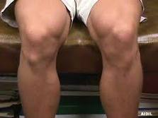
Shin splints/ Medial Tibial stress syndrome:
- Causes: Poor footwear, tight calf muscles, wearing spikes excessively, poor glut (bum) muscle control.
- Treatment: Modified rest- aqua jogging, ice, compression socks, footwear advice, foam rolling and stretching ++.
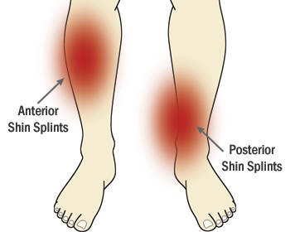
Anterior shin splints; tight calfs
Posterior Shin splints; footwear
All the above are preventable and you should visit your ‘Chartered Physiotherapist’ to resolve these ASAP.

