Hamstring tendonitis- a real pain in the butt!

Jane-Ann Meehan Chartered Physiotherapist& Athletics specialist

Athenry physiotherapy and performance clinic

091/874922

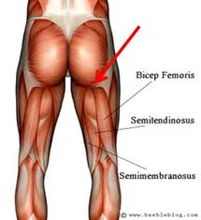

The hamstring muscle, located at the back of your thigh is responsible for propelling you forward whilst running but when injured can hinder your stride and cause bum and hamstring pain. Medically it’s known as proximal hamstring tendinopathy but to most others high hamstring/bum pain.

The hamstring is composed of three separate muscles all originating at the ischial tuberosity or that ‘boney prominence’ at your bum crease( see diagram). As the hamstring functionally does three roles with running; 1)slowing the striding leg down as it approaches the ground, 2)extending the hip and propulsion of the body forward and 3)assisting the calf muscle as it help to move the knee, it is prone to injury with incorrect training.

A risk factor for this is an unidentified level of sciatic nerve irritation, which will cause lower back dysfunction and subsequent over stretching of the muscles and nerves in the posterior thigh. Nerve irritation can weaken the hamstring and leave it exposed to the above injury.

What to do???

Back weakness, poor glut control and lack of stretching are all contributing factors to this. As runners we have a tendency to concentrate on quantity rather than quality. Most of us would benefit from fewer miles, quality sessions and some strength exercises.

Once lower back issues have been rules out, treatment of the tendon origin manually, coupled with an intensive strength programme and rest from running will get you on the road to recovery.

Sample exercises would be the simple bridge, quadriceps press, hip abductor exercises and basic squat. Technique is key in the above. Your chartered physiotherapist is specifically trained in the rehabilitation of such injuries.