Figures
Birth Weight, Parental Investment, and Child Development in Rural China (anonymous)

Contents
Figure 1. Distribution of maternal-reported birth weight and county variation in low birth weight 2
Figure 2. Birth endowments and child development 3
Figure 3. Partial residual plots of the birth weight gradient 4
Figure 4. Birth endowments and parental investment in learning 5
Figure 5. Birth weight gradients by old-age support expectations and other moderators 6
Figure 6. Robustness of the birth weight coefficient across specifications 7

Figures follow the order of citation in the manuscript. Vector versions (SVG, PDF) and 600 dpi PNG files are in the figures folder.

Figure 1. Distribution of maternal-reported birth weight and county variation in low birth weight
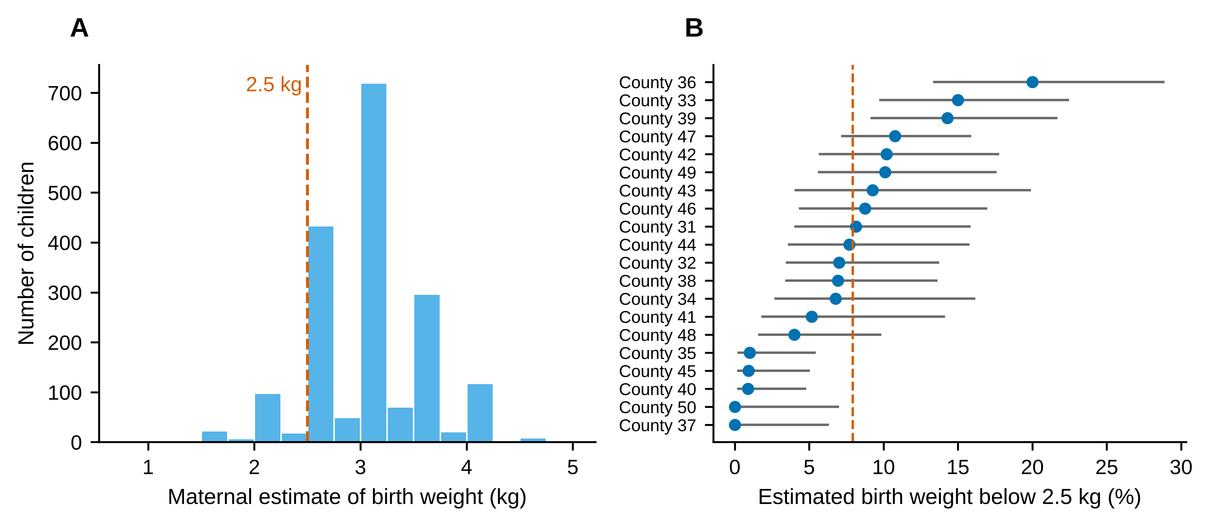
Notes. Panel A: histogram of the maternal estimate of birth weight (converted from jin); the dashed line marks 2.5 kg and heaping at 3.0 kg is visible. Panel B: share of children with an estimated weight below 2.5 kg by county (points) with 95% Wilson confidence intervals; the dashed line is the sample share. County codes are the GSCF numeric codes.

Figure 2. Birth endowments and child development
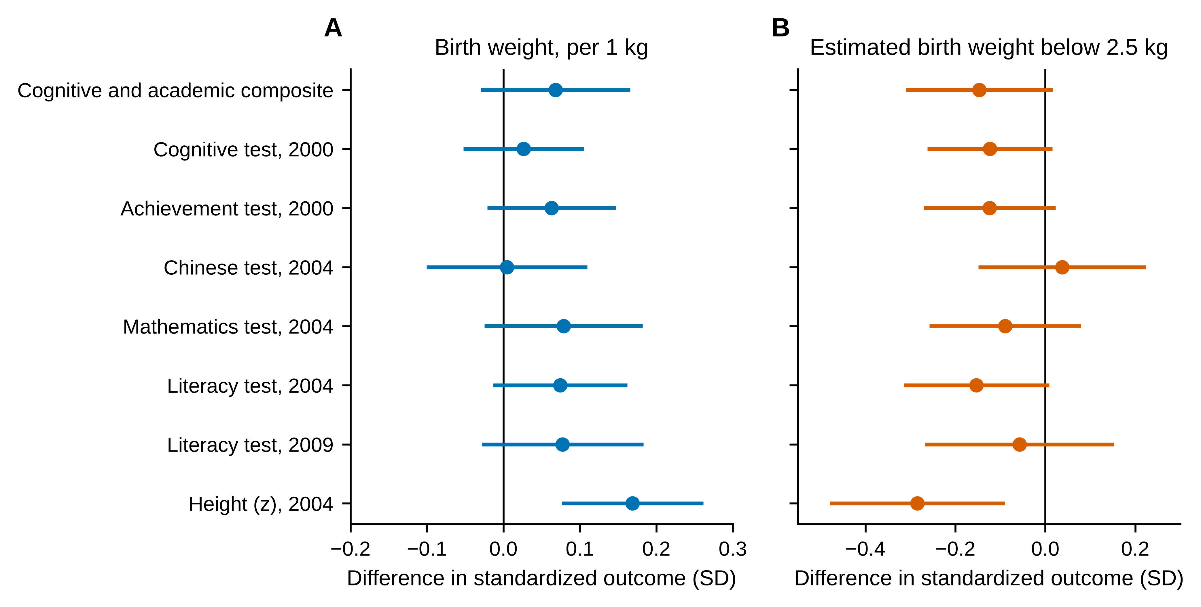
Notes. Coefficients and 95% confidence intervals from separate OLS regressions of standardized outcomes on birth weight per 1 kg (Panel A) and on an indicator for estimated weight below 2.5 kg (Panel B), with county fixed effects and baseline controls; standard errors clustered at the village level.

Figure 3. Partial residual plots of the birth weight gradient
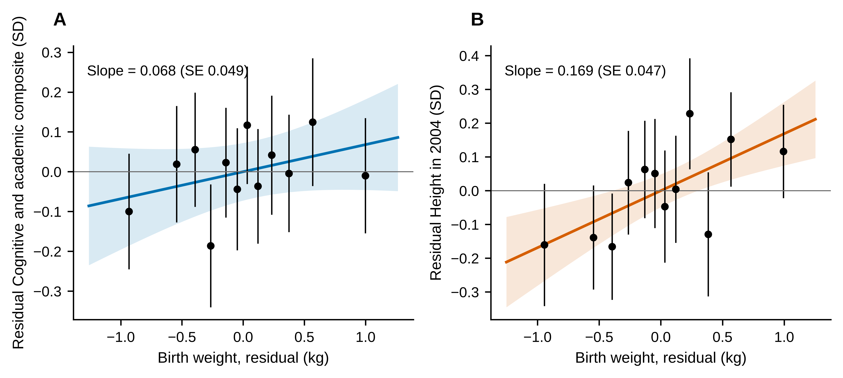
Notes. Residuals of the outcome and of birth weight after partialling out the baseline controls and county fixed effects. Points are means within twelve equal-sized bins of residual birth weight with 95% confidence intervals; the line and band are the linear fit with village-clustered 95% confidence interval.

Figure 4. Birth endowments and parental investment in learning
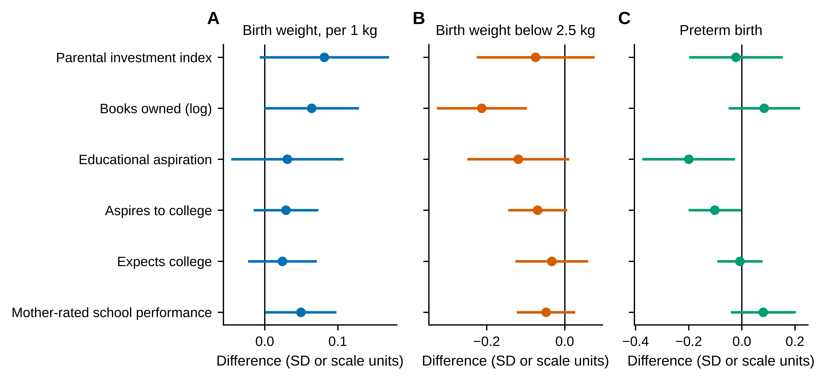
Notes. Coefficients and 95% confidence intervals from separate OLS regressions with county fixed effects and baseline controls. Investment index and books owned are standardized; aspiration and expectation items are on their original scales.

Figure 5. Birth weight gradients by old-age support expectations and other moderators
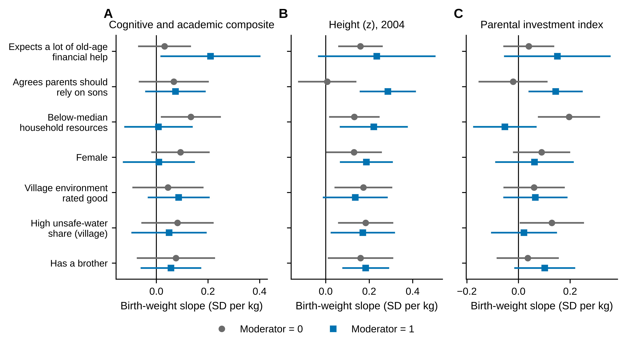
Notes. Birth weight slopes (per 1 kg) with 95% confidence intervals estimated separately for children in households with the moderator equal to 0 (grey circles) and 1 (blue squares). Interaction tests are in Table 4 and are exploratory.

Figure 6. Robustness of the birth weight coefficient across specifications
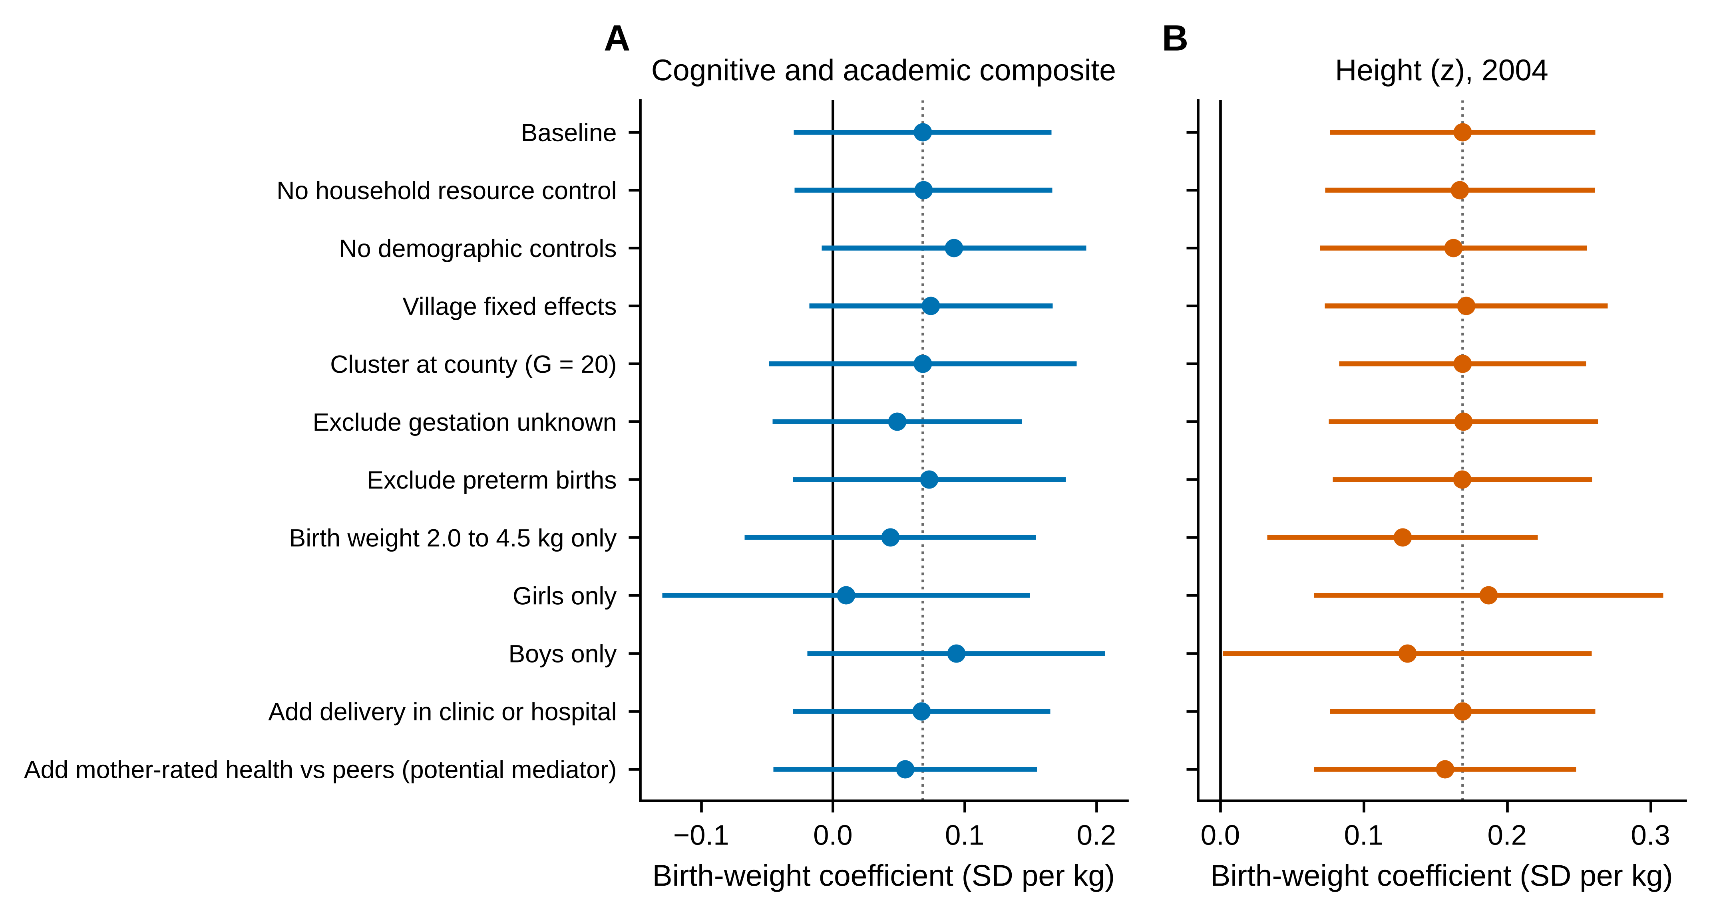
Notes. Coefficients and 95% confidence intervals for birth weight per 1 kg under the specifications listed in Table 5. The dotted line marks the baseline estimate.

