Supplementary Appendix
Birth Weight, Parental Investment, and Child Development in Rural China (anonymous)

Contents
Part 1. Supplementary tables 2
Table A1. Variable definitions 2
Table A2. Full main estimates with confidence intervals and q-values 3
Table A3. Parental investment estimates with q-values 4
Table A4. Heterogeneity: subgroup slopes and interaction tests 4
Table A5. Attrition and inverse probability weights 5
Panel A. Predictors of being observed in later waves (logit coefficients) 5
Panel B. Birth weight coefficient with and without inverse probability weights 6
Table A6. Additional health outcomes (2004) 6
Table A7. Nonlinearity: birth weight bins (reference 2.5 to 3.0 kg) 6
Table A8. Item nonresponse for birth weight 6
Part 2. Supplementary figures 7
Figure A1. Nonlinearity in the birth weight gradient 7
Figure A2. Follow-up by birth weight 7
Figure A3. Bias-adjusted coefficients (Oster bounds) 8

This appendix contains supplementary tables and figures referred to in the manuscript.

Part 1. Supplementary tables

Table A1. Variable definitions
Construct | GSCF file: variables | Definition
Birth weight (continuous) | moth2000ts: mh4 | Mother's estimate of birth weight in jin, valid range 2 to 12, multiplied by 0.5 (kg) and centered at 3.0 kg.
Estimated weight below 2.5 kg | moth2000ts: mh4 | Indicator, estimated weight below 2.5 kg.
Maternal "light" category | moth2000ts: mh3 | Indicator, mother rated birth weight as light (1 heavy, 2 average, 3 light).
Preterm birth | moth2000ts: mh2 | Indicator, mother reported preterm birth (1 term, 2 preterm, 3 post-term, 4 unknown); unknown is retained in the comparison group.
Delivery place | moth2000ts: mh5 | Clinic or hospital (village clinic, township or higher hospital) versus home or other.
Health vs village peers | moth2000ts: mh6 | Mother's rating of current child health compared with village children, reversed so that 5 is much better.
Old-age support expectation | moth2000ts: md2 | Indicator, mother expects "a lot" of financial help from children in the future (reversed three-point scale).
Reliance on sons | moth2000ts: md1h | Indicator, agrees that parents should rely on sons for care in old age.
Village environment rating | moth2000ts: mb1 | Mother's rating of the village environment for child growth; indicator for "good".
Unsafe-water share | vill2000: vd1a to vd1e | Share of village households drinking from unpumped wells, rivers, lakes, or ponds; indicator for above the village median.
Household resource index | moth2000ts: me1, me2, me3, me8a to me8c, mf1 | Mean of seven standardized items (satisfaction with economic situation, relative standing, income sufficiency, desk, dictionary, reading materials, food sufficiency); at least five required; re-standardized.
Parental investment index | moth2000ts: mk1a, mk1b, mk1d, mk1e | Mean of four standardized items (reading story books, helping with homework, playing, taking the child to a bookstore or shop); at least three required; re-standardized.
Books owned | moth2000ts: mk14 | Number of books owned by the child (values above 90 excluded), log(1 + books), standardized.
Educational aspiration / expectation | moth2000ts: mj12, mj11 | Highest level the mother hopes (expects) the child will reach, 1 primary to 4 college; indicators for college.
Child age | GSCF_merge_pid: byear00 | Age in 2000 = 2000 minus birth year; truncated to 9 to 13 and entered as single-year dummies.
Child sex | health2004t, literacy2004t: sex | Female indicator; missing for children not observed in the 2004 files (indicator included).
Parents' ages | GSCF_merge_pid: fbyear00, mbyear00 | Age in 2000.
Sibship | GSCF_merge_pid: relat00 | Counts by relationship code (first digit 2 older brother, 3 younger brother, 4 older sister, 5 younger sister, inferred from the pattern of birth years); sibship size truncated at 3, first-born, any brother.
Cognitive test, 2000 | litracy2000t: renzhi | Standardized score.
Achievement test, 2000 | achieve2000t: ceyan, a4 | Chinese or mathematics test (assigned by the parity of the household code), standardized within form.
Chinese and mathematics, 2004 | achieve2004t: yuwen, shuxue, schlevel | Standardized within school-level test form.
Literacy test, 2004 | literacy2004t: total | Total score, standardized; nine repeated household identifiers dropped.
Literacy test, 2009 | literacy2009t: items | Sum of item scores, standardized; one repeated household identifier dropped.
Height, 2004 | health2004t: height, sex, byear | Measured height (120 to 200 cm) standardized within sex by birth-year cells.
Cognitive and academic composite | constructed | Mean of the six standardized test scores, at least four required, re-standardized.
Notes. Negative GSCF codes (-1, -2, -3, -6) are set to missing. GSCF = Gansu Survey of Children and Families.

Table A2. Full main estimates with confidence intervals and q-values
Exposure | Outcome | b | SE | 95% CI | p | q | N
Birth weight, per 1 kg | Cognitive and academic composite | 0.068 | 0.050 | -0.030 to 0.166 | 0.172 | 0.230 | 1,630
Birth weight, per 1 kg | Cognitive test, 2000 | 0.027 | 0.040 | -0.052 to 0.105 | 0.509 | 0.582 | 1,863
Birth weight, per 1 kg | Achievement test, 2000 | 0.063 | 0.043 | -0.021 to 0.147 | 0.142 | 0.230 | 1,863
Birth weight, per 1 kg | Chinese test, 2004 | 0.005 | 0.054 | -0.101 to 0.110 | 0.931 | 0.931 | 1,596
Birth weight, per 1 kg | Mathematics test, 2004 | 0.079 | 0.053 | -0.025 to 0.182 | 0.136 | 0.230 | 1,596
Birth weight, per 1 kg | Literacy test, 2004 | 0.074* | 0.045 | -0.014 to 0.162 | 0.098 | 0.230 | 1,577
Birth weight, per 1 kg | Literacy test, 2009 | 0.077 | 0.054 | -0.028 to 0.183 | 0.151 | 0.230 | 1,223
Birth weight, per 1 kg | Height (z), 2004 | 0.169*** | 0.047 | 0.076 to 0.261 | 0.000 | 0.003 | 1,621
Estimated weight below 2.5 kg | Cognitive and academic composite | -0.147* | 0.083 | -0.310 to 0.016 | 0.078 | 0.156 | 1,630
Estimated weight below 2.5 kg | Cognitive test, 2000 | -0.123* | 0.071 | -0.262 to 0.016 | 0.083 | 0.156 | 1,863
Estimated weight below 2.5 kg | Achievement test, 2000 | -0.124* | 0.075 | -0.270 to 0.023 | 0.097 | 0.156 | 1,863
Estimated weight below 2.5 kg | Chinese test, 2004 | 0.038 | 0.095 | -0.149 to 0.224 | 0.693 | 0.693 | 1,596
Estimated weight below 2.5 kg | Mathematics test, 2004 | -0.089 | 0.086 | -0.257 to 0.079 | 0.299 | 0.399 | 1,596
Estimated weight below 2.5 kg | Literacy test, 2004 | -0.153* | 0.082 | -0.315 to 0.009 | 0.064 | 0.156 | 1,577
Estimated weight below 2.5 kg | Literacy test, 2009 | -0.057 | 0.107 | -0.267 to 0.152 | 0.592 | 0.676 | 1,223
Estimated weight below 2.5 kg | Height (z), 2004 | -0.285*** | 0.099 | -0.479 to -0.090 | 0.004 | 0.033 | 1,621
Maternal category "light" | Cognitive and academic composite | 0.023 | 0.075 | -0.125 to 0.170 | 0.764 | 0.816 | 1,717
Maternal category "light" | Cognitive test, 2000 | 0.028 | 0.065 | -0.099 to 0.155 | 0.668 | 0.816 | 1,962
Maternal category "light" | Achievement test, 2000 | -0.078 | 0.074 | -0.224 to 0.067 | 0.292 | 0.633 | 1,962
Maternal category "light" | Chinese test, 2004 | 0.129* | 0.069 | -0.005 to 0.264 | 0.059 | 0.253 | 1,681
Maternal category "light" | Mathematics test, 2004 | 0.078 | 0.078 | -0.075 to 0.230 | 0.316 | 0.633 | 1,681
Maternal category "light" | Literacy test, 2004 | -0.037 | 0.063 | -0.160 to 0.087 | 0.559 | 0.816 | 1,657
Maternal category "light" | Literacy test, 2009 | -0.020 | 0.086 | -0.188 to 0.148 | 0.816 | 0.816 | 1,295
Maternal category "light" | Height (z), 2004 | -0.164* | 0.088 | -0.337 to 0.009 | 0.063 | 0.253 | 1,702
Preterm birth | Cognitive and academic composite | -0.094 | 0.099 | -0.288 to 0.101 | 0.347 | 0.554 | 1,729
Preterm birth | Cognitive test, 2000 | -0.212* | 0.112 | -0.430 to 0.007 | 0.058 | 0.232 | 1,972
Preterm birth | Achievement test, 2000 | -0.014 | 0.108 | -0.227 to 0.198 | 0.896 | 0.896 | 1,972
Preterm birth | Chinese test, 2004 | -0.098 | 0.122 | -0.337 to 0.141 | 0.421 | 0.561 | 1,691
Preterm birth | Mathematics test, 2004 | -0.111 | 0.094 | -0.296 to 0.074 | 0.241 | 0.482 | 1,691
Preterm birth | Literacy test, 2004 | 0.237*** | 0.088 | 0.064 to 0.411 | 0.007 | 0.057 | 1,668
Preterm birth | Literacy test, 2009 | 0.157 | 0.115 | -0.067 to 0.382 | 0.170 | 0.453 | 1,306
Preterm birth | Height (z), 2004 | 0.033 | 0.093 | -0.150 to 0.215 | 0.726 | 0.830 | 1,711
Notes. q is the Benjamini-Hochberg q-value within exposure across eight outcomes. All models are OLS with county fixed effects and controls for age in single years, sex (with a missing indicator), parents' ages, sibship size, first-born status, presence of a brother, and the household resource index; standard errors are clustered at the village level (100 clusters). Outcomes are standardized. * p < 0.10, ** p < 0.05, *** p < 0.01.

Table A3. Parental investment estimates with q-values
Predictor | Outcome | b | SE | p | q | N
Birth weight, per 1 kg | Parental investment index | 0.081* | 0.045 | 0.071 | 0.142 | 1,864
Birth weight, per 1 kg | Books owned (log, z) | 0.064* | 0.033 | 0.051 | 0.142 | 1,689
Birth weight, per 1 kg | Educational aspiration (1 to 4) | 0.031 | 0.039 | 0.431 | 0.431 | 1,832
Birth weight, per 1 kg | Aspires to college | 0.029 | 0.023 | 0.200 | 0.300 | 1,832
Birth weight, per 1 kg | Expects college | 0.024 | 0.024 | 0.315 | 0.377 | 1,823
Birth weight, per 1 kg | Mother-rated school performance | 0.049** | 0.025 | 0.046 | 0.142 | 1,855
Estimated weight below 2.5 kg | Parental investment index | -0.075 | 0.077 | 0.331 | 0.397 | 1,864
Estimated weight below 2.5 kg | Books owned (log, z) | -0.212*** | 0.059 | 0.000 | 0.002 | 1,689
Estimated weight below 2.5 kg | Educational aspiration (1 to 4) | -0.119* | 0.066 | 0.073 | 0.147 | 1,832
Estimated weight below 2.5 kg | Aspires to college | -0.069* | 0.038 | 0.071 | 0.147 | 1,832
Estimated weight below 2.5 kg | Expects college | -0.033 | 0.048 | 0.482 | 0.482 | 1,823
Estimated weight below 2.5 kg | Mother-rated school performance | -0.048 | 0.038 | 0.207 | 0.311 | 1,855
Maternal category "light" | Parental investment index | -0.113 | 0.081 | 0.165 | 0.494 | 1,963
Maternal category "light" | Books owned (log, z) | -0.111 | 0.067 | 0.101 | 0.494 | 1,757
Maternal category "light" | Educational aspiration (1 to 4) | -0.030 | 0.059 | 0.613 | 0.736 | 1,927
Maternal category "light" | Aspires to college | -0.020 | 0.037 | 0.585 | 0.736 | 1,927
Maternal category "light" | Expects college | -0.033 | 0.032 | 0.306 | 0.612 | 1,917
Maternal category "light" | Mother-rated school performance | -0.003 | 0.041 | 0.942 | 0.942 | 1,954
Preterm birth | Parental investment index | -0.022 | 0.090 | 0.805 | 0.862 | 1,972
Preterm birth | Books owned (log, z) | 0.084 | 0.068 | 0.218 | 0.327 | 1,763
Preterm birth | Educational aspiration (1 to 4) | -0.200** | 0.089 | 0.025 | 0.133 | 1,935
Preterm birth | Aspires to college | -0.102** | 0.051 | 0.044 | 0.133 | 1,935
Preterm birth | Expects college | -0.008 | 0.043 | 0.862 | 0.862 | 1,923
Preterm birth | Mother-rated school performance | 0.081 | 0.062 | 0.196 | 0.327 | 1,964
Health vs village peers (1 to 5) | Parental investment index | 0.093*** | 0.023 | 0.000 | 0.000 | 1,979
Health vs village peers (1 to 5) | Books owned (log, z) | 0.063*** | 0.023 | 0.006 | 0.012 | 1,765
Health vs village peers (1 to 5) | Educational aspiration (1 to 4) | 0.044* | 0.025 | 0.080 | 0.080 | 1,942
Health vs village peers (1 to 5) | Aspires to college | 0.027** | 0.014 | 0.049 | 0.059 | 1,942
Health vs village peers (1 to 5) | Expects college | 0.022** | 0.010 | 0.028 | 0.041 | 1,930
Health vs village peers (1 to 5) | Mother-rated school performance | 0.054*** | 0.015 | 0.000 | 0.001 | 1,971
Notes. q is the Benjamini-Hochberg q-value within predictor across six outcomes. All models are OLS with county fixed effects and controls for age in single years, sex (with a missing indicator), parents' ages, sibship size, first-born status, presence of a brother, and the household resource index; standard errors are clustered at the village level (100 clusters). Outcomes are standardized. * p < 0.10, ** p < 0.05, *** p < 0.01.

Table A4. Heterogeneity: subgroup slopes and interaction tests
Moderator | Outcome | Slope, moderator = 0 | Slope, moderator = 1 | Interaction | p | q | N
Expects a lot of old-age financial help | Cognitive and academic composite | 0.032 (0.052) | 0.210 (0.099) | 0.210** | 0.032 | 0.228 | 1,605
Expects a lot of old-age financial help | Height (z), 2004 | 0.160 (0.052) | 0.235 (0.138) | 0.058 | 0.693 | 0.925 | 1,594
Expects a lot of old-age financial help | Parental investment index | 0.040 (0.050) | 0.151 (0.105) | 0.077 | 0.465 | 0.925 | 1,833
Expects a lot of old-age financial help | Educational aspiration (1 to 4) | 0.014 (0.042) | -0.006 (0.059) | -0.017 | 0.800 | 0.925 | 1,803
Agrees parents should rely on sons | Cognitive and academic composite | 0.068 (0.069) | 0.074 (0.060) | -0.032 | 0.681 | 0.925 | 1,623
Agrees parents should rely on sons | Height (z), 2004 | 0.007 (0.069) | 0.286 (0.066) | 0.266*** | 0.004 | 0.060 | 1,613
Agrees parents should rely on sons | Parental investment index | -0.021 (0.068) | 0.144 (0.054) | 0.170** | 0.033 | 0.228 | 1,856
Agrees parents should rely on sons | Educational aspiration (1 to 4) | 0.034 (0.052) | 0.031 (0.054) | 0.002 | 0.982 | 0.982 | 1,824
Below-median household resources | Cognitive and academic composite | 0.134 (0.059) | 0.008 (0.068) | -0.086 | 0.258 | 0.802 | 1,630
Below-median household resources | Height (z), 2004 | 0.132 (0.059) | 0.221 (0.080) | 0.063 | 0.500 | 0.925 | 1,621
Below-median household resources | Parental investment index | 0.196 (0.061) | -0.053 (0.063) | -0.237*** | 0.004 | 0.060 | 1,864
Below-median household resources | Educational aspiration (1 to 4) | 0.029 (0.057) | 0.029 (0.047) | 0.005 | 0.930 | 0.982 | 1,832
Female | Cognitive and academic composite | 0.093 (0.058) | 0.010 (0.071) | -0.108 | 0.197 | 0.690 | 1,630
Female | Height (z), 2004 | 0.130 (0.066) | 0.187 (0.062) | 0.081 | 0.307 | 0.860 | 1,621
Female | Parental investment index | 0.090 (0.057) | 0.062 (0.078) | 0.020 | 0.812 | 0.925 | 1,749
Female | Educational aspiration (1 to 4) | 0.034 (0.039) | 0.033 (0.058) | 0.015 | 0.795 | 0.925 | 1,722
Village environment rated good | Cognitive and academic composite | 0.045 (0.070) | 0.086 (0.061) | 0.060 | 0.458 | 0.925 | 1,629
Village environment rated good | Height (z), 2004 | 0.173 (0.068) | 0.136 (0.076) | -0.005 | 0.958 | 0.982 | 1,620
Village environment rated good | Parental investment index | 0.061 (0.061) | 0.066 (0.063) | -0.028 | 0.739 | 0.925 | 1,863
Village environment rated good | Educational aspiration (1 to 4) | -0.032 (0.051) | 0.093 (0.054) | 0.113* | 0.085 | 0.442 | 1,831
Village unsafe-water share above median | Cognitive and academic composite | 0.082 (0.071) | 0.049 (0.075) | -0.024 | 0.806 | 0.925 | 1,630
Village unsafe-water share above median | Height (z), 2004 | 0.184 (0.065) | 0.171 (0.075) | -0.021 | 0.826 | 0.925 | 1,621
Village unsafe-water share above median | Parental investment index | 0.129 (0.064) | 0.022 (0.065) | -0.138 | 0.120 | 0.479 | 1,864
Village unsafe-water share above median | Educational aspiration (1 to 4) | 0.038 (0.046) | 0.024 (0.064) | -0.023 | 0.769 | 0.925 | 1,832
Has a brother | Cognitive and academic composite | 0.076 (0.077) | 0.056 (0.060) | -0.028 | 0.757 | 0.925 | 1,630
Has a brother | Height (z), 2004 | 0.160 (0.077) | 0.184 (0.055) | 0.029 | 0.730 | 0.925 | 1,621
Has a brother | Parental investment index | 0.036 (0.061) | 0.102 (0.060) | 0.070 | 0.391 | 0.925 | 1,864
Has a brother | Educational aspiration (1 to 4) | -0.028 (0.052) | 0.071 (0.051) | 0.124* | 0.095 | 0.442 | 1,832
Notes. Slopes are birth weight per 1 kg estimated separately by group with baseline controls; q is the Benjamini-Hochberg q-value across the 28 interaction tests. * p < 0.10, ** p < 0.05, *** p < 0.01.

Table A5. Attrition and inverse probability weights

Panel A. Predictors of being observed in later waves (logit coefficients)
Sample | Share observed | Birth weight | p | Resource index | p | Preterm | p
Tests observed in 2004 | 0.881 | 0.237 | 0.453 | 0.230 | 0.091 | -0.755 | 0.140
Height measured in 2004 | 0.867 | 0.520 | 0.079 | -0.034 | 0.743 | 0.835 | 0.049
Literacy test observed in 2009 | 0.660 | -0.210 | 0.044 | 0.038 | 0.537 | -0.313 | 0.116
Notes. Logit models include county fixed effects and the baseline controls, village-clustered standard errors.

Panel B. Birth weight coefficient with and without inverse probability weights
Outcome | Unweighted (SE) | Weighted (SE) | p, weighted | N, weighted
Chinese test, 2004 | 0.005 (0.054) | 0.014 (0.056) | 0.803 | 1,567
Mathematics test, 2004 | 0.079 (0.053) | 0.073 (0.055) | 0.187 | 1,567
Literacy test, 2004 | 0.074 (0.045) | 0.070 (0.047) | 0.138 | 1,547
Height (z), 2004 | 0.169 (0.047) | 0.176 (0.048) | 0.000 | 1,590
Literacy test, 2009 | 0.077 (0.054) | 0.065 (0.058) | 0.256 | 1,205
Notes. Stabilized weights are the inverse of the predicted probability of observing the outcome, from a logit on baseline covariates, birth weight, preterm birth, old-age expectation, village environment rating, and investment.

Table A6. Additional health outcomes (2004)
Exposure | Outcome | b | SE | p | N
Birth weight, per 1 kg | Hemoglobin (z), 2004 | -0.038 | 0.044 | 0.394 | 1,608
Estimated weight below 2.5 kg | Hemoglobin (z), 2004 | 0.062 | 0.083 | 0.459 | 1,608
Maternal category "light" | Hemoglobin (z), 2004 | 0.055 | 0.083 | 0.511 | 1,688
Preterm birth | Hemoglobin (z), 2004 | 0.134 | 0.123 | 0.277 | 1,697
Birth weight, per 1 kg | Body mass index (z), 2004 | 0.156*** | 0.048 | 0.001 | 1,622
Estimated weight below 2.5 kg | Body mass index (z), 2004 | -0.115 | 0.086 | 0.183 | 1,622
Maternal category "light" | Body mass index (z), 2004 | -0.093 | 0.081 | 0.247 | 1,704
Preterm birth | Body mass index (z), 2004 | 0.134 | 0.163 | 0.409 | 1,713
Notes. All models are OLS with county fixed effects and controls for age in single years, sex (with a missing indicator), parents' ages, sibship size, first-born status, presence of a brother, and the household resource index; standard errors are clustered at the village level (100 clusters). Outcomes are standardized. * p < 0.10, ** p < 0.05, *** p < 0.01.

Table A7. Nonlinearity: birth weight bins (reference 2.5 to 3.0 kg)
Outcome | Birth weight (kg) | b | SE | p | N
Cognitive and academic composite | <2.5 | -0.125 | 0.084 | 0.136 | 1,630
Cognitive and academic composite | 3.0-3.5 | 0.022 | 0.059 | 0.708 | 1,630
Cognitive and academic composite | >3.5 | 0.054 | 0.075 | 0.473 | 1,630
Height (z), 2004 | <2.5 | -0.177 | 0.096 | 0.064 | 1,621
Height (z), 2004 | 3.0-3.5 | 0.151 | 0.054 | 0.005 | 1,621
Height (z), 2004 | >3.5 | 0.172 | 0.067 | 0.011 | 1,621
Parental investment index | <2.5 | -0.053 | 0.090 | 0.556 | 1,864
Parental investment index | 3.0-3.5 | -0.003 | 0.065 | 0.963 | 1,864
Parental investment index | >3.5 | 0.099 | 0.074 | 0.178 | 1,864
Notes. All models are OLS with county fixed effects and controls for age in single years, sex (with a missing indicator), parents' ages, sibship size, first-born status, presence of a brother, and the household resource index; standard errors are clustered at the village level (100 clusters). Outcomes are standardized.

Table A8. Item nonresponse for birth weight
Predictor | Logit coefficient | SE | p
Household resource index | 0.020 | 0.128 | 0.877
Father's age | 0.068 | 0.034 | 0.049
Mother's age | -0.069 | 0.043 | 0.109
Has a brother | -0.457 | 0.247 | 0.065
First-born | 0.136 | 0.178 | 0.444
Female | 0.216 | 0.214 | 0.313
Old-age support expectation high | 0.011 | 0.352 | 0.974
Notes. Outcome is a missing estimate of birth weight (6.2% of children). County fixed effects included; village-clustered standard errors.

Part 2. Supplementary figures

Figure A1. Nonlinearity in the birth weight gradient
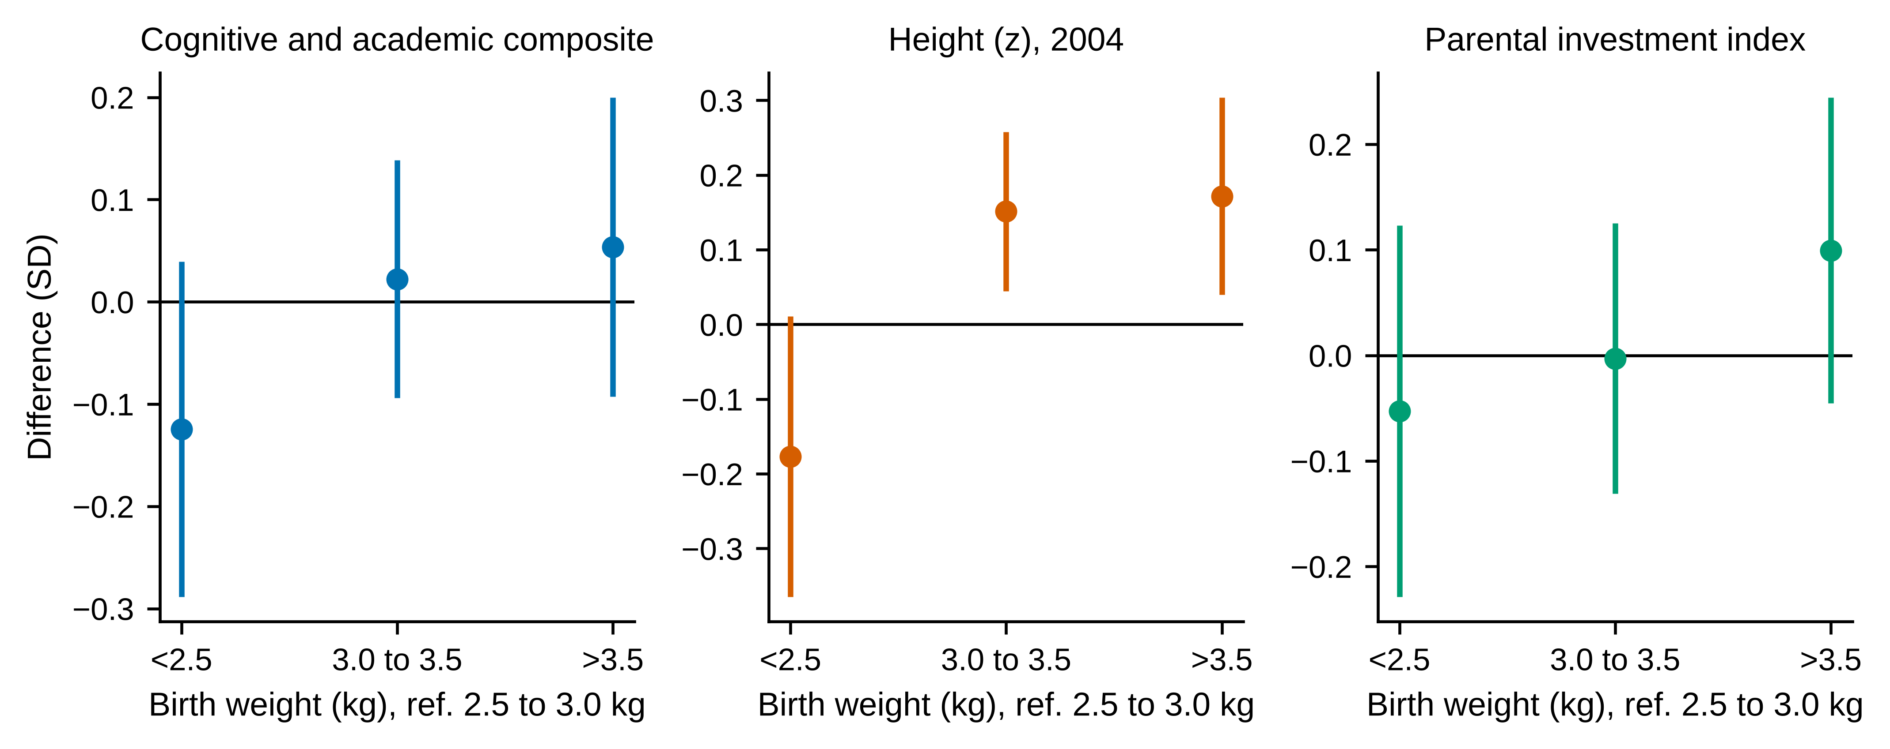
Notes. Coefficients and 95% confidence intervals for birth weight bins (reference 2.5 to 3.0 kg), baseline controls and county fixed effects, village-clustered standard errors.

Figure A2. Follow-up by birth weight
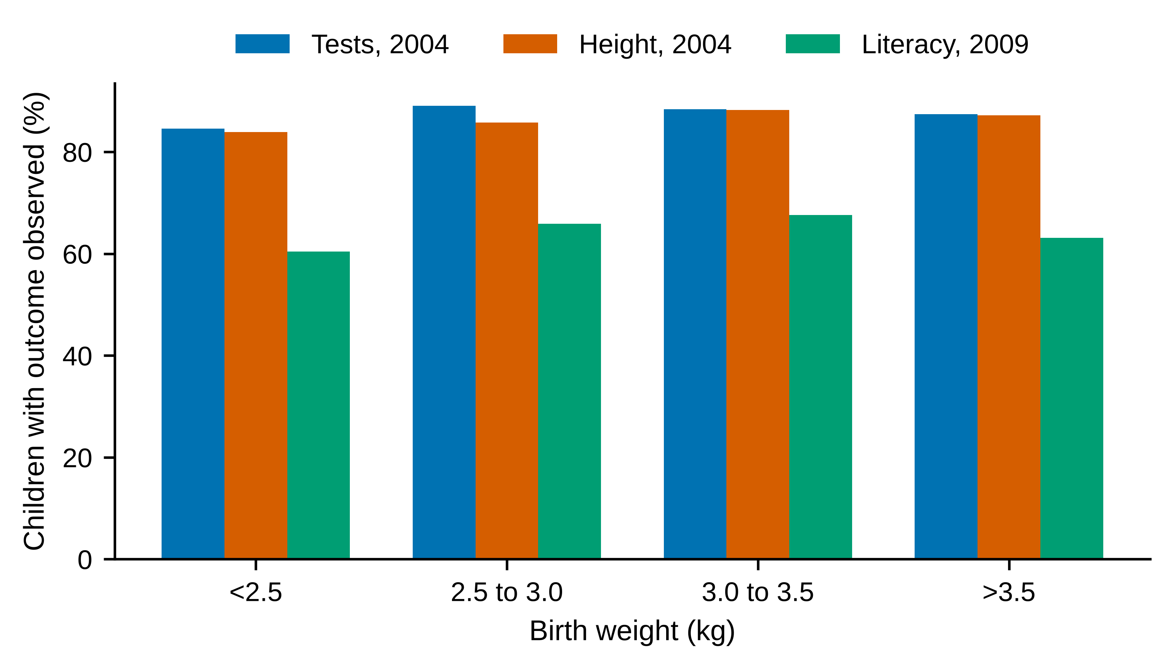
Notes. Share of children with the outcome observed, by estimated birth weight bin.

Figure A3. Bias-adjusted coefficients (Oster bounds)
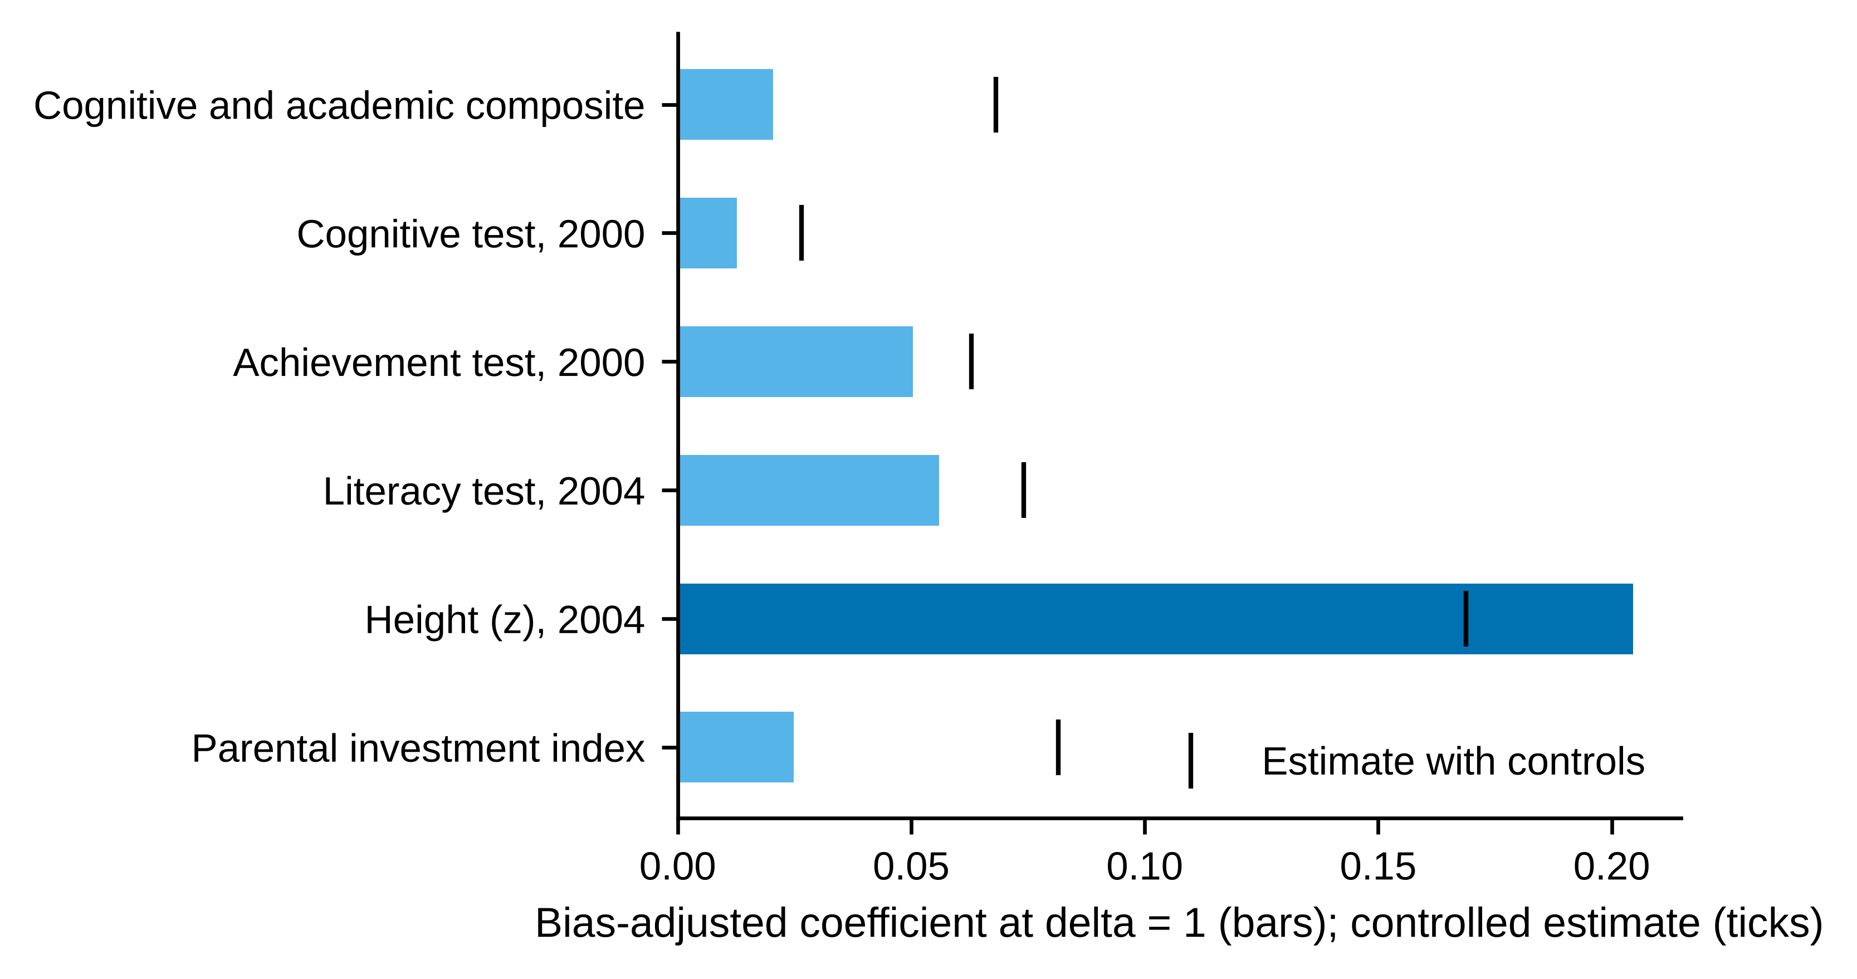
Notes. Bars: bias-adjusted coefficient assuming selection on unobservables equals selection on observables (delta = 1) and Rmax = min(1, 1.3 times the R2 of the controlled model); ticks: controlled estimate.

