Cannonball Kid Official Guide

How This Guide Works:
Hi everyone - if you are reading this, that means you are playing our game. We really appreciate you trying it out! We made this guide for Cannonball Kid because we know it’s possible to get stuck or run into situations where you just need a little help or guidance to complete a level. The goal here is to provide a spoiler-free walkthrough of the game so you can get the help you need when you need it and figure everything else out for yourself if that’s what you want. The solution to each level is listed below, the levels go in order and there is a level caption above the solution so you know you are looking at the level or levels you have questions on. There’s a table of contents right after this section so you can jump to a specific level (click the links) and avoid scrolling. Have fun!

Table Of Contents:
Note: Green highlights are city levels, yellow highlights are forest levels, orange highlights are sky levels, and red highlights are space levels. Some levels have more than one solution.

Metropolis
Mixed
Multiple Answers Accepted
Skyscrapers
Power Lines
Daisy
Relay Race

Climb The Ladder
Teeming
Wheel
Ash Cloud
Blooming
Big Positive
Lost In The Woods
Mowing The Lawn
Branches

Silver Bullet
Direct Approach
Vultures
Round & Round
Get Away From It All
Cyclone
We Have You Surrounded
Full Circle

Overpopulation
The Road Less Traveled
Every Last One
Giant Drop
Asteroid
Lights Out
Mothership

Metropolis
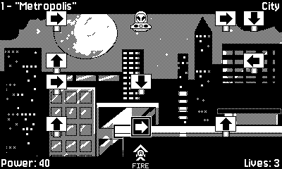

Mixed
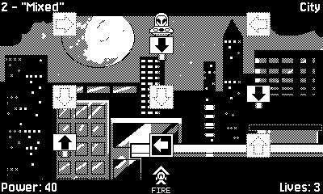

Multiple Answers Accepted
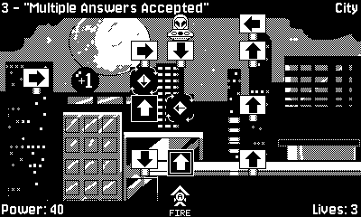

Skyscrapers
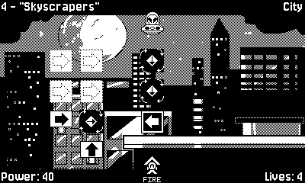

Power Lines
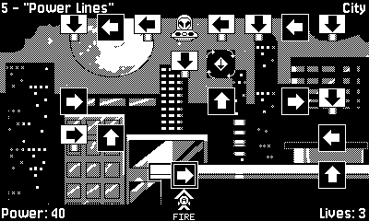

Daisy
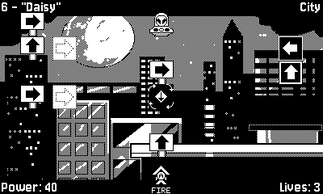

Relay Race
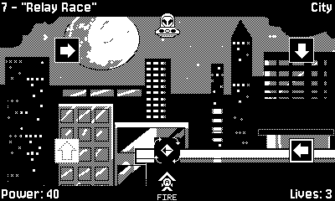

Climb The Ladder
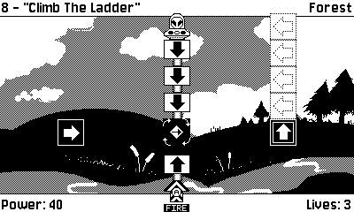

Teeming
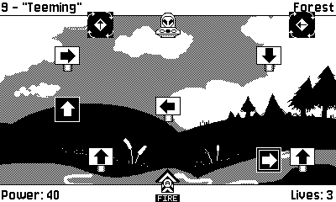

Wheel
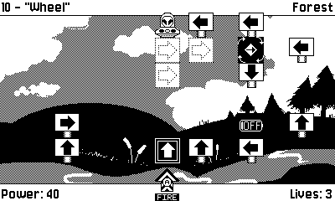

Ash Cloud
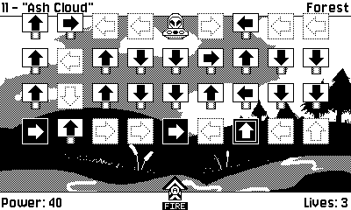
Blooming
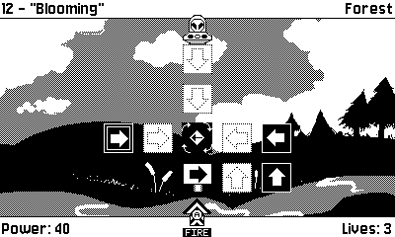

Big Positive
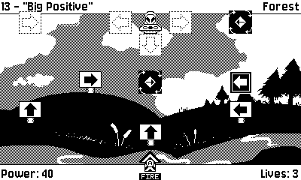

Lost In The Woods
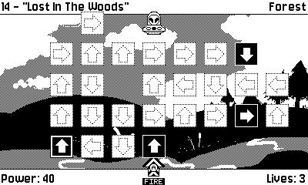

Mowing The Lawn
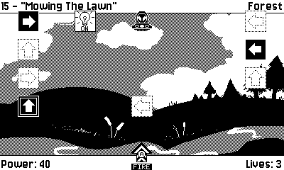

Branches
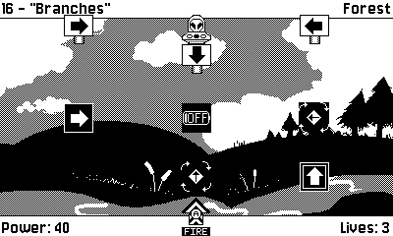

Silver Bullet
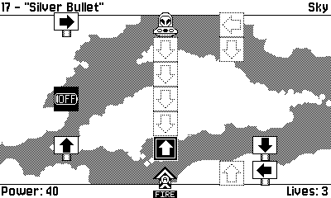

Direct Approach
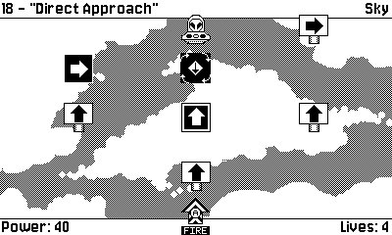

Vultures
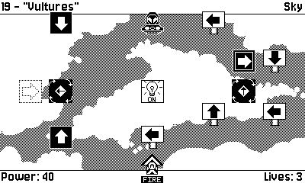

Round & Round
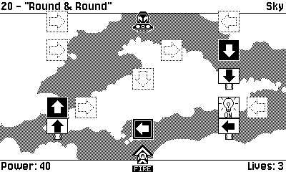

Get Away From It All
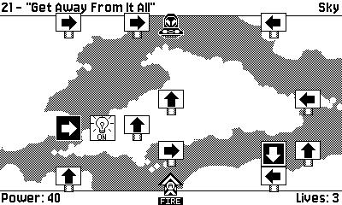

Cyclone
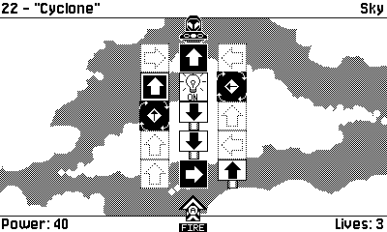

We Have You Surrounded
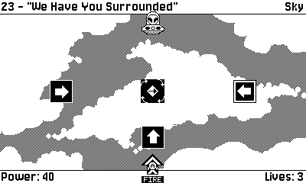

Full Circle
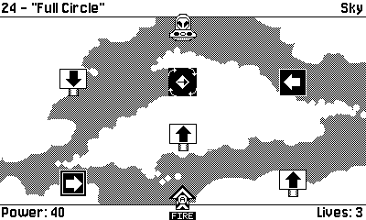

Overpopulation
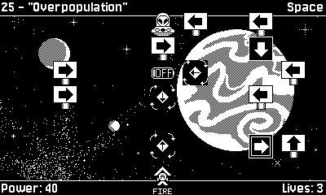

The Road Less Traveled
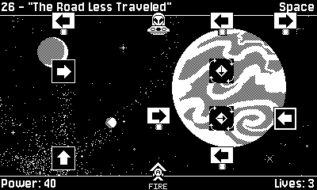

Every Last One
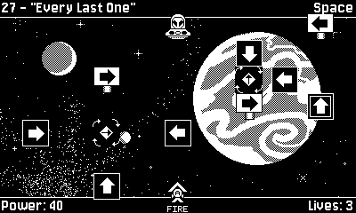

Giant Drop
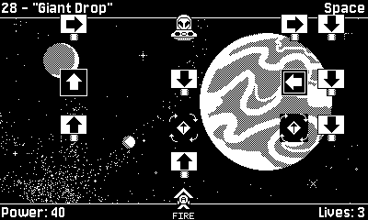

Asteroid
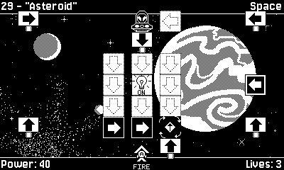

Lights Out
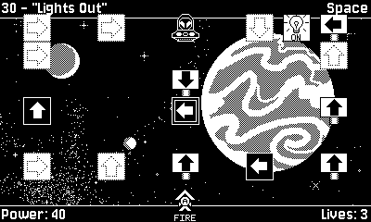

Mothership
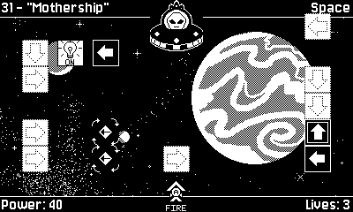

Endings:
There are two possible endings, a good ending and a bad ending. If you get a Game Over during your playthrough that automatically triggers the bad ending. If you complete the game without getting a Game Over from the beginning then you will receive a campaign award based on how many lives you have left after you defeat the mothership. You can always play again and improve your score to get a higher campaign award.

Number Of Lives With No Game Over | Award Received
3+ | Commissioned Cup
2 | Legion Of Honor
1 | Medal Of Valor

Back To The Top

