**crowdHub Coding Incentivisation Scheme Plagiarism Declaration**

I certify that all of the attached works submitted as part of this assessment are my own work, and that they are an honest reflection of my ability.

I understand that any plagiarism of other people’s work, unapproved use of copyrighted works without appropriate attribution, or gaming of the system for monetary gain is against the values and standards of the British Military, of which I am a part, and will be dealt with appropriate disciplinary action.

Signed:

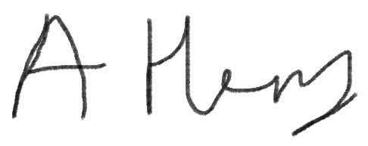

Print name:

LCpl Alan Henry

Service number:

30123309

Unit & Station:

Band of the Coldstream Guards, London Central Garrison

Date:

9 May 21