YONC PROJECT SYSTEM

Canvas UI & Elastic Timeline View
  - Interaction, visual grammar, scheduling behavior, and cross-view requirements
Specification v1.1 — 28 Aug 2026 | Audience: Product, UX, frontend, graph/runtime
Lossless structured synthesis of the shared design conversation
Shared design conversation

Information preservation note
This document is a structured, lossless synthesis of the shared design conversation and the supplied Yonc_Graph_Project_System_Spec_v0.1.md reference. Conversational repetition and speech disfluencies have been normalized, but accepted requirements, examples, corrections, rejected interpretations, deferred ideas, and unresolved mappings are retained and labeled. The dedicated Timeline View is documented separately from the Canvas even though both project the same graph.
Core product principle: Show the whole system when the user wants to understand; hide the system when the user wants to act.

1. View architecture
The system is not one screen. It is one project graph projected into several views, each answering a different question and preserving its own view state.
View | Primary question | Primary unit | Interaction model
Portfolio / Project | What projects or modules are currently worth managing? | WBS L1–L2 or any selected project scope | Cards, filters, scope selection
Canvas | How is the system structured and connected? | Project through Action, with selective Resources | Zoom, pan, toggle, constrained drag, split
Timeline | How much time does the work occupy, overlap, and pressure the deadline? | Mostly WBS L2–L3; actions support estimates | Drag, resize, day-block scheduling, forecast
Mobile / Focus | What matters now on a small screen? | Important projects, current actions, deadlines | Tap, long-press, review; no graph dragging

- Desktop/tablet uses the graph dashboard and full Timeline. Mobile does not shrink the entire Canvas; it exposes focused project/action cards.
- Notion remains a possible projection, not the source of truth.
- A node may be promoted to the current Project Scope. Project is therefore partly a viewing scale, not only a fixed node type.
- WBS L2 modules may appear as project cards in Portfolio View even when their graph node type remains Deliverable or Module.
- Canvas and Timeline should normally remember expanded/collapsed state independently because the user may want different detail in each projection.

2. Canvas View — spatial graph
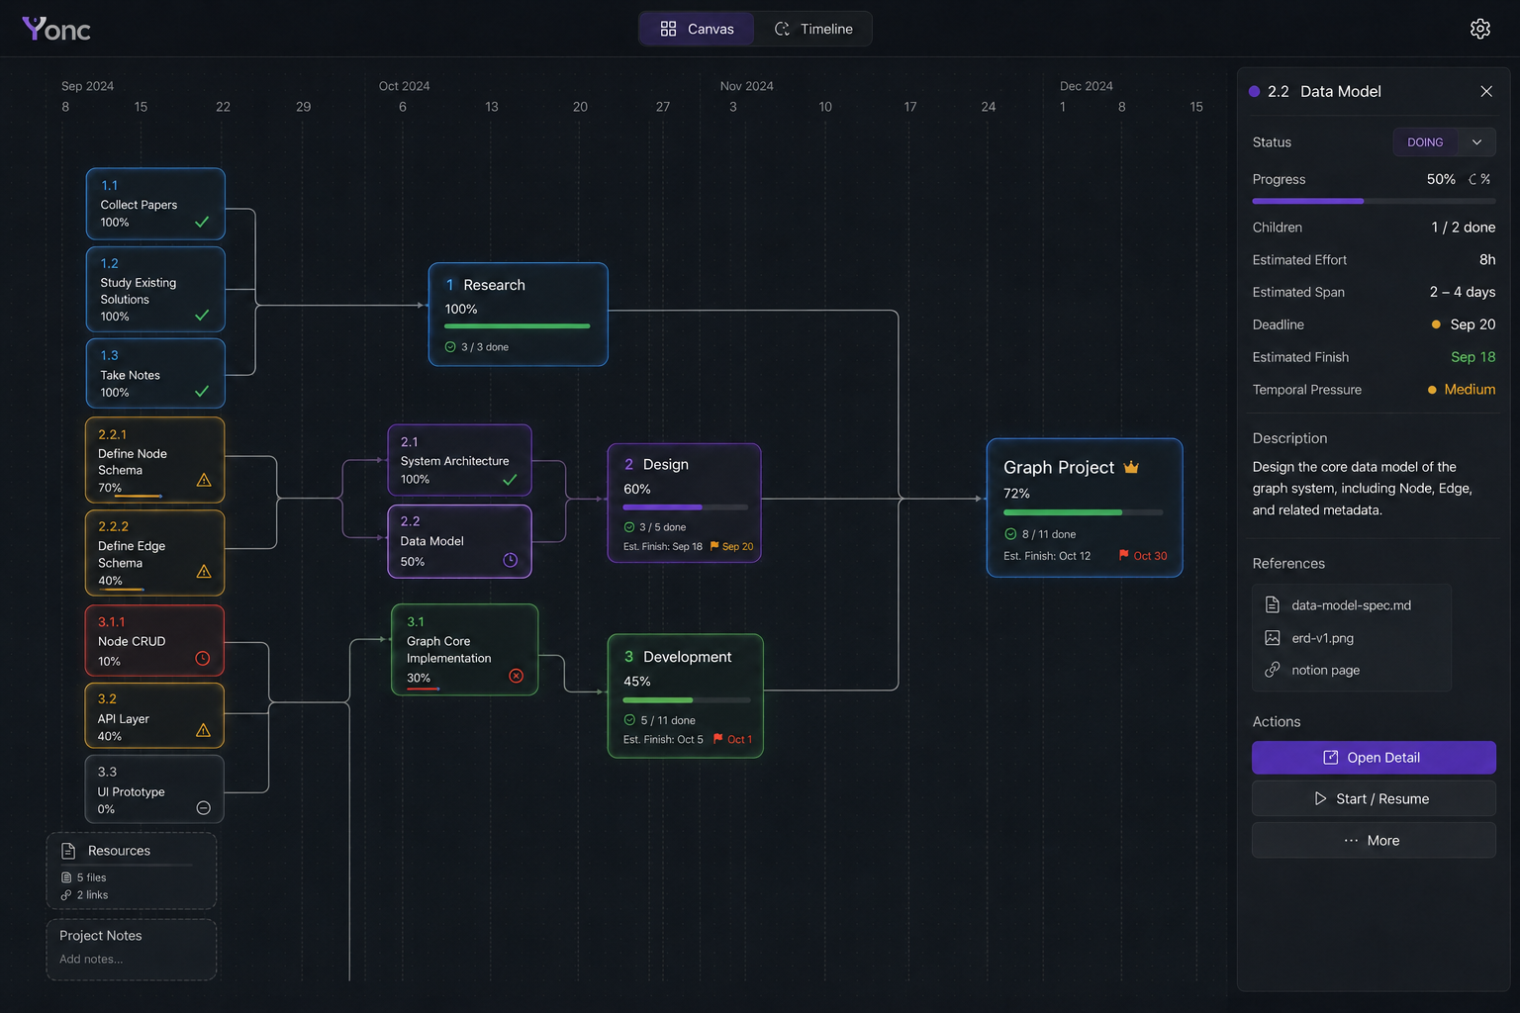
Figure 1. User-supplied Canvas UI reference: time-constrained graph, orthogonal dependencies, WBS cards, progress, resources, and inspector.

2.1 Canvas purpose and shell
The Canvas is a structured, time-constrained graph surface, not a generic whiteboard and not a text editor. It supports understanding, planning, structural navigation, and graph construction. Detailed editing belongs in an inspector or linear detail surface.
Region | Required content
Top toolbar | Project/scope selector, time context, filter, search, settings; quarter markers may appear as quiet reference points.
Left rail | Portfolio, Canvas, Timeline, Focus, Search, Auto-layout, Zoom.
Central Canvas | Project containers, nodes, orthogonal edges, temporal constraints, selected neighborhood.
Lower-left minimap | Current location inside a large project landscape; retain because the graph may span many scopes.
Right inspector | Selected node facts, status/stage, time fields, dependencies, resources, warnings, and events.
Bottom strip | Restrained metrics only: progress, blocked count, deadline/temporal pressure, recent activity if useful.

2.2 Spatial and temporal rules
- The horizontal axis carries time: NOW on the left and future/deadline toward the right. The vertical axis separates project branches and hierarchy.
- The background uses very faint quarterly reference lines (for example Mar, Jun, Sep, Dec). Months or weeks appear only when zoomed in; never render an Excel-like full grid on the Canvas.
- A node with an explicit deadline is an Anchor Node. Its horizontal position is locked on the Canvas; changing it requires the node detail flow, not casual dragging.
- A child without its own deadline is a Flexible Node. It may move inside its ancestor's allowed temporal region but cannot cross the nearest deadline-bearing ancestor.
- Parent deadline is the descendants' right boundary. Dependency constraints also apply: if B depends on A, B cannot be placed before A. Forbidden regions appear during drag.
- Dragging changes planned/rough temporal placement and view position; it never infers or changes parent-child hierarchy.
- Start with auto-layout. Manual movement refines a stable structure; free dragging must not become the main organization mechanism.
Structural: Project → Deliverable → Work Package → Action
Logical: A depends_on B
Temporal: child.end ≤ parent.deadline; B.start ≥ A.complete

2.3 Node grammar
Each visual channel owns one meaning. This avoids the common failure where red could mean project, blocked, urgent, or overdue at the same time.
Visual channel | Meaning | Rule
Project hue | Which project/line owns the node | One hue family per project; do not reuse hue as status.
Color lightness | WBS/decomposition depth | Project/Goal darkest; Action lightest.
Whole-card border | Lifecycle/stage/runtime state | Use perimeter treatment, not a small status dot.
Glow intensity | Temporal pressure / urgency | Derived from Timeliner; glow is information, never decoration.
Warning icon | Graph health issue | Small corner signal; details appear on click/hover.
Expand/collapse | How much structure the user currently wants | Persistent view state, separate from graph facts.
Canvas position | Rough temporal planning and branch location | Constrained by deadline and dependency rules.

2.4 Lifecycle border and light language
State | Block treatment | Motion / attention
Planning | Dim body; thin or partially illuminated perimeter | Static and quiet
Proposed / discussion | Semi-transparent body; incomplete glow; dashed proposal edges | Subtle only; visually distinct from committed reality
Approved / Ready | Complete clean border | Bright enough to read, normally static
Active / Doing | Complete border and full-card aura | Slow breathing glow; do not use gaming-style RGB animation
Blocked | Broken or interrupted border/glow | Static; flow interruption is visible without turning the whole card red
Review | Complete border with a thin perimeter sweep | Restrained slow motion
Done | Low-contrast body and no glow | Static; completed work should stop competing for attention

The source discussion briefly explored a small punk/cyber emblem (black hair, one eye, crown) in a card corner. That idea was not accepted as the status mechanism; the user corrected the design toward whole-card perimeter light. Treat an emblem/character mark as optional future identity styling, never as the primary lifecycle signal.

2.5 Attention and motion budget
- Truth is never hidden: if many nodes are urgent, all may retain bright static borders.
- Motion is budgeted: at most one critical pulse and roughly two to three breathing active nodes in the same viewport.
- Selected project remains at full brightness; related projects may sit near 60%; unrelated projects may dim to 20–30% without disappearing.
- Selecting a node keeps its parents, children, dependencies, and resources legible while the distant graph dims.
- Temporal position answers when; glow answers how much deadline pressure. They are complementary, not duplicate channels.

2.6 Zoom, project containers, and progressive disclosure
- Zoom out shows project containers; closer zoom reveals Deliverables; closer again reveals Work Packages and Actions.
- Project may be rendered as a group/container, not only a card. Zoomed-out Canvas shows the user's project landscape; zooming into a container reveals internal lineage.
- Zoom changes visual scale and semantic detail. Expand/collapse separately controls whether a specific node's children are exposed.
- Expand state persists per user and per view. A collapsed node reports hidden child count (for example, ‘6 hidden’).
- Proposal nodes must not look committed. Use translucency, partial glow, and dashed edges until Commit Split creates graph facts.

2.7 Interaction details
- Hovering near the right edge/right corner of a block for roughly 0.8–1.0 seconds reveals a small plus affordance. It is hidden at rest to protect attention.
- The plus means Split / Extend and enters graph construction; it must not silently add an arbitrary todo.
- On mobile, replace hover with long-press or selection followed by an action menu.
- Node click opens the inspector or contextual detail; it does not turn the Canvas into an inline text editor.
- Primary edge routing is orthogonal: horizontal, vertical, and right-angle turns only. Avoid diagonal and arbitrary curved edges.

2.8 Canvas controls and inspector contract
Surface | Required controls / content
Global | Project/Scope, Search, Filter, Zoom +/−, Fit, Auto Layout, Undo, and Canvas/Timeline/Mobile Preview switching.
Selected node | Toggle, Split, Add Link/Dependency, Set Deadline, Resources, Status, Mark Done, Cancel, Supersede, Set as Current Project Scope, Move/reparent, and View History.
Inspector facts | Title, stage/status, project/WBS level, description, deadline, estimated effort/span/finish, temporal pressure, progress, dependencies, children, resources, warnings, and history.
Status reasons | DONE needs no reason. CANCELLED and SUPERSEDED show their required reason; Superseded may link to and open the replacement node.

The first version should not overload double-click. Single click selects and updates the Inspector; expand/collapse and scope focus remain explicit controls. The current Project Scope may be an L1, L2, or L3 node according to the scale the user is managing.

3. Timeline View — temporal graph
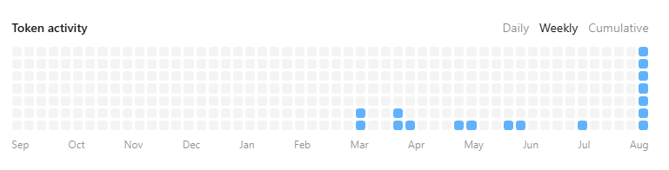
Figure 2. Source reference supplied in the conversation: a contribution-style square activity grid.
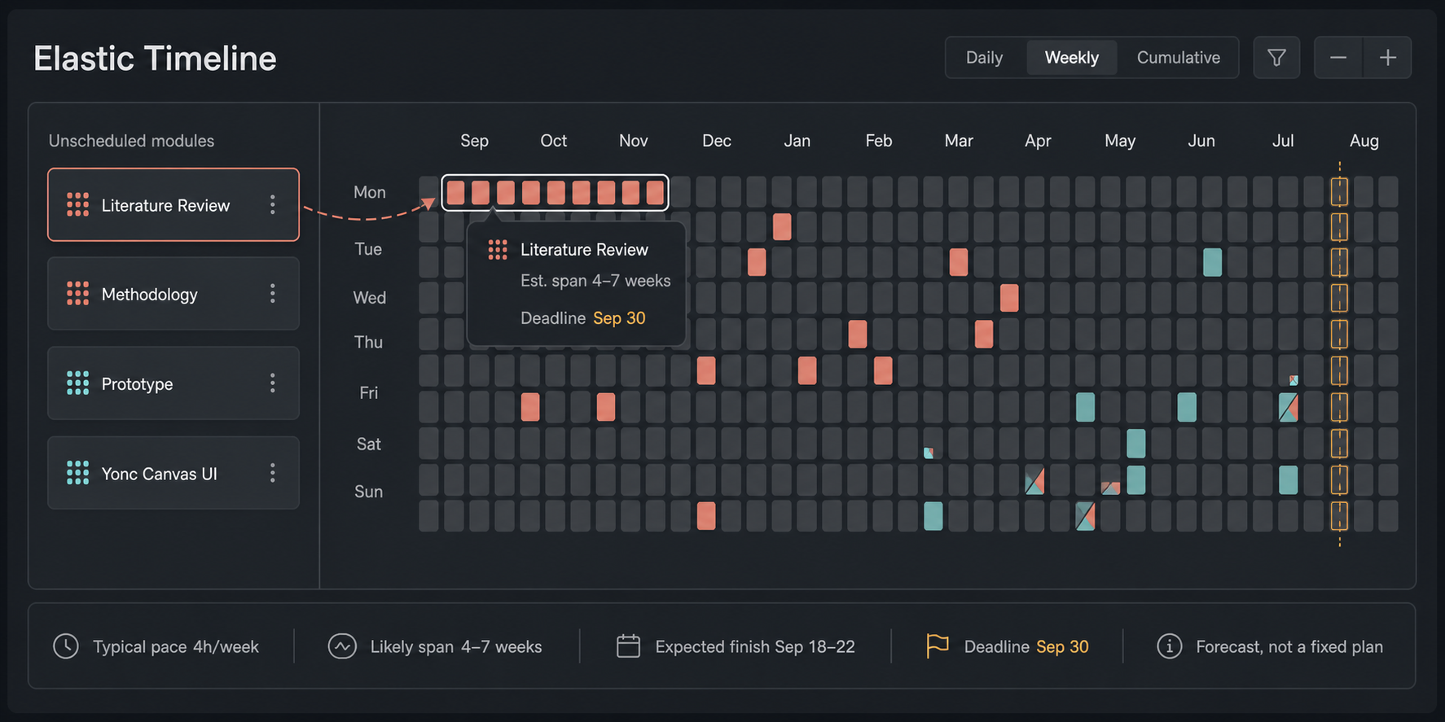
Figure 3. Original Elastic Timeline UI concept with module pool, day cells, overlap, capacity strip, and forecast panel.

3.1 Product philosophy
Timeline is not a plan: It is a Forecast + Capacity Map. Dragging work to a date means ‘I roughly intend this work to live around here,’ not ‘I must perform this task on that date.’

When work is not completed on the intended day, the forecast slides and recomputes. The system must not frame normal ADHD variability as failure.

3.2 Two Timeline modes
Mode | Question | Form
Estimate | Roughly how long will this project/module take, and will it meet the deadline? | Compact temporal graph / Gantt-like summary at Project or Module level; dependency and deadline remain visible.
Block | Where does this work occupy calendar capacity, overlap with other work, or overload a period? | Left card pool plus right square day-block grid; draggable/resizable regions; overlap split by project color.

3.3 Block mode layout and behavior
- Left panel holds unscheduled Project/Module/Deliverable/Work Package cards with estimated effort, deadline, and tags.
- Right panel is a horizontal time grid. The first version uses one square per day; day/week/month zoom may follow.
- Timeline primarily schedules WBS L2–L3. Atomic Actions support estimation but are not all rendered as draggable blocks by default.
- A scheduled region spans several day cells and displays the project/module name across the region.
- When two projects occupy a day, the cell uses a clean half-and-half split (left/right is the preferred first implementation; top/bottom is an alternative).
- A module may be resized by its right edge. The forecasted length may initialize the region, but user movement remains a rough intention.
- Explicit deadline is a diamond/anchor and creates a forbidden region. Children cannot be dragged beyond the relevant parent deadline.
- A Capacity Strip below the grid shows daily load density and identifies overload without blaming the user.

3.4 Elastic forecast model
The accepted model estimates delivery from completed workload, not timers and not an assumed fixed number of work hours per day.
estimated_effort = task size in hour-equivalent
completed_estimated_effort = sum(estimated_effort for user-marked DONE actions)
observed_delivery_pace = completed_estimated_effort / calendar window
typical_pace = median weekly pace over the most recent 4–8 weeks
estimated_calendar_span ≈ project_estimated_workload / typical_pace
estimated_finish = forecast range adjusted for dependencies, existing project load, and deadline constraints
- Observed Delivery Pace is not actual labor time. It means the amount of estimated workload the user has historically closed in real calendar time.
- Use the most recent 4–8 weeks. Typical pace is approximately the median; variability should remain visible rather than being averaged away. The exact variability statistic was not fixed in the conversation.
- Display a likely range, not false precision. Example: typical span about 5 weeks; likely range 4–7 weeks.
- First version may use one overall pace. Task-type-specific pace (Read, Write, Coding, and so on) is a future enhancement.
- Graph changes trigger derived-state recomputation: workload, estimated span, estimated finish, deadline gap, temporal pressure, and Canvas glow.
- Estimated Finish and Deadline are separate fields. Their gap creates a warning, for example Estimated Finish 12 Oct versus Deadline 30 Sep.
Example
DONE over 14 calendar days: 1h + 2h + 3h + 1h = 7h-equivalent
Observed Delivery Pace = 3.5h-equivalent/week
New project workload = 20h; typical pace ≈ 4h/week
Forecast: about 5 weeks, likely range 4–7 weeks

3.5 Effort, observed time, and task-type defaults
- Estimated effort describes task size. It is not a promise about duration or a daily plan.
- Estimate source precedence: user value when provided; otherwise AI suggestion; otherwise Task Type default.
- Source examples for configurable defaults: Read 30m, Search 45m, Research 60m, Write 90m, Design 120m, Build 120m, Discussion 30m. These are starting values, not universal truths.
- Do not ask a completion Q&A such as ‘How long did it take?’ and do not require a timer.
- Optional passive observation may record observed_work_time from active sessions, but this is only system-observed time and must never be labeled actual effort.
- The first version does not depend on observed_work_time. Delivery pace comes from user-marked DONE workload.

3.6 Timeline and Canvas relationship
Dimension | Canvas projection | Timeline projection
Primary emphasis | Hierarchy, relation, state, resource | Time, overlap, load, forecast, deadline
Temporal pressure | Whole-card glow | Explained score/range and capacity context
Deadline | Anchor/constraint on the spatial graph | Visible date anchor and forbidden region
Expand state | Canvas-specific | Timeline-specific
Atomic Actions | Visible on demand | Usually hidden; used to calculate Module length

3.7 Timeline controls and block actions
Surface | Required controls / behavior
Timeline global | Estimate, Block Grid, Today, Previous, Next, Day/Week/Month/Quarter, Filter, Unscheduled, Fit Project, Forecast, and Toggle.
Scheduled block | Open, Toggle, Set Deadline, Resize Span, Remove from Timeline, View in Canvas, and Resources.
Remove from Timeline | Removes only the rough temporal placement. It must never delete the graph node.
Cross-view locate | A selected node should be easy to locate in either projection through View in Canvas / View in Timeline.

4. Cross-view data and view state
- Graph facts include node identity, hierarchy, dependencies, lifecycle, deadlines, estimates, tags, and resource references.
- View state includes per-view expanded nodes, selected scope, filters, zoom/pan, and optional manual placement. It must not pollute graph facts.
- Proposal state is separate from committed graph state.
- Canvas and Timeline must be projections of the same graph; they may not maintain divergent task records.
- Notion and future views may read the same source of truth without changing the core schema.

5. ADHD and INTP positioning
The product should not claim to solve or treat ADHD. Its design intent is to reduce executive-function load by externalizing goal hierarchy, dependency, deadline, next-step clarity, status, and output location. Likewise, INTP/MBTI language may describe preferences but should not be presented as scientific proof of interface suitability.
- Canvas serves users who want system-level understanding and logic.
- Focus/mobile serves users who need the universe hidden while acting.
- Progressive disclosure, quiet motion, and persistent toggles reduce visual overload.
- The elastic Timeline accommodates bursty, inconsistent real-life delivery rather than enforcing calendar discipline.
- The Inbox/Capture concept remains important: users may capture an idea without immediately deciding its project or WBS level; human and AI can place it later.

6. Decision ledger
Status | Decision
Accepted | Canvas is a constrained graph dashboard with orthogonal edges, project hue, WBS lightness, perimeter lifecycle, Timeliner-derived glow, warning icon, persistent toggle, auto-layout-first behavior, and desktop emphasis.
Accepted | Dedicated Timeline View is separate from Canvas and contains Estimate and Block modes; Block mode uses a left card pool, daily square cells, split-color overlap, deadline anchors, capacity strip, and elastic forecast.
Accepted | Timeline is forecast/capacity, not a fixed plan. Observed Delivery Pace over recent 4–8 weeks drives the first version; no timer or completion Q&A.
Accepted | Mobile avoids complex dragging; use Focus/Current Project/Action cards and long-press or selection menus.
Corrected | Status is expressed by whole-card perimeter and aura, not only a right-corner light.
Deferred | Exact variance statistic, task-type-specific pace, day/week/month detail, and optional character/emblem styling.
Rejected / superseded | A single generic attention_level independent of time; glow is primarily Temporal Pressure. A rigid daily capacity plan is not the forecast model.
Out of scope for this project system | Agent Work Queue and Human Review Queue management; another orchestration system may own them.

7. Reference reconciliation and MVP acceptance checklist
Reference coverage: the supplied v0.1 specification’s product principle and visual-encoding rules are represented in Sections 1–2; Canvas sections 20–39 in Section 2; Timeline sections 40–52 in Section 3; Mobile, Portfolio, and Inbox sections 53–55 in Sections 1 and 5; button and non-violation summaries in Sections 2.8, 3.7, 6, and this checklist. This mapping is included so compact synthesis does not silently erase source requirements.
- Canvas renders project containers and WBS nodes from the graph source; edges are orthogonal and auto-layout is available.
- Project hue and WBS lightness are deterministic; lifecycle borders and temporal-pressure glow never conflict with project color.
- Anchored deadlines and child/dependency drag constraints are enforced with visible forbidden regions.
- Expand/collapse persists separately for Canvas and Timeline; proposal nodes are visually distinct from committed nodes.
- The edge-hover plus appears only after deliberate hover and enters a Split Session.
- Timeline Block mode schedules L2/L3 cards in daily squares, supports resize, renders overlap, and shows deadlines/capacity.
- Timeline forecast uses estimates plus 4–8-week Observed Delivery Pace and returns a range, Estimated Finish, Deadline, and gap warning.
- No completion-time Q&A or mandatory timer is introduced.
- The mobile view remains readable and action-oriented without graph dragging.

Source references
- Shared ChatGPT design conversation
- Yonc Graph Project System Specification v0.1
- Yonc Agent repository
- FlowTune dashboard visual reference

v1.1 refinement addendum
Version rule: All v1.0 content above remains part of the specification. This addendum resolves later decisions and overrides only where it explicitly says Corrected or Rejected.

Source traceability
Source | Authority / interpretation | v1.1 coverage
Shared design conversation | Primary source for user intent, corrections, and non-negotiable behavior. | All UI sections and decision ledgers.
Yonc Graph Project System v0.1 | Baseline product, graph, Canvas, Timeline, and Split requirements. | Contracts, edge cases, acceptance checks.
UI Spec v1.0 | Retained verbatim as the base specification. | This addendum narrows unresolved mappings.
Authoritative Canvas image | Controls dark shell, graph hierarchy, time axis, inspector, and restrained node styling. | Final Canvas contract and Figure 4.
Token-activity image | Controls calendar heatmap orientation only. | Capacity Grid week columns, weekday rows, month labels.
WhatsApp grid image | Visual reference only: rounded cells, gaps, color regions, dashed selection. Embedded puzzle rules are excluded. | Capacity Grid cell grammar and Figure 5.
Current graph_app | Implementation evidence, not product authority. | Corrected edge routing, scheduling, state, language, and mobile behavior.

v1.0 -> v1.1 changelog
- Canvas horizontal position is now strictly date-derived; vertical position remains view layout.
- Timeline is finalized as Forecast + Capacity Grid, with planned-capacity cells rather than completed-activity cells.
- Capacity Grid uses week columns, Monday-Sunday rows, month labels, large rounded cells, and split-color overlap.
- Main navigation and ordinary field labels remain English; dialogs, confirmations, validation, errors, toasts, and Split conversation use Simplified Chinese.
- A final dark Canvas mockup and final Timeline mockup replace unresolved visual alternatives.
- Desktop core is the first full milestone; mobile receives a safe compact action view without graph dragging.

Normalized cross-document vocabulary
Concept | v1.1 values | Rule
NodeKind | WORK, ARTIFACT, RESOURCE, AGENT | Describes what kind of entity the node represents.
WorkType | UNCLASSIFIED, GOAL, DELIVERABLE, WORK_PACKAGE, ACTION | Applies only to WORK nodes and replaces ambiguous TASK + WBS combinations.
Stage | CAPTURED, PLANNING, READY, EXECUTION, REVIEW, CLOSED | Describes lifecycle phase.
Status | TODO, DOING, BLOCKED, DONE, CANCELLED, SUPERSEDED | Describes current or terminal runtime truth.
Schedule | planned_start, planned_end, deadline | Planned dates are elastic intent; deadline is an explicit anchor.
Proposal | SplitSession + ProposalVersion | Draft state is never stored as committed graph nodes.
Operation | OperationBatch + ordered operations | All mutations are versioned, atomic, reviewable, and undoable.

8. Final Canvas contract
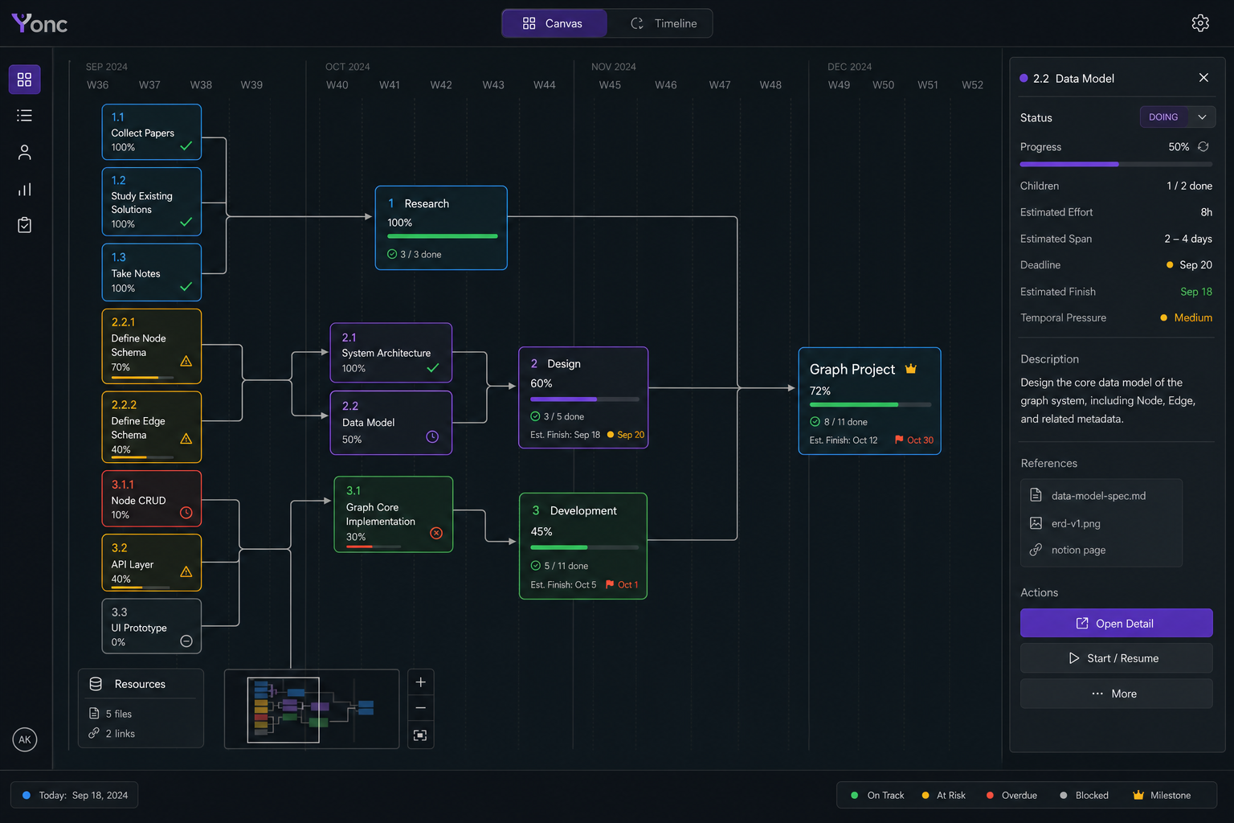
Figure 4. Final v1.1 Canvas mockup: date-derived X axis, orthogonal graph, scoped cards, and node inspector.

8.1 Layout and coordinate ownership
- The X coordinate is derived from planned_start, planned_end, or deadline against the visible date scale. It is not an arbitrary saved pixel coordinate.
- Unscheduled nodes occupy a dedicated lane before the dated region. The first horizontal drop creates planned_start; the system may derive planned_end from forecast.
- The Y coordinate separates project lineage and may be adjusted as view state. Vertical movement never reparents a node.
- All committed contains and dependency edges use horizontal/vertical segments with rounded right-angle corners. Curves and diagonals are prohibited.
- A deadline node is horizontally locked. Editing the deadline uses an explicit detail flow and Chinese confirmation dialog.

8.2 Card and inspector information
Surface | Always visible | On selection / detail
Collapsed card | Work type/WBS, title, status perimeter, progress, deadline when present, resource count, warning icon | No inline long-form editing
Inspector | Selected node identity and current state | Description, stage/status, effort, span, finish range, deadline, pressure, children, dependencies, resources, warnings, history
Neighborhood | Parents, children, dependencies, and resources remain legible | Unrelated graph dims but does not disappear
Hidden descendants | Collapsed card reports hidden count | Expand state persists separately for Canvas and Timeline

8.3 Drag and keyboard behavior
- Horizontal drag previews the derived date and validates nearest ancestor deadline plus dependency ordering before apply.
- Invalid regions are visibly shaded. A rejected drop restores the prior position and opens a Simplified Chinese explanation.
- Keyboard selection, inspector access, expand/collapse, and schedule nudging are available without pointer-only interaction.
- The delayed right-edge plus (0.8-1.0 seconds) opens Split Session. On touch/mobile, selection plus an action menu replaces hover.
- Reduced-motion mode removes pulsing while retaining static pressure brightness and all warning information.

9. Final Timeline contract
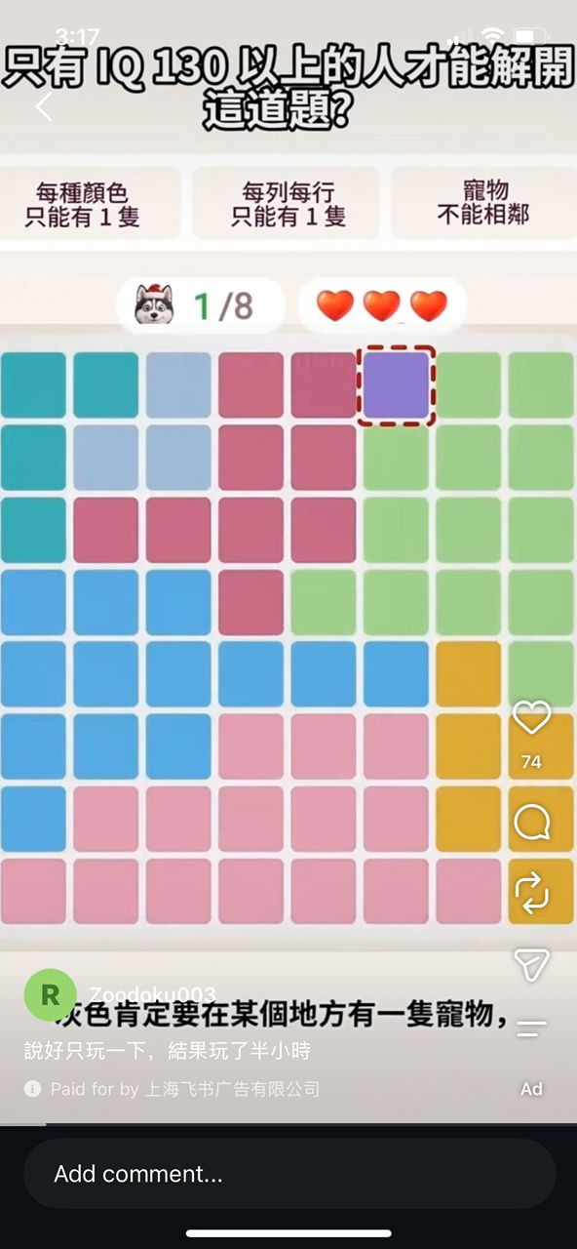
Figure 5. User-supplied cell-style reference. Only rounded cell geometry, spacing, color regions, and dashed selection are adopted; puzzle rules and social-media chrome are excluded.
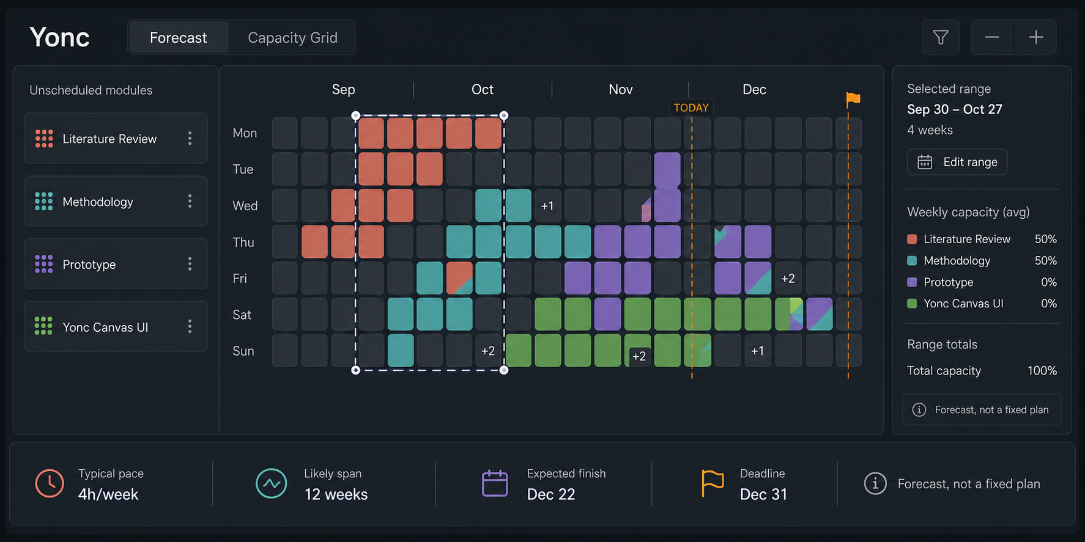
Figure 6. Final v1.1 Capacity Grid mockup with module pool, calendar heatmap, overlap, today/deadline markers, and forecast summary.

9.1 Modes, scales, and cell meaning
Control | Meaning
Forecast | Range-based project/module forecast, remaining-work curve, deadline gap, confidence, and pressure explanation.
Capacity Grid | Calendar heatmap of planned capacity/intention; it is not a completion or activity heatmap.
Day / Week / Month / Quarter | Aggregation/zoom inside Capacity Grid; the canonical day view uses week columns and Monday-Sunday rows.
Colored cell | One calendar day containing rough planned allocation for one or more scopes.
Empty cell | No planned placement. It makes no claim about productivity or availability.

9.2 Placement and overlap
- Drag an unscheduled L2/L3 module onto a day cell; that cell becomes planned_start.
- The system computes an initial natural-calendar range from remaining estimated effort and observed delivery pace.
- The user may move or resize the range. Resizing changes planned span, never estimated effort.
- Two allocations split a cell 50/50. More than two use compact project-color segments plus a +N indicator.
- Overlap raises planning-density warnings but never silently redistributes the user's delivery pace or moves another project.

9.3 Visual states
State | Treatment
Selected range | High-contrast dashed outline around the range, with draggable start/end handles.
Today | Single vertical marker and labeled current-day cell; never confused with deadline.
Deadline | Amber diamond/flag anchor with explicit date and locked editing flow.
Invalid date | Muted red forbidden region plus a Chinese validation explanation before apply.
Over capacity | Quiet density warning and details; no moral language or failure framing.
Low confidence | Forecast range is withheld or labeled insufficient history rather than invented.

10. Language, dialogs, and feedback
Language rule: Navigation, tabs, field labels, and API terminology remain English. Every modal, confirmation, validation message, error, toast, and Split conversation uses Simplified Chinese.

Trigger | Simplified Chinese dialog / message | Actions
Commit split | 确认提交拆分？提交后将创建正式节点和关系。 | 取消 / 提交拆分
Discard draft | 放弃当前拆分提案？未提交的内容不会写入项目图。 | 继续编辑 / 放弃
Deadline edit | 确认修改截止日期？这会重新计算预测和时间压力。 | 取消 / 确认修改
Invalid drop | 无法放置到此日期：已超出父级截止日期或违反依赖顺序。 | 查看原因 / 返回
Version conflict | 项目图已发生变化。请刷新上下文并重新确认提案。 | 取消 / 刷新
Mark done | 确认标记为完成？完成状态只能由你确认。 | 取消 / 标记完成
Cancel | 请输入取消原因。 | 返回 / 确认取消
Supersede | 请输入替代原因，并可选择新的替代节点。 | 返回 / 确认替代
Undo | 已撤销上一批项目图变更。 | 关闭
Import preview | 导入预览已生成。确认前不会修改本地图。 | 取消 / 应用导入
Loading failure | 无法载入项目图，请重试。 | 重试 / 关闭
Insufficient pace | 历史完成数据不足，暂不显示预计完成日期。 | 知道了

11. Responsive, accessibility, and failure states
- Desktop is complete. Compact mobile shows Current Scope, next Actions, deadline/forecast, warnings, resources, Split entry, and user-only Done; it does not expose free graph dragging.
- Every icon control has an accessible name, visible keyboard focus, and a text equivalent in menus or tooltips.
- Color is never the only signal: status, pressure, warning, overlap, and selection also use shape, perimeter, label, or pattern.
- Loading uses stable skeleton regions; empty states explain the next valid action; errors preserve unsaved form input when safe.
- Large graphs render through scope filtering, semantic zoom, and virtualization; layout computation must not freeze the main interface.

Decision ledgers

Accepted
- Dark Yonc shell with date-derived Canvas X coordinate and orthogonal edges.
- Forecast + Capacity Grid Timeline using calendar heatmap orientation and planned-capacity semantics.
- Large rounded grid cells, clear gaps, project color regions, dashed selection, split overlap, and +N overflow.
- English main interface with Simplified Chinese dialogs and Split conversation.
- Desktop core first with compact action-oriented mobile fallback.

Corrected
- Canvas saved pixel X is replaced by date-derived X; only vertical layout remains manual view state.
- Current curved implementation edges are replaced by orthogonal routing.
- The 14-day row table is replaced by Forecast and calendar Capacity Grid projections.

Rejected
- Treating colored grid cells as completed activity.
- Importing puzzle adjacency rules, animals, hearts, or social-media controls from the WhatsApp image.
- Using glow as a generic attention score or using color alone for state.

Deferred
- Full mobile graph editing, light theme, and task-type-specific delivery pace.
- User-authored non-contiguous day painting; v1 uses an automatically generated contiguous range that can be moved/resized.

Out of scope
- Automatic Notion writeback, general agent work queues, human review queues, and autonomous multi-agent scheduling.

12. UI acceptance criteria
- Canvas renders scoped graph data with real time guides, date-derived X, orthogonal edges, inspector, minimap, and persistent per-view expansion.
- A deadline/dependency-invalid drag cannot mutate the schedule and produces the required Chinese explanation.
- Capacity Grid displays horizontal weeks, Monday-Sunday rows, month labels, rounded cells, selection, overlap, today, deadline, and capacity warning states.
- Drag-to-start generates a forecast range; move/resize changes dates but not effort.
- All dialog/toast/error/Split strings are Simplified Chinese while main navigation remains English.
- Desktop and compact-mobile flows are keyboard accessible, readable without color alone, and stable under empty/loading/error states.

