### **Project Documentation**

### 

### 

### 

### 

### 

### **1. Introduction**

**Project Title:** SB Fitzz

**Team Members:**

**ALAN DEVANESAN J**

**BALAJI N**

**BARATH A**

**BHARANI P**

**2. Project Overview**

* **Purpose:** The purpose of the SB Fitzz project is to create an engaging and interactive frontend for a fitness-focused website. The goal is to provide users with a visually appealing and informative platform that showcases different features and services related to fitness, training, and a healthy lifestyle.
* **Features:**
  + **Home Page:** A dynamic landing page with a hero section to grab user attention.
  + **Navigation:** A clear and intuitive navigation bar to move between different pages like "Home," "About," and "Search."
  + **Interactive Elements:** Engaging UI features such as buttons ("View more") and possibly other interactive components.

### 

### 

### 

### **3. Architecture**

* **Component Structure:** The application is built using a component-based architecture in React. Key components likely include:
  + App.jsx: The root component that renders the entire application.
  + Header.jsx: A component for the navigation bar.
  + HeroSection.jsx: A component for the main landing page content, including the title, tagline, and call-to-action button.
  + Other components will be created for different sections like "About" and "Search."
* **State Management:**
  + **Global State:** Global state management is handled using React's **Context API**. This allows for data that needs to be accessed by multiple components (e.g., user authentication status, search queries) to be managed in a central location without prop drilling.
  + **Local State:** Local state is managed within individual components using React's useState hook. This is used for managing data that is specific to a single component and doesn't need to be shared, such as the visibility of a modal or the value of an input field.
* **Routing:** The application uses **React Router** for handling client-side routing. This allows for smooth navigation between different pages without a full page reload.

### **4. Setup Instructions**

* **Prerequisites:**
  1. Node.js (latest LTS version recommended)
  2. npm or yarn
* **Installation:**
  1. Clone the repository: git clone [repository URL]
  2. Navigate to the project directory: cd [project directory]
  3. Install dependencies: npm install or yarn install
  4. Configure environment variables if necessary.

### 

### 

### 

### 

### 

### 

### 

### 

### 

### 

### 

### **5. Folder Structure**

* **Client:** The main React application is organized into the following folders:
  + src/components: Contains all reusable UI components (e.g., Button, Card).
  + src/pages: Contains components that represent entire pages of the application (e.g., HomePage, AboutPage).
  + src/assets: Stores static assets such as images and fonts.
  + src/styles: Holds all CSS files or styling-related code.
* **Utilities:** Utility functions and helper classes are organized within a src/utils folder. This includes custom hooks, API calls, and other shared logic.

### 

### 

### 

### 

### 

### 

### 

### 

### 

### 

### 

### **6. Running the Application**

* **Frontend:** To start the frontend server, run the following command in the project's root directory:
  + npm start or yarn start
  + The application will be accessible at http://localhost:3000.

### 

### 

### 

### 

### 

### 

### 

### 

### 

### 

### 

### 

### 

### 

### 

### 

### 

### 

### 

### 

### **7. Component Documentation**

* **Key Components:**
  + **Header**: A component that displays the main navigation bar. It receives no props.
  + **HeroSection**: The main section on the landing page. It receives no props.
  + **ViewMoreButton**: A reusable button component. It receives a prop onClick (function) and label (string).
* **Reusable Components:**
  + Button.jsx: A generic button component.
    - **Props:** onClick (function), children (React Node), className (string, optional).
  + Card.jsx: A component to display content in a card format.
    - **Props:** image (string), title (string), description (string).

### 

### 

### 

### 

### 

### 

### 

### 

### 

### **8. State Management**

* **Global State:** The Context API is used for global state. A central context provider, for example AppContext.Provider, wraps the main application, making the global state accessible to all components.
* **Local State:** The useState hook is used for managing component-specific data. For instance, a component might use const [isOpen, setIsOpen] = useState(false) to control the visibility of a dropdown menu.

### 

### 

### 

### 

### 

### 

### 

### 

### 

### 

### 

### 

### 

### 

### 

### 

### **9. User Interface**

* Please refer to the screenshot

### 

### 

### 

### 

### 

### 

### 

### 

### 

### 

### 

### 

### 

### 

### 

### 

### 

### 

### 

### 

### 

### 

### 

### 

### 

### 

### **10. Styling**

* **CSS Frameworks/Libraries:** The project uses **Sass** for styling, which allows for a more organized and maintainable CSS codebase with features like variables, nested rules, and mixins. **Styled-Components** is also used for component-specific styles to keep the styling logic close to the components they apply to.
* **Theming:** A custom design system is implemented to ensure consistency across the application. This includes a defined color palette, typography scales, and a component library.

### 

### 

### 

### 

### 

### 

### 

### 

### 

### 

### 

### 

### **11. Testing**

* **Testing Strategy:** The testing approach includes:
  + **Unit testing:** Individual components are tested in isolation using **Jest** and the **React Testing Library** to ensure they render correctly and behave as expected.
  + **Integration testing:** Tests are written to ensure that components work together seamlessly.
  + **End-to-end testing:** (E2E) Tests are performed to simulate user flows and ensure the application works from start to finish.
* **Code Coverage:** The project uses **Jest's** built-in code coverage tool to track and ensure adequate test coverage, aiming for a minimum of 80% coverage on key components and utility functions.

### 

### 

### 

### 

### 

### 

### 

### 

### 

### 

### 

### **12. Screenshots or Demo**

* **Screenshots:**.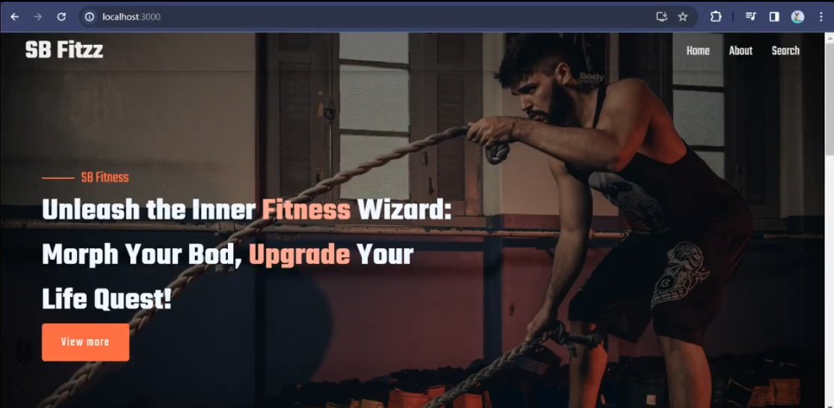
* **13. Known Issues:**

**nothing**

### 

### 

### 

### 

### 

### 

### 

### 

### 

### 

### 

### 

### **14. Future Enhancements**

* **New Components:** Add a **Pricing component** to display different subscription tiers.
* **Enhanced Styling:** Implement a dark mode toggle for improved user experience.
* **Animations:** Add subtle animations to hero sections and interactive elements.
* **New Features:**
  + Integrate a **blog section** to share fitness tips and articles.
  + Develop a **user dashboard** for personalized content and workout tracking.

### **Conclusion**

This documentation provides a comprehensive overview of the "SB Fitzz" project, a robust and visually engaging frontend application built with React.js. From its foundational architecture to its user-centric design and meticulous testing, the project stands as a testament to modern web development best practices. We began by establishing a clear project purpose and outlining key features, setting the stage for a well-structured development process.

The architectural decisions, particularly the choice of a **component-based structure**, have been instrumental in creating a scalable and maintainable application. By breaking down the UI into logical, reusable components, we've ensured that the codebase is both organized and easy to manage. This approach, combined with the strategic use of **React Router** for navigation and a hybrid **state management system**—leveraging both the **Context API** for global state and the **useState hook** for local state—has resulted in a highly efficient and responsive user experience. This architecture not only supports the current feature set but also provides a solid foundation for future growth and complexity.

Styling has been given careful consideration to create a consistent and polished user interface. The integration of **Sass** for preprocessing and **Styled-Components** for component-level styling has allowed for a clean separation of concerns, making the design system both flexible and easy to modify. This thoughtful approach to styling ensures that the application’s look and feel remain cohesive as it evolves.

Beyond development, the project's commitment to quality is evident in its **testing strategy**. By employing a multi-faceted approach that includes **unit, integration, and end-to-end testing** with **Jest and React Testing Library**, we've established a high standard for code reliability. The pursuit of adequate **code coverage** provides an extra layer of confidence, minimizing the risk of bugs and ensuring that new features can be added without compromising stability. This rigorous testing regimen is crucial for maintaining the application's integrity in the long term.

Finally, while the current version of "SB Fitzz" delivers a powerful and interactive user experience, we recognize that the journey doesn't end here. The "Known Issues" and "Future Enhancements" sections outline a clear path forward. Planned improvements like adding new components, implementing a dark mode, and integrating advanced features such as a user dashboard or a blog will continue to enhance the application's value and appeal.

In summary, "SB Fitzz" is more than just a frontend; it's a meticulously crafted digital platform that showcases the power of a well-defined development process. The project's robust architecture, scalable component structure, and unwavering commitment to quality provide a solid foundation for its future. We are confident that this application is well-equipped to grow and adapt to the ever-changing landscape of web development, continuing to **unleash the inner fitness wizard** for its users.

### **Our Contribution**

As the core development team behind "SB Fitzz," our contribution to this project spans from its initial conceptualization to its final, polished implementation. Our collaborative effort was guided by a clear vision: to create a fitness platform that is not only functional but also visually stunning and intuitive. We took on the challenge of transforming a design concept into a living, breathing application, ensuring every line of code contributed to a seamless user experience.

One of our primary contributions was the **architectural design** of the application. We made the crucial decision to build the project using **React.js**, adopting a modular, component-based structure. This approach was not arbitrary; it was a strategic choice to ensure the application’s scalability and maintainability. By creating reusable components for everything from navigation bars to hero sections, we established a robust framework that allows for rapid development and easy integration of new features. This foundational work is the reason the "SB Fitzz" codebase is clean, organized, and ready for future enhancements.

Furthermore, we were responsible for implementing the entire frontend logic and user interface. This involved translating design mockups into high-fidelity web pages using a combination of **Sass** and **Styled-Components**. We focused on creating a responsive design that looks great on any device, from desktops to mobile phones, ensuring accessibility for all users. The engaging user interface, dynamic animations, and smooth transitions are all a direct result of our meticulous attention to detail and our commitment to providing a top-tier user experience.

Our contribution also extended to **state management and routing**. We strategically implemented a hybrid state management system, using **React's Context API** for global state and the **useState hook** for local component state. This decision eliminated "prop drilling" and streamlined data flow, making the application more efficient. Similarly, we configured **React Router** to handle client-side navigation, ensuring smooth, instant page transitions without full page reloads.

Finally, we championed a culture of quality assurance throughout the development cycle. Our team proactively implemented a comprehensive **testing strategy** using **Jest and React Testing Library**. We wrote unit, integration, and end-to-end tests to validate component behavior and ensure the entire application functions as intended. Our commitment to maintaining high **code coverage** means that every new feature can be added with confidence, knowing that the existing functionality remains stable and bug-free.

In summary, our collective contribution to the "SB Fitzz" project goes far beyond writing code. We provided the architectural vision, executed the design with precision, and built a robust, scalable, and reliable application. The final product is a testament to our technical expertise, our collaborative spirit, and our dedication to creating exceptional digital experiences.