**Experta**

HomePage:

Components:

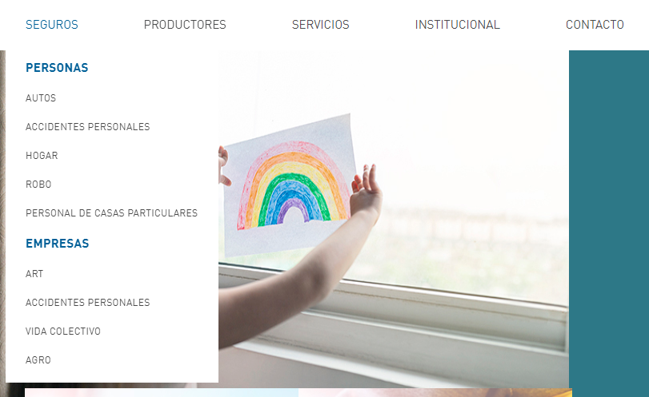

homeSecurePage()

stoleSecurePage()

SecurePage:

Components:

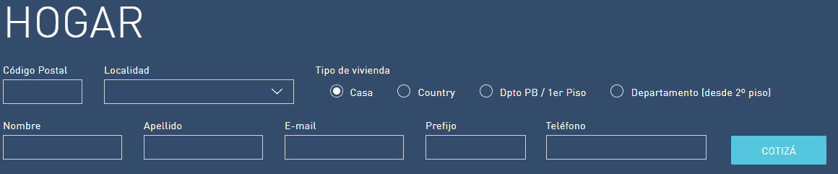

setPostalCode()  
selectLocation()

selectTypeOfHouse()

setName()

setSurname()

setEmail()

setTelephonePrefix()

setTelephone()

quote()

PlanPage:

Components:

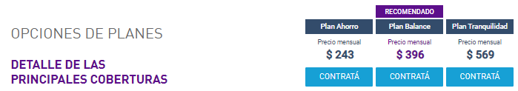

selectHires()

SecurePersonalInformationPage:

Components:

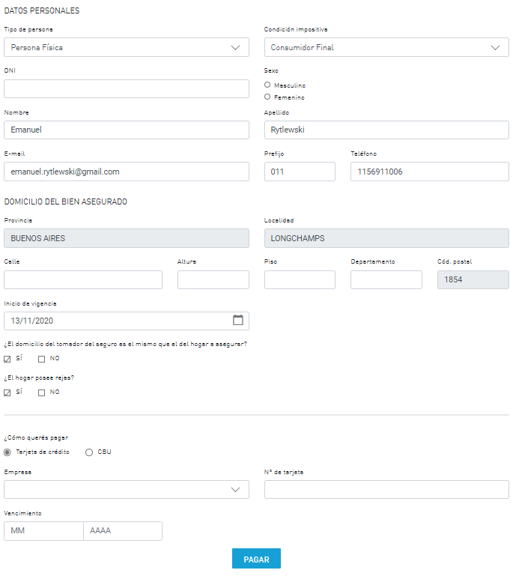

selectTypeOfPerson()

selectTaxStatus()

setDni()

selectGender()

setName()

setSurName()

setEmail()

setTelephonePrefix()

setTelephone()

setProvince()

setLocation()

setStreet()

setAdressNumber()

setFloor()

setDepartment()

setPostalcode()

selectBeginningOfValidity()

checkyesdomicilio tomador de seguro()

uncheckyesdomicilio tomador de seguro ()

checkyesrejas()

uncheckyesrejas()

selectPaymentMethod()

selectCompany()

setCardNumber()

setExpiration()

Pay()

StolePage:

Component 1:

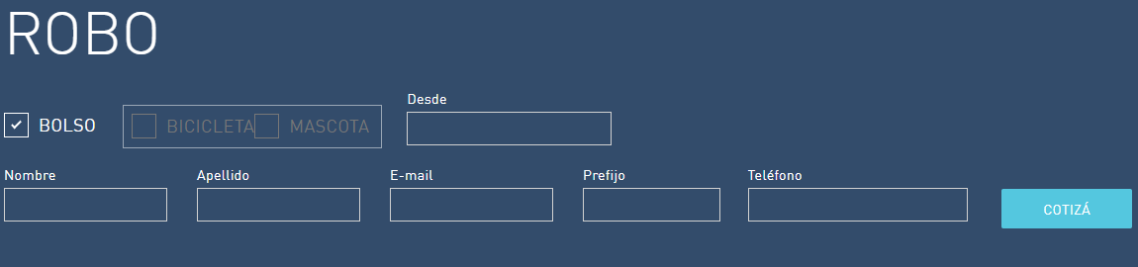

checkBag()

unCheckBag()

checkBike()

unCheckBike()

checkPet()

unCheckPet()

setSince()

setName()

setSurName()

setEmail()

setTelephonePrefix()

setTelephone()

quote()

Component 2:

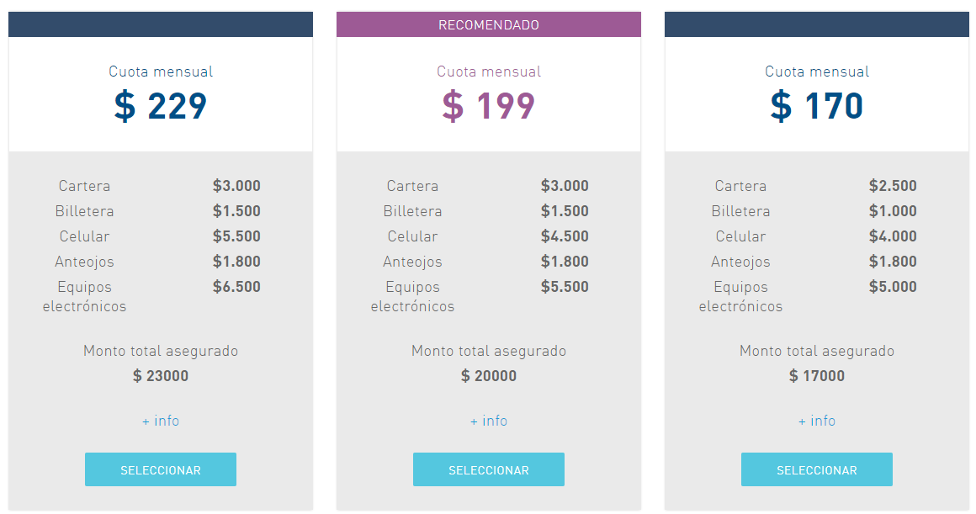

selectCombo()

StolePersonalInformationPage:

Components:

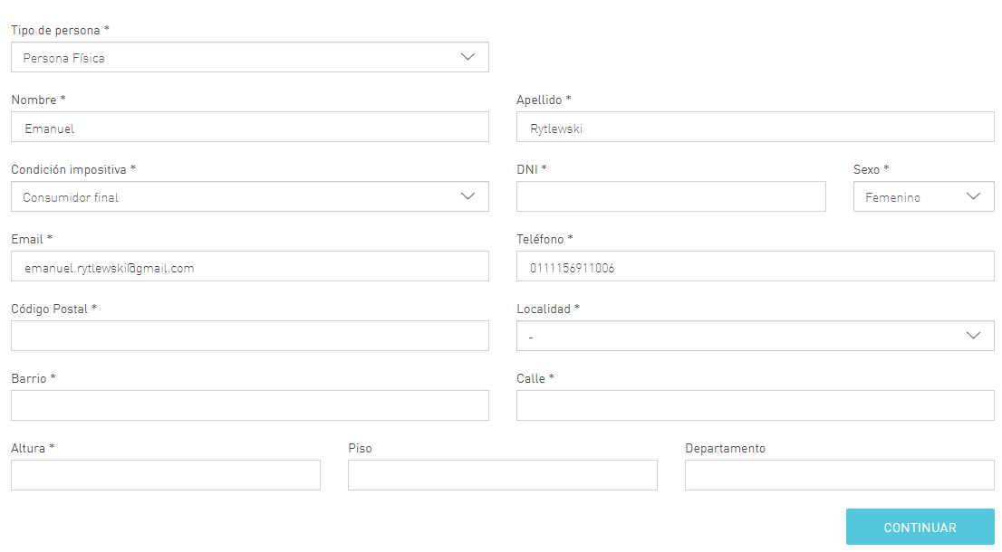

selectTypeOfPerson()

setName()

setSurName()

selectTaxStatus()

setDni()

selectGender()

setEmail()

setTelephone()

setPostalcode()

selectLocation()

setNeighborhood()

setStreet()

setAdressNumber()

setFloor()

setDepartment()

continue()

PayPage:

Components:

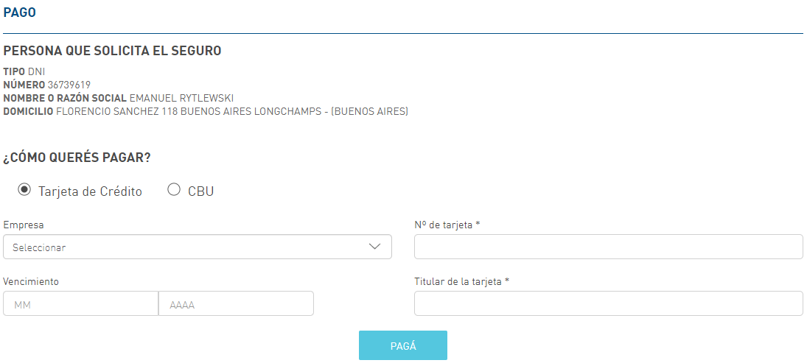

selectPaymentMethod()

selectCompany()

setCardNumber()

setExpiration()

setCardholder()

pay()