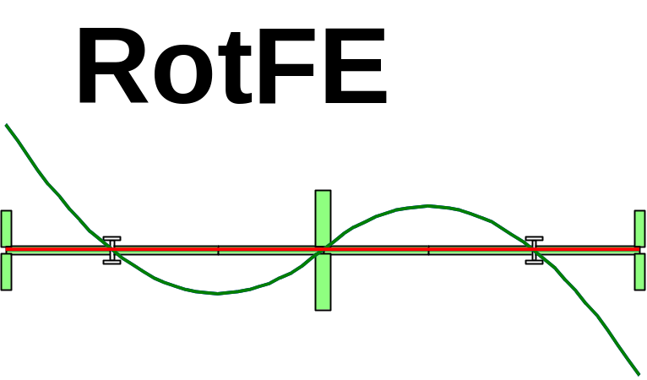

A Package for dynamic modelling and simulation of
rotating machines in MATLAB and Simulink

Version 2.0 Written during summer 1998

By : Dr. I. Bucher

Dynamics Section Imperial college

1. INTRODUCTION

Main features (short version):
• Finite element based
• Creates compact models exploiting isotropy and sparsity
• Modular and easily modified and extended
• Interfaces and creates models for Simulink™
• Computation of natural frequencies, critical speeds and modes shapes
• Allows for the inclusion of Mass properties, Stiffness and damping of the supports , internal, external and modal damping
• Allows for the inclusion of unbalance forces
• Inclusion of misalignment
• Possible to select specific response and excitation locations

Method of operating the software
The software is composed of Matlab™ functions and script files (m-files). The programs can be called in two ways:
- By explicitly calling a Matlab™ function with the appropriate input(s)
- By using the graphical user interfaces (model plot, modeshapes, Campbell diagram).

Model file
All modes of operation require a description of the model, which should be provided by means of a model file. The model file, which is in effect a Matlab™ script file, defines some model parameters, using pre-defined names. These variables allow the main Finite-element program to construct the model from the: geometry, material properties, boundary conditions, actuators and sensor locations, unbalance, misalignment.
This file must be a syntactically valid Matlab™ script file otherwise the model cannot be built.

Explicit use of the Matlab™ functions in the toolbox
The explicit usage of the functions in the toolbox is meant for people who are somehow familiar with Matlab™, but this is by no means an absolute requirement. Following and/or modifying the examples given in this user-guide one can perform many operations.

Example: Construct a Finite Element model of a rotating shaft from a model file called femodel1.m and store the results in a Matlab™ structure called R1:

>>R1=rotfe('femodel1 ');

Upon completion, the Matlab™ variable R1, contains all the necessary information about the finite element model and about the geometry of the model. In fact all the available information which is contained in the model file is embedded into R1, along with some matrices and vector describing the discretised equations of motion.

For example, the mass matrix (M) of this model, as contained in R1, can be accessed by typing R1.M. We can use the Matlab™ function spy, which allows us to visualise the sparsity of any matrix by typing

>>spy(R1.M);
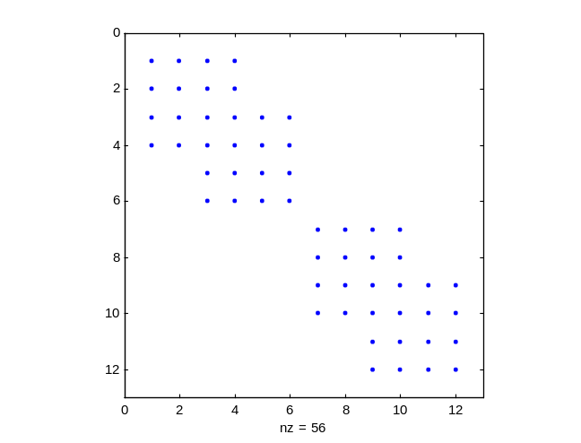

Using the Graphical user interfaces (GUI)
The current version supports
<i> Computation and plotting of modeshapes, (modeplot)
<ii> draw the model and identify elements in it (drawrot)
<iii> Compute and draw the Campbell diagram. (campbell)
<iv> Use a pre-defined model within the Simulink™ environment (Simulink™ is part of Matlab™ and can be used to represent dynamical systems in a graphical manner.)

The required input for most of the GUIs is the name of the mode file and in some cases the speed of rotation is also required.
The operation of those devices is performed by manipulation of the graphical controls, e.g. buttons, pop-up menus etc.
As an example, if one types from the Matlab™ environment

>>modeplot

The following window appears.
Press this
button to compute and display the modeshapes
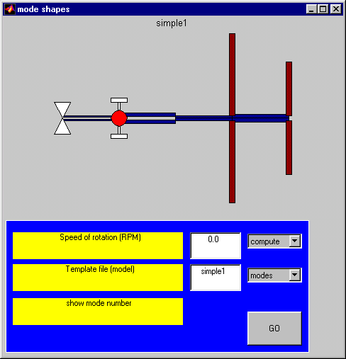

2. The structure of the model file
As mentioned before, the model file is central to all the functions in this toolbox. In this file the definitions leading to the required model are written in a format that will be explained below. The current version of Rotfe supports the following variables
Variable name | Desciption
NODES | A vector of locations along the x axis at which nodal points are defined. A finite shaft element is defined between two nodes, thus the NODES vector determines the length of the elements.  In addition to that, bearings, discs, unbalance, forces and response coordinates are all defined at nodal locations.
ELEMENTS | ELEMENTS is an array which defines shaft elements in terms of their dimensions and material properties.
MATERIALS | This vector defines sets of material properties which can be used in the definition of shaft elements or discs.
DISCS | Defining rigid discs connected to the shaft at specified nodal locations.
SPRINGS | Part of the definition of a supporting bearing. This variable defines the stiffness properties of a bearing at a defined node as a stiffness matrix. The springs apply a restoring force which is proportional to the displacement.
DASHPOTS | Similar to the Springs, this variable allows one to define viscous dampers, which apply a restoring force proportional to the speed. As for springs, each line defines damping matrix acting at a specified node.
BCNodeDir | Defines a restrain, (e.g. a spring having infinite stiffness). A restrained coordinate remains zero and is in fact fixed.
UNBALANCE | Defines an imperfection, which causes the center of mass to deviate from the center of rotation. Unbalance is defined in units of Length*Mass (e.g. mass times its distance from the center of rotation)
FnodeDir, RnodeDir | Defines coordinates at which forces act and response is to be 'measured'. These vectors which have the same input format define a coordinate at a specific node. These variables are being used in the Simulink™ models and in frequency response functions.
MISALIGN | Defines static misalignment of a bearing. This is translated into equivalent constant forces.
Reduct  Reduct.Nmodes  Reduct.Type | Defines the number of modes to be included in a reduced model (a parameter for model reduction)  Reduct.Nmodes – any positive integer smaller than no. of modes in the full model  Reduct.Type – 'modal', 'mixed' or 'static'

Coordinate system of each element

Each element is defined between two nodes whereas each node is assigned 4 degrees of freedom.

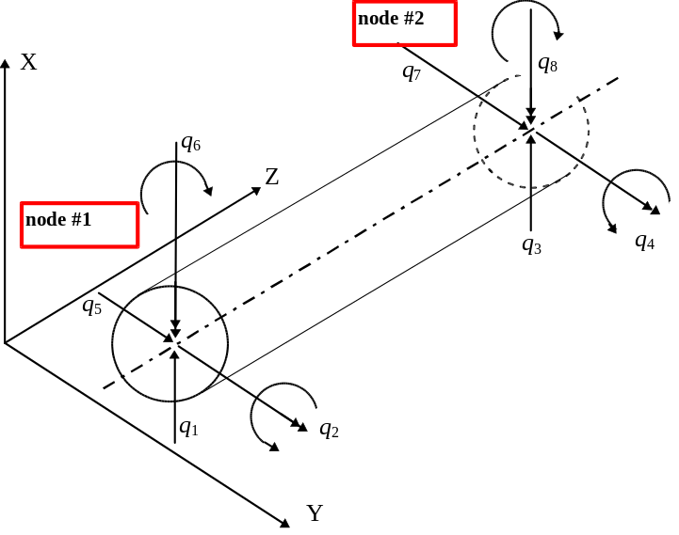 | ROTFE co-ordinate order  q₁₌ Node=1, DIR=1 ➔ 1.1  q₂₌ Node=1, DIR=2 ➔ 1.2  q₃₌ Node=2, DIR=1 ➔ 2.1  q₄₌ Node=2, DIR=2 ➔ 2.2  q₅₌ Node=1, DIR=3 ➔ 1.3  q₆₌ Node=2, DIR=3 ➔ 2.3  q₇₌ Node=1, DIR=4 ➔ 1.4  q₈₌ Node=2, DIR=4 ➔ 2.4
Figure 1, element degrees of freedom

Each element therefor posses 8 x 8 mass, damping stiffness, gyroscopic etc. matrices. Four (4) degrees of freedom will describe motions in the XZ plane while the additional 4 will describe motions in the YZ plane.

Finite element model – background
The shaft in ROFE is derived using Timoshenko theory where the effect of rotation gives rise to a few additional features, which make this model depart from the usual non-rotating beam model. Firstly a gyroscopic term is being added, secondly internal damping within the shaft manifests itself ([See Hashish and Sankar]) in terms of a symmetric viscous term and a skew-symmetric stiffness term. Inertia elements give contributes to the gyroscopic matrix in addition to the usual contribution to the mass matrix. An accelerating rotor gives rise to time varying equations (matrices), but in two cases, a rotor having a variable speed can still be described by means of linear time invariant models.
(1) Constant acceleration rate: (2) Treatment of the rotor in a pseudo constant speed manner can be valid in many cases.
A complete derivation of the element matrices and the assembly process is beyond the scope of this guide and the interested reader is referred to the numerous textbooks (Kramer, Lee) and to the literature (Sankar and Hashish , Zorzi,)

Expanded description of each variable in the model file
A model file can be created by means of a text editor where only the necessary variables should be entered. the file should always have the extension .m and should reside in the 'matlab search path' – see matlabpath in the Matlab help . The finite element program, while processing the model file, will use the appropriate defaults in the absence of some variables from this file.

NODES

General format: NODES=[z1 z2 z3 ….. . . ]

This variable is entered as a vector of locations along the z axis. Any valid Matlab statements the result in a row-vector NODES is acceptable, as long as, the entries are provided in an increasing order.
Examples for valid entries in the model file:
NODES=[0 0.1 0.12 0.5 1.2];
or
NODES= 0.11:0.1:12;

ELEMENTS

General format:
ELEMENTS=[n1 n2 d_o1 d_i1 material_no1
n2 n3 d_o2 d_i2 material_no2
.. …
]
Each line of this variable describes a single element. The element is between n1, n2 etc. (integers which describe the indices of the appropriate nodes as defined in NODES (see above). These indices determine the length of the element which is NODES(n2)-NODES(n1). d_o and d_i define the outer and inner diameters of this element (which can be generally hollow (d_i>0) or solid (d_i=0). material_no is once more an integer index which reflects the appropriate row (material set of properties) in the MATERIALS matrix.

MATERIALS

General format:

MATERIALS=[E1 rho1 nu1; E2 rho2 nu2; ..... ]
units= E - [Pa] [psi] (young modulus)
rho [Kg/m^3] [lb/in^3] (density)
nu [.] poison ration (0.3 for most metals)

Each line of this variable describes a material set, different elements can have different material properties.

DISCS

General format:

DISCS=[n1 d_out d_in width material_no
n2 ... ]

n1 - integer, nodes number
d_out, d_in - (length) [m] [in] (diameter)
width - (length) [m] [in] (disc's width)
material_no - integer, defines the material set

Each line of this variable defines a disc at a pre-defined node. The disc a rigid connected to the shaft by obviously moves along with the shaft as if deflects and bends. As for the shaft d_out and d_in define the inner and outer diameters of the disc. Width defines the width as expected and the material number is in effect being used to select the material set with a suitable density.

SPRINGS

General format:
SPRINGS=[n1 Kxx1 Kyy1 Kxy1 Kyx1 Ktt1 Kpp1 Ktp1 Kpt1
n2 Kxx2 Kyy2 Kxy2 Kyx2 Ktt2 Kpp2 Ktp2 Kpt2
……
];

n1 - integer, nodes number
Kxx1, Kyy1, Kxy1, Kyx1 - [N/m]
Ktt1, Kpp1, Ktp1, Kpt1 - [N*m/Rad]

The stiffness matrix is assumed to be block-diagonal having 2 4x4 blocks. The assumption is that there is no cross coupling between angular and linear degrees of freedom, hence the stiffness matrix of each bearing has the form:

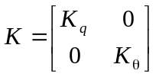, 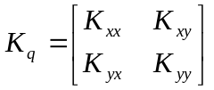, 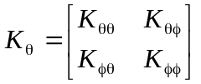

Where 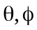 are identical to 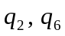 (in figure 1) respectively
- .Note: if only 4 elements are typed in: SPRINGS=[n1 Kxx1 Kyy1 Kxy1 Kyx1]
It is implicitly assumed that all cross stiffness terms are
zero

DASHPOTS

General format:
DASHPOTS=[n1 Dxx1 Dyy1 Dxy1 Dyx1 Dtt1 Dpp1 Dtp1 Dpt1
n2 Dxx2 Dyy2 Dxy2 Dyx2 Dtt2 Dpp2 Dtp2 Dpt2
. . . ]

For each bearing a viscous damping matrix having the dimension of 8 x 8 with the same structure and assumptions as defined for the SPRINGS matrix.

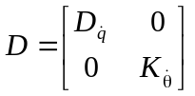, 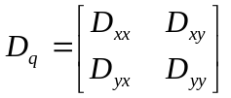, 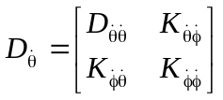

- Note if only 2 terms are being used, e.g. DASHPOTS=[n1 Dxx1 Dyy1], it is implicitly assumed that all cross-terms and all angular related damping coefficients are zero.

BCNodeDir

General format: BCNodeDir=[node1.dir1 ; node2.dir2; ... nodeQ.dirQ]
node1=1,2, .. dir=1,2,3,4
dir1=1->'x' 3->'y' 4->'rotation around x' 2->'rotation around -y'

This variable is used to force certain degrees of freedom to zero. Since there are 4 degrees of freedom associated with each node, we can choose one of 4 dofs for every node (e.g. 1,2,3 or 4).
In order to constrain all the dofs associate with a specific node, one can choose, dir=0.

Example: BCNodeDir=[1.1 1.3 5.0]
This will indicate the x and y directions at node #1 and all 4 dofs at node 5.

FnodeDir, RNodeDir

General format: FNodeDir=[node1.dir1 ; node2.dir2; ... nodeQ.dirQ]
node1=1,2, .. dir=1,2,3,4
dir1=1->'x' 3->'y' 4->'rotation around x' 2->'rotation around -y'

FnodeDir, RnodeDir: These variables determine the co-ordinates where force and response (F* and R* respectively) are to applied or measured.

These variables play a key role when conversion into state-space (rot2ss) or Simulink™ models are dealt with.

MISALIGHN

General format: MISALIGN=[node1 dx dy]
node1=1,2, .. dx,dy
where dx,dy is the amount of misalignment in [m]
- MISALIGNMNET is usually defined at a bearing (where there's a spring)
- MISALIGNMNET is defined at zero speed

The effect of MISALIGNMNET is implemented by application of
a constant vector of forces, causing the specified MISALIGNMNET

This force is retuned in the variable Fmalgn

Redcut

General format: Reduct.Nmodes=N
N = 2,3,4 … (number of dofs)
Reduct.Type = TYPE
TYPE = 'modal' 'mixed' or 'static'
Reduct determines the size of the reduced model. Together with RNodeDir (which is used in MIXED reduction). A reduced model can be computed upon request.
Reduct.Nmodes is used for modal reduction (See reduce). This paramter determines the number of modes (stating at the lowest natural frequencies upwards) to be included in the reduction transformation.
RnodeDir is used (in addition to Nmodes) when reduces (mixed static + modal reduction ) is used. The co-ordinates specified in RnodeDoir are taken as the master DOFs for the static (Guyan) reduction with is added to the truncated modal transformation.

A minimal example:
In order to define a simple model let us define a shaft consisting of two elements.
As a minimal model one should create a definition of a shaft. This means that NODES, ELEMENTS, MATERIALS must be defined. In case no supporting bearings (i.e. SPRINGS, BCNodeDir) are defined, the shaft will be unconstrained.
The model describes a steel shaft modelled by 2 elements having do=0.1, 0.15 respectively and di=0.05, 0.05, with a total length of 1.0 . The mode file will have the following form

% min_model.m ⬅ File name
% minimal model file ⬅ This is a remark
NODES=[0 0.5 1.0];
ELEMENTS=[ 1 2 0.1 0.05 1; 2 3 0.15 0.05 1];
MATERIALS=[209e9 7800 0.3];

Alternatively one could define manually those variable thus the need for a model file is removed. If we type the following lines within the matlab™ command window
Rot.NODES=[0 0.5 1.0];
Rot.ELEMENTS=[ 1 2 0.1 0.05 1; 2 3 0.15 0.05 1];
Rot.MATERIALS=[209e9 7800 0.3];

In the case of a model file, a finite element model is buing built by typing
>> Rot=rotfe('min_model');

while in the case of the directly typed model we can use this structure as the input to rotfe, namely:
>>Rot=rotfe(Rot);
This will add several fields to Rot, among which we have Rot.M, Rot.K etc.

Plotting the modeshapes

The modeplot utility solves one of three eignvalue problems according to the provided input and the required plot.
Issuing the command

>>modeplot min_model
or alternatively (if we prefer not to use a mode file, but define Rot as above)
>>modeplot(Rot)

We obtain:
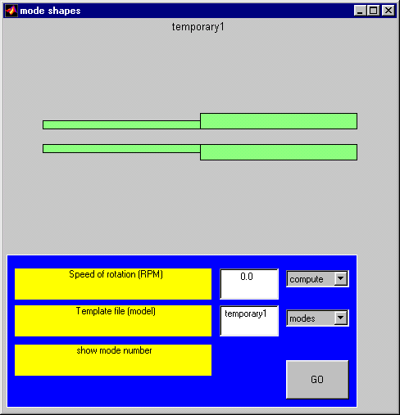

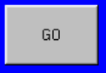
Each time we press the button the appropriate eigenvalue problem is computed,

according to the following criterions.
(1) When the selector 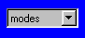 and the indicated speed of rotation is 0.0 (zero) there is no gyroscopic coupling, hence a fast lanczos solver can be used.

Appendix – testing the convergence of the element

In order to verify the FE code, the mass and the stiffness matrices of the Timoshenko (Shaft) element which adds to the ordinary Euler's beam model, rotatory inertia and Shear capabilities are examined.
The comparison is based upon an analytical solution found in :
- Genta " Vibration ..", page 87 eq. 2-40

The

