ROTFE 2.0 : A note on the degrees of freedom retained in the model

In order to interpret the eigenvectors etc. one needs to understand how each equation is matched with the degrees of freedom in the model.

* An additional field in the Rot structure Rot.cord_name now describes the meaning of each degrees of freedom in the model.

Coordinate system of each element

Each element is defined between two nodes whereas each node is assigned 4 degrees of freedom.

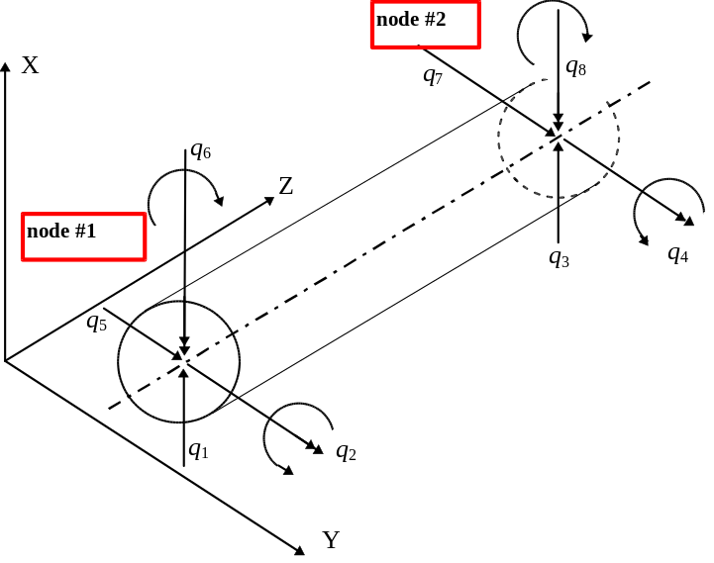 | ROTFE co-ordinate order  q₁₌ Node=1, DIR=1 ➔ 1.1  q₂₌ Node=1, DIR=2 ➔ 1.2  q₃₌ Node=2, DIR=1 ➔ 2.1  q₄₌ Node=2, DIR=2 ➔ 2.2  q₅₌ Node=1, DIR=3 ➔ 1.3  q₆₌ Node=2, DIR=3 ➔ 2.3  q₇₌ Node=1, DIR=4 ➔ 1.4  q₈₌ Node=2, DIR=4 ➔ 2.4
Figure 1, element degrees of freedom

Each element therefor posses 8 x 8 mass, damping stiffness, gyroscopic etc. matrices. The first 4 degrees of freedom will describe motions in the XZ plane while the additional 4 will describe motions in the YZ plane.
.

Assembly of the elements -

The complete vector of degrees of freedom is composed of all the degrees of freedom in the model ordered NODEwise and DIRectionwise.. I.e. the degrees of freedom are split into xz and yz directions. The vector of dofs is partitioned as:

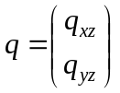

The degrees of freedom that are constrained to zero via BCNodeDir (see in the model file) are removed and their numbers are recorded in Rot.Bcord.
The total no. of DOFs in the model is No_of__nodes*4-length(Rot.Bcord)

In order to find the dof belonging to a specific DOF, one could make use of the function roteqn1.m

For example, if one wishes to find the DOF in the y-direction at node no. 2, we choose
ndr=2.3;

and
eq_no=roteqn1(ndr,Rot.Bcord,Rot.dim);

EXAMPLE:
» drawrot simple1 nod
» Rot=rotfe('simple1');
» eqn_no=roteqn1(2.3,Rot.Bcord,Rot.dim)

eqn_no =

9

Remark: one cannot ask for the equation no. of a constrained DOF (e.g.
  - in simple1.m is forced to zero thus roteqn1(1.1,Rot.Bcord,Rot.dim) is illegal).

The DOF are ordered (in q) as:

Where those forced to zero are removed. For example if the vector Rot.Bcord contains the numbers 1 and 3, this means that x₁ and x₂ are constrained to zero and are thus removed from this vector which becomes:

