Tutorial example for using ROTFE 2.0

In this example a simple mode will be built from scratch and the various analysis options will be demonstrated.

The model to be built is depicted below
Node no. 1
Node no. 5

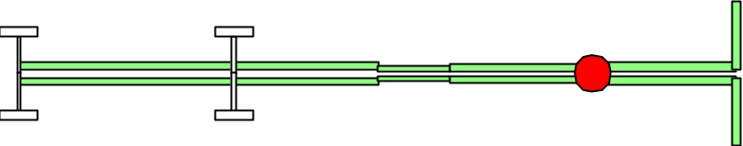
Concentrated
mass
Disc
shaft element
shaft element
Spring (Boundary
condition- bearing)

Step 1
Create a template file having the sufix .m (e.g. tutorial.m) in a text editor

- Define nodal locations for elements. Nodal locations are defied in a vector of numbers in consistent units (meters). In our example we use:
NODES=[0 0.3 0.5 0.6 0.8 1.0 ] ;
(Here z=0 defines node no.1 z=0.3 node no.2 etc.)

- Once the nodes have been defined, elements are defined between the various nodes
ELEMENTS=[ 1 2 30e-3 12e-3 1
2 3 32e-3 10e-3 1
3 4 22e-3 8e-3 1
4 5 28e-3 6e-3 1
5 6 30e-3 6e-3 1];

Each element is defined by means of a single row in the ELEMENTS matrix. The format of each line is:
First_node Second_node Outer_diameter Inner_diameter Material_Set_number
- Defining a material set:
In the below Matlab line, two different materials are defined. The first row consitutes of material no. 1 etc.
MATERIALS=[210e9 7800 0.3; 70e9 3200 0.3];

Each row in the MATERIALS matrix has the following format
Young_Modulus Desnity Poison_constant

- Defining a disc at a specific node
DISCS=[ 6 0.2 12e-3 12e-3 1 ];

where the format is
Node_no Outer_diameter Inner_diameter Width Material_no

- Bearings are defined by means of their stiffness and damping properties. Let us assume that the bearings posses no damping and that their equivalent spring rate in the x and y directions is 2000 [N/m]. A bearing is to be defined at nodes no. 1 and 2

SPRINGS=[1 2e3 2e3; 2 2e3 2e3];
where the format is
Node_no Kxx Kyy

(The bearing model treatrd by ROTFE can be more complicated and cross terms (Kxy, Kyx) and angular stiffness terms can be also used. The general format of the bearing input is in the reference section.
A fixed degree of freedom (inifinite stiffness) can be defined by means of the BCNodeDir vector. Since each node contains 4 dofs, inclusion of the entry Node.DOF (e.g. 1.3) in this vector will force the 3rd dof in node 1 (motion in the y-direction) to be forced to zero. (See other examples for more).

- In this example a point mass will be added in node 5
POINT_MASS=[5 .01 0 0];
where the format is
Node_no m Jp Jt

Step 2 draw the model to assure correctness

Assuming that a file has been created named tutorial.m and that the file is in the Matlab search path. The file contents should be
NODES=[0 0.3 0.5 0.6 0.8 1.0 ] ;
ELEMENTS=[ ...
1 2 30e-3 12e-3 1
2 3 32e-3 10e-3 1
3 4 22e-3 8e-3 1
4 5 28e-3 6e-3 1
5 6 30e-3 6e-3 1];
MATERIALS=[210e9 7800 0.3; 70e9 3200 0.3];
DISCS=[ 6 0.2 12e-3 12e-3 1 ];
SPRINGS=[1 2e3 2e3; 2 2e3 2e3];
POINT_MASS=[5 .01 0 0];

Use the Matlab command
drawrot tutorial
to obtain the figure in page 1. This command apart from plotting the geometry of the model, checks the correctness of the template file and it's compatibility with ROTFE 2.0.

Step 3 Run ROTFE

The finite element model is built by typing the following command from the Matlab command line.
Rot=rotfe('tutorial');
The structure Rot contains all the information about the model.
Typing
Rot ↵
yields

Rot =

File: 'tutorial'
ELEMENTS: [ 5x5 double]
dim: 24
M: [24x24 sparse]
K: [24x24 sparse]
G: [24x24 sparse]
D: [24x24 sparse]
KH: [24x24 double]
Kst: [24x24 double]
dof: [ 1x24 double]
W: 1
NODES: [0 0.3000 0.5000 0.6000 0.8000 1]
MATERIALS: [ 2x3 double]
DISCS: [6 0.2000 0.0120 0.0120 1]
POINT_MASS: [5 0.0100 0 0]
SPRINGS: [ 2x9 double]
BCNodeDir: []
…

Further inspection of the model, i.e. displaying the non-zero elements in the mass and gyroscopic matrices. This can be achieved by typing
spy(Rot.M)
and
spy(Rot.G)

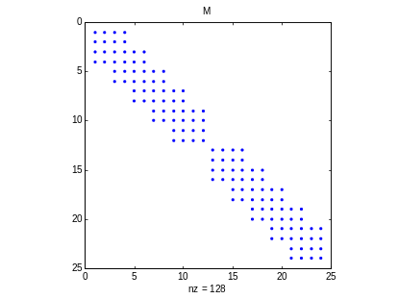 | 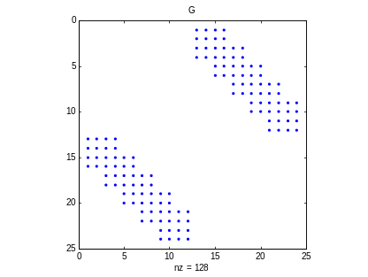

Step 4 Plot modes

The modeshapes plotting GUI is invoked by typing
modeplot
In the model name edit box, type tutorial and hit the return key. Successful typing will produce a plot of the model identical to the one obtained in step 2.
The GUI should accept the following form:

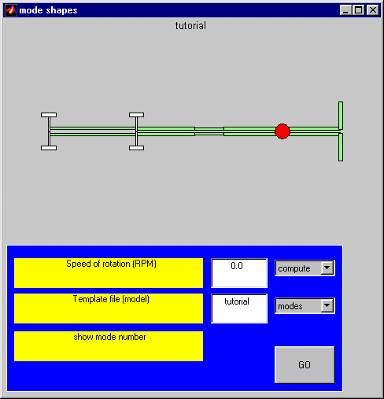
Model: template file name
Start computation
Model: template file name
Speed of rotation (RPM)

Press the [GO] button to perform the computation for the specified speed of rotation.

Use the [3D] check box to obtain this view
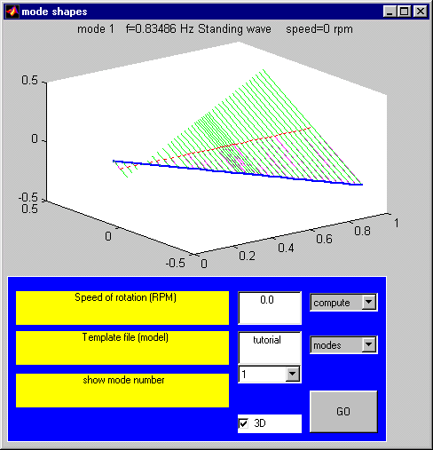

The various mode shapes can be viewed in 2D (3D not checked) and different modes can be selected
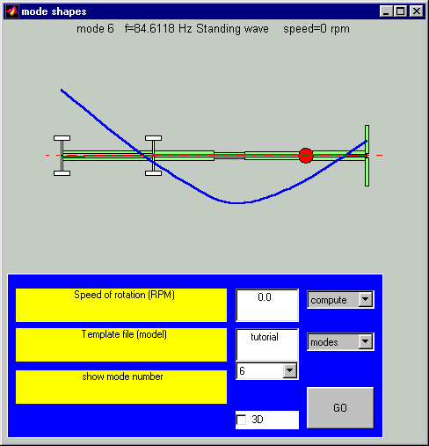
Mode number selector

Enter Speed of rotation of 1200 RPM and press [GO]
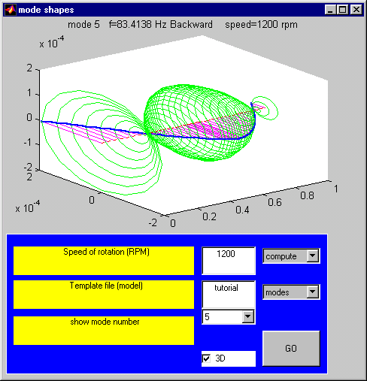
Step 5 Compute and draw the Campbell diagram

In the matlab command window, type

campbell
And in the model file name type tutorial followed by presseing the [GO] button

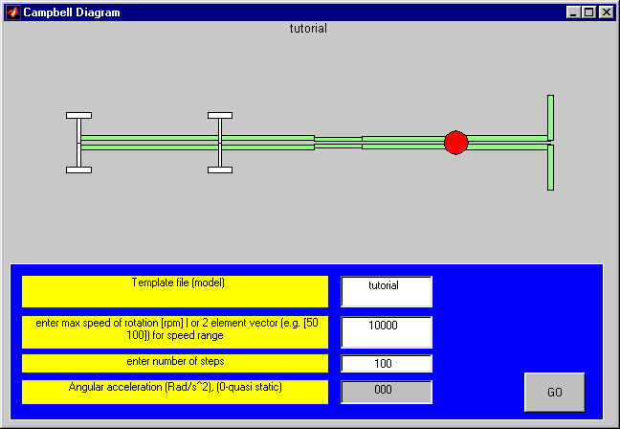

The zoom command is active in the plot window and using the mouse and the left button one can inspect a confined area of the obtained plot.
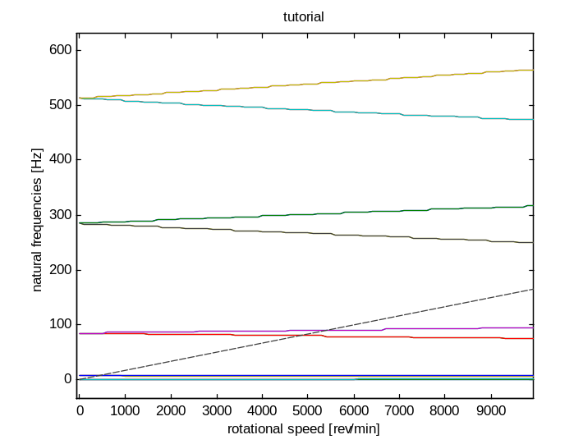

Simulink example

Type
>>simrotor1

and press the go button (  )

Type
>> simrotor3a

and run the program

The simulink model save the ooutput in a variable named y. We could plot this variable in time
plot(y(:,2))
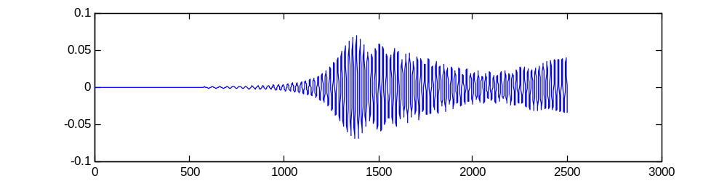
or compute the Campbell diagram, by
>>specgram(y(:,1),[],50)
