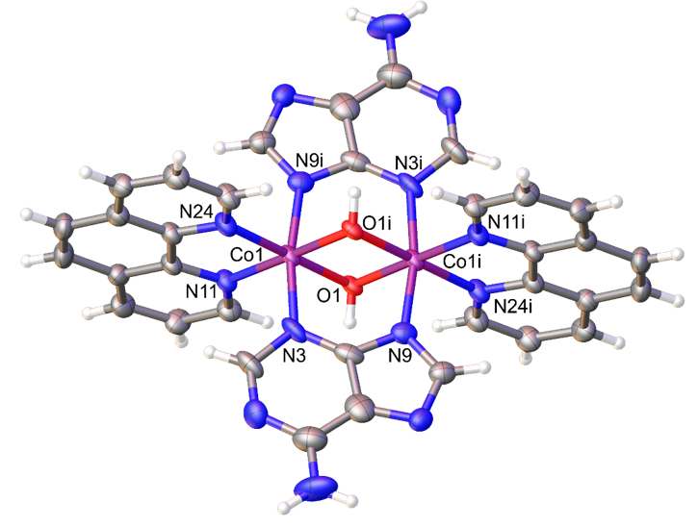

Figure 1 Molecular structure of complex [Co2(µ-L1H)(µ-L1)(L2)2(µ-OH)2] 3(NO3)ˑ6(H2O)

nitrate groups and water solvent were removed for clarity. ​(i= -x, -y+1, -z)

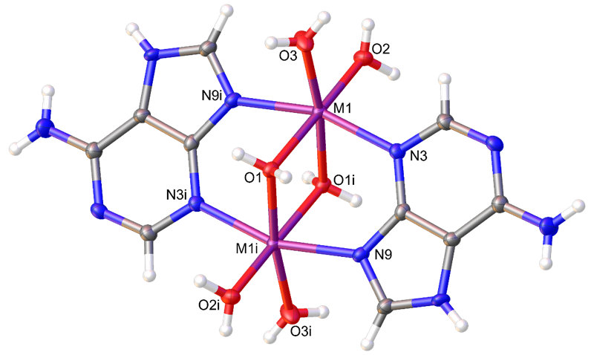

Figure 2 Molecular structure of Complex [Co2(µ-L1)2(µ-H2O)2(H2O)4]4(NO3).2(H2O)

(i= symmetry operation [-x+1, -y+1, -z+1] for complex 4)

Nitrate groups and water solvent were removed for clarity.

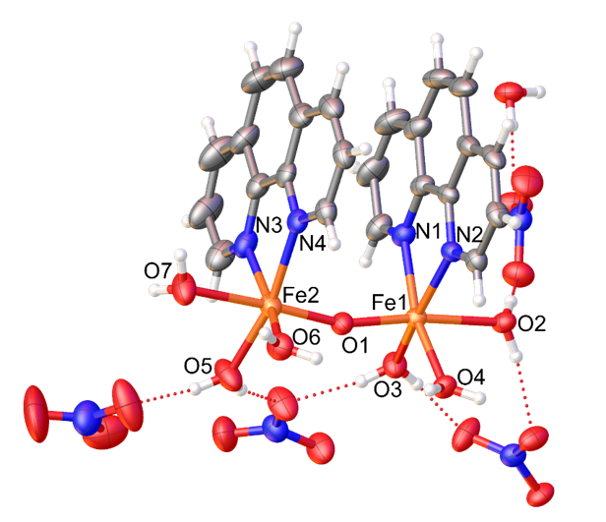

Figure 3 Molecular structure of Complex [Fe2(µ-O)(phen)2(H2O)6](NO3)4 (H2O)

(i= symmetry operation [-x, y+1/2, -z+1/2])

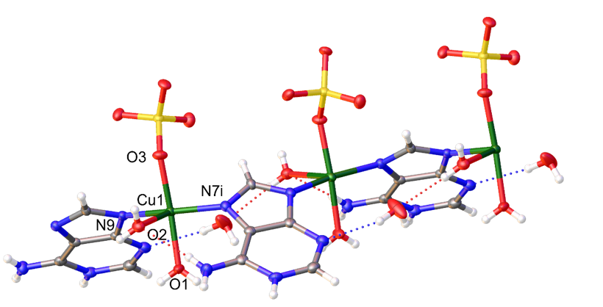

Figure 4 Molecular structure of Complex 8 [[Cu(μ-L1)(H2O)2(SO4)].2(H2O)]n

The dash lines show H-bonds (i= symmetry operation [x-1/2, -y+1/2, z-1/2])