FOR IMMEDIATE RELEASE: January 18, 2021

Emily Pitcher

Sondering Studios

(805) 807-9506

spacebtwngame@gmail.com

**The Space in Between, an unconventional visual novel featuring Asian American representation and mental health, releases for free**Story written from lived experience for those underrepresented in gaming

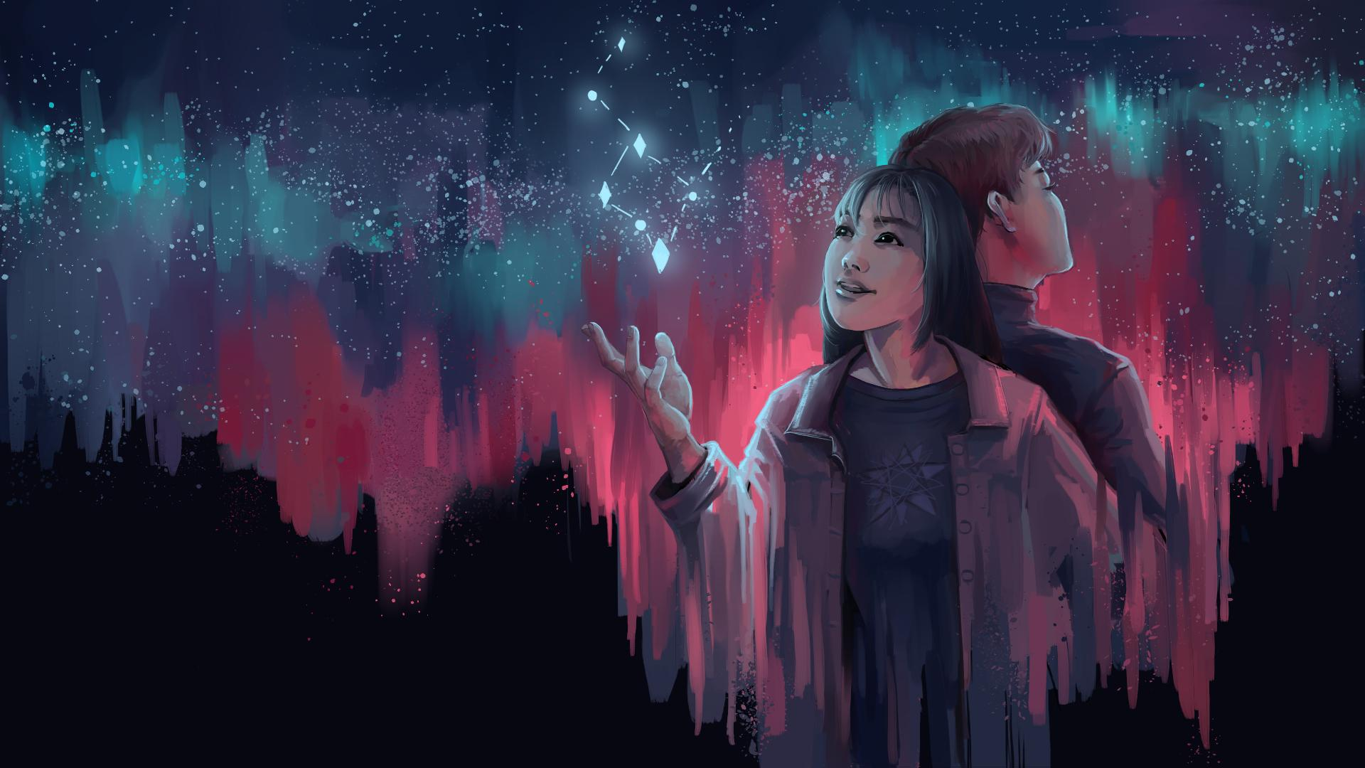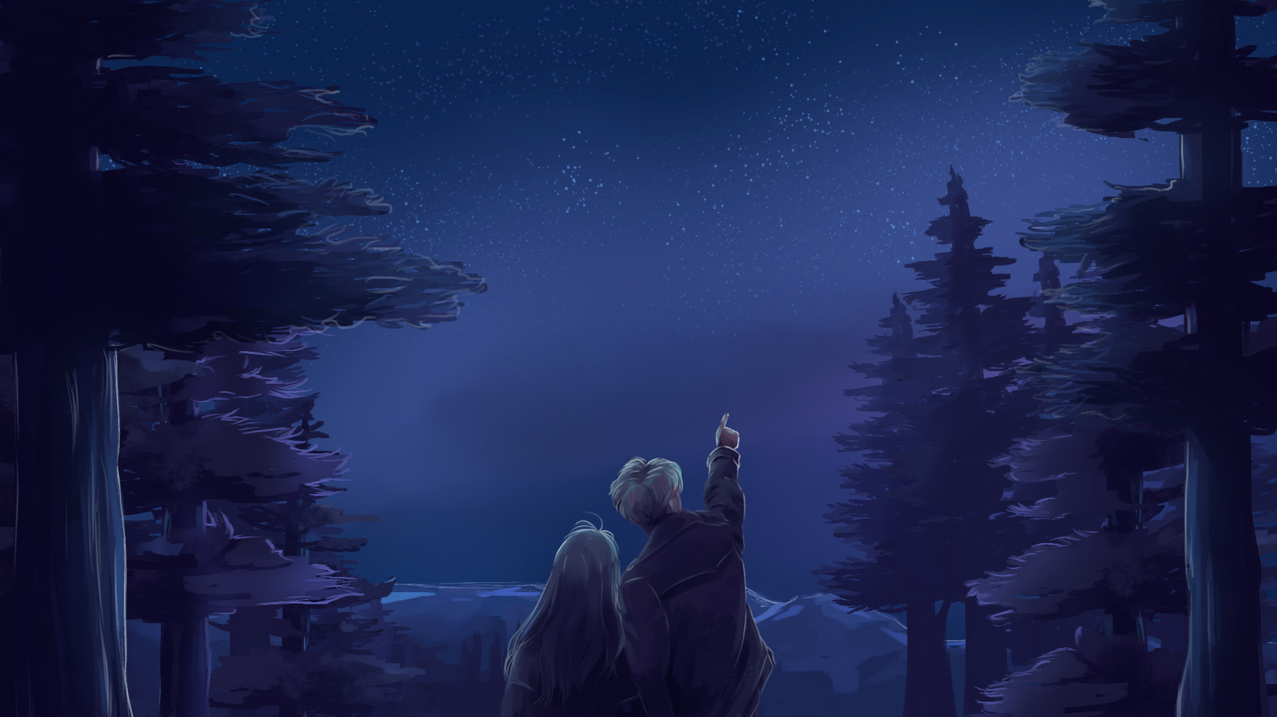

Los Angeles, California, United States of America -- January 18, 2021 -- Sondering Studios today released their first game, *The Space in Between*, for free on Steam (PC) and Itch (PC, Mac, Browser). Control the narrative of an emotional visual novel and dating simulator that features a poignant story about Asian American identity and mental health.

Indie studio Sondering Studios is headed by University of California, Los Angeles (UCLA) student Emily Pitcher, a Chinese American woman, and six of the seven other members working on *The Space in Between* are Asian American as well. Pitcher recognized that the few Asian roles in mainstream American gaming are samurai warriors or martial artists, so she wanted to create a project with contemporary representation. She hopes to make young creatives feel heard and pave the way for other women developers of color to tell their stories through gaming.

*The Space in Between* follows the love story between June, a spunky Chinese American college student trying to make sense of her complicated relationship with her immigrant mother, and Miles, a quiet artist who is recovering after a harsh past with mental illness. The player can affect the narrative by connecting stars to make constellations -- depending on what constellation the player forms, a different personal story is told. The game features two recommended playthroughs and original writing, art, and music.

Relive the first time you fell in love. Experience a nuanced perspective on the Chinese American experience and mental illness. Play *The Space in Between* for free on Steam and Itch.

Steam page (PC only): <https://store.steampowered.com/app/1430240/The_Space_in_Between/>  
Itch page (PC, Mac, Browser): <https://volcanogirl.itch.io/the-space-in-between>  
Press kit: <https://alanguan98.github.io/The-Space-In-Between>