**Gerber Generation: 2 Layer Board**

1. Open CAM Processor from Layout window: File->CAM Processor

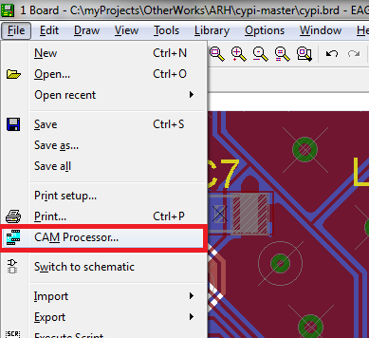

1. The CAM Processor window pops. By default, it will not have any settings:

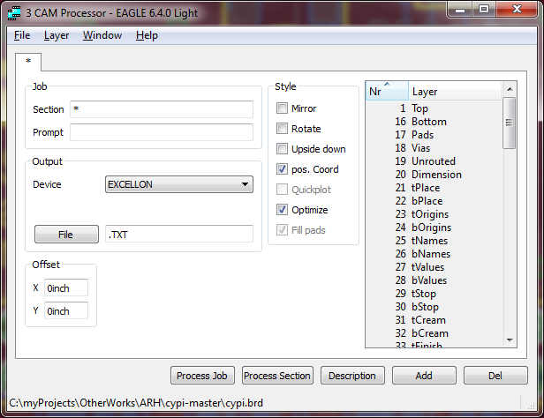

1. The layers can be generated manually or using a Job file. The layers of interest are:
   1. Top Copper – 1.Top + 17.Pads + 18.Vias + 20.Dimension
   2. Bottom Copper – 16.Bottom + 17.Pads + 18.Vias + 20.Dimension
   3. Top Silk – 121._tSilk
   4. Bottom Silk – 122._bSilk
   5. Top Paste – 31.tCream
   6. Bottom Paste – 32.bCream
   7. Top Solder Mask – 29.tStop
   8. Bottom Solder Mask – 30.bStop
   9. Drill File – 44.Drills + 45.Holes

**Note:** Some layers are optional based on the design and may be opted-out.

1. To use the Job File, open the file: File->Open->Job

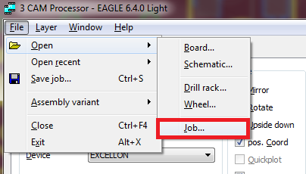

1. Find and select the required *.CAM file. In this case it is “cypi-gerb274x.cam”. The settings will load automatically.

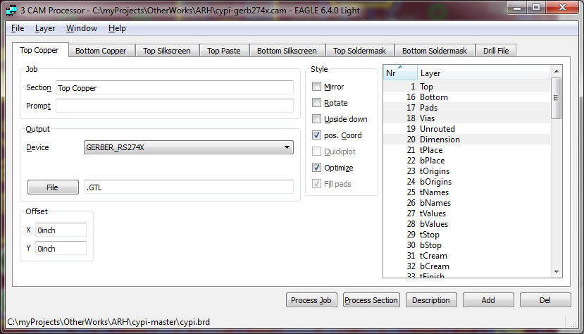

1. Verify whether you have all layers and correct Gerber data and press “Process Job” button. This will generate the requested Gerber data with file extension mentioned in “File” text-box of each Gerber layer.
2. The files will be generated in the same directory as the *.brd file. Now, copy the required files (pick based on file extension) and send for fabrication. The files can be verified using CAM tools like “G C Prevue”
3. The Job File above can be used as a template if you are generating Gerber manually. The following picture marks the fields of interest.

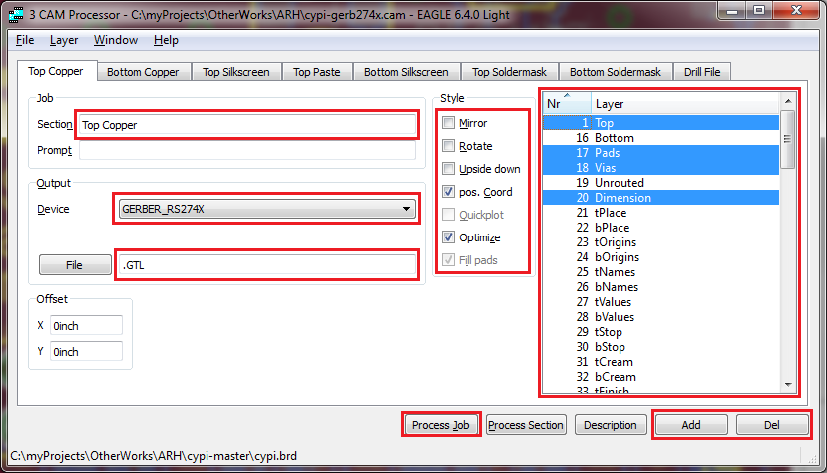

1. Details:

|  |  |
| --- | --- |
| **Field** | **Description** |
| Section | Name of the Gerber Layer. This appears on the tab corresponding to that layer. This is just for ease of understanding. |
| Device | This specifies which “device” to use for fabricating that layer.  Common Devices are:  All Layers: GERBER_RS274X  Drill File: EXCELLON |
| File | The extension to use while storing the Gerber data of that particular layer to disk. The extension always start with a dot (“.”), followed by the extension.  Common Extensions are:  Top Copper – “.GTL”  Bottom Copper – “.GBL”  Top Silk – “.GTO”  Bottom Silk – “.GBO”  Top Paste – “.GTP”  Bottom Paste – “.GBP”  Top Solder Mask – “.GTS”  Bottom Solder Mask – “.GBS”  Drill File – “.TXT” |
| Style | How the layer should be seen on the Gerber data. Common settings for all layers are: “pos. Coord” + “Optimize”  This uses optimized layer data with Positive Co-ordinates. |
| Layer | Select the combination of layers required on that particular Gerber layer data. Clicking on the layer name selects/deselects the layer.  Multiple board layers can be selected per Gerber data. |
| Add/Delete | Add – Adds a new Gerber layer. Creates a new tab.  Delete – Removes an existing Gerber layer. Deletes the open tab. |
| Process Job | Creates Gerber data and saves it as files in the same directory as the board (.brd) file. |