Verification of the Model for Refraction (Snell's Law)
Using a Glass Block
Aim: To investigate the relationship between the angle of incidence and angle of refraction, and to determine the refractive index of a glass block.

1. Equipment Required
- Rectangular glass block
- Laser
- White paper
- Pencil and ruler
- Protractor
- Set square (for constructing the normal accurately)

2. Diagram
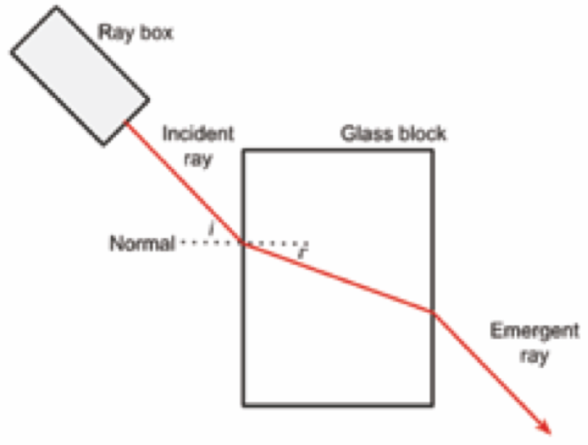

3. Data to Be Gathered and Variables
For each trial, measure the angle of incidence, i, and the corresponding angle of refraction, r. Calculate sin i and sin r for graphing.
Variable type | Variable | How it is treated
Independent | Angle of incidence, i (°) | Changed deliberately over a wide range (20° to 70° in the supplied data).
Dependent | Angle of refraction, r (°) | Measured for each value of i; sin r is then calculated.
Controlled | Glass material; light colour/wavelength; same face of the block | Use the same glass block and light source throughout, with the ray entering the same face.

4. Method
- Place the glass block on a sheet of white paper and trace carefully around the block with a sharp pencil.
- Choose a point on one face of the block where the light ray will enter. Use a set square to draw a normal at 90° to the surface at this point.
- Position the ray box so that a narrow incident ray strikes the glass block at the chosen point.
- Mark two well-separated points along the incident ray and two well-separated points along the emergent ray.
- Remove the glass block. Use a ruler to draw the incident and emergent ray paths. Join the entry and exit points through the traced block to show the refracted ray.
- Using a protractor, measure the angle of incidence i between the incident ray and the normal, and the angle of refraction r between the refracted ray and the normal.
- Repeat for several different angles of incidence, keeping the same glass block and light source.
- Record i and r in a table. Calculate sin i and sin r for every trial.
- Plot sin i on the y-axis against sin r on the x-axis and draw a line of best fit.
- Determine the gradient of the line of best fit. For air to glass, the gradient gives the refractive index of the glass.

5. Precautions
- Use a narrow ray and mark its centre consistently. A wide ray makes the exact ray path difficult to identify and increases uncertainty in the measured angles.
- Mark two points as far apart as practical along each ray. A small positional error then has less effect on the direction of the drawn ray.
- Construct the normal with a set square. Both i and r are measured from the normal, so an incorrectly drawn normal affects both angle measurements.
- Place the centre of the protractor exactly at the point of incidence and read the scale at eye level. This reduces alignment and parallax errors when measuring the angles.
- Avoid very small angles of incidence. The corresponding refraction angles are small, so a fixed angular uncertainty becomes a larger percentage uncertainty.
- Keep the glass block aligned with its traced outline. Movement of the block changes the entry/exit geometry and therefore the ray path.

6. Data

i (°) | r (°) | sin i | sin r
20 | 13 | 0.342 | 0.225
30 | 19 | 0.500 | 0.326
40 | 27 | 0.643 | 0.454
50 | 30 | 0.766 | 0.500
60 | 35 | 0.866 | 0.574
70 | 39 | 0.940 | 0.629

7. Graph: sin i versus sin r
Op. SALT check: Scale - both axes run from 0.0 to 1.0, with major divisions of 0.1 and minor gridlines every 0.02. Axes - sin r is on the x-axis and sin i is on the y-axis. Labels - both axes are clearly labelled. Title - the graph states what is plotted.
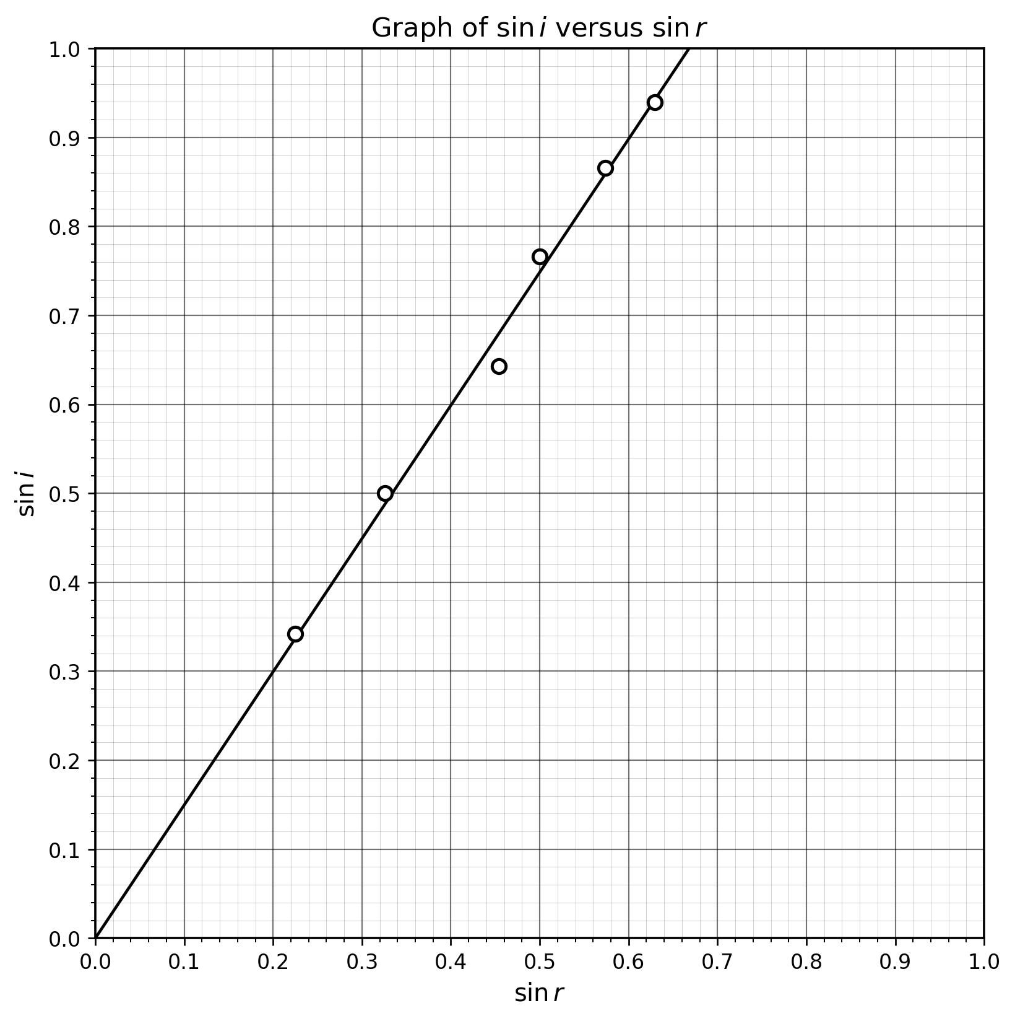
Figure 2. Graph of sin i versus sin r. The straight line is a line of best fit constrained through the origin, as predicted by the model.

8. Calculations
Example sine calculation:
For i = 20°: sin i = sin(20°) = 0.342
For r = 13°: sin r = sin(13°) = 0.225
Slope of the line:
Choose two widely separated points on the line of best fit, for example (0.00, 0.00) and (0.60, 0.90).
Slope = change in y / change in x
= Δ(sin i) / Δ(sin r)
= (0.90 - 0.00) / (0.60 - 0.00)
= 0.90 / 0.60
= 1.5
Therefore, refractive index of the glass, n ≈ 1.5.

9. Result and Analysis
- The plotted points show an linear relationship between sin i and sin r.
- The line of best fit passes through the origin, indicating that sin i is directly proportional to sin r.
- The Slope of the graph is 1.5.
- Because sin i is plotted on the y-axis and sin r on the x-axis, the Slope represents sin i / sin r. For light travelling from air into glass, this is the refractive index of the glass.
- The measured refractive index is therefore approximately n = 1.5.
- The small scatter of points around the line is consistent with measurement uncertainty in tracing rays and measuring angles.

10. Conclusion Using the PEER Framework
Point: The results show that sin i is directly proportional to sin r. The refractive index of the glass was found experimentally to be approximately 1.5.
Evidence: The graph of sin i against sin r produced a straight line through the origin. Using two widely separated points on the line of best fit, (0.00, 0.00) and (0.60, 0.90), the Slope was calculated to be 1.5.
Explanation: Snell's law predicts that sin i / sin r = n for light travelling from air into glass. Since sin i was plotted on the y-axis and sin r on the x-axis, the Slope represents the refractive index of the glass. The linear relationship and gradient of 1.5 are consistent with the prediction of the model. Therefore, the experimental evidence supports the model for refraction (Snell's law); the experiment does not prove the law.
Reflection: A limitation of the experiment was the finite width of the light ray. This made the exact centre of the ray difficult to identify, which introduced uncertainty when tracing the ray and measuring i and r. This could be improved by using a narrower light ray and marking two widely separated points along each ray, allowing the direction of the ray to be determined more accurately.

Framework to think and write about a limitation.
CAUSE: What specifically limited the measurement?
→ CONSEQUENCE: How could this affect the results?
→ IMPROVEMENT: What practical change would reduce this problem?

Cause | Consequence | Improvement
The light ray has a finite width. | It is difficult to identify the exact centre of the ray, creating uncertainty in the measured angles. | Use a narrower light ray and consistently mark its centre.
The points used to trace the ray are too close together. | A small error in the position of either point can cause a relatively large error in the direction of the drawn ray and hence the measured angle. | Mark two points as far apart as practical along the ray.
The normal may not be drawn exactly perpendicular to the glass surface. | Both i and r are measured relative to the normal, so an incorrectly drawn normal introduces error into the angle measurements. | Use a set square to construct the normal accurately at 90 degrees
Each angle is measured only once. | Random measurement uncertainty can have a significant effect on individual values and therefore on the graph. | Repeat each measurement and calculate the mean value of r for each i.
Only a small number of angles are measured. | There are fewer points with which to establish the trend and determine a reliable line of best fit. | Take more measurements across a wide range of angles.

