Exemplar Physics Experimental Report
  - Measuring the critical angle of glass and verifying n = 1/sin C

CHECKLIST 1. Aim
To measure the critical angle C for light travelling from glass into air, calculate the refractive index n of the glass using n = 1/sin C, and compare the result with an accepted value.

CHECKLIST 2. Equipment
Ray box with single-slit attachment, power supply, semicircular glass block, white paper, pencil, ruler and protractor.

CHECKLIST 3. Labelled diagram
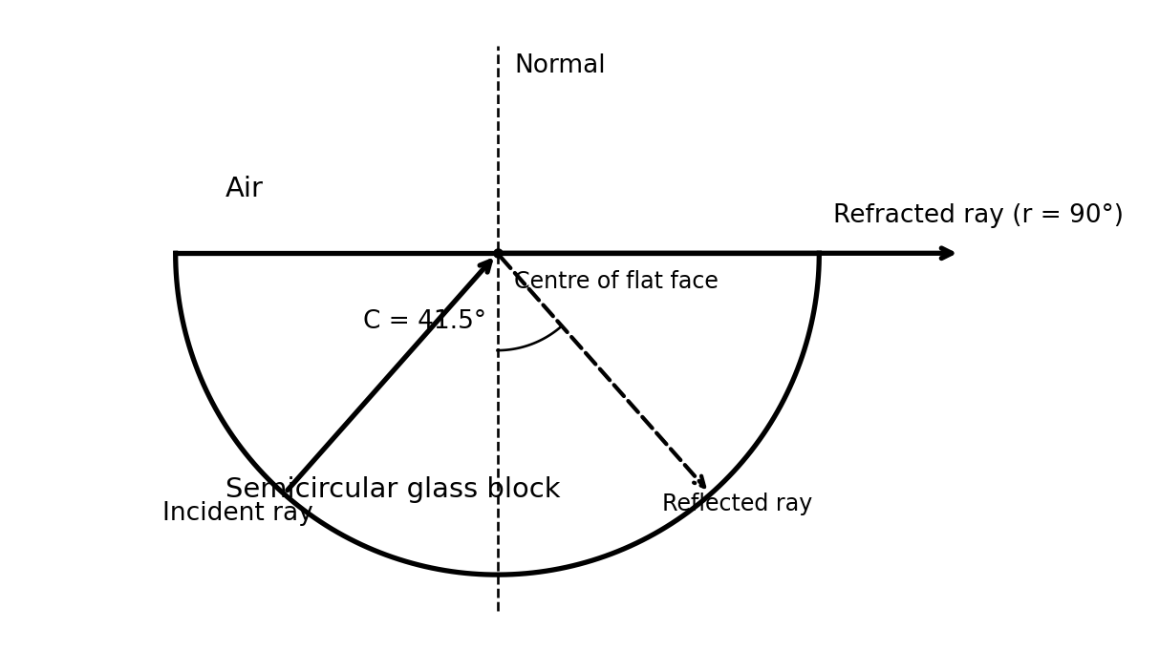
Schematic (not to scale). The ray enters through the curved face towards the centre, so it is approximately normal to that face. C is measured from the normal at the flat glass–air boundary.

CHECKLIST 4. Variables
Independent variable: angle of incidence at the flat glass–air surface, varied until the critical condition is reached.
Dependent variable: behaviour/direction of the emerging ray, used to identify the critical angle.
Controlled variables: same glass block and flat face, same ray-box setting and colour of light, block position and method of angle measurement.

CHECKLIST 5. Method
1. Place the semicircular glass block on white paper, trace its outline and mark the centre of its flat face.
2. Direct a narrow ray from the ray box into the curved surface towards the centre of the flat face.
3. Adjust the incident direction gradually and observe the ray at the flat glass–air boundary.
4. Find the position at which the refracted ray just travels along the flat surface (angle of refraction approximately 90°).
5. Mark the incident ray, the centre and the normal to the flat face. Remove the block and use a protractor to measure C between the incident ray and the normal.
6. Repeat the measurement five times, repositioning and realigning the ray each time. Record the results.
7. Calculate the mean critical angle, then calculate n = 1/sin C and compare with an accepted reference value.

CHECKLIST 6. Precautions
- Use a single narrow ray to make its direction easier to judge.
- Aim through the centre of curvature to minimise refraction at the curved face.
- Draw a thin, accurate normal at 90° to the flat surface.
- Measure C from the normal, not the surface.
- Keep the glass block on its traced outline and read the protractor at eye level to reduce parallax.
- Avoid looking directly into the bright light source.

CHECKLIST 7. Results
Trial | Critical angle C (°)
1 | 41.0
2 | 41.5
3 | 42.0
4 | 41.5
5 | 41.5
Instrument reading resolution: approximately 0.5° (estimated for this exemplar).

CHECKLIST 8. Graph
No graph is required for this method: the result is obtained from repeated measurements of a single critical angle, not from a relationship between two continuously varying quantities.
The graph criterion in the general checklist applies only when a graph is appropriate.

CHECKLIST 9. Analysis and calculations
Mean C = (41.0 + 41.5 + 42.0 + 41.5 + 41.5) / 5 = 41.5°
n = 1 / sin C = 1 / sin(41.5°) = 1 / 0.6626 = 1.51 (3 significant figures).
Using an illustrative accepted refractive index for crown glass of 1.52:
Percentage difference = |1.51 − 1.52| / 1.52 × 100 = 0.66%.
The refractive index has no unit. The accepted value depends on the type of glass and wavelength of light; 1.52 is a comparison value, not a certified value for this particular block.

CHECKLIST 10. Conclusion, evaluation and improvements — PEER
POINT — The measured critical angle of the glass was 41.5°, giving a refractive index of 1.51. The results support the relationship n = 1/sin C for a glass–air boundary.
EVIDENCE — Five measurements ranged from 41.0° to 42.0°. The calculated value of 1.51 is close to the illustrative accepted crown-glass value of 1.52 (0.66% difference).
EXPLAIN — At the critical angle, the refracted ray travels along the boundary, so r = 90°. From Snell’s law, n(glass) sin C = n(air) sin 90°. Taking n(air) ≈ 1 gives n(glass) ≈ 1/sin C.
REFLECT — The point where the emerging ray just grazed the surface was difficult to judge because the ray had a finite width. This could shift the measured angle and therefore the calculated n. A narrower ray and a larger, clearer protractor scale would reduce this uncertainty. Repeating the measurement and averaging helps reduce random variation, but cannot remove a consistent alignment error.
Limitation: this investigation provides one estimate for one glass block; agreement with a reference value supports, but does not prove universally, the model. A stronger test would repeat the procedure with other transparent materials and compare measured n with 1/sin C for each.
.

