X# from Scratch

Eric Selje

Salty Dog Solutions, LLC

* @EricSelje

www.SaltyDogLLC.Com

eric@saltydogllc.com

X# is on your radar but you're a little unsure how to get started? This whitepaper will walk you through building your first X# application. We’ll take a sample FoxPro application and convert it piece by piece to X# and demonstrate transferring our existing VFP skills to X#'s paradigms.

You will learn:

* How to take your first steps with X#
* How to access DBF files in X#
* How to create classes, forms, and reports in X#

# Introduction

In 2019 at Southwest Fox, I presented a high-level overview of X#, covering its origins and evolution up to its present state. X# is a very stable and mature product at this point, and perfectly capable of creating sophisticated datacentric Windows applications, or being the middleware for web-based ASP.Net apps. If you haven’t read my whitepaper from that session, I think it’d give you a good foundation. It’s at <http://saltydogllc.com/wp-content/uploads/SELJE-Look-at-X-Sharp.pdf>.

While X# has been around for years, what’s newer and exciting in X# is its support for the Visual FoxPro *dialect*. This support makes learning X# from a Visual FoxPro developer’s perspective as easy as, say, learning Spanish once you know Italian (I’m speculating here – I know neither!) There’s a lot in common and many cognates so you should be able to translate your skills to a product that is still supported and takes advantage of the .Net Framework rather than the old Win32 classes.

Putting together this session, the most difficulties I had were not with the language itself but navigating the differences between Visual FoxPro’s development environment and Visual Studio’s. If you’re experienced with Visual Studio that will be one less barrier for you to hurdle. And if you’re experienced with developing C# applications in Visual Studio, you’ll probably find X# to be extremely easy to pick up.

Aside: If you’re wondering, “Why should I even learn X# if I’m an experienced C# developer,” it’s because X# adds DBF handling capabilities natively into the language. You can create data handling classes in X# that are referenced by your existing C# classes.

Let’s get started! In this session we’re going to start with what we already know – a Visual FoxPro application that I put together. It’s not a real functioning application because I wanted an example that was small enough to translate but also included a lot of the features that we use in FoxPro and will want to use in X# as well.

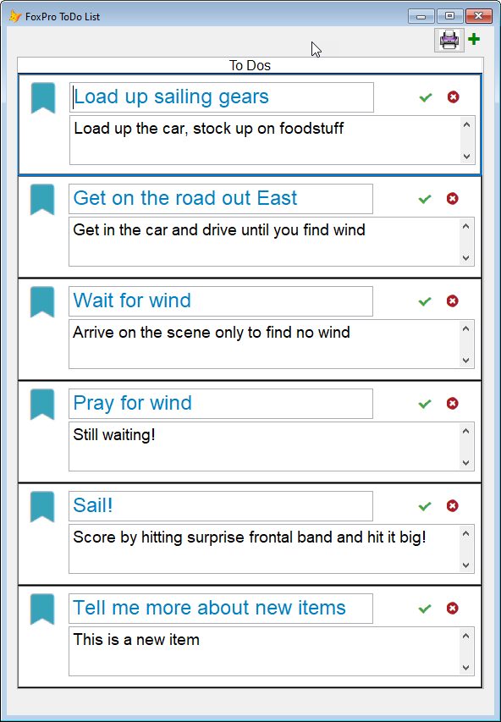

Figure 1: FoxToDos

# Our Sample Application

The original FoxPro app is a simple ToDo list manager, FoxToDos. If it looks familiar it’s because I borrowed the UI heavily from Rick Strahl’s Vue session. [Thanks Rick!] I even used the same DBF free table that he used because his To Do list is much, much cooler than mine.

You can grab the source code for FoxToDos at my GitHub account, <https://github.com/eselje/FoxToDos>.

Under the covers, our application consists of the parts shown here.

FoxToDos was not based on any application framework, so it’s simpler and less robust than any real application would ever be. It contains (in order):

* ToDos.dbf, the free table with our tasks.

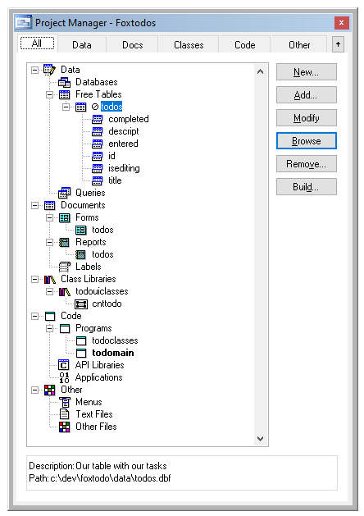

Figure 2: FoxToDos Project Structure

* ToDos.scx, a form that serves as the user interface and includes a grid that contains one custom control, cntToDo.
* ToDos.frx, a simple, wizard-generated report for those that like their tasks on paper.
* ToDoUIClasses.vcx, a visual class library , that has the cntToDo control we use in the grid on our form.
* ToDoClasses.prg contains our non-visual business objects. while has one user interface control, cntToDo, for presenting each task on the form cohesively. Lastly, we have a simple wizard-generated report Converting these to X# should be enough to give us a good feel for what the experience is like.
* ToDoMain.prg. A simple startup program that gets us going.

## Conversion Strategy

The steps we’re going to follow to convert this Visual FoxPro application to X# is:

1. Create a new project in Visual Studio
2. Rewrite the classes in ToDoClasses.prg as X# classes
3. Unit test those business objects inside of Visual Studio
4. Create a form in Visual Studio that uses those business objects to interact with the database, and also contains the equivalent of our user-interface composite control.
5. Create an application that has code to setup, run our form, and shutdown.
6. Look at possibilities for creating a report to output the tasks.

# The Development Environment

For developing in X#, you have three choices:

1. Use any editor you like (ahem, VI), and compile using the command-line compiler. I’ll leave it to the reader to explore this option.
2. XIDE, the X# integrated development environment that may be downloaded along with the rest of X#. XIDE is a perfectly serviceable environment and has a lot in common with Visual FoxPro’s IDE. It’s written in X# itself, so it provides a dramatic example of what the language can do in the right hands.
3. Visual Studio, either the Professional (ie paid) or Community (ie free) Edition. The big advantage of Visual Studio is that it’s used by a lot of developers all over the world, so it’s well-supported by its developer and the community. It has a ton of features but in my experience it’s also a bit of a dog performance-wise and is a resource hog. It’s a hog and a dog –a hot dog if you will. (If you laughed at that joke, shoot me an email and I’ll buy you a drink the next time I see you.)

Visual Studio Professional 2017 is the environment I’ll be using for this session. If you’re not familiar with Visual Studio, the X# Help File has an introduction on using X# in Visual Studio.

## Create a New Solution

In Visual Studio’s parlance, a “Solution” is the main structure for an application. It’s a collection of Projects, which are the main work units. It’s good practice to put business objects in their own Project and keep user interface elements in their own separate Project, because then the business objects can be re-used (i.e. “referenced”) in multiple Solutions.

To create a new Solution from scratch, choose File, New, *Project* from the menu. The dialog lets you specify the name of the Solution that will contain your new Project, and will create the solution for you. (If you wanted to create a new project as part of an *existing* Solution, you must open that Solution, and choose Add, New Project. See Figure 4).

Because we’ve installed X# already (an exercise left to the reader, but it’s a straightforward download and install from http://www.xsharp.info), we have XSharp Templates available to us.

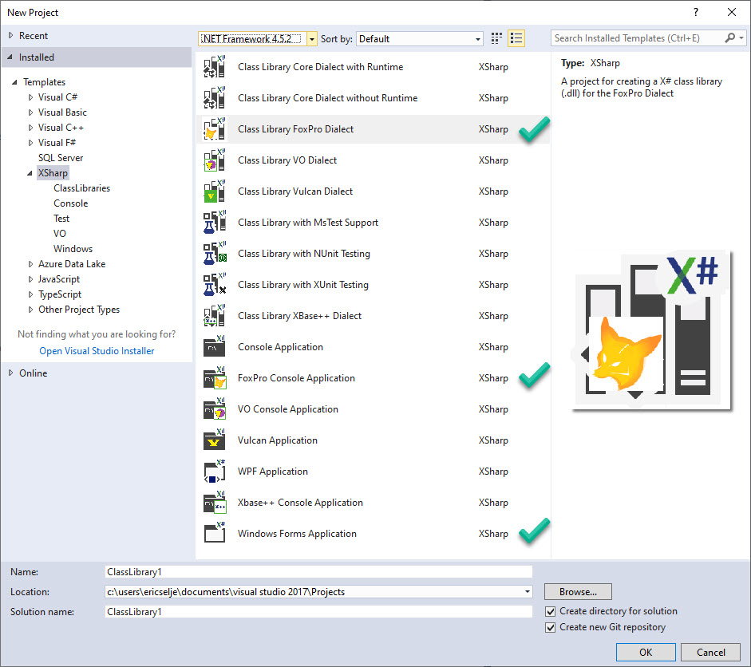

Figure 3: New Project dialog, with interesting Project Templates noted

What do Project Templates do for you?

Project Templates set certain properties (see Figure 4) of the project that are tweaked for that project type. They may also include code files and other assets that that type of project will typically use. For example, notice how the Dialect is automatically set to **FoxPro** after we create a Project based on the **Class Library FoxPro Dialect** template. Projects based on this template also contains one barebones PRG library to get us started (Figure 5) , but they could contain include as much as a complete application framework.

Visual Studio allows developers to create their own Project templates, much like Word and Excel allow you to create your own templates for documents and spreadsheets.

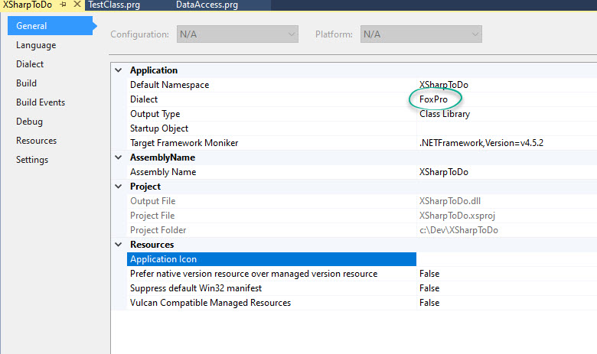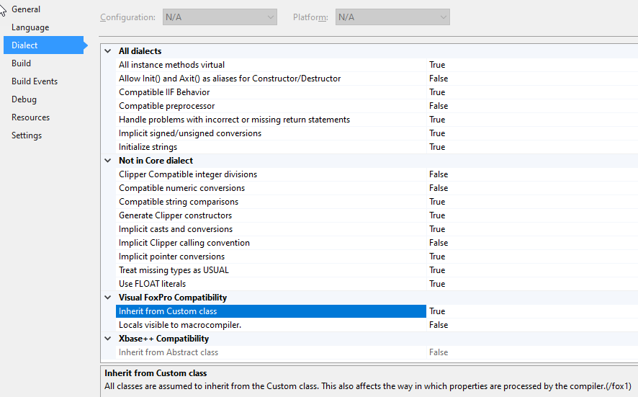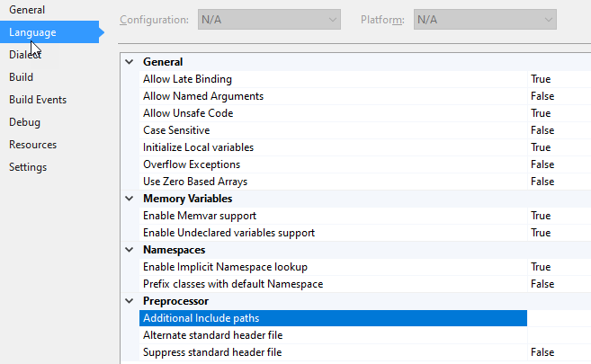

Figure 4: Project Properties, as set by the Project Templates

There are three Project Templates shown in Figure 3 that are of specific interest to us as FoxPro developers:

* **Class Library FoxPro Dialect**. A project of this type will have the FoxPro dialect pre-set in the General properties (see Figure 4) and include a barebones starter class definition.
* **FoxPro Console Application.** This also sets the dialect to FoxPro, but also sets the “Output Type” property to “Console Application”. This allows us to create command line utilities in a FoxPro dialect with proper Exit Codes, which was difficult using Visual FoxPro. Command line applications play well with development pipelines such as Jenkins, a Continuous Integration tool.
* Windows Forms (or WPF) Application

These aren’t FoxPro-specific, but we’ll be explore using these to create the user interface for our task list.

What’s interesting about the starter class from the template is that it uses syntax that doesn’t really look like FoxPro’s. The X# dev team has updated its understanding of VFP syntax now, but I suspect the templates were written before that was officially supported. We’ll see the updated syntax used in our translations later.

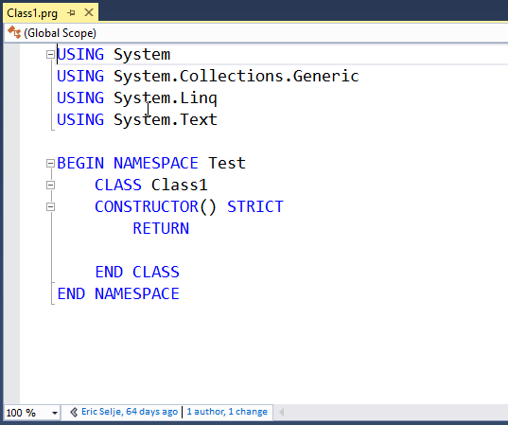

Figure 5: Starter Code from the Project Template

Pay extra special attention to the **Visual FoxPro Compatibility / Inherit from Custom Class** setting. If you want your code to behave the way it does in VFP, you want that set to True. Among other things, that causes X# to fire an Init() method (which wasn’t a thing in X# before, as they use Constructor()) and create virtual _access and _assign methods for our “properties” – more on that later.

The code for the classes we’re going to migrate is in Appendix A, for readability’s sake. You can download the FoxPro source code from my GitHub repository at <https://github.com/eselje/FoxToDos> and the final X# solution at <https://github.com/eselje/XToDos>.

This FoxPro class library includes two class definitions:

* ToDo, which manages an individual task, and
* ToDos, which manages a collection of the ToDo objects

Though I could have written this class library in a VCX (Visual Class Library), I chose to do it in straight code because it makes it easier to illustrate the transition to X#, which doesn’t have the concept of “Visual Classes” as we know them. All coding is done in text, which is a huge advantage when it comes to source control because there’s no need for any of the myriad workarounds that we had to implement in VFP to serialize our binaries. As we’ll see when we talk about forms, menus, and custom controls, there is a “visual” element to Visual Studio, but the source code itself is all text.

Disclaimer: Any imperfections or questionable design decisions that you find in this code may have been purposely included to illustrate some important point. Or they may just be an error. It’s hard to say.

## Converting Classes

ToDo => XtoDo

We’ll start with the ToDo class, which reads and writes individual tasks to the DBF file.

In FoxPro, we begin defining the class with

DEFINE CLASS **ToDo** AS Custom

Name = "ToDo"

cId = ""

oData = .null.

lNew = .f.

lSaved = .f.

lLoaded = .f.

oException = .null.in XSharp, we begin with

USING System

USING System.Collections.Generic

USING System.Text

BEGIN NAMESPACE XSharpToDo

DEFINE CLASS XToDo as Custom

public id as string

public title as string

public descript as string

public entered as datetime

public completed as boolean

private isEditing as boolean

###### Using

The initial X# using statements are somewhat akin to FoxPro’s set classlib toin that they tell the program, “Hey I have some code stored somewhere else that I’m maybe going to use here so make this available to me, and if I make a call to a function that you don’t recognize it may be in one of these classes.” There’s no requirement that you actually *do* use them, but if you refer to them the compiler is going to include them. In other .Net languages I’ve used, you could remove any unneeded usingby right+clicking and choosing “Remove Unused Usings” (an awkward phrasing, in my opinion), but that doesn’t seem to work on .prg files so you’ll want to remove any that you don’t use manually to shrink the size of your codebase.

.Net has a minimalist concept, along the lines of “If you want it, you gotta include it or it’s not going to be available.” System is the root namespace and includes what we might refer to as the “Base Classes” in VFP, but not the visual base classes that were included in _Classes.vcx, but the native data types such as strings, integers, etc. If you didn’t include System explicitly, you’d have to preface any of the classes that are in system each time you called them, so Console.Write() would have to be called as System.Console.Write().

Also notice that USING System does NOT include every sub-namespace of System. You have to explicitly use any library that you want access to. For a complete list of .Net’s native class libraries, see the (excellent) docs at <https://docs.microsoft.com/en-us/dotnet/standard/class-library-overview>.

###### Begin Namespace

Namespaces aren’t new to FoxPro developers, although we maybe didn’t refer to them as such. If you created an OLEPUBLIC class in Visual FoxPro, the name of the DLL you created would be its Namespace. You could then use that class from another program with CreateObject(“NameSpace.ClassName”).

By specifying the namespace in code with BEGIN NAMESPACE, .Net allows you to spread the code for classes among multiple files which makes it *much* easier to manage the source control. No more conflicts because one developer was refactoring an entire class when you only wanted to make a minor tweak to another class in the same class library!

The next few lines are very similar. .Net is strictly typed, so when you specify the class property you must specify the type too. Also, in VFP we have the very powerful SCATTER and GATHER command, allowing us to use one property, oData in my example, to dynamically store the field values, while in the X# class we don’t have that yet (UPDATE: This was released on Sept 20, 2020, in version 2.6, too late for me to implement!), so must explicitly name the fields.

###### Properties v. Fields

There is a fundamental difference in .NET classes vs Visual FoxPro classes. In VFP when we added what we called a “property” to a class, we could immediately assign values to that property without going through any hoops. This is bad, because there were no checks on the input at all, and anyone could read the value. We got around that by adding _access and _assign methods to the properties. The “visibility” of the property (public, protected, hidden) affected how whether other objects could see the properties, but had no effect on what values were visible within the class itself.

.Net classes call those “Fields” rather than properties, and their visibility is determined by whether they’re Public or Private. Public fields are akin to our Properties, but this isn’t recommended because all the reasons mentioned above.

Properties on a .Net class are the public-facing interface, akin to our _access and _assign, they have get() and set() methods, which filter the input to the fields or restrict the output.

Best Practice

Use PRIVATE fields and PUBLIC properties

In order to emulate Visual FoxPro’s class behavior, there’s an option for X# classes to “Inherit from Custom Class”, which is set to True by default in the FoxPro Project Templates. Under the covers, this Custom class emulates FoxPro Properties in .NET’s Fields.

###### Init() vs Constructor()

FoxPro’s classes all come with an Init() method that accepts parameters . You get exactly one Init per class and you must code around the possible combinations of parameters that were sent in. X# classes have a Constructor method, and you can overload them with different “*signatures”*: different combinations of parameters, which is awesome.

FoxPro

PROCEDURE Init

LPARAMETERS cId

This.cId = cId

IF EMPTY(cId)

This.New()

ELSE

This.Load(cId)

ENDIF

ENDPROCX#

public FUNCTION Constructor()   
// No Parameter. New Task.

This.New()

public FUNCTION Constructor(cId AS String)   
// Parameter. Existing Task  
 This.cId = cId

This.Load(cId)

In the FoxPro dialect, class definition in X# do have an init() method which you can use exactly like FoxPro’s.

When you create a task object, you either send it the ID of the task, or leave it blank if you want to create a new task. FoxPro’s init() handles that by inspecting the parameter and branching based on whether anything was passed in, but X# has the overloaded constructor that either takes an ID parameter or doesn’t. I find that much more intuitive.

The new() function highlights how similar X# can be to FoxPro, but also showcases the extra functionality you can get. The code we need to create GUIDs in .NET is available to us (in this cases, from System which we always include, but we have the entire universe of .NET libraries available to us and if for some reason we didn’t like this GUID library we could have referenced some other one instead.)

FoxPro

PROCEDURE New

LOCAL lUsed, oGUID

lUsed = This.OpenToDos()

oGUID = CreateObject("scriptlet.typelib")

SCATTER BLANK NAME This.oData MEMO

This.oData.Id =Strextract(oGUID.GUID, "{", "}" )

This.oData.Entered = DATETIME()

This.lNew = .t.

RETURN This.oData

X#

PROCEDURE New

LOCAL lUsed

This.Clear()

VAR g = GUID.NEWGUID()

This.id = g.TOSTRING()

this.entered = DateTime.Now

this.isEditing = true

this.isNew = .t.

RETURN This.oData

# Testing our Code

Now that we’ve got a couple of methods written for our X# class, we can check if it has errors in that time-honored tradition: Does it compile? Hit Ctrl+Shift+B to Build the solution and the Output window will display any issues it finds. DoubleClicking the row that has the issue will take you right to that code in the editor, or click on the error code to take you to a web page that can give you more information about that error.

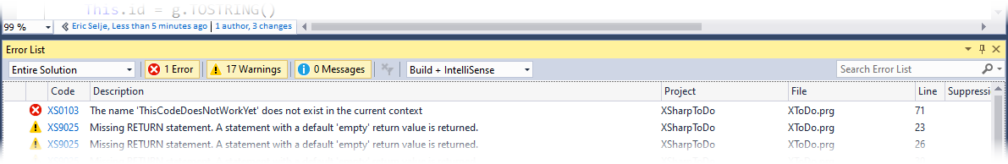

Once it compiles without any errors, we want to find a way to make sure it actually works.

## Command Window?

We FoxPro developers love to “test” our code by opening the Command Window, instantiating an instance of our class, and invoking the methods manually. If they didn’t do what we expected, we’d set a Breakpoint and walk through the code in debug mode.

Visual Studio doesn’t have a Command Window though. If you installed the XIDE environment you will get something *like* a Command Window called XSI, the X# Interpreter (there’s more on XSI in last year’s whitepaper.) Since we are using Visual Studio for this demonstration, we’ll instead create a quick Console Application that we can use to “test” our code.

To create the Console Application, Right+Click on the Solution, choose Add, New Project (See figure 6), base it on the **FoxPro Console Project** template (refer back to Figure 3), give it a name, add a reference to the library that we want to test (Figure 7), set our new project as the Startup project, and change the code to write our rudimentary test:

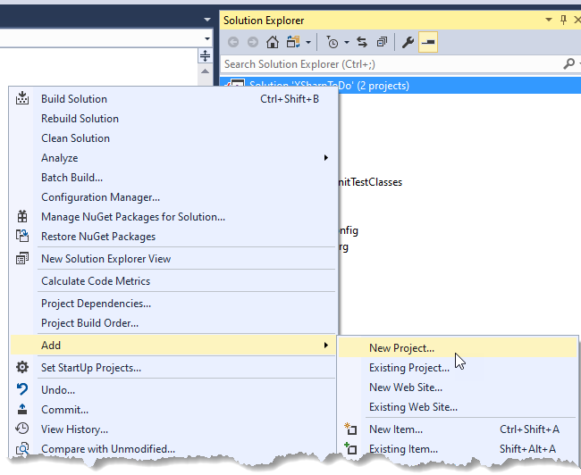

Figure 6: Add project to existing solution

FUNCTION Start() AS VOID STRICT

Var oToDo := createObject("XToDo")

oToDo.Load("1")

? oToDo.descript

WAIT

RETURN

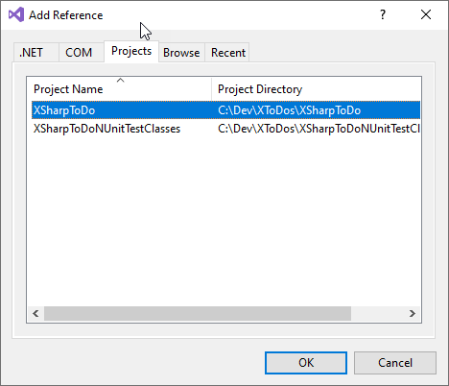

Figure 7: Add a Reference

After a few rounds of debugging your code (and as an experienced FoxPro developer you’ll have no difficulty grokking Visual Studio’s debugger), you should get the expected output in the Output window: 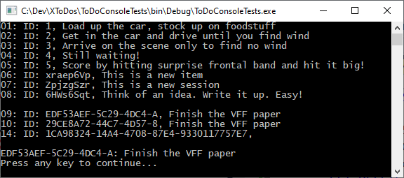

“But wait”, you say, “I see a Command Window right there when I’m running this app and you *just said* Visual Studio doesn’t have a Command Window! “

Don’t get too excited about this. This “Command Window” is only available while you’re actively debugging code, and it doesn’t even understand all of our FoxPro commands, so it’s not particularly useful (yet).

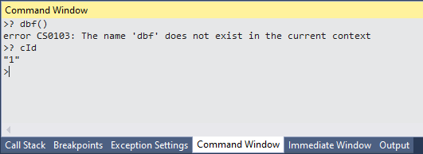

Figure 8: The Command Window

## Unit Tests

A better way to test your code is to write unit tests, and in fact true Test-Driven development would have directed us to write those even before we started coding. Without getting too deep into the semantics of why these aren’t true “unit tests”, let’s see how this might work.

With FoxPro there is one popular unit testing harness, FoxUnit. It’s a separate install (via Thor, ideally) and not integrated into the IDE at all.

Visual Studio on the other hand has testing built into the IDE from the ground up, and you have multiple testing frameworks to choose from. I chose Nunit to demo because it’s very similar to FoxUnit. In order to create tests, you add a New Project based on the **Class Library with Nunit Testing** to your solution (see Figure 3).

Next add a reference to the library we’re testing, XSharpToDo, just like we did with our rudimentary console testing app, and write a test:

[Test];

METHOD getToDo AS VOID STRICT

VAR oToDos := XSharpToDo.XToDos{}

IF oToDos.openTodos()

VAR oTodo := oToDos.getToDo("1")

VAR cExpected := "Load up sailing gear"

Assert.AreEqual(cExpected, oTodo.descript, "Did not get the right TODO")

else

Assert.Fail("Could not open TODOS.dbf")

ENDIF

RETURN

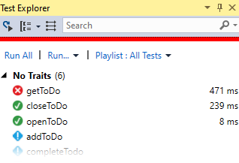That test now appears in the Test Explorer. When you run the tests, either individually or entirely (Ctrl+R, A) there’s a clear signal whether the test passed, failed, or hasn’t been implemented yet. It also indicates how long the test took to run, which is an early indicator of the performance of your methods.

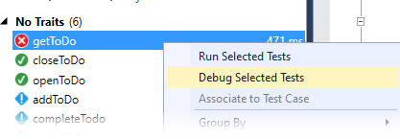If you’re having difficulty getting the result you expected from a test, select Debug Selected Tests in order to stop at the breakpoints that you’ve set. That is also when the Command Window will be available to you, as well as Locals and a Watch Window just like Visual FoxPro.

Now we know how to add and test methods to our XToDo class, and we can continue adding the rest of them. The code is straightforward. See **Appendix B** for the finished X# code for this class.

**Side Note:** One *very* frustrating problem I was having, and this is an Nunit problem and not an X# problem, is that I kept getting this message when trying to run my tests:



I am not the only person having this issue, and the only reliable solution seemed to be clearing out the Nunit cache (deleting the folder) at

%appdata%\..\Local\Temp\VisualStudioTestExplorerExtensions\<nUnitVersion>

and restarting Visual Studio. I may consider XUnit or MSTest in the future!

## Adding Another Class to our Namespace

In FoxPro we can, and usually do, stick all of our individual classes for a class library in either one VCX or one PRG. The name of our FoxPro project determined the NameSpace of our classes.

In .NET, this is discouraged. Each class in X# should be in its own codefile (.prg) and the classlibrary is its own project. This makes it much easier to determine which exact class was modifed when examing source code check-ins, and reduces file conflicts.

To add a new class to the Project, right-click on the Project and choose Add, New Item. You’ll get the Add New Item dialog (Figure 9). This shows the list of Item Templates, which are similar to Project Templates mentioned before except they only create one file rather entire projects (makes sense!).

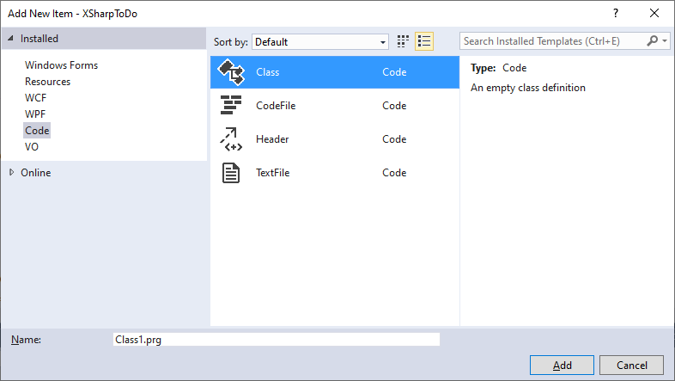

Figure 9: New Item Templates

Convention says to name your new .PRG with the name of the class you’re creating. The Namespace will default to the name of the Project, which is probably what you want, but you may change it if you like. You can have more than one Namespace in a project.

# The Startup Project

Earlier when we created the Console Project to test our software, we set that to be the Startup Project. Each application has to know what to do when you click Start, so somewhere in your Solution there must be at least one “Startup Project.” The Startup Project must have a class with a method called Start() to get things going for your application: setting up the environment and global variables, opening tables, invoking forms, etc. To set the Startup Project for your Solution, right+click on the Project and choose Set As Startup.

It is possible to set up multiple Startup Projects by right+clicking on the Solution and choosing Set Startup Projects. This might be useful if you want to, say, fire up an .ASP Net website when you start your Windows Form application.

The exception is if the Solution is a XAML Project, which we’ll talk about in the next section.

# Forms

Best Practice

PUT EACH CLASS IN ITS OWN CODEFILE

At this point our business logic is converted and tested, but this application does not yet have a proper user interface (the Console Project notwithstanding). We can choose from any number of user interfaces for our business classes, e.g. an Angular website or a mobile phone app, but a Windows Form is going to emulate our existing application closest.

There are two flavors of Windows Forms. The original WinForms at first glance seems to have a lot in common with Visual FoxPro forms. The design surface looks similar, and there is a toolbox with a lot of familiar controls like TextBox and CheckBox. But FoxPro forms were deceptively powerful, allowing you to include controls that were layers upon layers of composition and inheritance, and WinForms simply cannot match that power. Microsoft did say at one point that WinForms was not going to make the leap to .Net Core, the multiplatform version of the .Net framework. They have since walked back on that.

Then there’s the newer and more powerful WPF (Windows Presentation Format) forms.

The X# devs are working on a utility to convert FoxPro’s forms to either WPF or WinForms, but it’s not available yet. There can be an entire series of sessions in and of itself so we’re going to give the short version here for now and expand on this topic as time allows.

We want to put our user interface in a separate Project from our business classes. To create this new Project, right+click on the Solution and choose Add, New Project (see Figure 3). We will choose XSharp, WPF Application as a Project Template.

Our Visual FoxPro app consisted of only one form (way back in Figure 1). That form had a grid and a couple of buttons to complete a task and add a new task.

[WPF form information here]

## Binding our Events to Forms

## Binding Data to Forms

# Reports

I’m not aware of any tool that will convert FRX files to a .NET equivalent, though the X# developers do have that on their wish list. There is a paid product called ReportPro 3 that has a report designer that looks very similar to FoxPro’s. It has banding, grouping, summarizing, etc. While it does support DBF files, it does not import FRX files yet.

If your data is in a database like SQL Server, MySQL, or really anything except DBF, then there is a plethora of reporting tools available to you, such as Telerik Reports or the open source FastReport [not an endorsement of either one].

For outputting DBF data, I did see chatter on the X# forums about other attempts to work with FRX reports. One idea was to convert FoxyPreviewer, which is written in FoxPro, to X# itself. Another idea was to invoke FoxPro’s native runtime from within X# itself. Either way would require you to retain VFP to design or modify the reports. It turns out FoxPro was (is) powerful and hard to emulate!

# Other Development Considerations

## Databases

Besides the familiarity of the FoxPro-like syntax, the other compelling reason to choose X# as a development tool is its ability to use your existing DBF files, as shown. But X# can use a myriad of other databases, from SQLite to Oracle. A very popular backend, based on my perusal of the X# forums, is SQLAnywhere from Sybase. Anything that .NET can access through its System.Data library, which is vast and powerful.

## Frameworks?

In FoxPro we had a stable of application frameworks that we could choose from to give us a head start when creating programs from scratch. Names like Mere Mortals, ProMatrix, and CodeBook were often used. There are currently no application frameworks for X# based on the FoxPro dialect, but many C# applications frameworks like Oak Leaf’s MM.Net can be combined with X# business objects easily enough to get you further down the road.

## Source Control

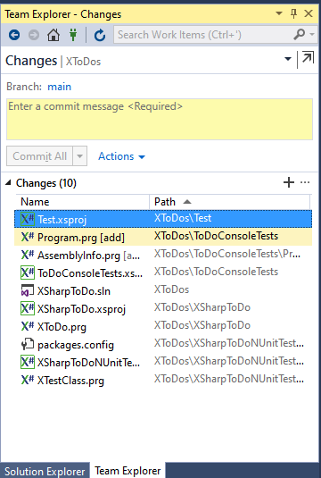One of the best features when working with a modern IDE like Visual Studio is its integrated source control. Many developers put in a lot of work to create utilities that would properly serialize/deserialize FoxPro’s binaries, and then added those tools to Thor to create as little friction as possible to manage source control, but nothing works as smoothly as the Team Explorer window. From here you can add, stage, commit to a local repository, and push to and pull from a remote repository. [Read Rick Borup’s whitepapers on Git for more information on what all that means if you need help.] Because there are no binaries in the code, there’s no need to serialize anything.

## External Libraries and IDE Add-Ons

If you like Thor and (and as a FoxPro dev, you should), you’re going to love Visual Studio’s equivalents. Thor is a visual manager that extends FoxPro’s IDE with utilities like GoFish5, Project Manager, PEMEditor, and FoxUnit. Visual Studio has the Visual Studio Marketplace (<https://marketplace.visualstudio.com/>) that has hundreds of extensions for Visual Studio.

VFPX is the central source code repository for many of FoxPro’s IDE utilities and additional class libraries, like FoxCharts and Log4VFP that you can use to embellish your applications. Nuget is the package manager for Visual Studio. It has thousands of class libraries you can take advantage of, and most of them are free. Everything from Payment Gateways to Entity Frameworks to entire Application Frameworks.

## Getting Help

If you need assistance while you’re learning X#, the best place to start is [www.xsharp.info](http://www.xsharp.info). You can easily get there by choosing Help, Xsharp Website from the Visual Studio menu. There are active user forums on there, and a specific one just for FoxPro migrators. The core group of developers jump in quickly to answer questions.

The Help File that comes with the X# download is also quite good. It will remind you of Visual FoxPro’s help file. You can find it either on your Start Menu or choose Help, XSharp Documentation in Visual Studio.

# Conclusion

This session barely covers all of the power and awesomeness of Visual Studio and coding in X# and the .NET Framework. I hope this walkthrough of converting a simple FoxPro app to X# has been enlightening. In my limited experience I think X# provides a very nice entré into understanding .NET development. I also think it’s important to get that, though X# gives you access to FoxPro-like syntax and concepts that give you an anchor into your development history, you’re not constrained to that – the entire .NET framework is available to you.

X# is never going to be able to take your existing FoxPro code and just compile it – it will take effort on your part. But it’s really not that difficult and it will give you the opportunity to revisit and refactor your code, as well as add robustness through unit tests and integrated version control.

The FoxPro compatibility has made impressive strides since I wrote the 2019 session. X# is open source, and while other developers in our community are contributing, the focus of the core of developers will be the wish list of the people who pay to be members of Friends of X#. Hey, they have to pay the bills! If you’d like to see development focused on the FoxPro compatibility features, you will want to support them with a membership.

## Credits and Bibliography

Twitter icon from Icons made by [Smashicons](https://www.flaticon.com/authors/smashicons) from [www.flaticon.com](https://www.flaticon.com/authors/smashicons)

<https://docs.microsoft.com/en-us/windows/apps/desktop/visual-studio-templates>

<https://fox.wikis.com/wc.dll?Wiki~GUIDGenerationCode~VB>

<https://docs.microsoft.com/en-us/dotnet/csharp/programming-guide/classes-and-structs/fields>

<https://www.xsharp.info/itm-help/foxpro-compatibility-list>

<https://www.wpf-tutorial.com>

For an interesting philosophical discussion on the future of Fox-based development in general: <https://support.west-wind.com/Thread5U70W2EQW.wwt>

# Appendix A: The Original FoxPro Classes

* Collection of ToDos

DEFINE CLASS **Todos** AS Custom

DIMENSION aToDos[1] && Array of ToDo Objects

nTodos = 0

cTableName = "data\ToDos"

PROCEDURE Init

SET EXCLUSIVE OFF

PROCEDURE OpenTodos

IF NOT USED(This.cTableName)

USE (This.cTableName)

ENDIF

RETURN USED(This.cTableName)

PROCEDURE Load

LOCAL n

This.OpenTodos()

SET DELETED ON

COUNT TO This.nToDos

DIMENSION This.aToDos[This.nToDos]

n = 1

SCAN

This.aToDos[n]=CREATEOBJECT("Todo", id)

n = n + 1

ENDSCAN

This.CloseTodos()

RETURN This.nToDos

PROCEDURE New

This.nTodos = This.nTodos + 1

DIMENSION This.aToDos[This.nToDos]

This.aTodos[This.nTodos] = CREATEOBJECT("Todo")

This.aTodos[This.nTodos].Save()

RETURN This.nToDos

PROCEDURE CloseToDos

LPARAMETERS lLeaveOpen

IF NOT lLeaveOpen

USE IN SELECT("ToDos")

ENDIF

PROCEDURE Complete

oToDo =CREATEOBJECT("ToDo", ToDos.id)

oToDo.oData.Completed=.t.

RETURN oToDo.Save()

PROCEDURE Delete

oToDo =CREATEOBJECT("ToDo", ToDos.id)

RETURN oToDo.Delete()

ENDDEFINE

* Individual ToDo

DEFINE CLASS **ToDo** AS Custom

Name = "ToDo"

cId = ""

oData = .null.

lNew = .f.

lSaved = .f.

lLoaded = .f.

oException = .null.

PROCEDURE Init

LPARAMETERS cId

This.cId = cId

IF EMPTY(cId)

This.New()

ELSE

This.Load(This.cId)

ENDIF

ENDPROC

PROCEDURE New

lUsed = This.OpenToDos()

SCATTER BLANK NAME This.oData MEMO

This.lNew = .t.

This.CloseTodos(lUsed)

RETURN This.oData

PROCEDURE Load

LPARAMETERS cId

LOCAL lUsed

cId = EVL(cId,This.cId)

IF NOT EMPTY(cId)

TRY

lUsed = This.OpenToDos()

LOCATE FOR id = cId

IF FOUND()

SCATTER NAME This.oData MEMO

This.cId = cId

This.lLoaded = .t.

This.lNew = .f.

ENDIF

CATCH TO oEx

This.oException = oEx

FINALLY

This.CloseTodos(lUsed)

ENDTRY

ENDIF

RETURN This.lLoaded

PROCEDURE Save

LOCAL lUsed

This.lSaved = .F.

IF This.lLoaded OR This.lNew

lUsed = This.OpenToDos()

TRY

IF This.lNew

* There are many ways to create a GUID, including calls to CoCreateGUID in Ole32.dll, but this is easy. From https://fox.wikis.com/wc.dll?Wiki~GUIDGenerationCode~VB

LOCAL oGUID

oGUID = CreateObject("scriptlet.typelib")

This.oData.Id = Strextract(oGUID.GUID, "{", "}" )

This.oData.Entered = DATETIME()

INSERT INTO ToDos FROM NAME This.oData

This.cId = This.oData.Id

ELSE

LOCATE FOR id = This.cId

GATHER NAME This.oData MEMO

ENDIF

This.lSaved = .t.

This.lNew = .f.

CATCH TO oEx

This.oException = oEx

FINALLY

This.CloseTodos(lUsed)

ENDTRY

ENDIF

RETURN This.lSaved

PROCEDURE Delete

LOCAL lUsed, lReturn

IF NOT EMPTY(This.cId)

lUsed = This.OpenToDos()

LOCATE FOR id = This.cId

lReturn = FOUND()

IF lReturn

DELETE

ENDIF

This.CloseTodos(lUsed)

ENDIF

RETURN lReturn

PROCEDURE OpenTodos

LOCAL lUsed

lUsed = USED("ToDos")

IF NOT lUsed

USE data\ToDos IN 0

ENDIF

SELECT ToDos

RETURN lUsed

PROCEDURE CloseToDos

LPARAMETERS lLeaveOpen

IF NOT lLeaveOpen

USE IN SELECT("ToDos")

ENDIF

ENDDEFINE && ToDo

# Appendix B: The X# Classes