The effects of Short Sale Circuit Breaker and the Efficiency of Stock Market: Evidence from SEC Rule 201

# Introduction

Regulation SHO (Reg SHO) provides a new regulatory framework governing short-selling of securities in U.S. equity markets. The rules became effective on May 10, 2010 (Securities Exchange Act Release No. 61595 (Feb. 26, 2010), 75 FR 11232 (Mar. 10, 2010) (“Rule 201 Adopting Release”)) with a compliance date of November 10, 2010. Unlike the market-wise circuit breaker, this approach establishes a narrowly-tailored Rule that will target only those securities that are experiencing significant intra-day price declines. The Securities and Exchange Commission (SEC) believes that the short-sale circuit breaker will “prevent short selling, including potentially manipulative or abusive short selling, from driving down further the price of a security that has already experienced a significant intra-day price decline” and “help address erosion of investor confidence in our market generally”.

In this paper, we study the effect on market efficiency of the SEC’s newly adopted short-sale circuit breaker. The circuit breaker will be triggered if the price of the covered security[1] decreases by 10% or more from its closing price of the last trading day. Once triggered, short sale orders of the covered security at a price that is less than or equal to the current national best bid[2] will be halted. However, broker-dealers can submit a “short exempt” order at a price that is above the current national best bid. The circuit breaker will remain effective for the remaining regular trading hours of that trading day and the following trading day.

# Literature Review

### Why is short-sale important?

Diether, Lee, and Werner (2008) find that short sales represent 31% of share volume for Nasdaq-listed stocks and 24% of share volume for NYSE-listed stocks in 2005.

Jones and Lamont (2002) find evidence supporting that expensive to short stocks are overpriced; stocks that have high shorting demand have low subsequent returns; short sale-related costs mean that stocks can become overpriced because the expected short sale return must compensate for both the true value of the stock and the short sale-related costs.

### The effects of previous short-sale restrictions

Boulton and Braga-Alves (2010). Policymakers should take a second thought when considering further short sale restrictions. The July 2008 Emergency Order by the SEC restricted naked short sales of the stocks of 19 financial firms brings many negative effects. The restriction successfully eliminated naked short sales for the restricted stocks, but other closely matched financial firms received dramatic increase in naked short sales. The negative impact also spreads to bid-ask spreads, trading volume, and various liquidity measures.

Autore et al. (2011). The 2008 short sale ban has more negative impact on stocks with larger liquidity declines. This effect is even stronger for more liquid stocks. The restricted stocks exhibit positive abnormal return.

Harries et al. (2013). The prices of the banned stocks are estimated to be inflated by 10-12%. The amount of money transferred from buyers to sellers due to the short-sale ban is conservatively estimated to be between $2.3 to $4.9 billion. This creates a bias toward long-sellers, which is inconsistent with fair markets.

Battalio and Schultz (2011). Financial regulators need to consider the impact of short selling regulation on derivative markets. The September 2008 short sale ban dramatically increased bid-ask spreads for options on banned stocks, the trading costs of these stocks also raise sharply, making it more difficult for investors to hedge related risks or speculate on a rebound in financial stock prices.

Kraus and Rubin (2003). In an economy with short sale restrictions, the equilibrium price of risky asset is higher than in an unconstrained economy. Concerning volatility, whether it will increase after relaxing the constraints depends on the variability of information and other exogenous economic variables.

Bai, Chang, and Wang (2006). Short sale constraints affect the market in two ways: limiting the trades for risk sharing and private information. However, their effects on the market is opposite to each other. Limiting trades for risk sharing increase the total asset demand. Leading to an increase in asset price as well as volatility. On the other hand, limiting trades for private information sharing will prevent negative information from flowing to the market, causing investors to perceive a lower risk of the asset. This drives the asset price and volatility downwards.

Alexander and Peterson (1999). The Uptick Rule hinders price discovery in both advancing and declining markets. They suggested an alternative form of the Uptick Rule, which only takes effects in declining markets. It sounds very similar to the alternative uptick rule. They also questioned whether the Uptick Rule itself is necessary. Because as SEC stated, the objective of the rule is to avoid price manipulation, especially the downside risk. However, price manipulation can also occur with purchases, the SEC did not introduce a “Downtick Rule”. What makes short sale so special? ~~Is it the public pressure?~~ The reason is, when you manipulate a stock’s price downward, the investors who own the stock *lose* money and they are not happy about it; however, on the other hand, if you manipulate the price upwards, current stock owners *gain* money, there is not much they can complaint about.

### Is short-sale a bad thing?

Diamond and Verrecchia (1987). Some papers suggest the unexpected increase in the short interest of a stock is a bad thing. Short-constraints can influence the rate at which private information is revealed to the public through observable trading, especially with respect to private bad news. They imply that periods of the absence of trade are bad news because they indicate an increased chance of informed traders with bad news who are constrained from selling short.

Senchack and Starks (1993) find that unusual increase in short interest is non-informative; stocks with options are less impacted by the unexpected short increases.

Daske et al. (2005). Short sale transactions are not concentrated prior to bad news events. No evidence indicating that short sales are based on private information.

Figlewski (1981). Because of the existence of short-sale restrictions, stocks with relatively more adverse information among investors tend to be overpriced. The number of shares of a stock sold short (the “short interest”) can be used as a proxy for the amount of negative information held by investors. A major problem concerning this issue is the use of options. Investors can by-pass the restrictions by buying put options or writing call options. A strategy buying only stocks with low short interest earns statistically significant excess returns. Test for 3 trading portfolios: a long portfolio of stocks with lowest short interest, a short portfolio of stocks with highest short interest, and an arbitrage portfolio combining the first and the second portfolio.

Boehmer, Jones, and Zhang (2008) investigate the short sales during 2000-2004 and find short sales not only account for more than 12.9% of trading volume on average but also are extremely well informed.

# Data Description

This study is based on the intraday price tick data, daily order placement, and daily option trading data. The time should range from 2004 to 2013 (3 years for Uptick Rule period, 3 years for the repeal period, and 3 years for short-sale circuit breaker period). The intraday price tick data can be obtained from Bloomberg terminal, and the daily order placement are recorded in NYSE TAQ data set. The option data is collected by CBOE. The TAQ and option data can be downloaded from WRDS.

Requirements:

daily price; daily market return;

intraday price ticks (midquote volatility)

(daily) # of shares shorted; # of short orders; monthly shares outstanding; monthly short positions; daily trading volume;

(Daily) # of long orders; # of shares sold long; placement time; execute time; execute ratio;

Monthly short shares outstanding (for calculating short interest).

option price; option volume;

|  |  |  |
| --- | --- | --- |
| data | source | Time Availability |
| Daily price/market return | WRDS | 1953 - now |
| Intraday quotes | TAQ | May 2008 – Dec 2011 |
| Daily short sales | NSX | Jan 2006 - now |
| Daily long orders | TAQ | May 2008 – Dec 2011 |
| Daily option | Option metrics | 1996 - now |

# Methodology

## Hypotheses

The abandon of the Uptick Rule and the introduce of the Short-sale Circuit Breaker offers a perfect time to compare the effects of difference level of short-sale constraints. First, we have the long-existed Uptick Rule since 1938; then the Uptick Rule was repealed in 2007, leaving no restrictions for short-sales at all (there was an emergency short sale ban on financial firms in 2008 but we will exclude that period from our data); in 2010, the SEC introduced the short-sale circuit breaker, also known as the “alternative uptick rule”. Thus, it is possible to closely compare the effects of difference short-sale restrictions, from the strictest Uptick Rule to the moderate Short-sale Circuit breaker to no restriction at all.

Bai et al. (2006) develop a rational expectations equilibrium model to investigate the ability of investors to trade risks and speculate on private information in a short-sale constrained market, they conclude that the presence of short-sale constraints can both increase and decrease volatility. Kraus and Rubin (2003) state whether the short-sale restrictions will reduce the volatility depends on the exogenous economy variables.

### 1 Effects on volatility (Good)

#### 1.1 General Volatility measures

This paper first questions whether the short-sale circuit breaker can reduce the volatility of the covered stocks, especially when a stock experienced a significant intraday price decline. Bai et al. (2006) and Kraus and Rubin (2003) develop economical models and conclude that short-sale restrictions can both increase and decrease the volatility, depending on other factors. Three measures of volatility are presented. They are the standard volatility, the semivariance, and the intraday volatility.

The standard volatility is calculated as the variance of the return. The semivariance volatility includes two parts. The intraday volatility is the variance of the price ticks of the stock during the trading day. (Or use midquote volatility which is essentially the k-minute return, k=5, 15, 30).

---

For each measurement, the data is winsorized to delete the lowest and highest 1 percentile.

The Pre and Post column reports the time-series average of the cross-sectional average of each variance measure in the pre- (January 1, 2007 – November 10, 2010) and post-circuit breaker period (November 11, 2010 – December 31, 2013).

The diff. Column represents the coefficients estimates of a circuit breaker dummy variable from a time-series regression of an intercept (not reported) and the dummy on each measure. The circuit breaker dummy takes a value of one when the date of the observation is after the compliance date of the breaker, which is 10 November, 2010, and zero otherwise. The test t-statistics of the dummy are displayed in the parenthesis.

The time-series daily volatility is calculated as the variance of the return. The pre and post period are calculated separately. The diff. Column for this measure is calculated as the post minus the pre.

The close-close volatility is calculated as the square of daily returns based on closing prices. The positive(up) semivariance is calculated as  and the negative (down) semivariance is calculated as , where $N$ is the number of observations and Xt is the daily closing price from CRSP. The intraday volatility is calculated using the Parkinson number approach introduced in Parkinson (1980); which is the natural logarithm of the daily high price divided by the daily low price. The significance could be calculated using Newey-west standard errors to correct for heteroscedasticity.

|  |  |  |  |  |
| --- | --- | --- | --- | --- |
|  | Pre | post | Diff. | OBS |
| Volatility(time-series daily) | 0.0010864 | 0.0005883 | -0.000498 | 4400(pre)  4408(post)  securities |
| Volatility(close-close) | 0.00094049 | 000532 | -0.00040844(-13.38) | 1761 |
| Semivariacne (up) | 0.00037338 | 0.000236 | -0.00013748(-8.59) | 1761 |
| Semivariance (down) | 0.00039939 | 0.000238 | -0.00016130(-8.38) | 1761 |
| Intraday(Parkinson) | 0.03976 | 0.02846 | -0.01130  (-19.06) | 1761 |
| # Obs. |  |  |  |  |

Since the short-sale circuit breaker is significantly less restrictive than the Uptick Rule, one could expect an increase in volatility (Diff13>0). The circuit breaker only triggers when the price of a stock declines by 10% or more from that last closing price, thus it should be fairly rare to happen. This should have little impact on the market comparing to the 2007-2010 period which has no short-restriction at all. Thus, the difference between the two is expected to be small and insignificant.

Extensive investigation can be performed on portfolios sorted on size, price, volatility, and turnover.

Methodology:

1. Select firms that exits constantly from 2007-2013.   
   use sql to count for monthly return observations. If it doesn't match 7*12=84, delete it. DONE.**✓**
2. Collect the PERMNO of the remained firms. DONE.**✓**
3. Download the daily close, high, and low price.DONE.**✓**
4. Calculate the standard volatility. DONE**✓**
5. Calculate the semivariance. DONE**✓**
6. Calculate the intraday volatility with Parkinson's approach. DONE.**✓**
7. Calculate the diffs.**✓**
8. Calculate the Newey-West standard errors.

#### 1.2 The downside volatility of the covered stocks is less than or equal to 10%.

Description: Because when the SSCB is effective, short sellers can only place orders at or above the NBBO price, I hypotheses that it's harder for the price of a stock to reverse (because of the piled short-orders above) and dive deeper (because short orders as a driving force is eliminated). Thus, the volatility is much smaller when the breaker is on. The breaker is effective if price declines 10% or more from the closing price of the last trading day.

This alternative version of the 10%-constraint hypothesis shown above is essentially derived from the same idea that the circuit breaker will restrain the downside volatility to 10%.

Description: The SEC introduced this rule to prevent another “flash crash” from happening, or more generally, prevent extreme downside volatility. If the downside volatility is mainly caused by short sellers, then the circuit breaker, when triggered by a 10% intra-day price declination, will prevent short-sellers from pushing the price further down and should be able to restrain the downside volatility of covered securities to nearly 10%.  
*Comment by Lorne: This is more of an empirical expectation than a hypothesis- but certainly needs to be documented in the analysis - and would make a valuable contribution.*

Methodology:   
a) Define events as a stock triggers the breaker. Collectively, the downside volatility is not significantly different from 10% for a) that day and b) the next trading day.  
B) Draw a regression of the volatility distribution pattern. And there should be some unusual bumps around 10% because of the presence of the breaker.

Assuming that the price decline is primarily caused by short sells. Logically, the breaker stands at the 10% downside volatility criterion would behave like a magnet that "attracts" the volatility of a lot of stocks to stay around it. When demonstrated in a volatility frequency distribution chart, I expect to see some results like the following. Particularly, there is likely to be an unusual bump around the 10% criterion where the circuit breaker stands.

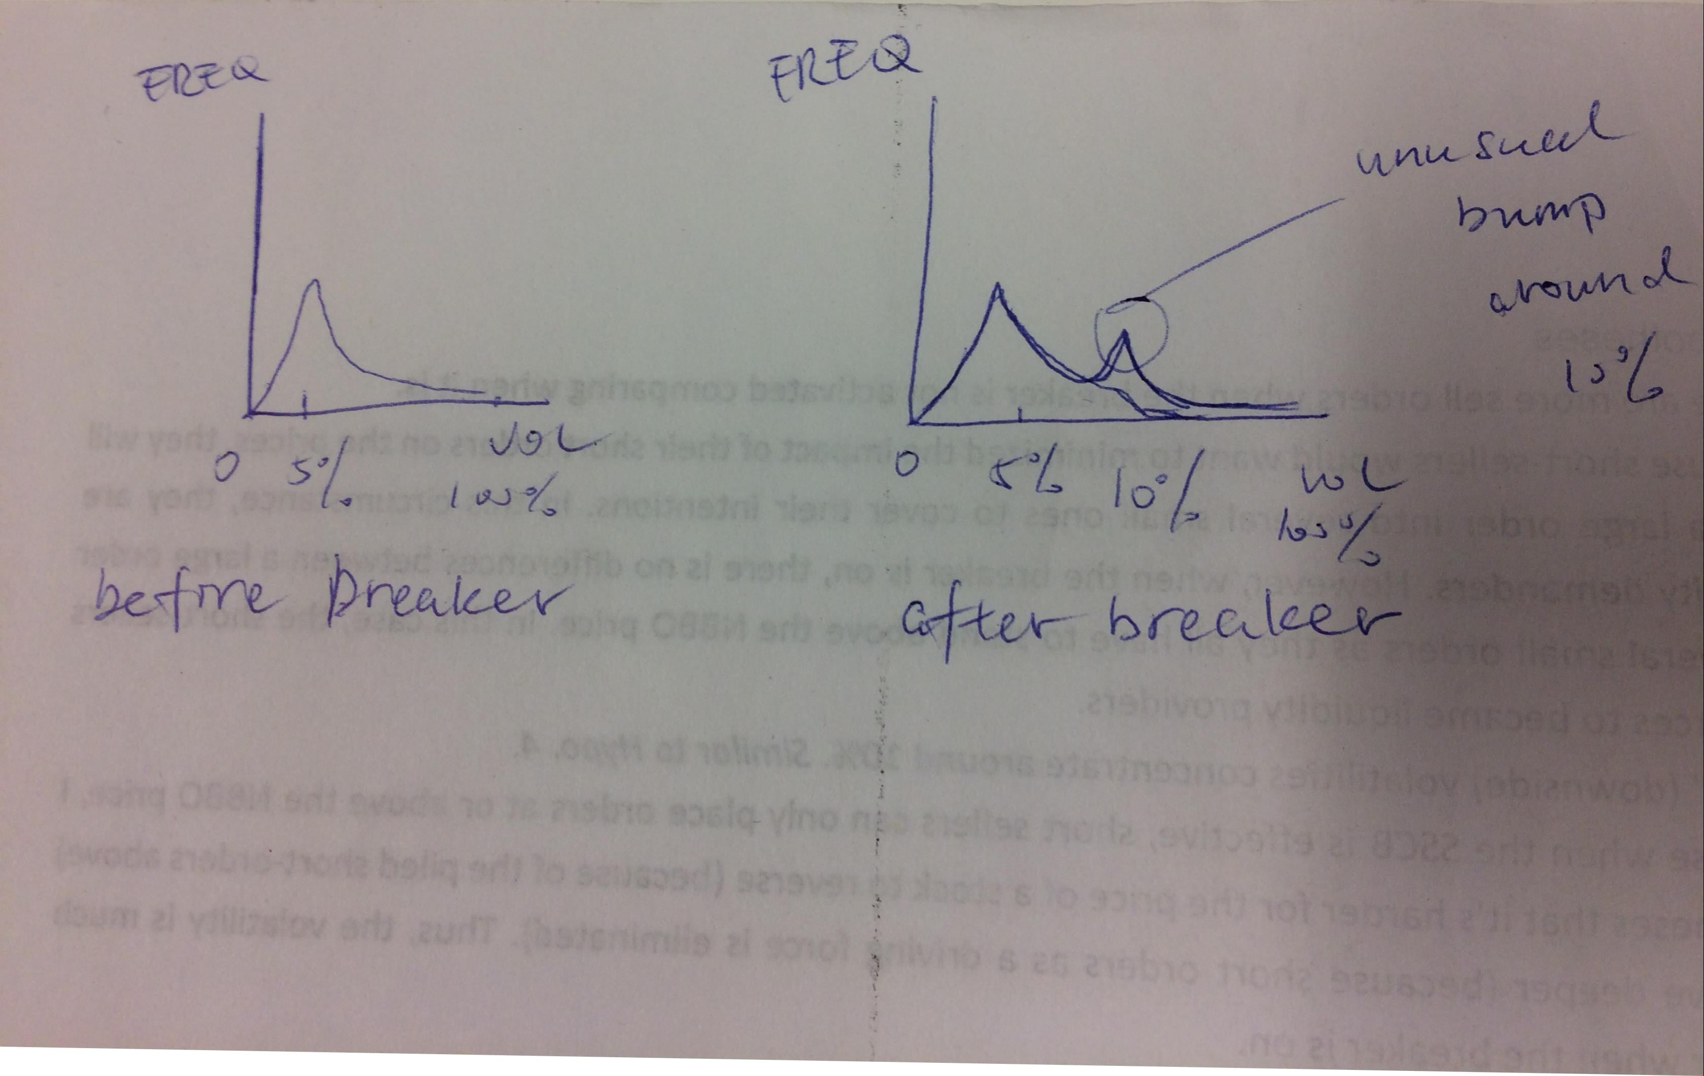

Result.

Following the definition of the short sale circuit breaker, we define the percentage of intraday decline as the percentage decline (DECPCT) of the low price of the current day comparing to the closing price of the previous trading day.

The daily stock price data is collected from CRSP, due to currently unknown reason, some securities shows abnormal price changes and would result in outliers in return and decline percentage calculations. Our current work-around is to get rid of any observation with a percentage decline larger than 100 percent (DECPCT<-1.0).

The distribution of decline percentage before short sale circuit breaker was effective:

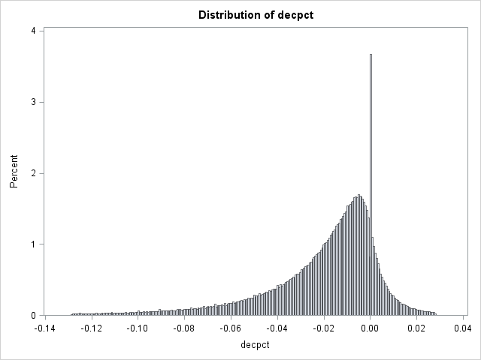

The same distribution after the breaker became effective

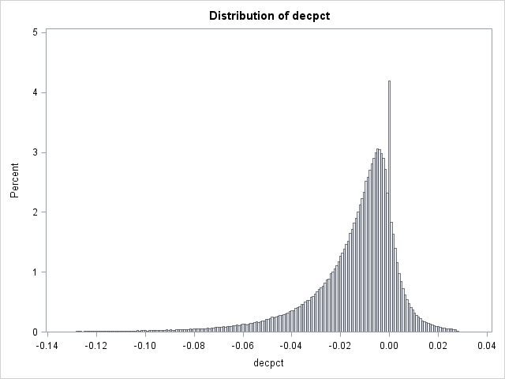

Notice the change in the left tile. In the pre-breaker histogram, the graph went quite smoothly through the –0.10 circuit-breaker criterion. However, when the breaker went effective, the part of the tile to the left of –0.10 is almost invisible to eyes.

The percentage of security-day observation that declined more than 10% in a day before the short sale circuit breaker went effective is 0.0139003202510 whereas after the breaker was implemented it is 0.0051110443957. There is a significant decline.

More statistics from this univariate analysis:

Pre-breaker

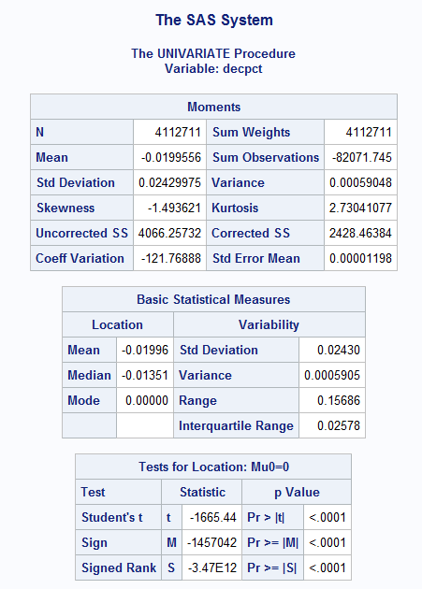

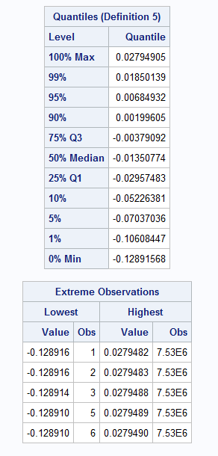

Post-breaker

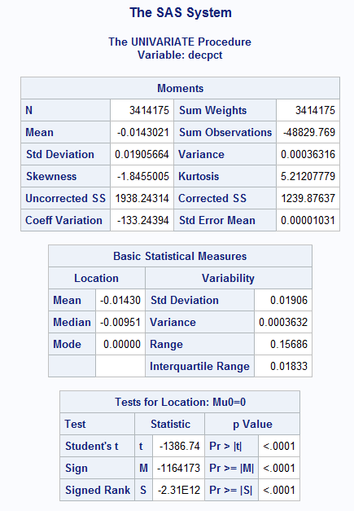

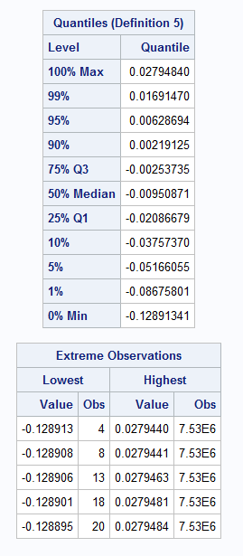

### Effects on short selling(Good. But check for data on daily short-selling)

The short-sale circuit breaker directly impacts the short selling-activity of the covered securities. In line with Diether et al (2009) and Boehmer et al. (2008)., the proxies for short-selling activity is chosen to be shares sold short, number of short sales, average trade size, relative short sales, and short interests. The relative short sales is the number of shorted shares divided by daily trading volume. Short interestis the monthly mean ratio of net short positions reported on the 15th of each month to shares outstanding at the start of the month.

Requirements:

# of shares shorted; D -> SROs

# of short orders;D -> SROs

monthly shares outstanding; M -> CRSP/COMPUSTAT

monthly short positions;M -> SROs

daily trading volume;D -> CRSP

**Using May 10, 2010 as the effective date of SSCB dummy.**

|  |  |  |  |  |  |
| --- | --- | --- | --- | --- | --- |
|  | ~~Uptick Rule~~  ~~(period 1)~~ | N/A  (period 2) | Circuit Breaker  (period 3) | Diff | ~~Diff23~~ |
| Shares sold short |  |  |  | -355699547  -25.71 |  |
| # of short sales |  |  |  | -180652  -4.44 |  |
| Avg. Short size |  |  |  | -108.70969  -38.37 |  |
| Avg. trade size |  |  |  | -260.62227  -30.36 |  |
| Relative short sales |  |  |  | -0.00886  -8.25 |  |
| # Obs. |  |  |  | 1596 |  |

**Using the compliance date, Nov 10, 2010, as the effective date of SSCB dummy.**

*significant at 10% level.**significant at 5% level. ***significant at 1% level.

|  |  |  |  |  |
| --- | --- | --- | --- | --- |
|  | unit | no breaker | Circuit Breaker | Diff |
| Shares sold short | million shares  (round to decimals) | 1090 | 831 | -259.07***  (-22.14) |
| # of short sales | 1,000 trades | 2544 | 2491 | -53.381  (-1.61) |
| Avg. Short size | shares | 431 | 335 | -96***  (-45.37) |
| Avg. trade size | shares | 999 | 766 | -233***  (-35.66) |
| Relative short sales | % | 0.126 | 0.128 | 0.0022**  (2.480) |
| Short interest | 1,000 shares |  |  |  |
| # Obs. |  |  |  | 1596 |

The restrictions on short sales are most restrictive in Period 1 (Uptick Rule), modest restrictive in period 2(N/A), and least restrictive in period 3 (Circuit Breaker). Thus the popularity of short selling activities is expected in order of p2 > p3 > p1.

### Effects on long-sell order execution efficiency

Once the circuit breaker is triggered, short sales are only allowed with a price above the current national best bid. This effectively put short sellers in a line behind long sellers. In fact, facilating the ability for long sellers to sell in declining market is one of the goals identified by the SEC in the official document. Several straightforward measures for long sell order execution efficiency are shares sold long, numbers of long sales, execute ratio, and execution time. Execute ratio is defined as the ratio of executed long orders on total long sale orders. Execution time is the average time a long sell order need to wait before being executed.

Requirements: on long-sell: # of orders; # or shares sold long; placement time; execute time; execute ratio;

**Difficulty**: hard to isolate the short-sell quote orders from the long-sell quote orders.

|  |  |  |  |  |  |
| --- | --- | --- | --- | --- | --- |
|  | Uptick Rule  (period 1) | N/A  (period 2) | Circuit Breaker  (period 3) | Diff13 | Diff23 |
| Shares sold long |  |  |  |  |  |
| # of long sales |  |  |  |  |  |
| Execute time |  |  |  |  |  |
| Execute ratio |  |  |  |  |  |
| # Obs. |  |  |  |  |  |

Short sales at a price lower than the current national best bid will drive down the stock price before most long sellers could complete their trades, hence it is expected that long sellers experienced the worst time in period 2 and the best time before the Uptick Rule was repealed. Ordering by the execution efficiency from easy to hard, the relation is expected to be p1 > p3 > p2.

### Effects on option trading

The short-sale circuit breaker prohibits short selling at a price equal to or lower than the current national best bid, but it does not cover the option market. Options offers the opportunity to avoid certain impediments to the short sale of stocks.[3] In fact, Figlewski and Webb(1993) suggests that introducing options trading can significantly reduce or even eliminate the informational effects of short sale constraints. Dedicated short sellers can easily find a work-around of this rule. It is of interests to see if the short-sale circuit breaker will push short sellers in a declining stock to the option markets. Firms with options available for trading are collected in to a subgroup to investigate the relation of stock price and options. Number of put options, put spread, number of call options, and call spread are selected as measures for the option market. Put spread (call spread) is the monthly average difference between the strike prices of put (call) options and the issue-day stock prices.

Requirements: option price; option amount; daily stock price;

**Difficulty**: cannot find options data.

|  |  |  |  |  |  |
| --- | --- | --- | --- | --- | --- |
|  | Uptick Rule  (period 1) | N/A  (period 2) | Circuit Breaker  (period 3) | Diff13 | Diff23 |
| Number of puts |  |  |  |  |  |
| Put spread |  |  |  |  |  |
| Number of calls |  |  |  |  |  |
| Call spread |  |  |  |  |  |
| # Obs. |  |  |  |  |  |

Although it is possible that short sellers use options to avoid the short sale restriction, the option market is not the only way and probably not the best way of doing this. Other work-around include long/short synthetic stocks or highly correlated stocks. Thus the statistics for put options should be similar for period 1 and period 3 with period 2 as the most active period.

Still, none of these methods can replicate the movement of the stock with 100% accuracy, which means short-sellers have to bear more risks. In turn, this ensures that the short-sale circuit breaker would not be completely bypassed.

### 2 Effects on stock prices

#### 2.1 General portfolio measure

1. Stocks with high short interests will outperform the market afterwards.  
   Because the short sellers are buying back stocks to cover their short positions.

There are several opinions on how short sell might influence the stock prices. One hypothesis, so called "sophisticated investor" theory, suggests that short sellers have exclusive negative information on the stocks; in this way, the short interests represents negative prediction on the stock's future price. The other one is the "excluded negative information" theory, which believes that all investors share the same information and it is the market constraints on short selling that caused the stock to generates abnormal returns.

When effective, the short-sale circuit breaker will largely prevent short sellers from placing aggressive short-sale orders. This leads to less downward pressure on the stocks. This paper tests if there are significant abnormal returns when short-sale circuit breaker is triggered. The event study methodology with event windows including [-1,1], [0,0], and [-10, 7] is used. Two measures of anomalies are presented in the table. The first one is the daily abnormal return, which is defined as the difference between the firms’ daily returns and the value weighted daily return of the market. The second measure is the BHAR equivalent, it is the buy-and-hold abnormal return compounded daily over the period considered.

Requirements: daily market return; daily stock return;

|  |  |  |  |
| --- | --- | --- | --- |
|  | [-1,1] | [0,0] | [-10,7] |
| Daily alpha |  |  |  |
| BHAR |  |  |  |
| # Obs. |  |  |  |

Another popular method to capture the long-run abnormal returns created by events like this is the portfolio approach. One could argue that a stock triggered the circuit breaker has more likelihood to decline than those do not. A way to test this is to construct a short portfolio consists of only the stocks that have reached the circuit breaker. Each stock will stay in the portfolio for K-month (K=6, 12, 24). The short portfolio is maintained by adding the newly triggered stocks and cover the positions of those have reached their holding time. After all positions in the portfolios have been covered, the abnormal return of the portfolio is simply derived by subtracting market index return from the portfolio return.

|  |  |  |  |
| --- | --- | --- | --- |
|  | Six month | One year | Two years |
| Abnormal returns |  |  |  |
| # Obs. |  |  |  |

There should not be significant abnormal returns.

#### 2.2 Overvaluation for low-price stocks.

The SCCB will cause stocks with a price per share smaller than K dollars (K=10, 15, 30) to be overvalued.

Description: Miller (1977) introduced a theory about stocks can be overvalued if it’s a) subject to a short-sale constraint and b) investors disagree on its price. This effect has been documented for the uptick rule (see Diether, Lee, and Werner (2009)). Although the SCCB is less restrictive, its effects can still be detected by comparing temporary and permanent price adjustments.   
*Comment by Lorne: this could be tested by looking at temporary vs. permanent price adjustments. One hypothesis is that the effect is temporary, and maybe there will be a short term significant effect. The other is that the effects are longer term - e.g. could last a week or a month or longer.*

#### 2.3 negative information spillover

The stocks that triggered the SCCB are more likely to decline in the following trading day(s).

Description: Because that means their prices declined at least 10% in a day, that’s not a good signal and it is like a red alert to other investors. We can test the cumulative abnormal returns in the next trading day, and the next 3 or 7 trading days.

*Discussion with Rahul: whether this is true depends on the stock’s sector beta. With a high sector beta, the stock is highly related to the sector, and it is not likely to continue declining in the following trading day(s). On the other hand, stocks with low sector beta are more likely to decline as there is a larger chance that the reason caused the stock to decline is idiosyncratic. The other parts in the sector will not be able to pull this stock back up, so it will continue dropping.*   
Practically, we define rewards for bearing idiosyncratic risks as $α=R_{stock}-R_{sector}$. Then we sort the portfolio into quintiles and see if idiosyncratic reasons will cause the stock to continue declining.   
We can control for other factors, such as the size. As we generally agree that small cap stocks generate higher return than large cap stocks, we can take the size factor into consideration and construct a 2*2 sort to isolate the effects.

### Market quality (Good. Use a portfolio sort approach.)

If one has to put a rule on the market, the rule should treat every stock equally, no matter small cap or big cap, barely traded or intensively traded. The rule should also have minimal impact on market liquidity.

Portfolios sorted on size, price, volatility, and turnover are to find out if the rule affects all kinds of stocks equally. Panel A (Panel B) reports the results on the data from period 1 (period 2) and period 3. The numbers in the small/low (large/high) columns are the period 3 dummy coefficients from a time-series regression of the difference of each variable between period 1 (perod2) and period 3 stock portfolios in the lowest (highest) quintile on an intercept (not reported) and the period 3 dummy. The F-statistics are derived from the SUR test of equality between the coefficient from the lowest and highest quintile portfolios.

Requirements: daily price; intraday price ticks (or mid-quote volatility)

Panel A. Uptick rule and short-sale circuit breaker

|  |  |  |  |  |
| --- | --- | --- | --- | --- |
|  | Size portfolio  Small (diff-diff) – Large(diff-diff) - F | Price portfolio  Low (diff-diff) – High(diff-diff) -F | Volatility portfolio  Low(diff-diff) – High(diff-diff) - F | Turnover portfolio  Low(diff-diff) – High(diff-diff) - F |
| Volatility |  |  |  |  |
| Semivariacne (up) |  |  |  |  |
| Semivariance (down) |  |  |  |  |
| Intraday |  |  |  |  |
| # Obs. |  |  |  |  |

Panel B. No short-sale restriction and short-sale circuit breaker

|  |  |  |  |  |
| --- | --- | --- | --- | --- |
|  | Size portfolio  Small – Large - F | Price portfolio  Low – High -F | Volatility portfolio  Low – High - F | Turnover portfolio  Low – High - F |
| Volatility |  |  |  |  |
| Semivariacne (up) |  |  |  |  |
| Semivariance (down) |  |  |  |  |
| Intraday |  |  |  |  |
| # Obs. |  |  |  |  |

The short-sale circuit breaker has mild influence on the market, the result should be small and insignificant between period 2 and period 3, whereas there are some changes from period 1 to period 3.

The bid-ask spread is used to represent the market liquidity, a smaller spread means the orders can be executed faster and there are more orders in the market. To measure different aspects of the spreads, this paper uses quoted, effective, and realized spread. Relative bid depth and buy imbalance/volume are also included to measure market asymmetries.

* Bid(ask) depth is the cumulative volume of current buy(sell) orders.
* Relative bid depth is 100*(bid depth – ask depth)/(ask depth + bid depth).
* Buy imbalance is daily buys minus sells, as defined in Lee and Ready (1991).
* Quoted spread is 2(price – midquote)[2(price –midquote)/midquote] for buys and 2(midquote – price)[2(midquote – price)/midquote] for sells. Trades are matched to the same second. It's based on changes in quote.
* Realized spread is of the same fashion as the quoted spread except that the trade is matched to quotes in force 5 minutes (midquote t+5) following the trade.

Requirements: Intraday quote data

Panel A. Uptick rule and short-sale circuit breaker

|  |  |  |  |  |
| --- | --- | --- | --- | --- |
|  | Size portfolio  Small (diff-diff) – Large(diff-diff) - F | Price portfolio  Low (diff-diff) – High(diff-diff) -F | Volatility portfolio  Low(diff-diff) – High(diff-diff) - F | Turnover portfolio  Low(diff-diff) – High(diff-diff) - F |
| Quoted spread |  |  |  |  |
| Effective spread |  |  |  |  |
| Realized spread |  |  |  |  |
| Relative bid depth |  |  |  |  |
| Relative bid depth |  |  |  |  |
| Buy imbalance/volume |  |  |  |  |
| # Obs. |  |  |  |  |

Panel B. No short-sale restriction and short-sale circuit breaker

|  |  |  |  |  |
| --- | --- | --- | --- | --- |
|  | Size portfolio  Small – Large - F | Price portfolio  Low – High -F | Volatility portfolio  Low – High - F | Turnover portfolio  Low – High - F |
| Quoted spread |  |  |  |  |
| Effective spread |  |  |  |  |
| Realized spread |  |  |  |  |
| Relative bid depth |  |  |  |  |
| Relative bid depth |  |  |  |  |
| Buy imbalance/volume |  |  |  |  |
| # Obs. |  |  |  |  |

### Stocks with low fundamental-to-price ratios are more likely to trigger SSCB

Dechow et al. (2001) suggests that short sellers tend to act on stocks with low fundamental-to-price ratios and then cover their positions when the ratios mean-revert. The activation of SSCB as a signal of dramatic price decline and poses impediments on short-selling, we believe stocks that triggered the circuit breaker are highly shorted. Following the logic of Dechow et al., these stocks are more likely to have low fundamental-to-price ratios.

The following table presents the empirical evidences. The ratio 1 to ratio 3 are different fundamental measurements on the price. The stocks are evenly sorted into decile portfolios according to the corresponding fundamental-to-price ratio. The portfolio is updated every year to reflect the changes in the ratios. The N column reports the total number of SSCB activation observations that belongs to the corresponding decile. The percentage is calculated as N/Total.

Assuming the activation of SSCB has no relation with the fundamentals of the stocks, we expect the SSCB observations to be equally distributed among the decile portfolios, that is, each decile has 10 percent of the total observations.

Align with Dechow et al. (2001), the fundamental ratios are chosen to be:

* Cash-flow-to-price. Cash flows for the fiscal year divided by the product of SHOUT and price at the fiscal-year end. Cash flow is calculated as EBITDA minus capital expenditure. There is another way (arguably more accurate) of calculating the cash flow, refer to Dechow et al. (2001).
* Earnings-to-price. Earnings for the fiscal year divided by the product of SHOUT and price at the fiscal-year end.
* Book-to-market. Book value of common equity at the end of the fiscal year divided by the product of SHOUT and the price at the fiscal-year end.
* Value-to-market. Book value of common [equity + (alpha_1*abnormal earnings)] / (SHOUT*PRC)
* Abnormal return. Refer to Dechow et al. (2011). Page 86.

The firm-year data is winsorized according to the corresponding fundamental-to-price ratio at the 1 percentile and 99 percentile before entering the table. The N column reports the number of SSCB observations in the decile portfolio. The firm-year average fundamental-to-price ratio is displayed under the mean column. Percentage is the ratio of the number of SSCB observation in the decile to the total number of SSCB observation.

**I've updated the filter, the sample should not include observations with negative numerator, which means there should be no negative mean. Re-run the program to obtain updated results.**

|  |  |  |  |  |  |  |
| --- | --- | --- | --- | --- | --- | --- |
| Fundamental/price |  | N | Abnormal return | Mean | Percentage | Expect |
| Cash-flow-to-price | Lowest(1) | 12399 |  | -1.0642 | 17 | 10 |
|  | Mid(2-9) | 51259 |  | -0.00425 | 72 | 80 |
|  | Highest(10) | 8672 |  | 0.3315 | 12 | 10 |
|  | **Total** | 72330 |  | -0.0767 | 100% | 100% |
| Earnings-to-price | Lowest(1) | 15341 |  | -0.9789 | 21 | 10 |
|  | Mid(2-9) | 48968 |  | 0.015438 | 68 | 80 |
|  | Highest(10) | 8183 |  | 0.3180 | 11 | 10 |
|  | **Total** | 72492 |  | -0.0537 | 100% | 100% |
| Book-to-market | Lowest(1) | 5755 |  | -0.8695 | 8 | 10 |
|  | Mid(2-9) | 0.574113 |  | 54493 | 76 | 80 |
|  | Highest(10) | 12667 |  | 2.4607 | 17 | 10 |
|  | **Total** | 72915 |  | 0.6184 | 100% | 100% |

# Empirical Results

# (Robustness Test)

# Conclusion

# References

Parkinson, M. (1980). The extreme value method for estimating the variance of the rate of return. *Journal of Business*, 61-65.

Diether, K. B., Lee, K. H., & Werner, I. M. (2009). Short-sale strategies and return predictability. *Review of financial Studies*, *22*(2), 575-607.

Jones, C. M., & Lamont, O. A. (2002). Short-sale constraints and stock returns. *Journal of Financial Economics*, *66*(2), 207-239.

Boulton, T. J., & Braga-Alves, M. V. (2010). The skinny on the 2008 naked short-sale restrictions. *Journal of Financial Markets*, *13*(4), 397-421.

Senchack, A. J., & Starks, L. T. (1993). Short-sale restrictions and market reaction to short-interest announcements. *Journal of Financial and quantitative analysis*, *28*(02), 177-194.

Battalio, R., & Schultz, P. (2011). Regulatory uncertainty and market liquidity: The 2008 short sale ban's impact on equity option markets. *The Journal of Finance*, *66*(6), 2013-2053.

Daske, H., Richardson, S. A., & Tuna, A. (2005). Do short sale transactions precede bad news events?. *Do Short Sale Transactions Precede Bad News Events*.

Diamond, D. W., & Verrecchia, R. E. (1987). Constraints on short-selling and asset price adjustment to private information. *Journal of Financial Economics*, *18*(2), 277-311.

Figlewski, S. (1981). The informational effects of restrictions on short sales: some empirical evidence. *Journal of Financial and Quantitative Analysis*,*16*(04), 463-476.

Billingsley, R. S., & Kovacs, T. (2011). The 2008 short sale ban: Liquidity, dispersion of opinion, and the cross-section of returns of US financial stocks. *Journal of Banking & Finance*, *35*(9), 2252-2266.

Harris, L., Namvar, E., & Phillips, B. (2013). Price inflation and wealth transfer during the 2008 SEC short-sale ban. *The Journal of Investment Management, Second Quarter*.

Kraus, A., & Rubin, A. (2003). The effect of short sale constraint removal on volatility in the presence of heterogeneous beliefs. *International Review of Finance*, *4*(3‐4), 171-188.

Bai, Y., Chang, E., & Wang, J. (2006). Asset prices under short-sale constraints.

Alexander, G. J., & Peterson, M. A. (1999). Short selling on the New York Stock Exchange and the effects of the uptick rule. *Journal of Financial Intermediation*, *8*(1), 90-116.

Boehmer, E., Jones, C. M., & Zhang, X. (2008). Which shorts are informed?.*The Journal of Finance*, *63*(2), 491-527.

Diether, K. B., Lee, K. H., & Werner, I. M. (2009). It's SHO Time! Short‐Sale Price Tests and Market Quality. *The Journal of Finance*, *64*(1), 37-73.

Boehmer, E., Jones, C. M., & Zhang, X. (2008). Unshackling short sellers: The repeal of the uptick rule. *Columbia Business School, unpublished manuscript, December*.

Grullon, G., Michenaud, S., & Weston, J. P. (2015). The real effects of short-selling constraints. *Review of Financial Studies*, *28*(6), 1737-1767.

# Additional information

## Other Hypotheses

1. There are more sell orders when the breaker is not activated comparing when it is.  
   Because short-sellers would want to minimized the impact of their short orders on the prices, they will split a large order into several small ones to cover their intentions. In this circumstance, they are liquidity demanders. However, when the breaker is on, there is no differences between a large order or several small orders as they all have to stand above the NBBO price. In this case, the short-sellers are forces to became liquidity providers.
2. The plunge of the stock prices is caused by short sellers.   
   Methodology: Test for significant increases (differ from average) in short volume (short interests, short interests ratio) in the (-5,-1) window of the activation of SSCB.

## Effects on Canadian Companies

### Canadian companies listed on NYSE, NASDAQ

There are 178 Canadian companies inter-listed on NASDAQ and 140 on NYSE. I do not find any internet resources suggesting that the short-sale circuit breaker has special impacts on Canadian companies. This is also highly unlikely because the SEC stated the covered securities to be almost all stocks and the rule does not differ on where the company is based. It is possible to statistically test this when performing data analysis but I do not expect significant result.

### Similar legislations in Canada

There was a legislation on short sales by IIROC (Investment Industry Regulatory Organization of Canada) called the *tick test*, which was similar to the repealed uptick rule in the United States. The tick test is a requirement under Rule 3.1 of UMIR (Universal Market Integrity Rules) that a short sale not be made at a price less than the last sale price of the security.

The Rule 3.1, named *Restrictions on Short Selling,* had gone through several amendments from 2004 to 2010 before the whole section was repealed in 2012[4][5]. Alongside with reliving market participants from the tick test, IIROC added a new restraint that requires the security must be “pre-borrowed” prior to a short sale under certain circumstances.

IIROC stated almost identical reasons for removing the tick test as the SEC provided for removing the uptick rule, which is studies found the rules have no appreciable impact on pricing. However, IIROC is not denying the existence of “abusive” short selling activities, it believes “there are better mechanisms to detect and address abusive short selling”, such as real-time alert.

On February 2012, the IIROC also adopted a single-stock circuit breaker. This coincides with the reintroduction of the alternative uptick rule in the United States. Comparing to the short-sale circuit breaker, the single-stock circuit breaker is harder to trigger but also poses much stricter restrictions once activated. [6]The single-stock circuit breaker is only triggered when the price of a security swings 10% or more within 5 minutes, that is, it restricts both upside and downside movements. Once triggered, the trading of the security is halted for five minutes. The rule is much stricter on the market than the short-sale circuit breaker which merely refrains investors from putting a short order lower than the current national best bid.

## About Rule 201

The Securities and Exchange Commission has adopted amendments to Regulation SHO under the Securities Exchange Act of 1934 ("Exchange Act") to implement a short sale-related circuit breaker that, if triggered, will restrict the prices at which securities may be sold short and to impose a "short exempt" marking requirement.

Rule 201, covers almost all securities, except options. Under Rule 201(b), the alternative uptick rule (short sale-related circuit breaker) applies to a security whose price has declined by 10% or more from the closing price of its last trading day. The short sell circuit breaker applies to the same range of securities. Once triggered, all short selling of the covered security is halted for the remainder of the trading day and for the following day.

The amendments are located in Rules 201 and 200(g) of Regulation SHO (17 CFR 242.201, 17 CFR 242.200(g)). 201 and 200(g) of Regulation SHO (17 CFR 242.201, 17 CFR 242.200(g)). The Commission adopted the amendments to help prevent short selling, including potentially abusive or manipulative short selling, from being used as a tool to exacerbate a decline in a security's price and to address concerns that excessive downward price pressure on individual securities, accompanied by the fear of unconstrained short selling, can undermine investor confidence in the markets.

**Covered securities**. ‘‘Covered security’’ is defined under Rule 201 by reference to ‘‘any NMS stock’’ other than options under Regulation NMS[5]. Rule 201 generally will apply to all securities, other than options, listed on a national securities exchange, whether traded on an exchange or in the OTC market. It will not include non-NMS stocks quoted on the OTC Bulletin Board or elsewhere, such as the pinksheets. Despite the SEC’s recognition that synthetic short positions can be created in the OTC derivatives and other markets, Rule 201 will not apply to those markets due to the differences in market structure and the difficulty in implementation of a rule applying to those instruments. Short sales to **hedge derivatives** transactions are, however, subject to the rule.

**National best Bid.** The national best bid, rather than the last sale price as under former Rule 10a-1, was chosen as the basis for the execution of short sales during a circuit breaker period. Why? Because it is easy to implement. In more details, the increased uses of HFT and the difficulty of tracking sequences of bids and actual last sale price. The SEC noted that changes in trading markets, including the increasing use of automated matching trading systems that offer price improvement based on national best bid and offer, and the difficulty of tracking sequences of bids and actual last sale prices under current trade reporting systems make the national best bid a more reliable indicator of the real time market.

**Short exempt**. Rule 201(c) provides that a broker-dealer submitting a short sale order after the circuit breaker is triggered may mark the order ‘‘short exempt’’ if the broker-dealer identifies the order as being at a price above the national best bid at the time of submission. Rule 200(g), the Regulation SHO marking provision, has been amended to reinsert ‘‘short exempt’’ as a category broker-dealers may include on an order, in addition to ‘‘long’’ and ‘‘short.’’ A broker-dealer may mark an order ‘‘short exempt’’ if any of the provisions of Rule 201(c) or (d) apply. Under Rule 201(b)(1)(iii)(B), a trading center’s policies and procedures must be reasonably designed to permit the execution or display of a short sale order of a covered security marked ‘‘short exempt’’ regardless of whether the order is at a price that is less than or equal to the current national bet bid. An order may be marked ‘‘short exempt’’ under either the **‘‘broker-dealer exception’’ of Rule 201(c)** or **the enumerated exceptions under Rule 201(d).**

**Time**. All market participants have to comply with the requirements of Rules 201 of Reg SHO by November 10, 2010. Passed on February 25,2010. An effective date of May 10, 2010 and a compliance date of November 10,2010.

Under certain conditions, a.k.a. “short exempt”, a short-sale order submitted by a broker-dealer after the circuit breaker is triggered may be marked “short exempt”.

## Timeline

1938 Uptick rule introduced

April, 2001. Decimalization finalized. [[1](http://www.forbes.com/2009/03/09/decimalization-uptick-rule-intelligent-investing-volatility.html)]

July, 2007. Uptick rule repealed.

Jan, 2008. Stock market downturn.

Feb, 2010. Alternative uptick rule introduced.

## 关于Uptick Rule演化过程的一些自问自答

The original uptick rule went into effect in 1938 and was removed when *Rule 201*[*Regulation SHO*](https://en.wikipedia.org/wiki/Regulation_SHO) became effective in 2007. A modified form of the rule, the alternative uptick rule, was adopted on 2010-02-24. Short story of the short sale constraints on [Investopedia](http://www.investopedia.com/articles/financial-theory/09/uptick-rule.asp). A [short-selling tutorial](http://www.investopedia.com/university/shortselling/).

The short sale circuit breaker does not prevent the price of a stock from declining. Investors with the stocks in hand can still sell them (long-sale) and the price can still drop. It’s just that the short-sellers cannot sell at a price lower than or equal to the National Best Bid price.

**Why is the uptick rule introduced in 1938?**

The stock market dropped sharply in 1937, the SEC blamed the short sellers for the crisis. Then, a short sale restraint, the uptick rule, was introduced to prevent similar crisis. [1]. Or more specifically, to prevent short-selling orders from executing in downward markets.

**Why is it repealed in 2007?**

The impetus to remove the 70-year old uptick rule came after the SEC conducted a pilot program that lasted from May 2,2005, through July 3, 2007. A pilot group of 1,000 stocks with the uptick rule removed was studied. The SEC concluded that the trading patterns of the stocks in pilot group showed no discernible difference comparing to the other stocks, including how the stocks were short with or without the rule. Academic studies agree with this conclusion. [2] Once the rule was removed, the public and business leaders rallied around the old standard. Public letters to the *Wall Street Journal* showed people were 5-to-1 in favor of the old rule. [3]

**Why the complete short sale ban in 2008?**

The uptick rule probably could have slowed the pace of the unwind and the panic, but whether slowing it down is a good thing is another story. A good thing about the absence of short sale constraints is that it hastened the publicly traded firms with fraud and corruption to collapse. The short sellers can still do it with options and synthetic stocks.

**Why is the alternative rule introduced in 2010?**

After the SEC repealed the so-called uptick rule in 2007, the 2008 financial crisis happened. The public criticize SEC for removing the short sale constraint and exacerbate the stock avalanche in 2008, particularly in financial stocks. There were rumors that a group of traders coordinated an assault on Bear Stearns’ stock. Similar suspicions were raised in the failure of Lehman Brothers. [4] ~~Due to the public pressure, the SEC felt it has to show some efforts.~~ They passed the alternative uptick rule by a 3-2 vote.

**What is the difference between the 2010 and 1938 rule?**

The new circuit breaker is a much less restrictive rule on short selling as it only applies to stocks that have fallen 10% or more during one trading day. The SEC commissioners said it would typically apply to just 1.3% of stocks on any given day during normal market conditions. However, the new circuit breaker does not address the naked short sale problem that helped take down Bear Stearns and Lehman Brothers.

The uptick rule forces traders who borrow stocks to sell them short to wait for an uptick in the price before putting on their trades. The new circuit breaker is much less restrictive. The stocks can be shorted freely until the price declines 10% or more from the closing price of the last trading day. Once triggered, short sales are only allowed with a price above the current national best bid. This effectively put short sellers in a line behind other types of sellers (long sellers). The circuit breaker will remain effective for the rest of that trading day and the following trading day as well.

**Does the 2010 rule address the drawbacks of the 1938 rule?**

The uptick rule was repealed because the pilot program found no difference in trading patterns between piloted stocks and other stocks. [2] The 2008 financial crisis happened right after that was probably not a coincidence. The predatory short sellers cannot assault when the uptick rule is in place. Will the same tests that concluded the uptick rule useless determine the alternative uptick rule to be a placebo? What different effects has the alternative rule placed on the market comparing to the uptick rule? We are going to find out in this paper.

References:

[1] Jerry W. Markham, A Financial History of the United States: From Christopher Columbus to the Robber Barons (1492-1900) P234

[2] Diether, K. B., Lee, K. H., & Werner, I. M. (2009). It's SHO Time! Short‐Sale Price Tests and Market Quality. *The Journal of Finance*, *64*(1), 37-73.

[3] <http://www.forbes.com/2009/03/25/uptick-rule-shorts-intelligent-investing-short-selling.html>

[4] <http://www.forbes.com/sites/streettalk/2010/02/24/secs-new-circuit-breaker-falls-short-of-uptick-rule/#f7e40605a25e>

## Costs and benefits of the SSCB

* What’s the cost?
  + **Market quality**. Test for the quote depth of bid and ask (Diether et al. (2009));
  + liquidity level,
  + Cannot hedge well.
  + **Intraday volatility**. Different measures: standard deviation, semivariance (Markowitz (1959)), trade-based volatility (midquote returns on a 5-, 15-, or 30-minute interval)
  + Speed of price discovery. If price of a stock continues declining after it resumes from the circuit breaker, then the circuit breaker is hindering the price recovery process. Because short-sellers can help accelerating the drop towards the new true value of the stock. However, the further decline could also be a result of bad news happened during the halted time.
* How effective is it? (the goal is to control the downside volatility, help stabilize the market)
  + There should be more buy quotes after the break.

## 关于Methodology的一些自问自答

1. Does the market rewards idiosyncratic risks? Since it can be diversified away.
2. In your hypothesis*, what if the idiosyncratic bad news only caused the stock price to drop for 9% or 10% to reach the new equilibrium? So it’s not going to continue declining in the following trading day. *\* The stocks that triggered the SCCB are more likely to decline in the following trading day(s)*
3. How do you define *systematic* returns or risks? Is it market-wise or sector-wise? Why do you choose one from another?

## What I can test

### Hypothesis

1. The change in short interests after triggered the CB, compare to those get close to the trigger without triggering it. The best estimate for this month’s short interest is the short interest of the last month (Senchack et al., 1993).
2. Number of stocks halted and the market return
3. How many CBs are triggered in the morning trading session, in the afternoon? Distribution among the week days? Through the months? Years?
4. Does the circuit breaker save the stock price from further declining? Volatility spillover hypothesis. Compare the price movements (upwards or downwards) of the stocks with price declined 8%~10% without triggering the circuit breaker with those triggered the circuit breaker.
5. Like what we do in testing price limits. Volatility spillover hypothesis, delayed price discovery hypothesis, trading interference hypothesis. But the alternative uptick rule is difference from the price limits. The price limits simply prevent any trading, long or short, from happening whereas the alternative uptick rule just ban short sale at or lower than the national best bid.
6. **Effects on daily returns and volatility**. Refer to the methodology used in Section IV, Diether et al. (2010). Here, your *pilot* stocks will be those on the circuit breaker whereas the control group will be those not in the breaker. The *Pre* and *Post* are pooled arithmetic average, the *Diff* and *Diff-Diff* are the beta coefficients from simple linear time-series regression of the variable in that row on the event dummy. You need to decide the event windows. **What to expect**. Since we are comparing the stocks that experience dramatic intraday decline in price, we expect the (downside) volatility in the pre-event window of these stocks to be larger and the daily returns are expected to be smaller. We will see how they do in the post-event period comparing to the control group, that’s when the effect of the circuit breaker shows off.
7. Information asymmetry. Use a Bayesian model, designed and empirically tested by Madhavan and Smidt (1991) and later applied by Choi and Subramanyam (1994).
8. Informed trades. Price limits (not CBs) will delay information revelation and price discovery because informed traders enter the market after a limit-hit cannot trade. The arrival rate of informed traders is one of four parameters in a model developed and tested by Easley, Kiefer, OíHara, and Paperman (1996).
9. **Order imbalance.** It is the ratio of the number of shares in buy orders to that in total orders. If the ratio is 0.5, then demand equals supply. A ratio larger than 0.5 implies there are more buys than sells, upward pressure is created. Independent variables include stock beta, size, financial leverage. t-Statistics are computed using White's (1980) correction for heteroscedasticity.
10. Because short sale constraints limited the downside volatility, you can test the positive and negative semivariance (Markowitz (1959)).

Reference:

Chan, S. H., Kim, K. A., & Rhee, S. G. (2005). Price limit performance: evidence from transactions data and the limit order book. *Journal of Empirical Finance*, *12*(2), 269-290.

### Control variables

use the Chicago Board Options Exchange Volatility Index (VIX) as a proxy for market-wide volatility.

market cap, dollar trading volume, the proportional daily range of transaction prices, and the daily volume-weighted average share price (VWAP).

### What other studies did? How did they test it?

Boehmer et al. (2008). [1] **Effects on shorting activity**. The result is shown in table 2. The change in shorting activity between pre-repeal and post-repeal for both pilot group and un-pilot group stocks. The shorting activity was measured in many ways, including shares shorted, number of shorting trades, short sales fraction of total volume, average trade size of short sales, trading volume, and short interest. The numbers in the pre and post columns are the time-series average of the cross-sectional average of each variable for the pre-period and for the post-period. The numbers in the $diff$ column was the post-repeal dummy variable coefficient from a time-series regression of each variable on an intercept (not reported) and the post-repeal dummy. The Dif-in-dif columns report the post-repeal dummy variable coefficient from a time-series regression of each variable on an intercept (not reported) and the post-repeal dummy. The t-stats are based on Newey-West (1987) standard errors with 20 lags. **Effects on stock prices**. The authors test two hypotheses. First, they hypothesis that if investors are completely rational or the uptick rule has no effect, the removal of the rule should not impact the market. This was tested by the change of NYSE market index price in the post-repeal period with the t-statistic based on the historical price volatility of the index. Second, they test if the uptick rule is indeed a short sale constraint. If it is, the price of the un-pilot group in the post-repeal period should decline. At least comparing to the unaffected pilot group. The numbers were simply the return of un-pilot group less the pilot group, the t-statistics were based on daily standard deviation of the group. **Short-sale order placement**. The short-sale orders are divided into aggressive orders and passive orders based on their likelihood of execution. Aggressive short sale orders are those marketable on the existing bid price, including market orders as well as the limit orders with limits below the existing bid price, whereas passive orders are limit orders with limits above the existing bid. The average effective spread of the short sale is measured by the weighted average of short price less quote midpoint. The numbers in the pre, post, and $Diff$ columns were calculated in the same fashion as in the *Effects on shorting activity*. The t-statistics were also resulted from Newey-West. **Liquidity measures.** Liquidity is used as a proxy for market quality in this paper. The proxy for liquidity is the effective spread. The narrower the effective spread, the more the liquidity. The effective spread is defined as twice the distance between the trade price and the quote midpoint prevailing at the time of the trade. The pilot stocks and non-pilot stocks are again considered separately; a cross-sectional average effective spread was calculated for each group on each trading day. Because the market became extremely volatile after the repeal, a difference-in-difference method was used to compare the changes in two groups. The author did not mention how the t-statistics were calculated, nor did they report the exact value of the statistics. **Informativeness.** If short sellers are informed, the stocks they short should underperform the stocks they avoid shorting. A portfolio approach was used to examine this effect. The approach was originally used in Boehmer et al. (2008). For each day, stocks were sorted into quintiles based on normalized shorting activity during the previous five trading days. Then, with one day skipped, a value-weighted portfolio was held for 20, 40, and 60 trading days. This process is repeated each trading day. The overlapped nearby days were accounted for with the Newey-West standard errors with 20, 40, or 60 lags, respectively. The Fama-French three-factor model was implemented to recover the alpha. **Momentum or contrarian shorting**. If a stock goes up one day, there is more shorting activity in that stock in the following day. This could be an artifact of the uptick rule. To test it, a time-series regression of shorting (measured as a fraction of trading volume) on lagged returns and control variables, including lagged shorting, lagged volatility measures, and lagged trading volume. The lagged period spread over the past five trading days. Each of the variables is interacted with a post-repeal dummy to detect the changes associated with the new regulatory regime. The result is shown in table 5. The numbers are cross-sectional averages of estimated coefficients, the t-statistics also aroused from the regression estimation.

Diether, Lee, and Werner (2009). **Hypo1, the suspension of price tests will increase the short-selling activity in Pilot stocks relative to Control stocks**. Results are summarized in table 3. The Pilot stocks and Control stocks are divided into pre- and postperiod. They implemented several measures of short sales, including shares sold short, number of short sales, average trade size, relative short sales, and short interests. The detailed method of calculating these variables can be found in the *data and methodology* part of the paper. For each period of each group, the time-series average of the cross-sectional average of the variable is displayed. They also used the *Diff* and *Diff-Diff* variables, the meaning and methodology of them are the same as in the previously summarized Boehmer et al. (2008) paper. **Hypo2, the suspension of price tests will be associated with lower returns for Pilot stocks relative to Control stocks**. Results shown in table 4. This hypothesis is examined by an event study. Daily returns from day $t-2$ to day $t+2$ around both the announcement and the effective dates of the Pilot Program. A pooled regression of daily returns (in percentage) on announcement window and event window dummy variables and pilot stock interactions was estimated. The numbers in the Pilot and Control columns are the average daily return from the estimated coefficients. The *Diff* column reports the coefficient of the interaction term between date dummy and Pilot dummy. **Hypo3, after the suspension, Pilot stocks will experience higher volatility relative to Control stocks**. Results reported in table 5. The numbers in *Pre* and *Post* columns are the time-series average of the cross-sectional average of the variable. The *Diff* and *Diff-Diff* columns are of similar meanings from those appeared in the table 3, hypothesis 1. Various volatility measures are used in this table, including daily quote range, close-close volatility, open-close volatility, close-close volatility, daily traded price range, and semivariance. Detailed explanations of these measures can be found near the end of the table description. **Market quality**. Described in table 6. Proxies for the asymmetries of market quality including quoted bid depth, quoted ask depth, relative bid depth, buy imbalance and buy imbalance/volume. Proxies for spreads are quoted spread, effective spread, and realized spread. Detailed explanations of these measures can be found near the end of the table description. **In terms of market quality, less liquid stocks are more adversely affected by the suspension of the price test**. Results demonstrated by table 7. Portfolios are sorted by size, price, volatility, and turnover to answer this question. The numbers in the small/low (large/high) column are the postperiod dummy coefficient from the regression of differences of each variable between Pilot and Control stock portfolios in the lowest (highest) quintile on intercept (not reported) and the postperiod dummy. The F-statistics are derived from the SUR test of equality between the coefficient from the lowest and highest quintile portfolios. The asymmetries are represented by relative bid depth and buy imbalance/volume whereas the spreads are still presented in terms of quoted, effective, and realized spread. **Intraday volatility**. Results shown in table 8 and 9. Two groups of intraday volatility measures are presented: trade-based and midquote-based. In the trade-based group, there are trade-to-trade volatility and semivariance. Midquote volatility are based on midquotes with 5-, 10- or 15-minue interval. Details in the table description. **In terms of intraday volatility, less liquid stocks are more adversely affected by the suspension of the price test**. Portfolios are sorted based on size, price, volatility and turnover. The same set of intraday volatility measurement variables are used. The *Diff-Diff* and ­*F* columns are calculated in the same fashion as in the previous portfolio sort implementation. Variance ratio. A method of modeling variance ratio of midquote returns are proposed by Lo and MacKinlay (1989). Results are compared between pre- and postperiod as well as between Pilot and Control stocks. The *Diff-Diff* method also appears in table 10.

Gustavo et al. (2015). Focuses on the effects of short sale constraints, the study was performed on the entire datasets and the small firms. Every empirical analysis was applied to the entire sample set and the small-firm sample separately. The small firms are defined as the ones with total assets below average. **Data**. Stock price data was collected from the CRSP with the Russell 3000 index. Some firms are excluded from the sample for various of reasons (see more in the second para., section 1). Corporate investment data set was collected from Compustat. As shown in table 1. This table reports the descriptive statistics, including the number of observations, mean, media, and standard deviations. The same set of statistics were reported for both Pilot group and Control group. Additionally, a two-sample Wilcoxon rank sum test was used to test the difference between the characters of the two groups. **Effects on short interest.** Corresponding to table 2, the authors tested two types of short interests: short interest and abnormal short interest. *Short interest* is the monthly mean ratio of net short positions reported on the 15th of each month to shares outstanding at the start of the month. *Abnormal short interest* is the residual from a fixed effect regression of short interest on firm fixed effect and control variables. The numbers in the Before and After columns are the time-series average of the cross-sectional average of the variable. T-statistics are constructed with Newey-West standard errors. **Effects on prices.** Related to table 3**.** They used event study methodology with four different event windows, which were [-1,1], [0,0], [-10,1], [-24,11]. Different from Diether et al. (2009), they focused on only the announcement day because they believed rational investors would be able to incorporate any expected changes. Two measures are displayed in the table. The first one is the daily abnormal return, which is defined as the difference between the firms’ daily returns and the value weighted daily return of the market. The second measure is the BHAR equivalent, it is the buy-and-hold abnormal return compounded daily over the period considered. **Event CARs**. In table 4, the Abnormal returns column reports the difference between the value-weighted alphas of the Pilot and Control groups. The alpha return for each stock is retrieved from the market model and the CAR is aggregated over a 6 months, 1 year, and 2-year period. Standard errors are adjusted for heteroscedasticity (didn’t say how). **Univariate test**. As in table 5. Each column reports the difference of the variable between the Pilot and Control group. **Multivariate test**. As shown by table 6. Each column reports the coefficient estimate of the Pilot dummy variable from a firm-fixed effects and year-fixed effects regression of the variable on the Pilot dummy, the interaction of Pilot dummy and Small Firms dummy, and control variables. **Effects on corporate behavior**. Shown in table 7. This table only reports the results for the small firms. The numbers under each column are the coefficient estimates of the Pilot dummy and the interaction between the Pilot dummy and the corresponding variable of the row by regressing the lowest/highest quintile of the variable on the Pilot dummy and the interaction dummy. Control variables are the same as used in table 6 but the coefficient estimates are not reported. Table 8 gives results from the same method on more dependent variables. **Downside risk**. Table 9 presents the time-series average of the cross-sectional average of the returns for the quintiles. The *Diff* and *Diff-Diff* techniques also made their appearance here. **Monte Carlo simulations**. The authors tested whether the standard errors and coefficients are results of pure chance. Bertrand, Duflo, and Mullainathan (2004) suggest that difference-indifferences statistics may underestimate standard errors when the dependent variables are serially correlated in a panel setting.

[1] Boehmer, E., Jones, C. M., & Zhang, X. (2008). Unshackling short sellers: The repeal of the uptick rule. *Columbia Business School, unpublished manuscript, December*.

Grullon, G., Michenaud, S., & Weston, J. P. (2015). The real effects of short-selling constraints. *Review of Financial Studies*, *28*(6), 1737-1767.

1. ‘‘Covered security’’ is defined under Rule 201 by reference to ‘‘any NMS stock’’ other than options under Regulation NMS[5]. Rule 201 generally will apply to all securities, other than options, listed on a national securities exchange, whether traded on an exchange or in the OTC market.
2. **.** The national best bid, rather than the last sale price as under former Rule 10a-1, was chosen as the basis for the execution of short sales during a circuit breaker period. Because it is easy to implement. The SEC noted that changes in trading markets, including the increasing use of automated matching trading systems that offer price improvement based on national best bid and offer, and the difficulty of tracking sequences of bids and actual last sale prices under current trade reporting systems make the national best bid a more reliable indicator of the real time market.
3. Cox and Rubinsten (1985, chapter 2)
4. See the history of changes on Rule 3.1 on http://www.iiroc.ca/industry/rulebook/Documents/UMIR0301_en.pdf
5. See IIROC Notice 12-0078 – “Provisions Respecting Regulation of Short Sales and Failed Trades” (March 2, 2012). http://www.iiroc.ca/Documents/2012/7026f168-80c3-45ea-a635-55b8802dbbaf_en.pdf
6. See IIROC letter on this issue http://docs.iiroc.ca/DisplayDocument.aspx?DocumentID=8017845B74E54F8888E7299DE3A8609F&Language=en