1 Maven Dependency
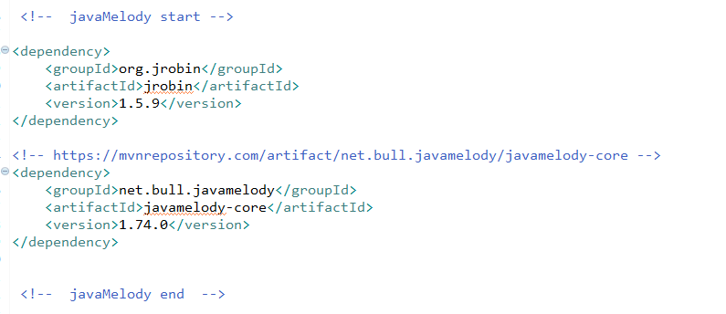

2 web.xml

<filter>

<filter-name>monitoring</filter-name>
<filter-class>net.bull.javamelody.MonitoringFilter</filter-class>
<async-supported>true</async-supported>
</filter>

<filter-mapping>

<filter-name>monitoring</filter-name>

<url-pattern>/*</url-pattern>

</filter-mapping>

<listener>

<listener-class>net.bull.javamelody.SessionListener</listener-class>

</listener>

3 spring 配置

