1 Gitlab 安装配置

1.1查看操作系统版本

$uname –a

$cat /proc/version

CentOS7

https://about.gitlab.com/installation/#centos-7

1.2 Installation

Install and configure the necessary dependencies
On CentOS 7 (and RedHat/Oracle/Scientific Linux 7), the commands below will also open HTTP and SSH access in the system firewall.

$sudo yum install -y curl policycoreutils-python openssh-server
$sudo systemctl enable sshd
$sudo systemctl start sshd
$sudo firewall-cmd --permanent --add-service=http

Step2: Next, install Postfix to send notification emails. If you want to use another solution to send emails please skip this step and configure an external SMTP server after GitLab has been installed.

$sudo yum install postfix
$sudo systemctl enable postfix
$sudo systemctl start postfix

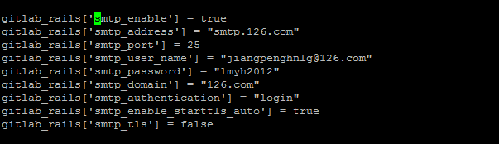
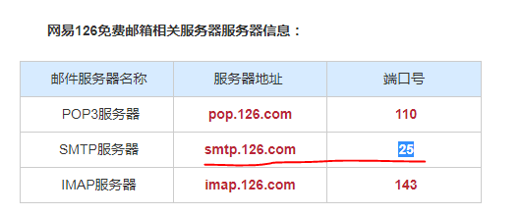
邮箱不发邮件：

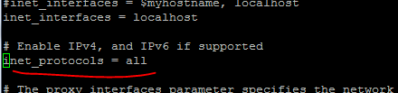

Step3: Add the GitLab package repository and install the package
Add the GitLab package repository.

$curl https://packages.gitlab.com/install/repositories/gitlab/gitlab-ee/script.rpm.sh | sudo bash

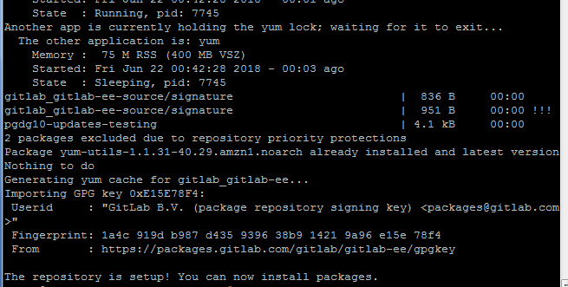

Step4:
Next, install the GitLab package. Change `http://gitlab.example.com` to the URL at which you want to access your GitLab instance. Installation will automatically configure and start GitLab at that URL. HTTPS requires additional configuration after installation.

sudo EXTERNAL_URL=" www.hanniukj.cn" yum install -y gitlab-ee

If you just configure the IP address as hostname:
$vi /etc/gitlab/gitlab.rb

$sudo gitlab-ctl reconfigure


Change the default port:

/etc/gitlab/gitlab.rb

nginx['listen_port'] = 9006

Restart
$gitlab-ctl restart

Change the nginx port : 8025

$ll /var/opt/gitlab/nginx/conf

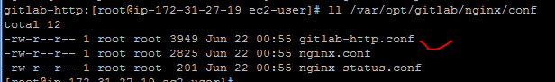

$vi gitlab-http.conf

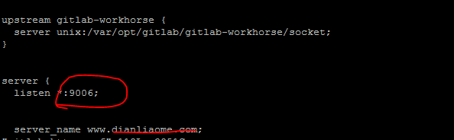
Restart the gitlab

$gitlab-ctl restart

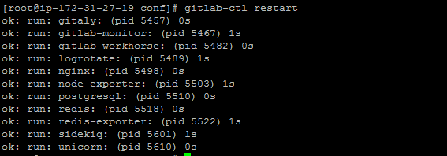

禁用自带nginx

vi /etc/gitlab/gitlab.rb
nginx['enable'] = false

Restart

sudo /usr/local/nginx/sbin/nginx -s reload
sudo gitlab-ctl reconfigure

9006端口访问gitlab

时间设置：

vim /etc/gitlab/gitlab.rb

登陆POSTGESQL数据库：

$su - gitlab-psql

$psql -h /var/opt/gitlab/postgresql -d gitlabhq_production

#select email, encrypted_password ,reset_password_token,reset_password_sent_at from users;

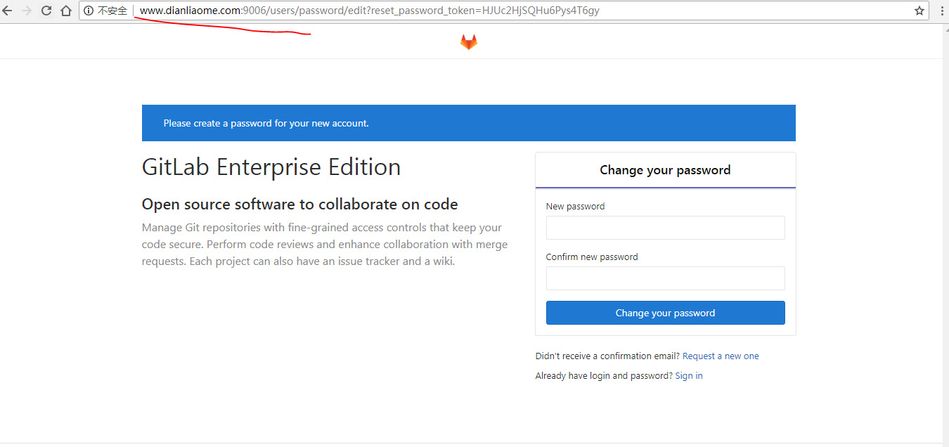

修改密码为：root/ Betty_****

注册用户

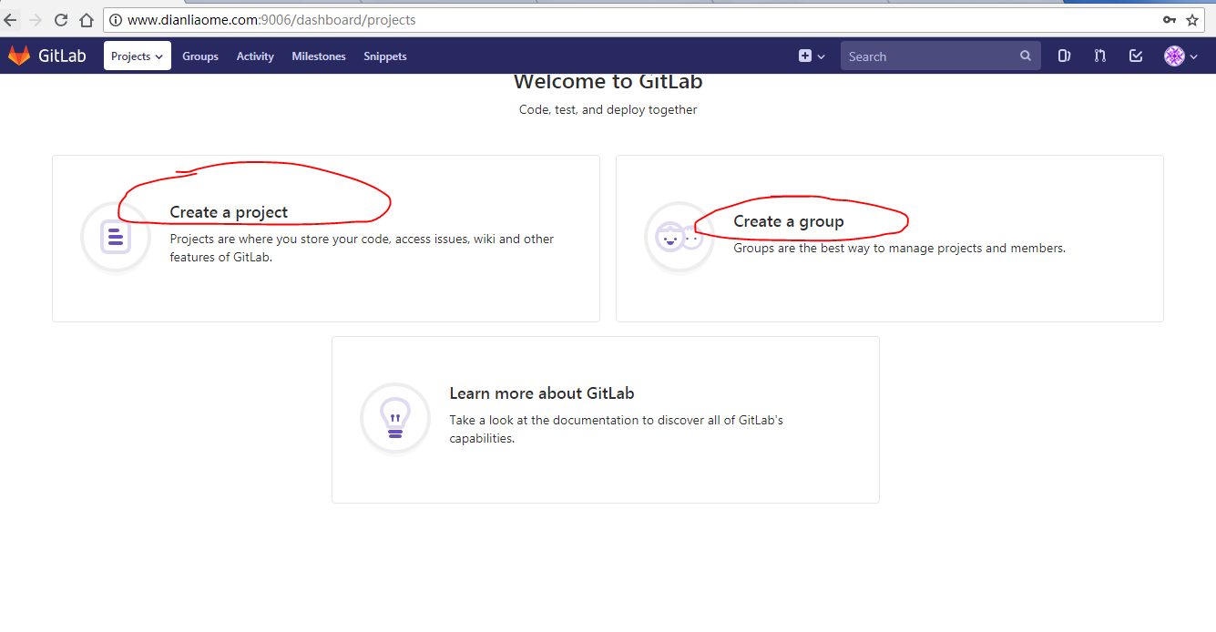

AWS 弹性卷：
查看当前的DISK

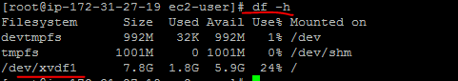

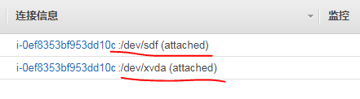

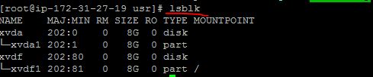

格式化并mount 挂载
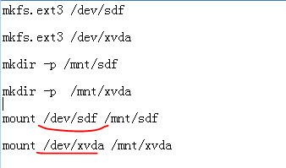

2 Gitlab创建仓储及项目
http://39.108.210.27/agilean-project/demo01

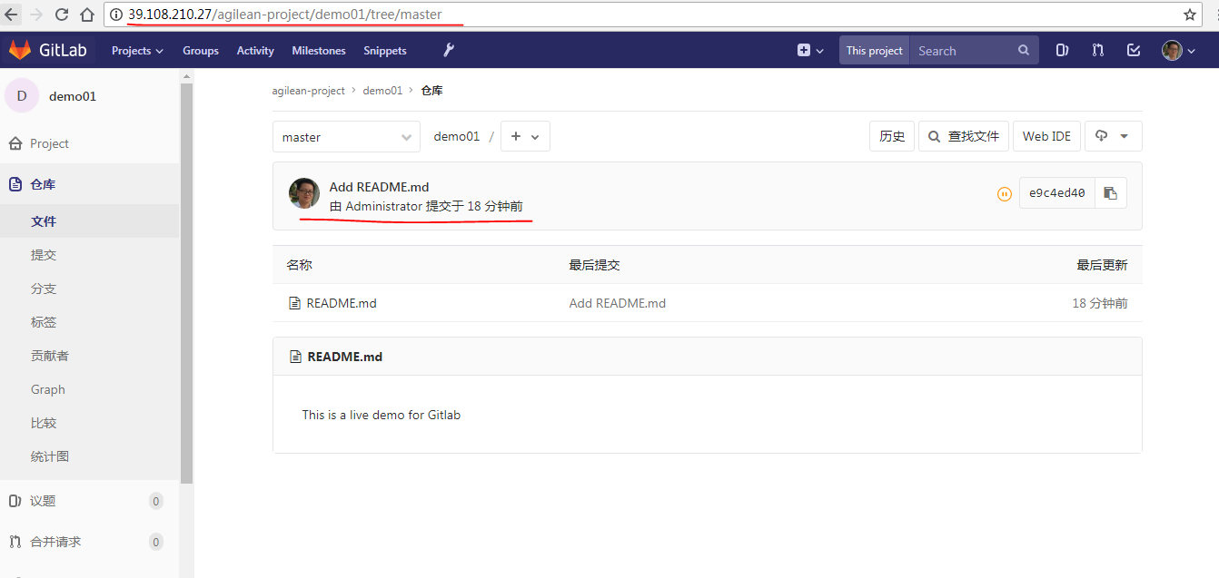

Projects:
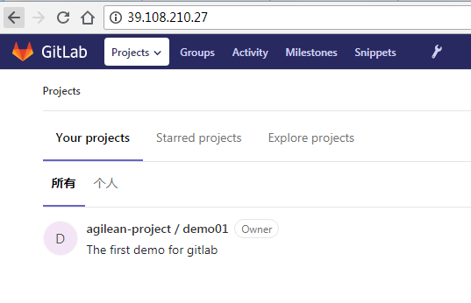
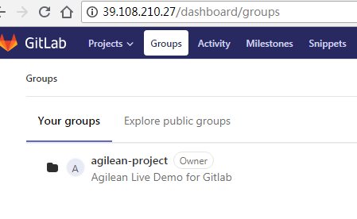

新建 SSH keys

http://39.108.210.27/profile/keys

http://39.108.210.27/help/ssh/README#generating-a-new-ssh-key-pair

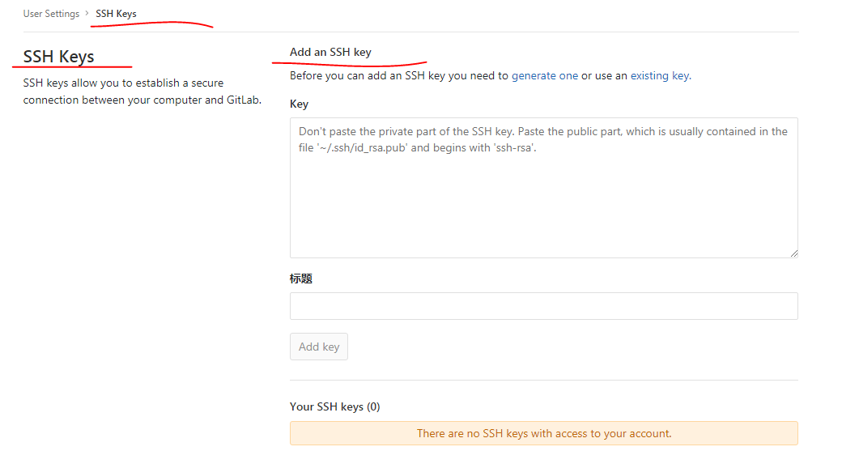

Log on the server:

说明还没有公钥：

$ssh-keygen -t rsa -C "jiangpenghnlg@126.com" -b 4096

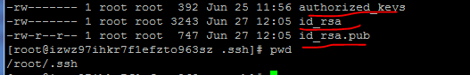

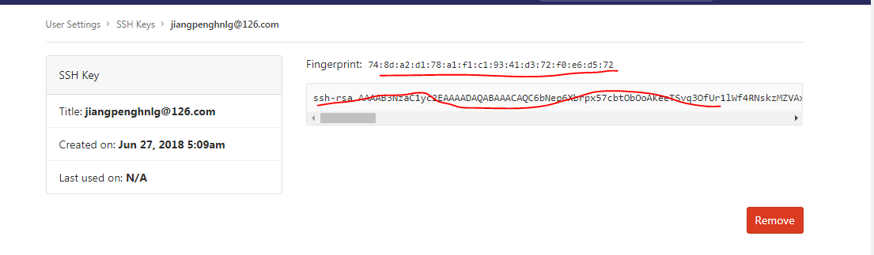

EGIT:

http://download.eclipse.org/egit/updates

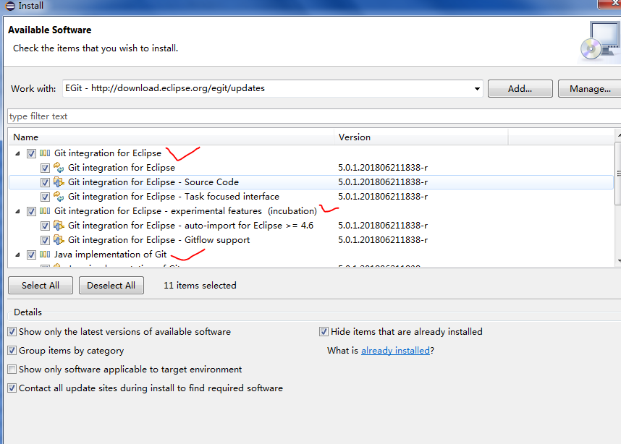

取一个GIT项目到本地：

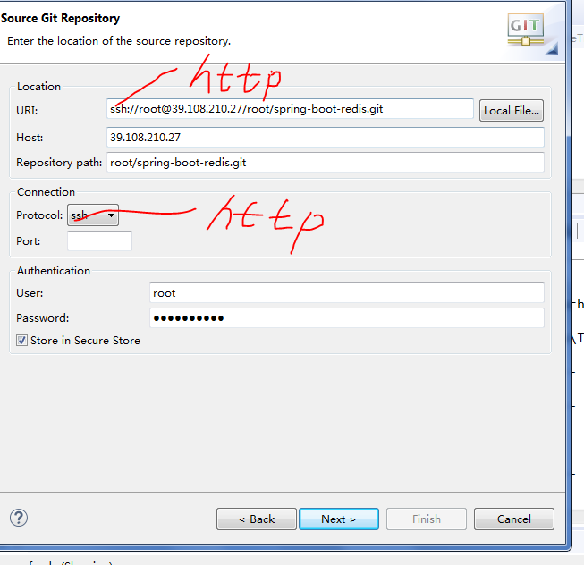

向项目新增成员：

http://39.108.210.27/root/spring-boot-redis/project_members

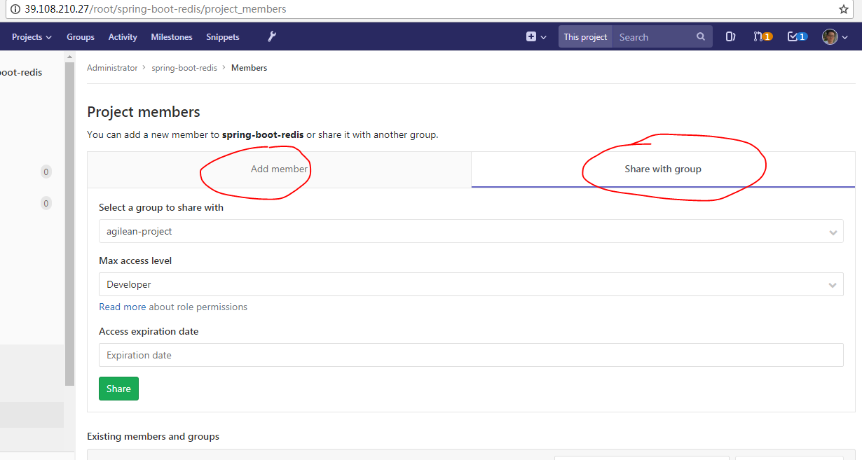

分支演变：

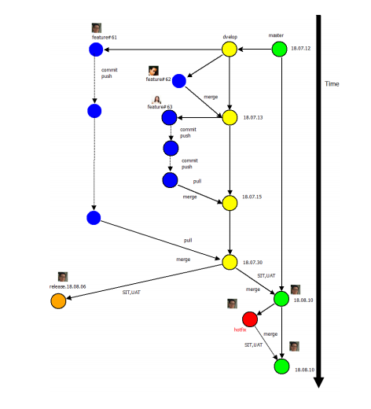

操作用例：

1，在远程原有的GIT分支上建立一个开发分支：

1.1克隆本地：

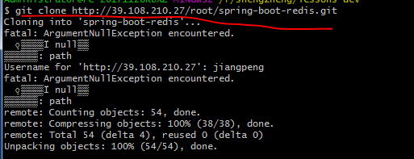

1.2 在本地master的基础上创建特性分支dev

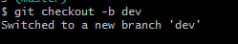

1.3 查看当前分支
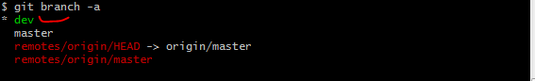

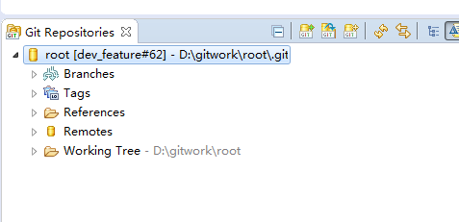

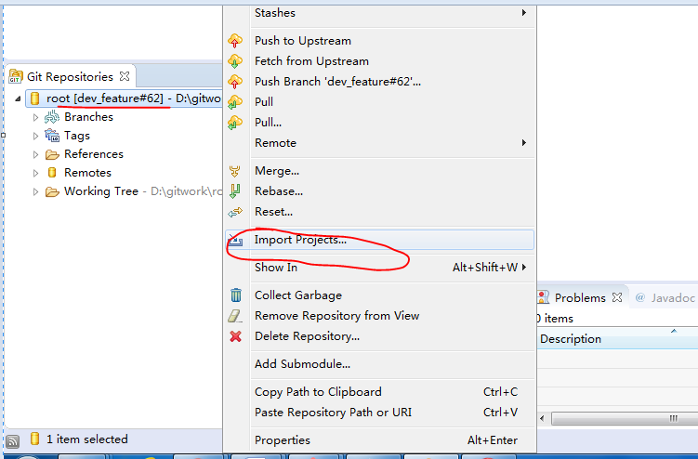

3 Gilab 资源库物理路径：

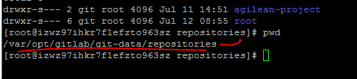

4 Gitlab 管理
$gitlab-ctl status

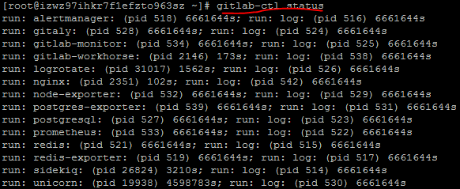

# 启动Gitlab所有组件

sudo gitlab-ctl start

# 停止Gitlab所有组件

sudo gitlab-ctl stop

# 重启Gitlab所有组件
sudo gitlab-ctl restart

