**MARSHALL ADULT EDUCATION**

**MICROSOFT**

**WORD**

**TRAINING**

### TABLE OF CONTENTS

Introduction 3

The Word 2000 Interface 4

What Page View Should I Use 5

Moving Around in a Document 6

Some Important Things First 7

Selecting Text 8

The Toolbars 9

Using the Formatting Toolbar 10

The Formatting Toolbar Chart 11

The Standard Toolbar 12

Format a Memo 13

Using the Format Painter to Format Text 14

Cut and Paste 15

Drag and Drop 16

Using the Spell Checker 17

Using the Thesaurus 18

Inserting Clipart 19

Setting the Left Tab Marker 20

Using the New Line Command 21

Setting the Center and Right Tab Markers 22

Setting Tabs and Using Dot Leaders 23

Inserting Symbols 24

Creating a Table 25

Creating a Table with the Insert Table Button 26

Adding Columns and Rows to a Table 27

Adding a Formula to a Table 28

Merging Cells in a Table 29

Deleting Rows and Columns 30

Averaging Test Scores 31

Calculating Net Profit 32

Recalculating a Table 33

Working With Columns and Breaks 34

Working With Columns and Breaks Part 2 35

Using Columns and Breaks and Page Setup 37

Creating a Header 39

Creating a Footer 40

Inserting Photos into a Document 41

Keyboard Shortcuts 43

The Best Word Shortcuts 44

250 Microsoft Word Shortcuts 45

Neat Tricks in Word 2000 47

Addendum 53

### Microsoft Word Training

**Introduction**

Microsoft Word is part of the “suite” of applications called Microsoft Office. Microsoft Office clearly has the largest market share for integrated office applications at a whopping 79% (according to PC Data). The 2 largest competitors, Corel and Lotus come in at a very low 6% and 4% respectively.

Microsoft Word is a very user friendly and stable word processing application. This series of lessons presents a variety of information about Microsoft Word from the basics to the advanced. It by no means covers all there is to know, but it does cover the basics of a lot of topics.

You may be a new user of Microsoft Word, or you may be an experienced user. There will be something here for everyone. Work through the parts of this training packet that you think will benefit you most. You may start at the beginning of this packet and work through it or, if you know some of the information in the packet, skip it and do those sections that you do not know.

There is an accompanying floppy disk that you will need for many of the lessons. If the lesson begins with “Open the file…,” then you know to use the floppy disk to begin the lesson.

On Page 53 Addendum – some topics that have been added since the first printing. Topics covered are:

How to Delete Text

When to Save and when to Save As

Use the Scroll Wheel

Insert Mode and Overstrike Mode

How to Save a File (on a Floppy Disk and on the Hard Drive)

How to Open a File

Two Features in Word You Want to Use

And as usual, if you have questions or comments, just holler! Have a great training session.

### The Word 2000 Interface

There are several areas that make up the Word 2000 interface. Find these areas on your monitor screen and be familiar with them as we will use them in this training.

|  |  |
| --- | --- |
| **Title Bar** | titlebar |
| **Menu Bar**-gives options for working with documents | menubar |
| **Standard Toolbar**-buttons for opening, saving, closing, and printing files and more…. | standard-toolbar |
| **Formatting Toolbar**-used for formatting text with different fonts, sizes, and colors and more… | formatting-toolbar |
| **Ruler**-used to help with cursor position, tabs, and indents. In Print View, there is a also vertical ruler along the right hand side. | ruler |
| **Text area**-the insertion point is where text is typed. In Page View, you can see the text boundaries. More on this later. | text-area |
| **Status Bar**-gives position of the insertion point and other information on the current document. Can you figure out what the other information is? | statusbar |

### What Page View Should I Use

For this lesson, open the file: Sample Text.doc

There are 4 page views to choose from: Normal, Web Layout, Print Layout, and Outline.

Click on **View** in the menu bar to select each view.

Try each of the views and read below what they are used for.

**Normal view** is a good view if you just want to type text. It does not show the page margins like Print Layout view.

**Web Layout view** only is used if you are creating a web page.

**Print Layout view** actually show the left and right margins of the page as well as the top and bottom margins of the page. A note about Print Layout view: You will want to have the text boundaries showing if you use this view (they probably already are). Follow these steps to show the text boundaries:

1. Click on Tools in the menu bar, then select Options.
2. Click on the Views tab and then click on Text Boundaries (place a checkmark (🗸) in the box)

**Outline view** is only used if you are making an outline.

**USING THE MOUSE TO SELECT THE VIEW**

You can also choose which view you want to use by clicking on the

views buttons. They are located in the lower left hand corner

of the screen, to the left of the horizontal scroll bar.

Place the cursor over each without clicking to see the name of each view button. Click on the one that you want to use.

### Moving Around in a Document

Text in Word 2000 is always entered at the insertion point. Open up the file: Sample text.doc

Below are some ways to move the insertion point around in your document. Try each of these ways

**LEFT ARROW** Moves the insertion point one character to the left

**RIGHT ARROW** Moves the insertion point one arrow to the right

**UP ARROW** Moves the insertion point one line higher

**DOWN ARROW** Moves the insertion point one line lower

**HOME** Moves the insertion point to the beginning of the line

**END** Moves the insertion point to the end of the line

**CTRL + HOME** Moves the insertion point to the beginning of the document

**CTRL +** **END** Moves the insertion point to the end of the document

**CTRL + Left Arrow** Move left to the beginning letter of each word

**CTRL + Right Arrow** Move right to the beginning letter of each word

**PAGE UP** Moves the insertion point one screen up

**PAGE DOWN** Moves the insertion point one screen down

### Some Important Things First

**What if I make a mistake?**

As you are working, you will undoubtedly make mistakes. If you make a mistake, you can **Undo** the mistake by clicking on the **Undo** button in the Formatting Toolbar, or by pressing Ctrl-Z. You may also click on the Edit Menu and select **Undo**. This is a neat way to **Undo** because it tells you there what you are undo-ing. Sometimes, you may have made a series of mistakes and you need to do the **Undo** several times. In fact, you can **Undo** yourself all the way back to the very beginning.

Now, if you Undo something, or several things, and you decide that you actually didn’t want to Undo those thing, you can **Redo** them. Just click on the **Redo** button in the Formatting Toolbar or press Ctrl-Y. And like Undo, you may also click on the Edit Menu and select **Redo**. You can **Redo** as many times as you want (just like you can Undo as many times as you want.

Keep **Undo** and **Redo** in the forefront of your mind. *(I couldn’t live without them!)*

**Is there more than one way to do a task?**

Yes, in Microsoft Word, there are usually many ways to do the same task. For example, you may be able to use the **Menu Bar** (sometimes called a drop-down menu) to do a task, or you may be able to **click on a toolbar**, or you may be able **to press a series of keys** (sometimes called keyboard shortcuts). Learn all the ways to do a task and then use the one that is easiest for you.

**When do I click once and when do I double-click?**

You always **click just once** unless it specifically says to **double-click**. The more experienced you get with Word, the more you will learn that in many cases, it is faster to double-click to accomplish a task than single-click.

**When do I right-click and when do I left-click.**

You always left-click unless it specifically says to right-click. Whenever you right-click, a pop-up menu always appears on the screen which gives you options and the ability to do something.

**Do I save my work?**

You can if you want to. It might be a good idea to save your work both on the floppy disk and on the hard drive so that you learn how to do it. If you need help, holler.

**What if something pops on my screen and I don’t know what it is?**

That’s what the Esc *(Escape)* key is for – just press it once. You problem may be solved.

**I really wanted to learn how to do** **\_ \_ \_ \_ \_ \_** **in Microsoft Word, but its not in the training packet?**

Just ask me what you want to learn. I have resources for just about anything you would want to learn and I will give it to you. *(Mail merge, making labels, printing envelopes, …..)*

**How do I remember all this stuff**?

You don’t the first time you do it (or the 2nd, 3rd, 4th…). Like anything else, the more you practice, the better you get and the more you remember.

One last thing, there is a real possibility (make that probability) there may be some mistakes in the training material. If you find one, let me know so that I can correct it. Microsoft Word catches a lot of mistakes – but it doesn’t catch them all!

### Selecting Text

**Open the file: Sample Text.doc. Read the text below and do the PRACTICE exercises below using the file you just opened.**

**Selecting Text** means that you highlight the text. This text is selected

You need to select text to make any changes to the text.

Often, it has been suggested that users should type up their documents first, and then format the text to meet their own needs. Word processors allow you to select, or highlight, text to make editing or formatting changes to it.

***PRACTICE----------------------------------------------------------------***

Here are the methods of selecting text using both the mouse and the keyboard. **TRY EACH**

1. **Select text using the mouse:** Click-and-drag across the text you want to format.
2. **To select a single word:**  Place the cursor on the word you want to format and double-click
3. **SHIFT-Click to select a series of words:** Click to the left of the first word you want to begin with, then, while holding down the **SHIFT** key, click to the right of the word you want to end with.
4. **To select a sentence:** Hold the [CTRL] key and click the sentence.
5. **You can also use SHIFT with the four arrow keys to select text:** Hold down the SHIFT Key and then push the left or right arrow keys (or the up and down arrow keys) to select the text.
6. 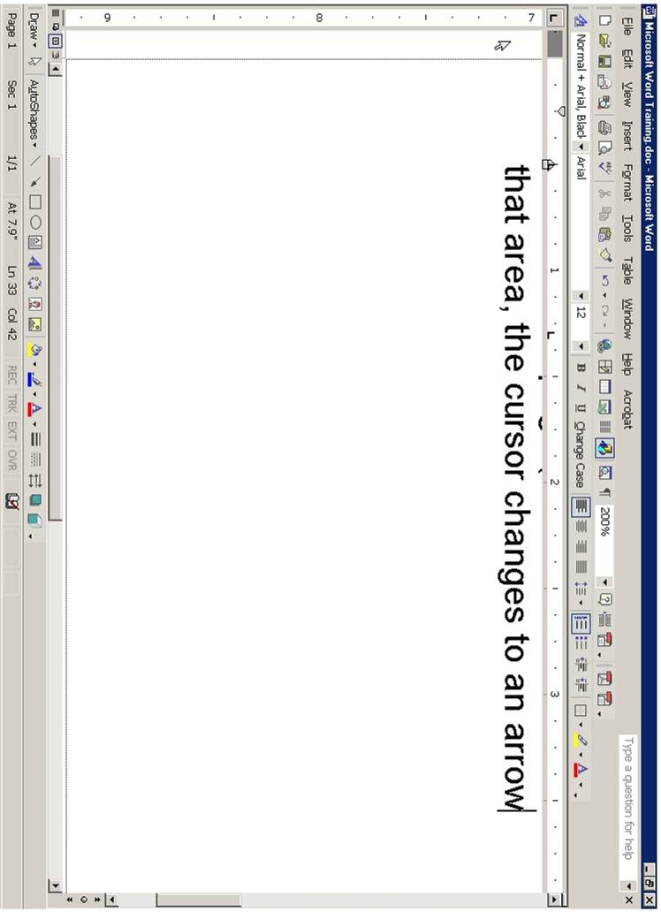**Use the Selection Bar to select text.**  The selection bar is the area in the left-hand border of the page (to the left of the text on the screen).   
   When you move the mouse in that area, the cursor changes to an arrow.  
     
   Place the cursor in the selection bar area and click to the left of the line that  
   you want to select.  
     
   If you want to select several lines, click in the selection bar area and drag down (or up) to include all the lines you want.

*So, which method do you use? Any method – use whichever is best for that situation.*

### The Toolbars

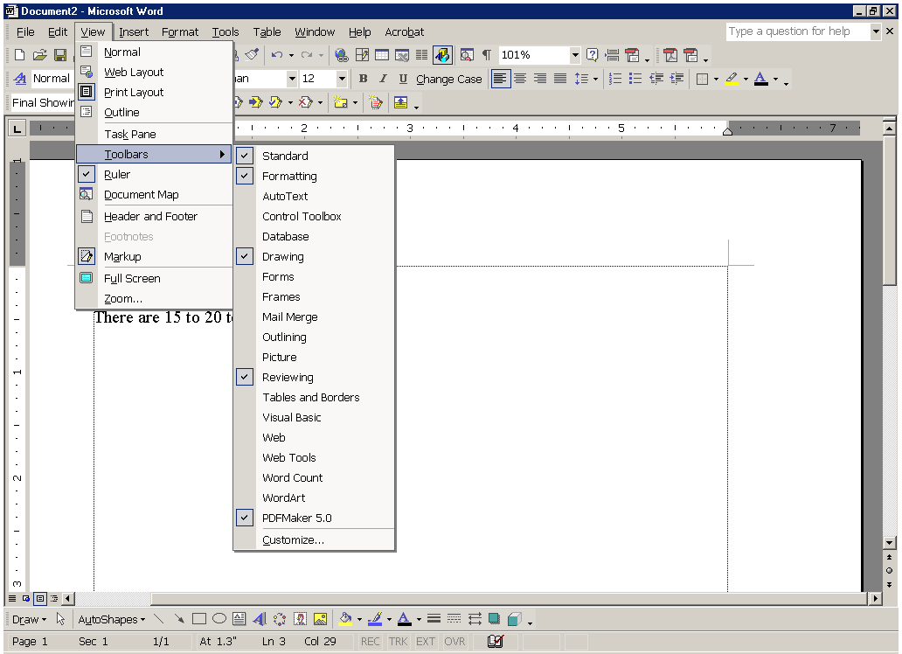

There are 15 to 20 toolbars in Microsoft Word (depending on your version of Word and how many add-ons you have installed). The 2 most important and most used toolbars are the Standard Toolbar and the Formatting Toolbar. Look at the top of the screen just under the Menu Bar and you will see those 2 toolbars.

To show or hide the toolbars, you click on the View menu and select Toolbars. The toolbars with a check mark are currently visible on the screen. Simply click on a toolbar to either show it or hide it. **Try clicking on some of the toolbars.**

Remember that you always want to show the Standard Toolbar and the Formatting Toolbar.

Toolbars can be moved to the top of the window, the bottom of the window, or to the left or right side of the window. To move a toolbar, place the cursor on the dim vertical line on the left side of the toolbar. When you get a cursor that has vertical and horizontal double arrows, click and drag the toolbar to the desired location. **Try it. *It will be a little awkward at first, but practice a little bit until you get the hang of it.***

The toolbars that you will most frequently use (besides the Standard Toolbar and the Formatting Toolbar) are the Picture Toolbar, the Drawing Toolbar, and the Tables and Borders Toolbar.

Another way (a very convenient way) to show and hide toolbars is to use the right-click method. **Try this.** Right-click at the top of the screen and to the right of one of the toolbars. You will see a pop-up menu appear. Just click on any of the toolbars that you want to show or hide.

We will do some exercises using the Formatting and Standard Toolbars.

### Using the Formatting Tool Bar

Using the chart **The Formatting Toolbar**, format the text below. Remember, to format text, you must first **select** it (highlight it by dragging over it).

Open the file on the floppy disk: **Using the Formatting Toolbar.** Format the text in each line. Use **The Formatting Toolbar** chart on the next page to find which button to click on

Bold this line of text.

Make this line of text in italics.

Underline this line of text.

Change this line of text to red.

Change this line of text to 18 point.

Change this line of text to a different font.

Center this line of text.

Right justify this line of text.

Indent this line of text.

Put a bullet in this line of text.

Number this line of text.

Highlight this line of text.

Put a border around this line of text.

Double space this line of text.

Make this line of text Bold, Italics, Underlined, Red and with a border.

### THE FORMATTING TOOLBAR - Chart The%20Formatting%20Toolbar

|  |
| --- |
| **Select Text**  Select text by holding down the mouse cotton and dragging over it with the mouse.  Example: This is selected text |

### The Standard Toolbar

The Standard Toolbar provides a convenient and easy way to do a wide variety of tasks. The Standard Bar on the computer you are looking at right now may look slightly different because the toolbar can be customized. Icons can be added or deleted according to your preference. But here is a basic toolbar with an explanation about what each icon is used for.

Study the icons, try some of them, and use them in your word processing.

**word_standardbar**

|  |  |  |  |
| --- | --- | --- | --- |
| **Function of commonly used buttons** | | | |
| word_but_new | Creates a new blank document based on the default template | word_but_open | Opens or finds a file |
| word_but_save | Saves the active file with its current file name, location and file format | word_but_print | Prints the active file - for more print options go to the File menu and select Print |
| word_but_preview | Print preview - Shows how the document will look when you print it. | word_but_spell | Spelling, grammar and writing style checker |
| word_but_cut | Cut - Removes the selection from the document and places it on the clipboard | word_but_copy | Copy - Copies the selected item(s) to the clipboard |
| word_but_paste | Paste - Places the content of the clipboard at the insertion point | word_but_format | Format painter - Copies the format from a selected object or text and applies to other objects or text |
| word_but_undo | Undo - Reverses the last command, use pull-down menu to undo several steps | word_but_redo | Redo - Reverses the action of the Undo button, use the pull-down menu to redo several steps |
| word_but_tab | Displays the Tables and Borders toolbar | word_but_table | Insert a table into the document, or make a table of selected text |
| word_but_ss | Insert an Excel spreadsheet into the Word document | word_but_column | Columns - Changes the number of columns in a document |
| word_but_art | Displays or hides the Drawing toolbar | word_but_zoom | Zoom - Enlarge or reduce the display of the active document |

### Format a Memo

Open the file: How To Make Iced Tea

Use the Formatting Toolbar to format the memo. Remember, you must always select the text before applying the format.

1. Select the heading: **How To Make Iced Tea**
2. **Bold** the heading, **underline** it, **center** it. make it **red** and make it **18 point.**
3. Bold and italicize the words: **Date**, **To**, **From**, and **RE.**
4. **Indent** the word Ingredients. **Bold** it, **underline** it and make it **red**
5. Add a **bullet** to the Ingredients list (water, tea, sugar and ice). Hint: Select all 4 ingredients at once before you click on the bullet button.
6. **Indent** the word Directions. **Bold** it, **underline** it and make it **red**
7. **Number** the Directions list. Hint: Select all 4 directions at once before you click on the numbering button.
8. **Center** the bottom line: Enjoy your iced tea! Also, **italicize** it, make it **blue,** **bold** it, make it **18 point**, change the font to **Rockwell**, and put a **border** around it.
9. When you are finished with all the formatting, **print it**.

### Using the Format Painter to Format Text

Open the file: **You Are Invited to a Party**

Format the text according to the instructions below. Remember, you must always **select** the text before formatting it.

1. Press **Ctrl-A** to select all the text. Click on the **Center** button in the Formatting Toolbar.
2. **Bold** the title: You Are Invited to a Party. Also, make it **red**, change the font to **Rockwell**, make it **18 point**, and put a **border** around it.
3. **Bold** the word: **Date:** Also, **underline** it and make it **red**
4. Be sure the word **Date**: is selected and then **double-click** on the **Format Painter** icon in the Standard Toolbar. (It is the icon that looks like a paint brush).
5. Notice that your cursor changes into **paint brush.**
6. Now, you are going to “**paint**” over the other headings: **Time, Place What to Bring, and Schedule**. Just drag the paint brush over those words – carefully. As you drag over each work, the word takes on the formatting of the original word (Date).
7. Now select the words: **December 31, 2002**. **Bold** it and make it **blue**.
8. Once again, turn on your **Format Painter** by **double clicking** on it. Paint (drage over) all the rest of the text which is under the headings **Time, Place, What to Bring, and Schedule.** Hint: when you have 3 lines of text (such as is under Place and What to Bring), you can drag over all 3 lines at the same time.
9. **Select** the 3 lines under the heading: **What to bring** and **Number** these lines
10. **Select** the 4 lines under the heading: **Schedule**. Place a **bullet** in these lines.
11. Print a copy of your formatted file.

### Cut and Paste

Open the File: **Cut and Paste**

In this document, you will **cut** the answer on the right side and **paste** it in the correct line on the left side.

1. **Select** the text ***cold feet***. (Hint: It is easier if you place the cursor to the right of ***cold feet*** and click and drag toward the left).
2. **Cut** the selected text. There are 3 ways to cut the text:  
    (1) Click on the **Scissors icon** in the Standard Toolbar.  
    (2) Press **Ctrl-X** (the keyboard shortcut for Cut).  
    (3) Click on the **Edit** menu and select **Cut.**  
   Use one of these methods to cut ***cold feet.***
3. Place the cursor to the **right** of line #1 (***When you are afraid you have***).
4. **Paste** the selected text. There are also 3 ways to paste the text:  
    (1) Click on the **Paste** icon in the Standard Toolbar.  
    (2) Press **Ctrl-V** (the keyboard shortcut for Paste).  
    (3) Click on the **Edit** Menu and select Paste.  
   Used one of these methods to paste ***cold feet*** in line #1.
5. Continue **cutting and pasting** each of the answers on the right side to the correct line on the left side.

Print the Page.

**Copy Text**

**Copying text** is similar to cutting text except that when you copy selected text, you leave the original text in place and copy the text in the desired location.

There are 3 ways to copy text:

(1) Click on the **Copy icon** in the Standard Toolbar.  
 (2) Press **Ctrl-C** (the keyboard shortcut for Copy).  
 (3) Click on the **Edit** menu and select **Copy.**

### Drag and Drop

Open the file: **Drag and Drop**

In this lesson, you will drag the road sign names at the top to the correct road sign icons below.

1. **Select** the first road sign title, ***Railroad******Crossing***.
2. Place the **cursor** over the selected text so that the cursor changes to a **white arrow**.
3. Hold down the **mouse button** while **dragging** the text to the Railroad Crossing icon (in the right hand column). When you see a small **vertical line** appear just to the right of the icon, release the mouse button.
4. Continue dragging the road sign titles to the correct icons. If the icon is **not visible** (it is below the bottom edge of the window), drag the text toward the bottom of the screen and the screen will start to scroll downward.
5. **Drag** **and drop** all the titles to their respective icons.
6. Print the page.

**Copying with Drag and Drop.**

If you hold the **Ctrl** key down while you drag selected text, you will leave a copy of the text in its original position. ***Try it.***

### Using the Spell Checker

Open the file **Using the Spellchecker**

You will use the **Microsoft Spell Checker** to check the spelling of this memo. As you look at the document, words that are underlined in red are misspelled words. Words that are underlined in green are grammatical errors. The Spell Checker will find both misspelled words and grammatical errors.

1. Click on the **Spelling and Grammar** icon in the **Standard** **Toolbar**.
2. The **Spell** **Checker dialog box** appears. The **top** part of the dialog box shows the misspelled word in red. The **bottom** part of the box shows a list of suggested words. The **right** **side** shows several actions that can be taken.
3. If the correct spelling of the word is in the suggested list, click on the word and click on **Change**. (You can also click on **Change** **All** if that word is used more than once in the document).
4. If the correct spelling of the word is **NOT** in the Suggestions box, you may change the misspelled word in the upper box yourself by deleting the word and retyping it correctly. After correcting the word yourself, click on **Change**.
5. If you know a word is **not** **misspelled**, for example, a person’s name, click on **Ignore**. You may also click on **Ignore** **All** if that word is used in the document more than once.
6. You may **add** any word that is not in the dictionary (that doesn’t show up in the list of suggestions) to the dictionary by clicking on **Add**. (Just be sure that the word is typed correctly!)
7. You may add any word to the **Auto** **Correct** feature by clicking on **Auto** **Correct**. (Auto Correct is a feature that automatically corrects some words as you type them. For example, if you type the word ***adn***, Word will change it to ***and*** automatically.)
8. Continue checking the entire document until you get to the **pop**-**up** box that says. ***The spelling and grammar check is complete.***
9. **You are not finished!** The Spell Checker does not find **every** error in your document. In this document, there are incorrectly used words that the Spell Checker did not find. You always need to proofread a document to find words that may not be misspelled but are not used correctly in the context of the document. Can you find the incorrectly used words?

### Using the Thesaurus

Open the file: **Using the Thesaurus**

Use the **Thesaurus** to change selected words in the memo.

1. **Double click** on (select) the word “**main**” in the first paragraph. Click on the **Tools** menu, point to **Language** and then click on **Thesaurus** (Notice that you can also use the shortcut **SHIFT-F7**). Select the word “**primary**” and click on **Replace**.
2. Replace the word “**injured**” in the first paragraph with “**harmed**” using the steps in Step 1. (Paragraph 1)
3. Replace the word “**concern**” in the second paragraph with the word “**consideration**” using the right-click method.
4. Right-click on the word **cash**, point to Synonyms, and select the word “**money**.” (This is a shortcut to using the Thesaurus.)
5. Replace “**warmth**” with “**heat**.” (3rd paragraph)
6. Replace “**continuously**” to “**constantly**.” (3rd paragraph) using any of the methods described above.
7. Print the file.

### Inserting Clipart

Open the file: Inserting Clipart

In the lesson, you will learn how to insert clip using the Microsoft Office Online website. This website is specifically designed to be used with Microsoft Office applications and contains thousands of graphics and clipart. Follow the instructions to add clipart to the document.

**To insert a picture into your file, do the following:**

1. In the Menu Bar, click on Insert
2. Click on Picture
3. Click on Clipart
4. Click on Clips Online
5. Type in the name of the picture that you want to search for in the upper right hand corner box just to the left of the green arrow.
6. Press on the Green Arrow.
7. Put the mouse on the picture you wish to use and click on the down pointing arrow.
8. Click on Add to Selection Basket
9. Click on Download 1 Item located in the blue bar just above the pictures
10. Click on Download Now
11. Click on Open
12. Click OK
13. Right-Click on the picture and select Copy
14. Close the Window (Click on the X or press Alt-F4)
15. Click on your file in the Task Bar at the bottom of the screen.
16. Click the mouse to the right of the sentence or word where you want to graphic to appear.
17. Click on the Paste button
18. Make the picture smaller if it is too big. To make the picture smaller, click in the middle of the picture to select the picture. Handles will appear in the corners and sides of the picture. Then place the mouse on the “handle” in the lower right hand corner of the picture and when the cursor changes in a diagonal line with double arrows, click and drag the picture until it is the size that you want.
19. The layout of the picture can be formatted in several ways. To see the layout options, right-click on the picture and select Format Picture. Click on Layout. Choose the layout that you want (experiment with them).
20. Print the document.

### Setting the Left Tab Marker

Be sure the **Ruler** is showing. If it is not showing, click on **view** and click on Ruler.

The **Tab Markers** are located in the small box to the left of the ruler. When you click on the box, you cycle through each tab marker as illustrated below.

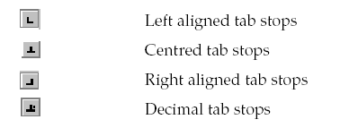

Left Tab Marker

Center Tab Marker

Right Tab Marker

Decimal Tab Marker

Follow these directions to set left tab markers and then type the names and titles below.

1. Click on the **Tab Marker** box to the left of the ruler until the **left tab marker** is showing.
2. To set the **left tab**, click the mouse on the ruler at **2 inches mark**. Also, click the mouse on the ruler at the **4 inch mark**.
3. Type the following names and titles using those tab settings. Press **TAB** before you type each name and after you type each name. Press **Enter** at the end of each line.

Jason Jones Director

Shirley Blanchette Training Supervisor

Paul Simpson Trainer Specialist

Mary Johnson Trainer Specialist

Lucille Jorgenson Trainer Specialist

Tiffany Tillemans Administrative Assistant

**Moving the Tab Markers**

**Select** all the names you just typed. **Very carefully**, move the **2 inch tab marker** to the **one inch** mark. Move the **4 inch tab marker** to the **3 inch** mark. If you move the tab marker off the ruler, your will lose it – be careful!.

Notice that you have to **select** the text in order to move the marker and the text to a different place.

Print the document.

### Setting the Left Tab Marker - Part 2

**Using the New Line Command**

1. Set a **left tab marker** at **2 inches** and set one at **4 inches.**
2. Type the names and job titles below. At the end of each line, hold down the **SHIFT key** and press **enter**. **Do this at the end of each line**. This is called **New Line Command**.

Jason Jones Director

Shirley Blanchette Training Supervisor

Paul Simpson Trainer Specialist

Mary Johnson Trainer Specialist

Lucille Jorgenson Trainer Specialist

Tiffany Tillemans Administrative Assistant

1. Click in the **middle** of any **name**. Move the **2 inch tab marker** to the **1 inch** mark.

4. Click in the **middle** of any **job title**. Move the **4 inch tab marker** to the **3 inch**  
 mark.

5. Notice that when you use the **New Line Command** you **DO NOT** have to **select**  
 the text in order to move the marker and the text to a different place. Just click   
 anywhere in the text and move the marker.

1. Print the document

### Setting the Center and Right Tab Markers

1. Type **TRAINING DATES AND COSTS** at the top of the page. **Center** it and **bold** it.

2. Press **Enter** 2 times and click on the **Align Left** button in the Formatting

toolbar. Also take off **Bold**

3. Set a **left tab** at the 0.5 inch mark.

Set a **center tab** at the 3.5 inch mark.

Set a **right tab** at the 5.5 inch mark

Type the following using the tab markers you just set.

Management September 12 $110

Documentation Training September 23 125

Using the Internet October 7 120

Sending E-mail October 14 100

Principals of Commerce October 23 85

4. **Select all** the text you just typed.

5. Hold down the **ALT** key and click on the 3.5 inch tab marker and move it to the 3.3 inch mark.

6. Hold down the **ALT** key and click on the 5.5 inch tab marker and move it to the 4.7 inch mark.

### Setting Tabs and Using Dot Leaders with the

**Tabs Dialog Box**

You can use the **Tabs Dialog** **box** to set tabs. You **must** use the **Tabs Dialog box** if you wish to use **dot** **leaders**. Follow these instructions carefully to set up the tabs for the text below.

1. Type: **Table of Contents**. **Center** and **Bold** it.

2. Press **Enter** 3 times. Click on **Align** **Left** button in the Formatting Tool Bar and take off **bold**.

3. Click **Format** in the **Menu** **Bar** and click on **Tabs**. Click on **Clear All**. Click on **Left**.

4. Click in the **small white box** just below **Tab Stop Position**. Type: **1**  - Click **Set**.

5. Type: **5** - Click on **Right** in the **Alignment section**. Click on **2** in the **Leader Section.** Click **Set**.

6. Click **OK** (or press **Enter**)

7. Type the text below. Be sure to press **TAB** before each entry and press enter after each line.

Teleconferencing Basics 3

Installation Methods 10

Signal Routing 23

Video Codec Interface 39

Telephone Line Interface 48

Print the document.

### Inserting Symbols

1. You will learn how to insert symbols into your document in this lesson. **Read** through the directions and then type the letter at the bottom of the page.

2. When you get to the word “Tomás,” **NOTICE** that it has an accent about the a. Type only the first **5 letters** of the name (Tom) and then click on **Insert**, and select **Symbols**.

3. Click on the little **up arrow** next to the Font dialog box. Select the normal text font or the Times New Roman font.

4. Look for the letter **a** with the **accent** above it **(á).** Click on it. Click on **Insert** and click on **Close**.

5. Continue typing the paragraph adding symbols in the same manner when you get to them.

6. When you get to the last line and have to look for the symbol of the **globe** ( 🌎 ), you must change to font to **Webdings**. (Do the same for the **airplane** (🛪).

6. When you get to the **smiley** **face** at the end, use the font calle Lucida Console.

---------------------------------------------------------------------------------------------------

DATE: May 3, 2004

TO: Jeremy Harrison

FROM: Roberto Muñez

SUBJECT: Visit to Marshall

The city of Marshall, Minnesota, is located in Lyon County. It has a population of about 12,735 people. Marshall is located 150 miles southwest of Minneapolis/St. Paul and 90 miles northeast of Sioux Falls. The coldest month of the year in Marshall is January. The hottest (☼) is August with the average temperature of 87° to 89°. The average snowfall in Marshall is 35 inches. The city of Marshall comprises an area of 7.5 square miles. For recreation Marshall has ►seven city parks, ►a golf course, ►a bowling alley and a ►movie theater. Marshall also has an outdoor Aquatic Center that has three pools and a water slide. The airport is on the outskirts of town (🛪). Towns surrounding Marshall include Minneota, Redwood Falls and Granite Falls. Marshall is one of the best small towns on the globe. ( 🌎 ) I hope you enjoy your visit. B

---------------------------------------------------------------------------------------------------

Print the Document

### CREATING A TABLE

1. 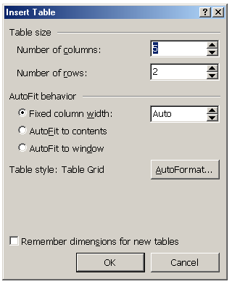To create a table, click on **Table** in the menu bar, point to **Insert** and click **Table**. The **Insert Table** dialog box will appear.
2. Select the number of **columns and rows** you want by either clicking on the up or down arrows or by just typing in the number in the box.
3. For the table below, select **3 columns** and **6 rows**.
4. Type the information below in the table you have created. Be sure to **center** and **bold** the text in the first row.  
   **NOTE**: To move from cell to cell, use the **TAB** key. To move backward from cell to cell, use **SHIFT-TAB.**   
   To move within a cell, use the **left and right arrow keys**.   
   To move up or down a row, use the **up and down arrow keys**.

|  |  |  |
| --- | --- | --- |
| **Name** | **Title** | **Department** |
| Doris Larsen | President | Administrative Services |
| Robert Norcutt | Director | Human Resources |
| Dale Peterson | Assistant Director | Sales |
| Joseph Prahm | Treasurer | Marketing |
| Sandra Fuller | Secretary | Main Office |

**Resizing and centering the table.**

1. To **resize** the table (make it smaller), place the cursor in the **lower left hand corner** of the table (the last cell) – ***do not click the mouse.***
2. A **small square** will appear – place the cursor over that square and click and drag the table to the left, so it is smaller – make it about one inch smaller.
3. To **center** the table, (move into the center of the paper), you must select it first. Place the cursor in the **first cell** (up left-hand corner) of the table. A **small box** will appear with a cross sign in it. Click on this box.
4. The table is selected. Now click on **Center** in the **Formatting Tool Bar**. (NOTE: You can also select the entire table by clicking on **Table** in the menu bar, point to **Select** and click on **Table**).
5. **NOTE:** You may also center the table by clicking anywhere in the table, selecting **Table Properties** from the **Table menu**, and clicking on center. *Try it.*

Print the document.

### Creating a Table with the Insert Table Button

You will used the **Insert Table** button on the Standard Toolbar to create a table.

1. Type the title, **Meyer Electrical Corporation**. **Center** and **bold** it. Press **Enter** twice
2. Type the sub-title, **Human Resource Department**. (Center and bold it). Press **Enter** 3 times.
3. Click on the **Insert Table** button  
   in the **Standard Toolbar**.   
   Hold down the **left mouse button**.  
   This causes the grid to appear. Move the mouse pointer down and to the right until the number below the grid displays as **6 x 2** and then release the mouse button.
4. Type the information below in the cells. Use the **TAB** key to move from cell to cell. Use the **Shift-TAB** to move backward from cell to cell.
5. Use the instructions on the previous page to resize and center the table.
6. Print the table

**MEYER ELECTRICAL CORPORATION**

**Officers**

|  |  |
| --- | --- |
| Jerry Ziegler | President-CEO |
| Dale Wynia | Vice President |
| Alma Torres | Personnel Director |
| Cliff Scholten | Assistant Director |
| Jenny Meinert | Training Department |
| Marge Klooster | Assistant Trainer |

### Adding Columns and Rows to a Table

Open the file: **Adding a Column to a Table**. (It will look similar to the first two columns in the table below).

Make the following changes to the table to add a row and a column to the table.

**Add a row to the table**

1. Position the mouse in any cell in the **first row.** Click on **Table** in the **Menu Bar,** point to **Insert** and then click on **Rows Above**
2. In the **first cell** of the new row, type the word **Name**. In the **2nd cell** of the new row, type the word **Title.**

**Add a column to the table.**

1. Position the mouse in any cell in the **second column**. Click on **Table** in the **Menu** **Bar**, point to **Insert** and click on **Columns to the Right.**
2. In new column, type the following information in the cells beginning with the top cell:

Ext.   
 1034

1036

1128

1110

1230

1232

Make the table **smaller** and **center** the table on the page. Click on the **vertical grid lines** to adjust the column size of the table.

|  |  |  |
| --- | --- | --- |
| **Name** | **Title** | **Ext.** |
| David Knips | President | 1034 |
| Alvin Halgeson | Vice President | 1036 |
| Dora Fisk | Director | 1128 |
| Barbara Connell | Assistant Director | 1110 |
| Blanche Clifford | Trainer | 1230 |
| Choa Thaing | Trainer | 1232 |

**Center** and **bold** the top row headings (Name, Title and Ext.).

Print the table.

### ADDING A FORMULA TO A TABLE

1. Start a new document. Click on **Table** in the menu bar
2. Click on **Insert** – then click on Table.
3. Number of Columns - **6.**
4. Number of Rows - **7**. Click **OK**.
5. Click on the **vertical line** between the 5th and 6th row and move it to the left to shorten up the last column.
6. Click on the **vertical line** between the 4th and 5th row and move it to the left to shorten up the 5th column.
7. Shorten the other column columns in the same way. The widest column should be the 1st column.
8. Type the chart in the table.

|  |  |  |  |  |  |
| --- | --- | --- | --- | --- | --- |
| Name | #1 | #2 | #3 | #4 | Total |
| Robert Rolf | 74 | 77 | 84 | 83 |  |
| Jane McKigney | 88 | 93 | 86 | 90 |  |
| Jesse Keeward | 96 | 95 | 93 | 98 |  |
| Dawn Palmer | 63 | 78 | 71 | 66 |  |
| Alicia Gomez | 83 | 83 | 92 | 87 |  |
| Cherie Lang | 93 | 94 | 84 | 90 |  |

**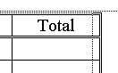**

**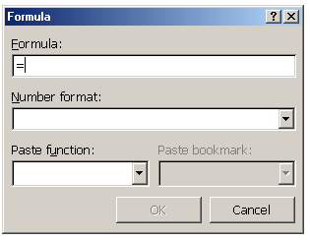Calculate the Totals in Each Row**

1. Click in the first blank cell under **Total**.
2. Click on **Table** in the menu bar, then click on   
   **Formula**. **Delete** the formula but leave the equals sign.
3. Click on the down arrow in **Paste Function**. Select **Sum**.

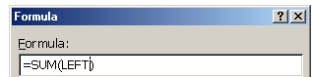

1. 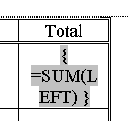Type **LEFT** between the parentheses.  
   (It may be there already).  
   Click **OK.**
2. If the formula is showing,

right-click here and choose

**Toggle Field Codes.**

1. Repeat above steps for each row – calculate the total each Row.

Print the Table

### Merging Cells in a Table

1. Start a new Blank Document. Create a table with 3 columns and 10 rows

1. You will use the **Table Markers** in the ruler to change the width of the columns. Click the mouse in any cell in the table.
2. Hold down the **ALT** key and position the mouse over the **Move Table Column** marker in the ruler.

**Click and drag** to change the width of the first column to 2.5 inches,

**Click and drag** to change the width of the 2nd column to 2 inches.

**Click and drag** to change the width of the 3rd column to 1 inch.

4. Place the mouse in the **first cell** all the way to the left so that the cursor changes to an **upward arrow**.

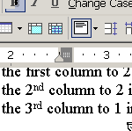5. **Double-click** to select the row. Click on **Table** in the menu bar and click on **Merge** **Cells**. (Note: You can also click on the **Merge** **Cell** button in the **Tables and Borders** tool bar ).

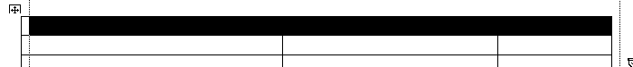 You can also select a row by dragging the mouse over the cells in the row as show below.

1. **Merge** the cells in the 2nd row in the same way.
2. Complete the table by typing the following:  
    In the first row, type: **PERSONNEL AND HUMAN RESOURCES DEPARTMENT** In the 2nd Row, Type: **Microsoft Word Training**  
    In the 3rd row type **Full Name** in the first column, **Section** in the 2nd column,   
    and **ID #** in the 3rd column.
3. **Select** the 3rd row and shade it with a light grey. Use the **Shading Color** button in the **Tables and Borders** toolbar to select the color.

Print the table.

### DELETING ROWS AND COLUMNS

Open the file on your floppy disk **Deleting Rows and Columns**. The file has 12 names in the table.

**Deleting Rows**

1. Position the cursor anywhere in the **last row** in the table (Heather Harris).
2. Click on **Table**, point to **Delete**, and click on **Rows**. The bottom row is deleted.
3. Position the cursor anywhere in the row that contains the name **Kevin Arondo.**
4. Click on **Table**, point to **Delete**, and click on **Rows**.
5. Delete the row that contains the name **June Oda** in the same way.

**Deleting a Column.**

1. Position the cursor in any cell in the **middle column.**
2. Click on **Table**, point to **Delete**, and click on **Columns**

**Change the memo.**

1. In the **first paragraph**, change the word ***twelve*** to ***nine***
2. In the first paragraph, delete the words ***employee ID number*** and also delete the **2 commas** before and after the words.

Print the table

### AVERAGING TEST SCORES

1. Open the file on the floppy disk called **Averaging Test Scores.**
2. 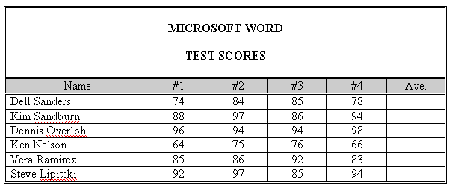Position the cursor in **cell F3**.
3. Click on **Table** and then **Formula**
4. Delete the formula in the **Formula** text box   
     
   ***except*** the equals sign

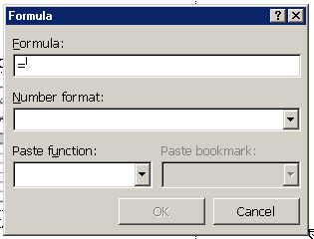

1. With the cursor positioned immediately after the equals sign, click on the **down-pointing triangle** to the right of the **Paste function** text box.
2. At the drop-down menu, click on ***AVERAGE.***
3. 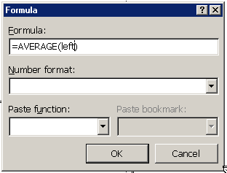With the cursor position between the parenthesis, type the word ***left.***
4. Click the **down-pointing triangle** to the right of the **Number format** text box and then click the fifth option from the top *(0%)* at the drop-down list
5. Click **OK** (or press **Enter**).
6. Postion the Cursor in **cell F4** (just below the cell you were just in) and press the **F4 key** *(NOTE: It’s an F key in the top row on the keyboard - F4).* This is called the **Repeat Command key**.
7. Position the cursor in cell **F5** and then press **F4**.
8. Position the cursor in cell **F6** and then press **F4**.
9. Position the cursor in cell **F7** and then press **F4**.
10. Position the cursor in cell **F8** and then press **F4**.

Print the table.

### CALCULATING NET PROFIT

In this lesson, we will be using some keyboard shortcuts to do some tasks like Center, Bold, Align Right, etc.

1. Start with a new blank document. Press **Enter** once. Create a **table** with **4 columns** and **6 rows**
2. **Select** the entire first row and **merge** the cells
3. Position the cursor in the **first** **row** and press **Enter** once.
4. Press **Ctrl-E** (This centers the cursor in the row). 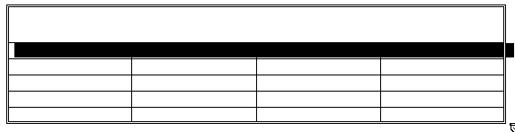Press **Ctrl-B** (This on Bold)  
    Press **Ctrl/Shift->** 6 times (This changes the font size to 24 point)
5. Now type **COLEMAN** **CORPORATION**
6. **Select** the entire 2nd row  
   Press **Ctrl-E** (Center this row)  
   Press **Ctrl-B** (Bold this row)

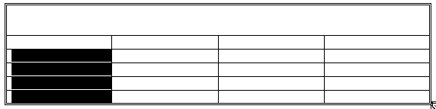

1. Select cells **A3 through A6**  
   Press **Ctrl-E** (Center these cells)
2. 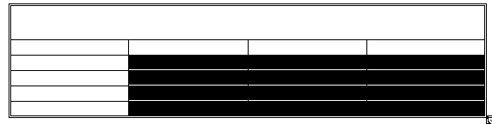Select **cells B3 through D6**  
   Press **Ctrl-R** (Align Right these cells)
3. Type in the text as shown in the table below.

|  |  |  |  |
| --- | --- | --- | --- |
| **Centennial Construction** | | | |
| **Year** | **Income** | **Expenses** | **Net Profit** |
| 2000 | $6,445,145.30 | $4,345,563.55 |  |
| 2001 | 5,545,428.68 | 4,255,453.16 |  |
| 2002 | 5,674,387.12 | 4,673,146.26 |  |
| 2003 | 6,122,144.54 | 4,855.245.52 |  |

**Insert a formula**

1. Position the cursor in **cell D3** (the cell below Net Profit).
2. Click on **Table** in the Menu Bar, then click on **Formula**.
3. In the white box below **Formula**: delete the formula. Type the following formula: **=B3-C3**
4. Click on the **down-pointing arrow** at the right side of the **Number format** box and then click the **3rd** **option** from the top.
5. Press **Enter** (you can also click OK).
6. Insert the formula **=B4-C4** using steps 12 through 16 in cells ***except*** click the 2nd option in the Number format drop-down list.
7. Insert the formula **=B5-C5** using steps 12 through 16 in cells ***except*** click the 2nd option in the Number format drop-down list.
8. Insert the formula **=B6-C6** using steps 12 through 16 in cells ***except*** click the 2nd option in the Number format drop-down list.
9. Add outside double border and shading in the 2nd row of the table as shown in the table above.

Print the table.

### RECALCULATING A TABLE

1. Open the file: **Recalculating a Table**
2. The figures in the **Expenses** column have changed. Change the table so that the figures in the Expenses column are the same as the table below.

|  |  |  |  |
| --- | --- | --- | --- |
| **Centennial Construction** | | | |
| **Year** | **Income** | **Expenses** | **Net Profit** |
| 2000 | $6,445,145.30 | $4,456,633.43 |  |
| 2001 | 5,545,428.68 | 4,522,457.43 |  |
| 2002 | 5,674,387.12 | 4,635,355.36 |  |
| 2003 | 6,122,144.54 | 4,844.367.45 |  |

1. Click once in cell **D3** (the cell right below **Net Profit**). Press the **F9** key (this key is in the top row of the keyboard). This will recalculate the cells.
2. Click once in cell **D4**. Press **F9**.
3. Click once in cell **D5**. Press **F9**.
4. Click once in cell **D6**. Press **F9**.
5. The figures in the **Net Profit** column have be **recalculated** as shown in the table below.

|  |  |  |  |
| --- | --- | --- | --- |
| **Coleman Corporation** | | | |
| **Year** | **Income** | **Expenses** | **Net Profit** |
| 1997 | $6,445,145.30 | $4,456,633.43 |  |
| 1998 | 5,545,428.68 | 4,522,457.43 |  |
| 1999 | 5,674,387.12 | 4,635,355.36 |  |
| 2000 | 6,122,144.54 | 4,844,367.45 |  |

Print the table.

### Working with Columns and Breaks

1. Start a **new** **document**.
2. Type the following heading: **TOP 20 BOYS AND GIRLS NAMES**
3. **Bold** and **Center** the heading
4. Press En**t**er 2 times
5. Click on the **Align Left** button in the Formatting Tool Bar. Turn off **Bold** in the Formatting Tool Bar.
6. Click on **Insert**. Click on **Break**. Click on **Continuous**. Click **OK**. *(You just added a Continuous break).*
7. Click on **Format** in the menu bar. Click on **columns**. Click on **two**. Click **OK**. *(You just added two columns to your page.*
8. Click on **Insert**. Click on **Break**. Select **Column Break**. Click **OK**. *(You just added a Column Break).*
9. Type the list of names in the columns below. Put all the boys’ names in the left hand column and put all the girls names in the right hand column. Use the mouse to click back and forth from the left column to right column. Type only one name on each line. Press return after you type each name.

Jacob Emily Madison Michael Hannah Joshua Matthew Ethan

Joseph Emma Alexis Ashley Andrew Abigail Sarah Christopher

Daniel Nicholas Samantha William Anthony Megan Elizabeth David

Tyler Alyssa Lauren Alexander Isabella Ryan Grace Jessica

John Brianna James Zachary Taylor Kayla Brandon Anna

### Working With Columns and Breaks Part 2

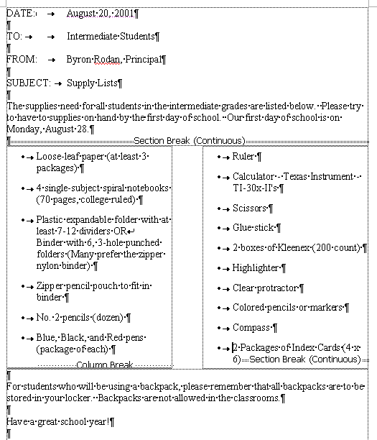

1. Type the memo on the next page.
2. After you type the first paragraph, you have to put in a Continuous Break and insert 2 columns by doing the following:
3. Click on Insert, then click on Break, then click on Continuous.
4. Click on the Columns button in the Standard Toolbar and select 2 columns.
5. After you type the last item in the first column, insert a Column Break. Click on Insert, then Break, then Column Break.
6. Type the 2nd column.
7. At the end of the 2nd column, Insert a Continuous Break. Click on Insert, then Break, then Continuous Break.
8. Remove the 2 columns by clicking on the Columns button in the Standard Toolbar and select 1 column.
9. Finish typing the memo.
10. Add your name to the bottom, save the memo, then print 2 copies.

DATE: August 20,2001

TO: Intermediate Students

FROM: Bryon Rodan, Principal

SUBJECT: Supply List

The supplies need for all students in the intermediate grades are listed below. Please try to have the supplies on hand by the first day of school. Our first day of school is on

Monday, August 28.

* Loose- leaf paper (at least 3 packages)
* 4 single-subject spiral notebooks (70pages, collage ruled)
* Plastic expandable folder with at least 7-12 dividers OR binder with 6, 3-hole punched folders (Many Prefer the zipper nylon binder)
* Zipper pencil pouch to fit in binder
* No. 2 pencils (dozen)
* Blue, Black, and Red pens (package of each)
* Ruler
* Calculator - Texas Instrument – TI-30x-II’s
* Scissors
* Glue stick
* 2 boxes of Kleenex (200 count )
* Highlighter
* Clear Protractor
* Colored pencils or markers
* Compass
* 2 Packages of Index Cards (4x6)

For students who will be using a backpack, please remember that all backpacks are to be stored in your locker. Backpacks are not allowed in the classrooms.

Have a great school year!

### Using Columns, Breaks, and Page Setup

1. Start a new document.
2. Click on the **File Menu**, then select **Page Setup**.
3. Set the left and right margins to **.8**
4. Click **OK**
5. Type the title of the page. **Center**, **Boldface**, **Underline** it. Increase the font size to **14**.  
    **10 Largest Cities According to the 2000 Census.**
6. Press **Enter** twice
7. Select **Insert Break**, then select **Continuous**. Click **OK**.
8. Click on the **Columns** button in the **Standard Toolbar**. Select **3 columns**
9. Click on the **Format** Menu and select **Columns**.
10. Select the box next to **Equal Column Width**
11. Change the width of Column **1** to **2.2.**
12. Click **OK**Click on the **Insert** **Menu**, then click on **Break**, select **Column** **Break**.
13. Click **OK**
14. Click on **Insert** **Menu**, then Click on **Break**, select **Column Break**.
15. Click **OK**
16. Click in the **first column**
17. Click on the **Center** Button in the **Formatting Toolbar**.
18. Type the chart on the next page. Double space between each line.

**CITY AND STATE**

New York, New York

Los Angeles, California

Chicago, Illinois

Houston, Texas

Philadelphia, Pennsylvania

Phoenix, Arizona

San Diego, California

Dallas, Texas

San Antonio, Texas

Detroit, Michigan**POPULATION**

**2000 CENSUS**

8,008,278

3,694,820

2,896,016

1,953,631

1,517,550

1,321,045

1,223,400

1,188,580

1,144,646

951,270**INCREASE/DECREASE**

**FROM 1990**

685,714

209,422

112,290

323,078

–68,027

337,642

112,851

181,703

208,713

–76,704

### Creating a Header

1. Open the file **Creating a Header**

2. Bold and underline the title: **Windows XP Service Pack 2**

3. Bold each of these 4 subheadings:

**THE DOWNLOAD**

**FEATURES OF SERVICE PACK 2**

**TOP 10 REASONS TO UPGRADE TO WINDOWS XP**

**THE 3 MOST IMPORTANT THINGS**

4. Create a header ***Windows XP Service Pack 2*** that is **bolded** and prints at the **left margin** on every page by completing these steps:

5. Click on **View** and then click on **Header and Footer**. The Header and Footer toolbar will appear. NOTE: You can move the toolbar by clicking on the gray area and dragging it to another location.

6. In the **header pane**, turn on **Bold** and type **Windows SP Service Pack2**. Press **Enter**.

7. Click on **Print** **Preview** to see how the header will appear on each page when printed.

Print the file.

### Creating a Footer

1. Open the file **Creating a Footer**.
2. **Bold** and **Underline** the title: **Security Settings in Outlook and Outlook Express**
3. 5. **Bold** the two sub-headings:   
   ***CHANGE THE SECURITY SETTINGS IN OUTLOOK EXPRESS***   
   ***CHANGE THE SECURITY SETTINGS IN OUTLOOK***
4. You will create a **footer** **Security Settings** in 12-Point Century Schoolbook Bold that prints at the left margin on every page and Page # (the # represents the page number) in 12 point Century Schoolbook bold that prints at the right margin of every page by completing the following steps.
5. Click **View**, then click **Header and Footer**.
6. Click the **Switch Between Header and Footer** button on the Header and Footer toolbar.
7. 
8. **This displays the Footer Pane.**
9. Change the font **to 12-point Century Schoolbook** and bold it.
10. Type: **Security Settings**
11. Press the **Tab** Key twice.
12. Type: **Page** and then press the **spacebar** once.
13. Click **Insert Page Number** button on the Header and Footer toolbar.
14. 
15. **Select** (highlight) the page number and then change the font to **12-point Century Schoolbook bold**
16. Click the **Close** button on the **Header and Footer toolbar**.
17. View the document in Print Preview.

Print the file.

### Inserting Photos Into A Document

1. Type the title: **Aerial Lift Bridge**
2. **Bold**, **center**, and **underline** the title.
3. Press **enter** 2 times
4. Click on **Align** **Left** in the Formatting Toolbar.
5. Insert a **Continuous** **break** (Insert, Break, Continuous).
6. Click on **Columns** in the Standard Toolbar and insert 2 columns.
7. Type the story as it appears on the next page.

**Add photos to the story by following these directions**.

1. Start **Internet Explorer.** Go to **google.com** (When you start Internet Explorer, google should appear since it is the default homepage).
2. Click on **Images.**
3. Type the name of the image that you want to find. Click on **Google Search.**
4. Click on an **image** you would like to add to your text.
5. Click on the **image** again to see the full size image.
6. **Right-click** on the picture and select **Save picture as**. The picture will be save in the **My Pictures** folder. Give the picture a **name** and click **Save**.
7. Click the cursor on your **Word** **document** in the **Task** **Bar** (bottom of the screen) to have your document appear on the screen.
8. Click the **cursor** where you want to picture to appear.
9. Click **Insert** (menu bar) and click on **Picture**. Then click on **From** **File**.
10. Find the **picture** that you saved and **double**-**click** on it.
11. Drag the picture where you want it to go. (You may have to click on Text Wrapping and click on In Front of Text).

Print the File

### Aerial Lift Bridge

Built in 1929-1930, this bridge was designed to carry vehicular and pedestrian over the entrance to Duluth Harbor.

The aerial lift bridge was a compact solution to the problem of getting people and goods from one side to the other while allowing huge ships to also pass through the same patch of space through the same patch of space. Because of urbanization on both sides of the channel, a traditional bridge was not possible as the approaches would have needed to be extremely long, reducing the utility of the structure.

Picture of Aerial Lift Bridge

Until the bridge was built, the people of Duluth made do with ferries tin the summer and temporary bridges in the winter when the port was frozen. The bridge, itself, is owned and operated by the City of Duluth, but the land and water surrounding it is the property of the U.S. Army Corps of Engineers.

At it’s widest point it is 386 feet and has a maximum height of 227 feet.

Picture of Duluth Harbor

Picture of Duluth

### KEYBOARD SHORTCUTS

Large Picture of Lift Bridge

A **keyboard shortcut** is a way of accomplishing a task using the keyboard instead of the mouse. **Keyboard** **shortcuts** are a great way to increase your efficiency and speed in getting your word processing tasks done.

Included in this packet is a list of 250 Microsoft Word keyboard shortcuts. That’s mind-boggling!

So how do you remember all these shortcuts? **YOU DON’T!!!** You just learn and remember the ones that are important to you – that you really like.

***So which ones are they?***

Keyboard short cuts can be placed in 3 categories: (1) essential, (2) good but not necessarily essential, and (3) not essential.

So I have made a list of what I consider **Essential Shortcuts** and another list that I call **Good, But Not Essential Shortcuts**. The not essential shortcuts are not on these lists – but they are on the complete list of **250 Microsoft Word Shortcuts**. Read that list for yourself – who knows – you may find a shortcut there that you think is essential!

You should know all the **Essential Shortcuts.** They are important to know and to use

You might want to know some (or all) of the **Good, But Not Essential Shortcuts.** There are some really neat things you can do with these shortcuts.

Try to use these shortcuts - ***your word processing will be more fun and more efficient***.

### WORD SHORTCUTS

**ESSENTIAL SHORTCUTS**

**Formatting Text Shortcuts**

Bold Text Ctrl-B

Underline Text Ctrl-U

Italicize Text Ctrl-I

Copy Text Ctrl-C

Cut Text Ctrl-X

Paste Text Ctrl-V

Center Text Ctrl-E

Right Justify Text Ctrl-R

Left Justify Text Ctrl-L

Undo Last Ctrl-Z

Redo Last Ctrl-Y

Select all text Ctrl-A

**Working with Files**

Save a file Ctrl-S

Print a file Ctrl-P

Start a new file Ctrl-N

Close a file Ctrl-W

Close a file Ctrl-F4

Quit Microsoft Word Ctrl-F4

**GOOD BUT NON-ESSENTIAL SHORTCUTS**

**Formatting Text Shortcuts**

All Caps Ctrl-Shift-A

All Small Caps Ctrl-Shift-K

Change Case Shift-F3

Double Underline Ctrl-Shift-D

Extend Selection F8

Grow Font 1 Point Size Ctrl+]

Shrink Font 1 point Ctrl+[

Increase font size Ctrl-Shift->

Decrease font size Ctrl-Shift-<

Word Underline Ctrl+Shift-W

Subscript Ctrl+=

Superscript Ctrl+Shift+=

**Working with Files**

Find Text Ctrl-F

Replace Text Ctrl-H

Print Preview Ctrl-F2

Save As F12

**Miscellaneous**

Show/Hide Formatting Ctrl-Shift-8

Thesaurus Shift-F7

Check Spelling F7

Page Break Ctrl-Enter

### 250 Microsoft Word Shortcuts

**File menu:**

**Control o** open

**Control n** new document

**Control s** save to the default folder.

**Control p** print

**Edit menu:**

**Control z** undo

**Control y** repeat typing

**Control c** copy selected text

**Control x** cut selected text

**Control v** paste from clipboard

**Control a** select all

**Control f** find

**Control h** replace

**Control g** go to

**Control k** insert hyperlink

**Tools:**

**Spelling and grammar** F7

**Additional short cuts keys:**

**CONTROL KEYS**

**Control e** center

**Control I** italics

**Control b** bold

**Control u** underline

**Control d** brings you to the font menu

**Control f6** switches between documents

**Control r** right align

**Control l** left align

**Control j** justify

**Control shift s** brings you to the style menu

**Control shift f** brings you to the font combo box

**Control Shift p** brings you to a edit box where you can change font size

**ALT KEYS**

**Alt shift I** citation

**Alt shift o** table of contents entry

**Alt o** brings you to the format menu

**Alt a** draw table

**Alt f** brings you to the file menu

**Alt I** brings you to the insert menu

**Alt v** brings you to the View menu

**Alt w** new window

**Alt t** brings you to the tool menu

**Alt e** brings you to the edit menu

**F KEYS**

**F5** find and replace dialog

**F10** opens menus

**F12** save as

**Control f2** document preview

**Alt f6** paste dialog

**Alt f8** macro dialog

**---A---**

**All Caps** Ctrl+Shift+ A

**App Maximize** Alt+ F10

**Apply Heading1** Alt+Ctrl+ 1

**Apply Heading2** Alt+Ctrl+ 2

**Apply Heading3** Alt+Ctrl+ 3

**Apply List Bullet** Ctrl+Shift+ L

**Auto Format** Ctrl+ K

**Auto Text** Alt+Ctrl+ V

**Auto Text** F3

**---B---**

**Bookmark** Ctrl+Shift+ F5

**---C---**

**Change Case** Shift+ F3

**Close Pane** Alt+Shift+ C

**Column Break** Ctrl+Shift+ Enter

**Column Select** Ctrl+Shift+ F8

**Copy** Ctrl+ Ins

**Copy** Ctrl+ C

**Copy Format** Ctrl+Shift+ C

**Copy Text** Shift+ F2

**Customize Add Menu Shortcut** Alt+Ctrl+ =

**Customize Keyboard Shortcut** Alt+Ctrl+ Num +

**Customize Remove Menu Shortcut** Alt+Ctrl+ -

**Cut Ctrl**+ X

**Cut Shift**+ Del

**---D---**

**Date Field** Alt+Shift+ D

**Delete Back Word** Ctrl+ Backspace

**Delete W**ord Ctrl+ Del

**Do Field Cli**ck Alt+Shift+ F9

**Doc Close** Ctrl+ W

**Doc Close** Ctrl+ F4

**Doc Maximize** Ctrl+ F10

**Doc Move** Ctrl+ F7

**Doc Res**tore Ctrl+ F5

**Doc Size** Ctrl+ F8

**Doc Split** Alt+Ctrl+ S

**Double Underline** Ctrl+Shift+ D

**---E---**

**End of Column** Alt+Shift+ Page Down

**End of Column** Alt+ Page Down

**End of Doc Extend** Ctrl+Shift+ End

**End of Document** Ctrl+ End

**End of Line** End

**End of Line Extend** Shift+ End

**End of Row** Alt+Shift+ End

**End of Row** Alt+ End

**End of Win**dow Ctrl+ Page Down

**End of Window Extend** Ctrl+Shift+ Page Down

**Endnote Now** Alt+Ctrl+ E

**Exit** Alt+ F4

**Extend Selection** F8

**---F---**

**Field Chars** Ctrl+ F9

**Field Codes** Alt+ F9

**Find** Ctrl+ F

**Font** Ctrl+Shift+ F

**Font** Ctrl+ D

**Font Size Select** Ctrl+Shift+ P

**Footnote Now** Alt+Ctrl+ F

**---G---**

**Go Back** Alt+Ctrl+ Z

**Go Back** Shift+ F5

**Go To** Ctrl+ G

**Go To** F5

**Go to Next Page** Alt+Ctrl+ Page Down

**Go to Previous Page** Alt+Ctrl+ Page Up

**Goto Annotation Scope** Alt+ F11

**Grow Font** Ctrl+Shift+ .

**Grow** **Font One Point** Ctrl+ ]

**---H---**

**Hanging Indent** Ctrl+ T

**Header Footer Link** Alt+Shift+ R

**Hidden** Ctrl+Shift+ H

**---I---**

**Indent** Ctrl+ M

**Italic** Ctrl+Shift+ I

**Italic** Ctrl+ I

**---M---**

**Mark Citati**on Alt+Shift+ I

**Mark Index Entry** Alt+Shift+ X

**Mark Table of Contents E**ntry Alt+Shift+ O

**Menu M**ode F10

**Merge Field** Alt+Shift+ F

**Microsoft System Info** Alt+Ctrl+ F1

**Move Text** F2

**---N---**

**New** Ctrl+ N

**Next** **Field** F11

**Next** **Field** Alt+ F1

**Next Misspelling** Alt+ F7

**Next Object** Alt+ Down arrow

**Next Window** Ctrl+ F6

**Next Window** Alt+ F6

**Normal** Alt+Ctrl+ N

**Normal Style** Alt+Shift+ Num 5

**Normal Style** Ctrl+Shift+ N

**---O---**

**Open Ctrl**+ O

**Open** Alt+Ctrl+ F2

**Open** Ctrl+ F12

**Open or Close Up Para** Ctrl+ 0

**Other Pane S**hift+ F6

**Other Pane** F6

**Outline** Alt+Ctrl+ O

**Outline Coll**apse Alt+Shift+ Num -

**Outline Colla**pse Alt+Shift+ -

**Outline Demote** Alt+Shift+ Right arrow

**Outline Expand** Alt+Shift+ Num +

**Outline Exp**and Alt+Shift+ =

**Outline Move** Down Alt+Shift+ Down arrow

**Outline Move Up** Alt+Shift+ Up arrow

**Outline Promote** Alt+Shift+ Left arrow

**Outline Show First Line** Alt+Shift+ L

**Overtype** Ins

**---P---**

**Page** Alt+Ctrl+ P

**Page Break Ctrl**+ Enter

**Page Down** Page Down

**Page Down Extend Shift**+ Page Down

**Page Field** Alt+Shift+ P

**Page Up** Page Up

**Page Up Extend Shift**+ Page Up

**Para Down** Ctrl+ Down arrow

**Para Down Extend** Ctrl+Shift+ Down arrow

**Para Up** Ctrl+ Up arrow

**Para Up Extend** Ctrl+Shift+ Up arrow

**Paste** Ctrl+ V

**Paste Shift**+ Ins

**Paste Format** Ctrl+Shift+ V

**Prev Field** Shift+ F11

**Prev Field** Alt+Shift+ F1

**Prev Object** Alt+ Up arrow

**Prev Window** Ctrl+Shift+ F6

**Prev Window** Alt+Shift+ F6

**Print** Ctrl+ P

**Print** Ctrl+Shift+ F12

**Print Preview** Alt+Ctrl+ I

**Print Preview** Ctrl+ F2

**---R---**

**Redo** Alt+Shift+ Backspace

**Redo or Repeat** Ctrl+ Y

**Redo or Repeat** F4

**Redo or Re**peat Alt+ Enter

**Repeat Find** Alt+Ctrl+ Y

**Repeat Find** Shift+ F4

**Replace** Ctrl+ H

**Reset Char** Ctrl+Shift+ Z

**Reset Char** Ctrl+ Space

**Reset Para** Ctrl+ Q

**Right Para** Ctrl+ R

**---S---**

**Save** Ctrl+ S

**Save** Alt+Shift+ F2

**Save** Shift+ F12

**Save As** F12

**Select All** Ctrl+ Num 5

**Select Al**l Ctrl+ Num 5

**Select All** Ctrl+ A

**Select Table** Alt+ Num 5

**Show All** Ctrl+Shift+ 8

**Show All Headings** Alt+Shift+ A

**Show Heading1** Alt+Shift+ 1

**Show Heading2** Alt+Shift+ 2

**Show Heading3** Alt+Shift+ 3

**Show Heading4** Alt+Shift+ 4

**Show Heading5** Alt+Shift+ 5

**Show Heading6** Alt+Shift+ 6

**Show Heading7** Alt+Shift+ 7

**Show Heading8** Alt+Shift+ 8

**Show Heading9** Alt+Shift+ 9

**Shrink Font** Ctrl+Shift+ ,

**Shrink** **Font One Poi**nt Ctrl+

**Shrink Selection** Shift+ F8

**Small Caps** Ctrl+Shift+ K

**Space Para1** Ctrl+ 1

**Space Para15** Ctrl+ 5

**Space Para2** Ctrl+ 2

**Spelling** F7

**Spike** Ctrl+Shift+ F3

**Spike** Ctrl+ F3

**Start of Column** Alt+Shift+ Page Up

**Start of Colu**mn Alt+ Page Up

**Start of Doc Extend** Ctrl+Shift+ Home

**Start of Document** Ctrl+ Home

**Start of Line** Home

**Start of Line Extend** Shift+ Home

**Start of Row** Alt+Shift+ Home

**Start of Row** Alt+ Home

**Start of Window** Ctrl+ Page Up

**Start of Window Extend** Ctrl+Shift+ Page Up

**Style** Ctrl+Shift+ S

**Subscript** Ctrl+ =

**Superscript** Ctrl+Shift+ =

**Symbol Font** Ctrl+Shift+ Q

**---T---**

**Thesaurus** Shift+ F7

**Time** **Field** Alt+Shift+ T

**Toggle Field Display** Shift+ F9

**Tool** Shift+ F1

**---U---**

**Un Hang** Ctrl+Shift+ T

**Un Indent** Ctrl+Shift+ M

**Underline** Ctrl+Shift+ U

**Underline** Ctrl+ U

**Undo** Ctrl+ Z

**Undo** Alt+ Backspace

**Unlink Fields** Ctrl+Shift+ F9

**Unlink Fields** Ctrl+ 6

**Unlock Fields** Ctrl+Shift+ F11

**Unlock Fields** Ctrl+ 4

**Update Auto Format** Alt+Ctrl+ U

**Update Fields** Alt+Shift+ U

**Update Fields** F9

**Update Source** Ctrl+Shift+ F7

**---W---**

**Word Left** Ctrl+ Left Arrow

**Word Left** Alt+ Left arrow

**Word Left Ext**end Ctrl+Shift+ Left arrow

**Word Right** Ctrl+ Right arrow

**Word Right** Alt+ Right arrow

**Word Right Extend** Ctrl+Shift+ Right arrow

**Word Underline** Ctrl+Shift+ W

### Neat Tricks in Word 2000

**(OK – So Some of them are Useless)**

**NEAT TRICK #1 - A SMILEY FACE**

Try this in a new Word Document. Press Shift + : Then press Shift + )

*OK – so we did the useless one first?*

This trick works with Microsoft Word 2000. (I’m not sure about earlier versions – it doesn’t work with Microsoft Word XP).

There is a neat font called Smiley Face if you want it, it is on the floppy disk.

Here are some samples of some of the smiley faces in this font.

B\*@$')7[Û0,

If you want to use the font, you need to drag the font from the floppy disk into your Fonts folder which is on your hard drive. The Fonts folder is located in the Windows folder (or Win NT folder, depending which operating system you are using) in your hard drive (local disk c)

**NEAT TRICK #2 - CHANGE CASE QUICKLY**

Did you ever type some text and you realized your caps lock was down (or vice versa). *(“Oh no, I have to delete the text and type it again – RATS!!!”)* **No you don’t!!!**

Just highlight the text and press SHIFT +F3 (that’s the F3 key at the very top of the keyboard).

OK – so try it. Type some text in all caps, select it (highlight it) and press SHIFT + F3. You may need to press SHIFT +F3 to get the desired result you want.

**NEAT TRICK #3 - SAVE A WORD DOCUMENT AS A WEB PAGE**

Did you have want to send a friend a Word document you created but you know that they don’t have Microsoft Word (or maybe you don’t know and don’t want to take a chance). Well, here’s how to solve that problem.

Create your document in Word. When you are ready to save it, click on the File menu and then select Save As Web Page. That’s it! You have created a webpage out of your document. You can send anyone that webpage document and they will be able to open it with their web browser (Internet Explorer or Netscape). Everyone has a web browser!!!

If you want to include pictures (and you can), when you save your document, a special folder is created with the pictures in it. When you send the webpage attachment, be sure to send the folder with the pictures in it. Otherwise, they will be able to read the text, but won’t see the pictures.

*Try this little trick – it’s a good thing! (Been watching a little to much Martha Stewart lately)*

**NEAT TRICK #4 - NONBREAKING SPACE BETWEEN WORDS**When you type a proper name such as "John Smith" near the end of a line in Word 2000, Word may separate the words, putting "John" at the end of one line and "Smith" at the beginning of the next line.

To keep words together on the same line, insert a nonbreaking space between them. For example, type John, enter a nonbreaking space by pressing CTRL+SHIFT+SPACEBAR, and then type Smith.

I always have trouble when writing the name of my cousin, Francisco Javier Torres de Silva López de Letona. (Just kidding, that’s not my cousin - I made that name up – but I used the nonbreaking space to keep the name all on one line. Neat!)

Try it – create a new Word Document and type the paragraph above with the long name. (Actually, type just the first 2 lines).

When you are finished, click on the Show/Hide button in the Standard Toolbar (or press CTRL + SHIFT + \*). Do you see the little º marks between each of the names – that’s it – the nonbreaking space mark.

This trick works with older or newer versions of Microsoft Word.

*I know you can’t live without this Neat Trick!*

**NEAT TRICK #5 - A QUICK PAGE BREAK**

When you are tying a document and you want to skip to the next page, you need to put in a page break. Well, you can do that by clicking on Insert, Break, Page Break, and OK. That’s 4 clicks and a lot of mouse movement. Well, the neat thing is to press CTRL + Enter when you want to start at the top of a new page in your document. What could be easier!

Try it. Start a new document.

Type: This is the stuff on Page1. Press CTRL + Enter.

Type: This is the stuff on Page2. Press CTRL + Enter.

Type: This is the stuff on Page3. Press CTRL + Enter.

Notice, each time you press CTRL + Enter, you start at the top of the next page.

*Nifty!*

Ha – I just pressed CTRL + Enter and here I am at the top of Page 3 in my document.

**NEAT TRICK #6 - CLOSE/SAVE ALL**

Are you ever working on several documents at the save time (I always am – like right now). Well, you can save all open Word documents at once or you can close all word documents at once.

Just hold down the SHIFT key as you click the File menu, and then click Close All or Save All. Be sure you press and hold down the SHIFT key before you click on the File menu.

**Note:** If you decide to close all documents at once (Shift + File Menu + Close All), Word will give you the opportunity to save any of the documents that haven’t been save yet.

*Cool!*

**NEAT TRICK #7 - IMBED A LINK**

Did you know you could embed an internet link (website address) right in your Word Document.

Here’s how.

Type your document in word and just type in the website address wherever you want it. Whoever reads the file can then click on the website address and go to that site. Of course, the person has to have a live connection to the internet. NOTE: When you click on the website, you must hold down the

OK, let’s try it. Create a new document saying something about the neat organization you work for (Marshall Adult Learning Center). Write that you can check out the website and type the address. NOTE: You must use the complete address, e.g., [http://marshalladulteducation.org](http://marshalladulteducation.org/).

Now hold down the CTRL key and click on the website address. Did it work???

You can use this Neat Trick in conjunction with Neat Trick #3. Send your webpage document with the website address to a friend – they won’t have to hold down the CTRL key to go to the website – they just have to click on the address.

**NEAT TRICK #8 - CLOSE ALL IN THE TASK BAR**

OK – This is not an exclusively Microsoft Word Trick, but it’s kinda cool, so I had to include it. When you open files, folders, programs, etc, your task bar gets pretty crowded. When you are finished working with some or all of the items in your Task Bar, you can close all of them or as many of them as you want with a few simple clicks.

Try this. Open up 5 things – any 5 things – a few folders, a couple programs…whatever. Now hold down the CTRL key and click on 4 of the items in the task bar that you want to close (leave one open). Now, right-click on the any one of those items. A pop-up menu appears – left-click on Close. Wah-la – those 4 items close leaving only the one item in the task bar.

Notice, there are other options in that pop-up menu. I particularly like the Tile Vertically, since I frequently work with 2 or more folder windows at a time.

Well, you think you’ll ever use this tip – or is it useless??? *(I use it all the time! Of course, I’m a geek!)*

**NEAT TRICK #9 - WHAT’S THIS**

What's This? Ever seen that before? It is located in Help in the menu bar. If you want information about anything in Microsoft, this is a great way to get it fast!

Try it. First be sure that your ruler is visible. If it is not, Click on View in the menu bar and then click on Ruler.

Now, click on Help in the File Menu and select What’s This. Notice that your cursor turns into an arrow with a question mark.

Now click on the ruler. You get a nice little explanation of what the ruler is and how to use it.

T

ry this one. Click on Help in the File Menu and select What’s This. Now click on the format menu and click on Drop Cap. There it is – a nice explanation of what a drop cap is (Have you ever used a drop-cap before. *BTW, I used a drop cap in this paragraph. Can you tell???*

You can also use **What’s This** to get information in your text. Click on some text in a document and see what it says.

One more thing – there is even a keyboard shortcut to What’s This. Press Shift-F1. Try it! *Very Cool!*

**NEAT TRICK #10 - CLICK AND TYPE**  
You can place the insertion point at any place in the document by doubling clicking. Depending on where you double-click will depend on how the text is aligned.

**Try This.** Press ALT + N (this creates a new document). Be sure you are in Page Layout view. Double click about half way down the page just inside the left hand margin. Type a few words. *(See – it works!)*

**Try This.** Press CTRL + A (this selects all the text). Press CTRL + X (this Deletes all the text). And this time double click about half way down the sheet right in the middle of the page. Type a few words. This time, your text is centered on the page.

**Try this.** Press CTRL + A (this selects all the text). Press CTRL + X (this Deletes all the text). And this time double click about half way down the sheet but to the right of the right text boundary. Type a few words. This time, your text is justified along the right hand margin.

As you move your cursor around the blank document, notice how the cursor changes. This is how you determine how your text will be formatted when you double click the mouse. The chart below shows you how the text will be entered on the page

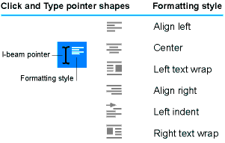

***Cool! Don’t forget to close the new document you just created – don’t save it.***

**NEAT TRICK #11 - ZOOM**

The **Zoom** arrow in the **Standard Formatting** bar is a way you can zoom (change the size of the page view). Click on the down arrow and see the various degrees you can “zoom” to.

There is a really neat way to zoom that is much more convenient that clicking on the Zoom button in the Standard Formatting bar. Here’s how: Hold the **Ctrl** **Button** down and turn the **scroll wheel** on the mouse – slowly – either up or down. And watch the screen automatically zoom. *Very Cool!!!*

**NEAT TRICK #12 - SORT TEXT**

Have a list of word you want to sort (alphabetize). Select (hold the mouse button down and drag over them) the words, then select Sort from the Tables menu. A dialog box will open. Select whether you want the list of words sorted in ascending order (A to Z) or descending order (Z to A).

### Addendum

**How to Delete Text**

There are actually 2 ways to delete text from your document. One is with the BACKSPACE key and one is with the DELETE key.

**The Backspace key.** Position the cursor to the right of the text you want to delete and press Backspace as many times as needed to delete the text. (You may also hold down the Backspace key).

**The Delete Key.** Position the cursor to the left of the test you want to delete and press Delete as many times as needed to delete the text. (You may also hold down the Delete key).

**When to use SAVE and when to use SAVE AS**

**Use SAVE AS whenever…**

…You are saving your file for the first time.

…You have saved your file already but you want to save under a different name.

…You have saved your file already by you want to save it in a different location.

**Use SAVE whenever…**

…You have already saved your file (*and given it a name*) and you have made changes to   
 it,

**Use the Scroll Wheel**

On a more modern mouse, you have a scroll wheel in between the 2 buttons. Turn the scroll upward or downward to scroll the text on the screen. It is more convenient to use the scroll wheel than clicking on the up and down arrows on the top and bottom of the vertical scroll bar.

If you don’t have a mouse with a scroll wheel, go buy one - you’ll be glad you did!

**Insert Mode and Overstrike Mode**

When you are typing in Insert mode, any text that you type is inserted into your document. For example, if you type a paragraph and you want to add some words in the middle of the paragraph, you click in the middle of the paragraph and start to type. The new text is inserted into the paragraph moving all the text in front of it to the right as you type.

You can place the keyboard into overstrike mode so that when you type, the new text that you type will overstrike (or replace) any text in front of it (to the right).

You almost always want to be in Insert mode. There are 2 ways to tell whether you are in Insert mode or Overstrike mode. (1) There is a light on the keyboard that lights up when you are in Insert mode. (2) When you are in Overstrike mode, the letters OVR in the become boldface in the status bar at the bottom of the screen.

### How to Save a File

**How To Save A File On A Floppy Disk**

1. Click on the File, then click on **Save As**
2. 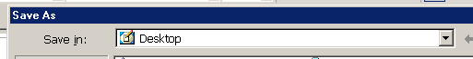Click on the down-pointing arrow next to the **Save In** box

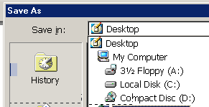

1. Click on **3 ½ Floppy (A:)**
2. Your floppy disk will spin and the  
   your **Save in** box will say:



1. Give your file a **name** and click on **SAVE** (lower right hand corner).

**How To Save On The Computer Hard Drive.**

1. Click on the File menu, the click on **Save** As
2. Click on the down-pointing arrow next to the **Save In** box

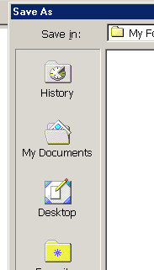

1. Choose the location that you want to save in,   
    - If you want to save in the **My Documents** folder, click on   
    **My Documents**. (If you want to save it in a special   
    folder in the My Documents folder, double-click   
    on that folder).  
     
    - If you want to save on the **Desktop,** click on the   
    **Desktop icon**  
    (If you want to save it in a special folder on the   
    Desktop, double click on that folder).
2. Give the file a **name** and click on **SAVE**.

### How to Open a File

**How to Open a File on a Floppy Disk**

1. Click on the File menu, then click on Open.
2. 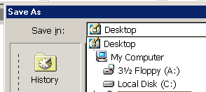Click on the down-pointing arrow to the right of the Look In box.
3. Click on 3½ Floppy (A:)
4. Click on the file you want to open and click on Open. (You may also double-click on the file to immediately open it).

### Two Features in Word You Want to Use.

Microsoft Word is set to only show a partial list of items in the drop-down menus. What a pain! You can correct this and have the full list of menu items show when you click on a menu item.

1. Click on **Tools**, then click on **Customize**.
2. Click on the **Options** tab.
3. Click on the box next to **Always show full menus**. (It should be checked)
4. Click on **Close**.
5. Click on a drop-down menu and you will now see all the menu items.

If you like to use **Print View** (*see What Page View Should I Use on page 5*), you will want to be able to see the page borders

1. Click on the **Tools** menu, then click on **Options**.
2. In the **Print and Web Layout Options**, click on the box next to **Text Boundaries** (it should be checked.
3. Click **OK**. You will now see the page borders when you are in Print View.