CURRICULUM VITAE
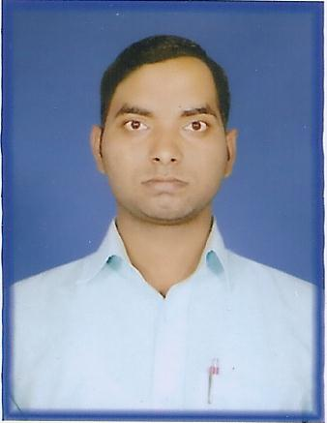
MAILING ADDRESS:
RAVIKANT KUMAR
VILL-MANI
POST-PHOOLPUR
DISTT- VARANASI (U.P)
PIN - 221206
E-mail: Ravicool1991@yahoo.com
Ravikant.exengg@gmail.com
Mob-09648590312; 08090556233 RAVIKANT KUMAR

CAREER OBJECTIVE

Being dynamic, Self-motivated and Quick learner wish to capitalize on my technical skills to be at senior position in my area of specialization.

EMPLOYMENT SUMMARY

HERO PRODUCTS INDIA PVT LTD

DESIGNATION – SERVICE ENGINEER

TRAINING EXPERINCE

One Year Training from UPPCL VARANASI as DIPLOMA TRAINEE ENGINEER.

TOTAL EXPERINCE
- 4+ Month in HERO Product India PVT LTD.
- Presently working-NORTH Region (VARANASI)
- Services Provided to AKZONOBEL(ICI) Paints, BERGER Paints, BRITISH Paints, NEROLAC Paints, INDIGO Paints etc.

JOB RESPONSIBILITIES-
- Responsible for Complain handling
- Customer Relationship
- Problem troubleshooting
- Responsible for Provide Services in TINTING machine, MIXER machine and COMPUTERS Hardware and Software.

EDUCATIONAL QUALIFICATION

- B. TECH. Electronics and Communication Engineering from SHEAT College Babatpur, Varanasi (APJAKTU LUCKNOW) with 67.97 % in 2015.

- DIPLOMA Electronics engineering form CHANDAULI POLYTECHNIC, CHANDAULI (BTE UP LUCKNOW) with First 77.27 % in 2011.

- SSC From SPBS IC Khalispur Varanasi (UP BOARD ALLAHABAD) with 55.16 % in 2007.

SUMMER TRAINING

- In Signal and Communication Department from INDIAN RAILWAY Mughalsarai Uttar Pradesh.

- In Routing and Switching from IHNC Varanasi Uttar Pradesh.

ACADEMIC PROJECTS

- INVERTER.
- HOME AUTOMATION using Bluetooth.

RELEVANT SKILLS AND COMPUTATIONAL SKILLS

- Certification in CCC.
- Microsoft office.
- Basic knowledge of C and C++ Computer Fundamentals and Network Concepts.
- Knowledge of Computer Hardware and Software.
- Problem Troubleshooting in Circuits.

PERSONAL DETAILS
Name -RAVIKANT KUMAR
Father’s Name -Mr. KAMLESH KUMAR
Date of Birth -08 Sept 1991
Language Known -Hindi & English
Gender -Male
Nationality -Indian
Hobbies -Listening music, Watching movie, Learning, Net surfing etc.

I hereby declare that the particulars furnished above are complete and correct to the best of my knowledge and belief.

Date : ------------

Place:------------- With Regard

