RAGINI DIPAKRAO KHADSE

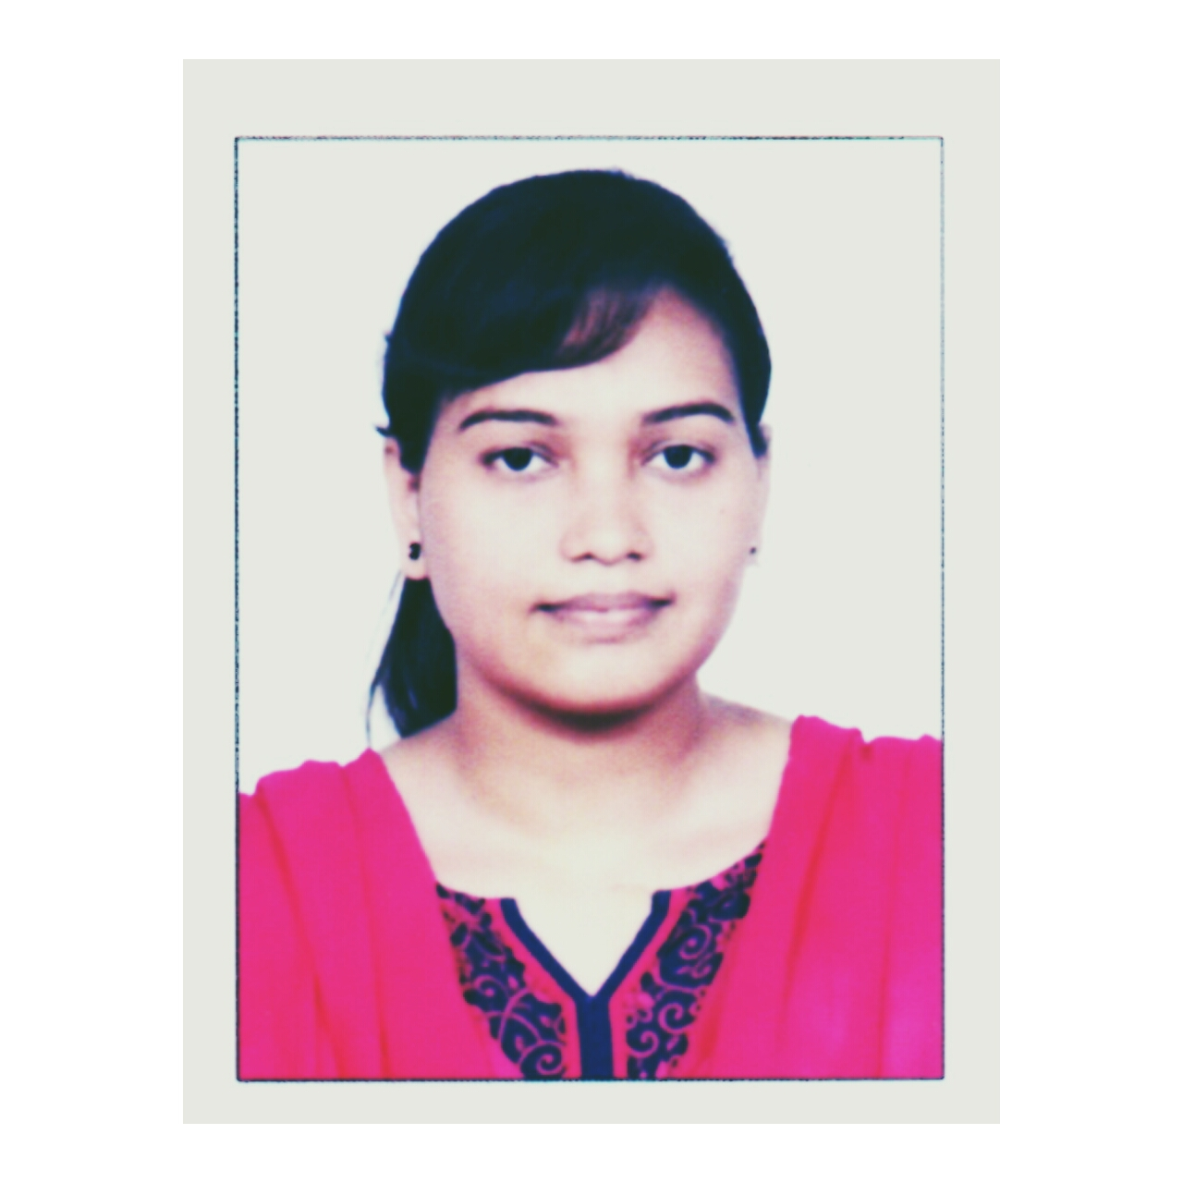

Photograph

Email: ragini2khadse@gmail.com

Mobile: +91-9665152621

**CAREER OBJECTIVE:**

Seeking an opportunity to leverage my academic background in electronics and telecommunications with a global organization

**EDUCATIONAL QUALIFICATIONS:**

**Master of Engineering** (Electronics &Telecommunications) From Sant Gadge Baba Amravati University, Amravati, in Electronics and Telecommunication (2015) Mark secured 6.5 CGPA

**Bachelor of Engineering** From Sant Gadge Baba Amravati University, Amravati, in Electronics and Telecommunication (2013) Marks secured 70.53%

**Diploma in Electronics and Telecommunication** from Panjabarao Deshmukh Girls Polytechnic, Amravati, in (2010) Marks secured 78.30%

**1oth Standard (SSC Board)** – Maharashtra State, Amravati (2007) – First Class

**Technical Qualification:**

* Obtained PGDIPRA (Post Graduate Diploma In Industrial Plant, Process, In Robotics Automation) from Technocrat Automation Pvt Limited (IAO Accredited), Chennai. With three months **hands on practical experience** in Industrial Automation Tools specializing in PLC, DCS, SCADA, VFD, HMI.

**Technical Skills:**

* **PLC** (**P**rogrammable **L**ogic **C**ontrollers) & **DCS** (**D**istributed **C**ontrol **S**ystem) - Programming languages such as **LD**(**L**adder **D**iagram) & **FBD** (**F**unctional **B**lock **D**iagram)
* **Hands on Practical exposure** in brands as **Keyence, OMRON, AB (A**llen Bradley**), ABB PLC, MITSUBHISHI PLC,** **MESSUNG**, **SCHNEIDER PLC,** **GE FANUC PLC, GSM PLC,** Interfacing to **Omron PLC** to **SCADA**, **MCC** Panel Wiring.
* **Hands on Practical exposure** in brands as SIEMENS PLC (**s7 200**), SIEMENS PLC (**s7 300**), SIEMENS HMI, SIEMENS VFD, WINCC.
* **ABB DCS(AC 800 M), S**CADA interfacing with ABB DCS PLC, **HMI** interfacing with ABB DCS PLC
* **SCADA** (**S**upervisory **C**ontrol & **D**ata **A**cquisition) –by using **I**NTELLTUTION FIX AND **W**ONDERWARE INTOUCH Screen designing, PC & PLC interface, Data collection & storage
* **P**NEMATICS **and F**EILD **I**NSTRUMENTS**-L**evel **T**ransmitter**,** ControlValves, **C**urrent **To P**ressure**(I/P) C**onverter**, RTD(R**esistance **T**emperature **D**etector**), T**hermocouple
* **I**ndustrial **R**obotics – Theoretical and Practical knowledge of Work Bench Drawing Application, Drilling Application on target Positioning, Milling Application, Color Sensing Pick and Place application, Curved and Plain Glass ‘Application using FD on Desk software (NACHI Robotics).
* **HMI** (**H**uman **M**achine **I**nterface) - Screen designing, PLC interface
* **VFD** (**V**ariable **F**requency **D**rive) – Commissioning and Troubleshooting

**INPLANT Training / INDUSTRIAL VISIT:**

**O**n **S**ite **R**eal **P**lant **A**utomation **T**raining in **B**oiler **W**ater **T**reatment Plant (**BWT)** used in **P**ower **I**ndustries and **O**il **W**ater **T**reatment Plant (**OWT**) used in **P**rocess **I**ndustries.

**ACADEMIC Project:**

**Master of Engineering Project Details-**

**Project title**: implementation of wireless sensor network for real time monitoring of agricultural parameter

**Based on**: wireless sensor network with GSM modem, AT mega 32 microcontroller sensors for monitoring parameters such as temperature , humidity ,light, moisture, wind speed and wind direction

**Project description**: monitoring various environmental parameters for agriculture by using various sensors via microcontroller programming and sending it to the client monitor through TCP/IP network.

**Bachelor of Engineering Project Details-**

**Project Title:** GSM GPS Based Tracking System Using TCP IP.

**Based On**: Electronic Components like GSM Modem, GPS Receiver, Microcontroller AT Mega 32

**Project Description**: The main goal of the project was to produce a cost efficient and portable device which should help to track the vehicle live and work as antitheft system

**strength:**

* Self-Motivated
* Good communication skills
* Hard working
* Quick learner

**ACHIEVEMENTS / CO-CURRICULAR ACTIVITIES / EXTRA CURRICULAR ACTIVITIES:**

1. Participated in various cultural activities

2. Participated in **National level Robotics** event held in P. R. Pote College of engineering and management, Amravati

3. Participated in **National level model engineering exhibition** in P. R. Pote College of engineering and management, Amravati

**HOBBIES:**

Reading, Singing, Movie buff, Socializing with friends, Travelling, Surfing internet, listening music, learning new things

**Personal profile:**

Father’s Name : **D**ipakrao S. **K**hadse

Date of Birth : 20 June 1992

Gender : Female

Passport Number & Validity : K3567894 & 02/05/2022

Language Known : Marathi, Hindi, English

Address : Vidyut Tantric Colony, Nawasari, Near Navodaya Vidyalaya, Amravati, Maharashtra, 444604

**DECLARATION:**

I hereby declare that the above particulars furnished by me are true to the best of my knowledge and belief.

Date: 14/10/2016

Place: Pune RAGINI KHADSE